Student Resource 2.2
Reading: A Brief History of Medicine and Health Care
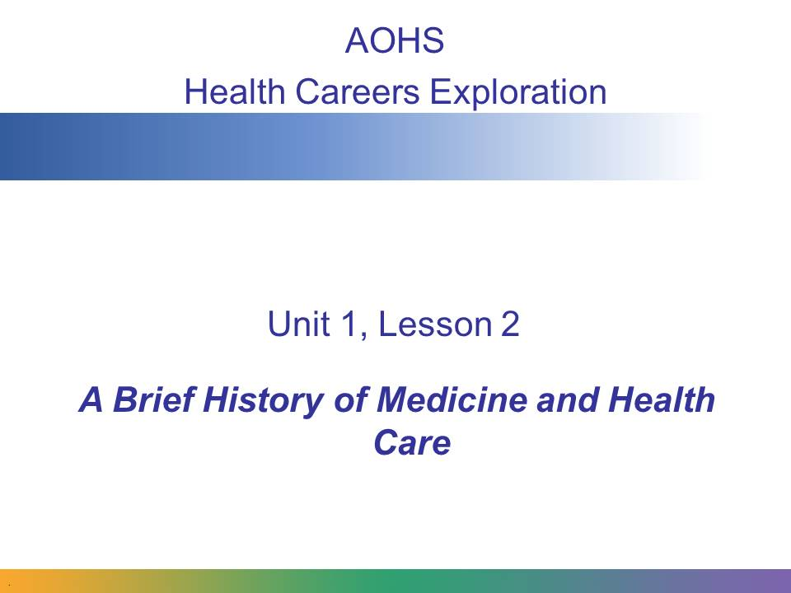
In this presentation, we’ll take a look at some of the major medical practices and events that occurred in each period of human history and see what they can teach us about what medicine and health care might look like in the future.
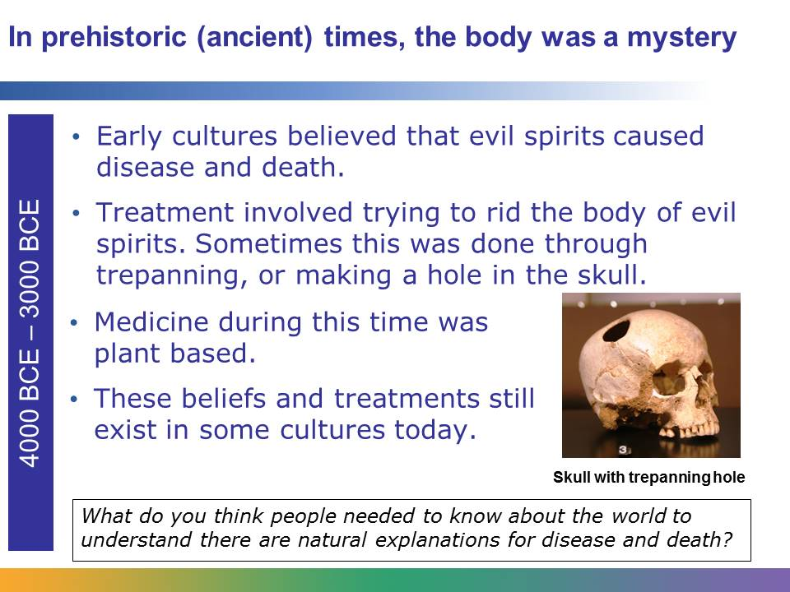
During prehistoric times, little was known about the human body and the natural causes of illness and death. Early religions prohibited the dissection of the human body, so how the body worked remained a mystery for centuries.
Many early cultures believed that evil spirits or demons caused disease and death. They also believed that a person who fell ill was being punished by a supernatural power. Treatment often focused on attempting to destroy the evil spirit. This was done through religious ceremonies or crude procedures, like trepanning. Trepanning, or boring a hole in the skull, was believed to release an evil spirit that caused epilepsy and mental illness.
During prehistoric times, people also used herbs and plants as medicine. Many of these herbal remedies are still in use today.
Image retrieved from http://commons.wikimedia.org/wiki/File:Crane-trepanation-img_0507_crop.jpg on June 5, 2013, and reproduced here under the terms of the Creative Commons Attribution-Share Alike 2.0 France (http://creativecommons.org/licenses/by-sa/2.0/fr/deed.en). Image courtesy of Rama.
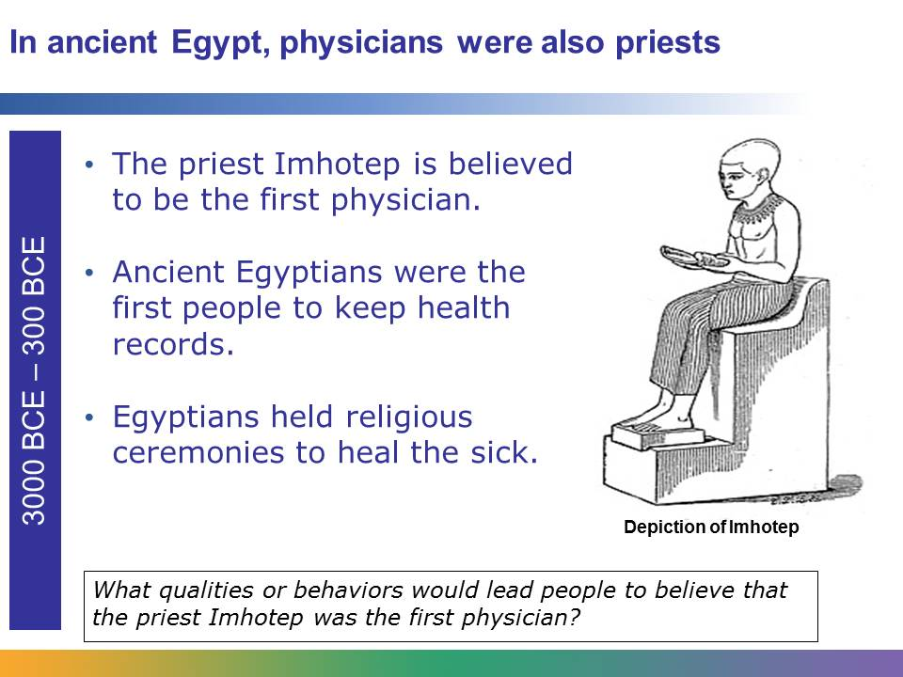
In ancient Egypt, physicians were priests. To heal the sick, ancient Egyptians, like prehistoric people, relied on religious ceremonies. Priests, like Imhotep, performed these ceremonies. Imhotep was also an architect and engineer.
Egyptians are considered to be the first people to keep health records. They kept these health records in stone.
The ancient Egyptians are also known for practicing bloodletting, or leeching. They believed that the body was a made up of a system of channels, and if the channels became clogged, sickness occurred. They used leeching to open the channels and release “bad” blood from ill patients.
Image retrieved from http://commons.wikimedia.org/wiki/File:Imhotep.jpg on June 5, 2013. From 4th edition of Meyers Konversationslexikon (1885‒90).
The ancient Chinese practiced holistic methods for treating the ill. They believed that to heal a patient, the person’s whole, or entire self, needed nourishment. This included the mind, body, and soul.
The ancient Chinese believed that a life energy called chi flows through an invisible system of pathways, or meridians, in the human body, and that disease and discomfort occur when a block forms along the pathways.
The ancient Chinese invented acupuncture as one way to restore and maintain a proper flow of energy along the pathways. Acupuncture is a treatment in which specific points in the skin are punctured with thin needles. Acupuncture was believed to relieve pain and promote healing by stimulating the flow of energy in the body.
The ancient Chinese also introduced the method of monitoring a person’s pulse to determine the health of his body.
Like other ancient people, they made medicine from herbs. They kept a record of the use of herbal medications.
Holistic medicine, acupuncture, and Chinese herbal medicine are all still used by people around the world today.
Ancient Indians developed Ayurveda, a type of holistic medicine. In Sanskrit, Ayurveda means “complete knowledge of long life.” Ayurvedic practices center around the idea of providing balance in the body. Encyclopedias that were created thousands of years ago form the foundation of Ayurveda. Treatments include plant-based medicines, massage, yoga, exercise, and careful attention to hygiene and diet.
In between the 10th and 12th centuries CE, India was overrun by Muslim invaders from the West who brought their own medicine, and the practice of Ayurveda subsided.
However, many people in India and parts of Asia still practice Ayurveda today.
Image retrieved from http://commons.wikimedia.org/wiki/File:An_Ayurvedic_Pharmacy,_Rishikesh_%281%29.jpg on June 5, 2013, and reproduced here under the terms of the Creative Commons Attribution-Share Alike 2.0 Generic license (http://creativecommons.org/licenses/by-sa/2.0/deed.en). Image courtesy of Ken Wieland.
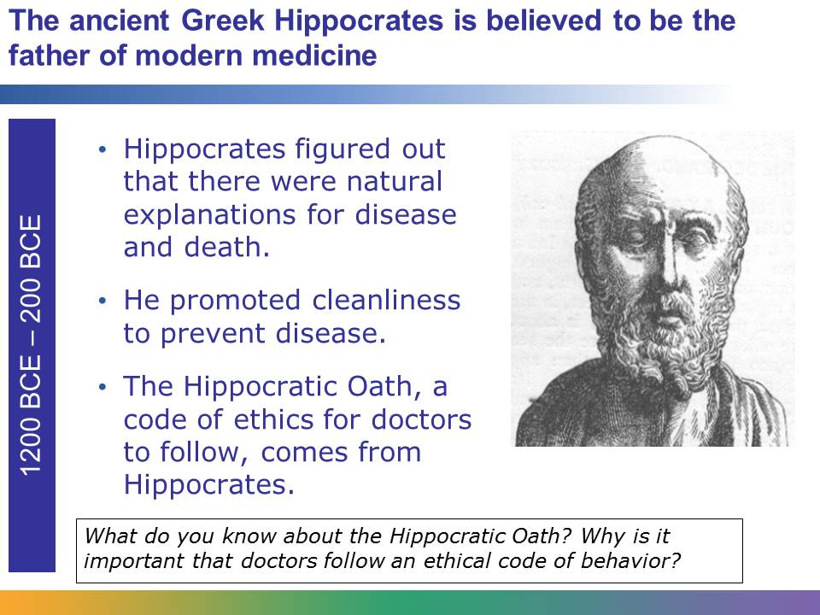
The Greek physician Hippocrates is often called “the father of medicine.” Many of his discoveries and achievements are still recognized today. Until the period of the ancient Greeks, people believed that supernatural forces caused illness and death. But Hippocrates, and other physicians of his time, developed an understanding that there were physical and natural explanations for disease and death.
We take for granted that cleanliness is an important part of maintaining good health, but this was something people had to discover. Hippocrates promoted a good diet, exercise, fresh air, and, perhaps most importantly, cleanliness to both prevent disease and help the sick heal. He also developed methods to observe the body and record signs and symptoms of disease, as doctors do today.
Of all of his accomplishments, he may be most famous for the Hippocratic Oath, a code of behavior that continues to be recognized by health care professionals. When health care professionals take this oath, they swear to practice medicine ethically. It includes ideas about respecting a patient’s privacy and treating patients with compassion.
Image of Hippocrates retrieved from http://commons.wikimedia.org/wiki/File:Hippocrates.jpg on June 5, 2013.
The ancient Romans learned from the work of the Greeks. They believed that poor sanitation and tainted water could cause disease. Armed with this information, they established public health and sanitation systems. They developed sewers to remove waste from the cities and built aqueducts to bring clean water to the people. The Romans established laws to keep garbage out of the streets, and they used filtering systems in public baths. They also drained swamps where mosquitoes carrying malaria thrived.
The ancient Romans, like the Greeks, began experimenting with dissecting animals. This process was necessary to study the organs and how the parts of the body were connected. It was through this work that the function of the muscles, kidney, and bladder was discovered.
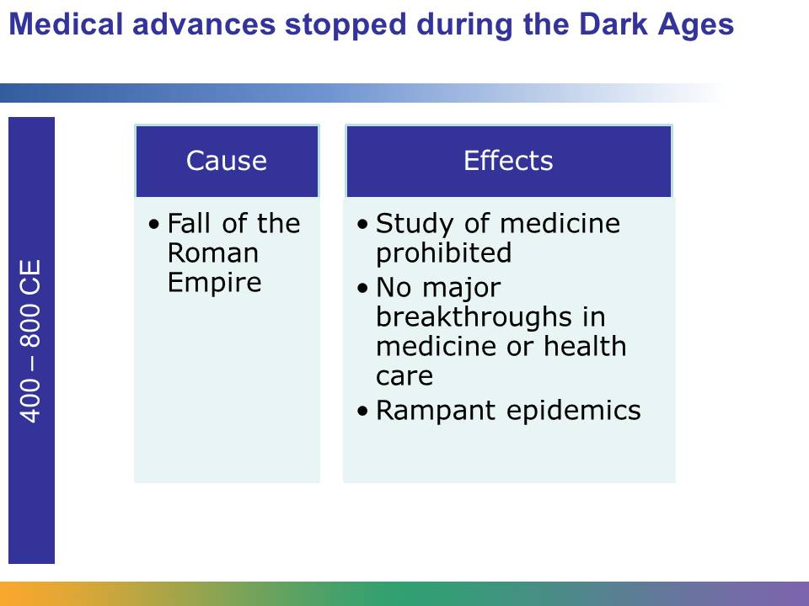
After the fall of the Roman Empire, progress temporarily came to a standstill. Superstition crept back into beliefs about medicine, and people were taught that diseases were punishment from God. Priests once again became the healers, and in many parts of what was once the Roman Empire, priests prohibited the study of medicine. Prayer and herbal remedies became the principle methods used to treat the sick, and priests were in charge of caring for patients. Unsanitary living conditions resumed, and with them came the spread of disease. Ultimately, for reasons not entirely clear, nonclerical physicians just ceased to exist.

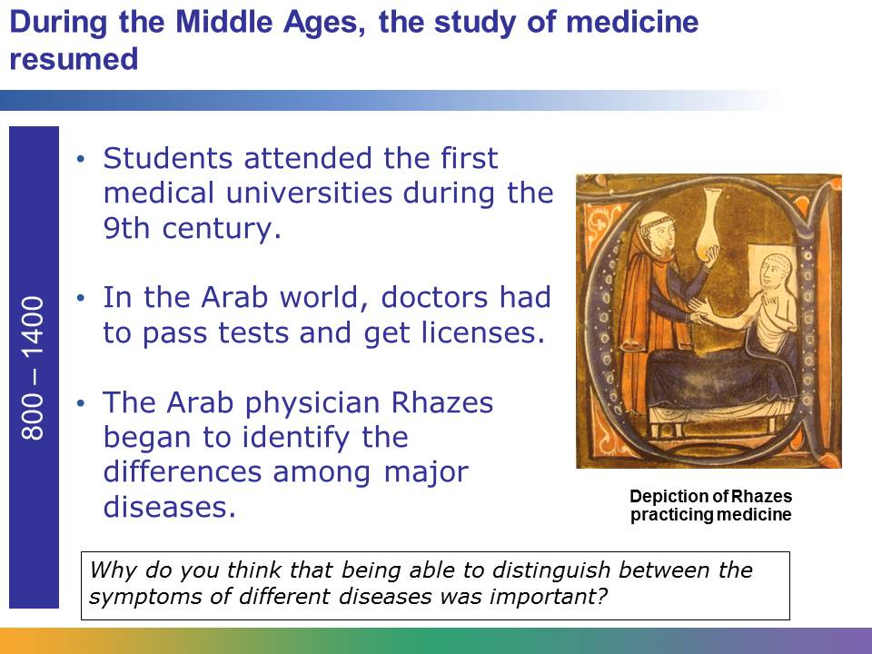
During the Middle Ages, there was a renewed interest in the work of the Greeks and Romans. The first medical universities were established, and it became a requirement for Arab physicians to pass a licensing exam to practice medicine.
The Arab physician Rhazes made great strides in distinguishing the signs and symptoms of different diseases. For example, Rhazes identified the difference between smallpox and measles. He also suggested that infections may be carried in the blood, and he developed suture material made from the guts of animals.
Image of Rhazes retrieved from http://en.wikipedia.org/wiki/File:Al-RaziInGerardusCremonensis1250.JPG on June 5, 2013.
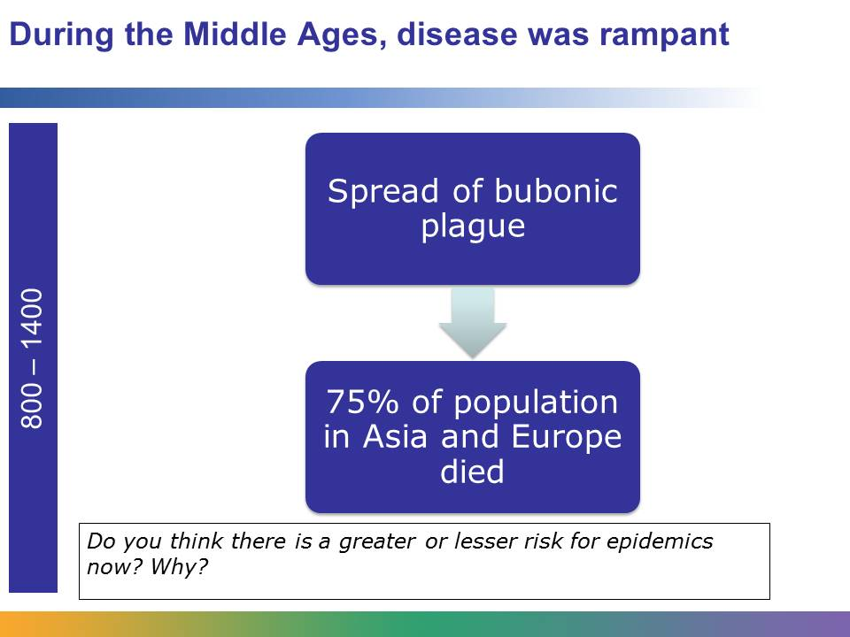
In spite of the advancements during the Middle Ages, disease continued to take a toll on the human population. In the 1300s, a horrific epidemic called the bubonic plague, or black death, killed almost 75% of the population of Asia and Europe. Also, major diseases like smallpox, diphtheria, tuberculosis, typhoid, and malaria were common and claimed many lives. The average life span during this period was 20 to 35 years.
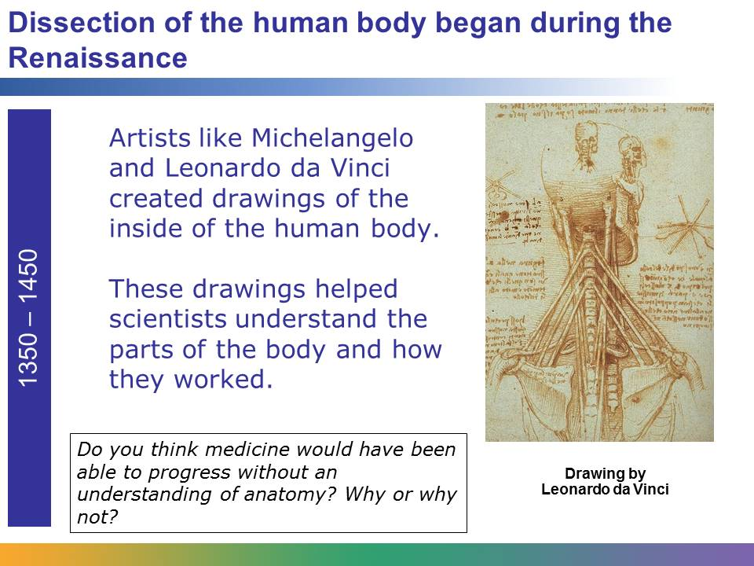
Ancient societies prohibited the dissection of the human body, but things changed during the Renaissance. Scientists began dissecting the human body, and with this advancement, came new knowledge and information.
Artists, like Michelangelo and Leonardo da Vinci, created accurate drawings of the body. The printing press, a new invention, allowed these drawings and information to be reproduced. The first book on human anatomy was published.
Image of Leonardo da Vinci’s Anatomy of the Neck retrieved from http://commons.wikimedia.org/wiki/File:Leonardo_Anatomy_of_the_Neck,_c._1515.jpg on June 5, 2015.

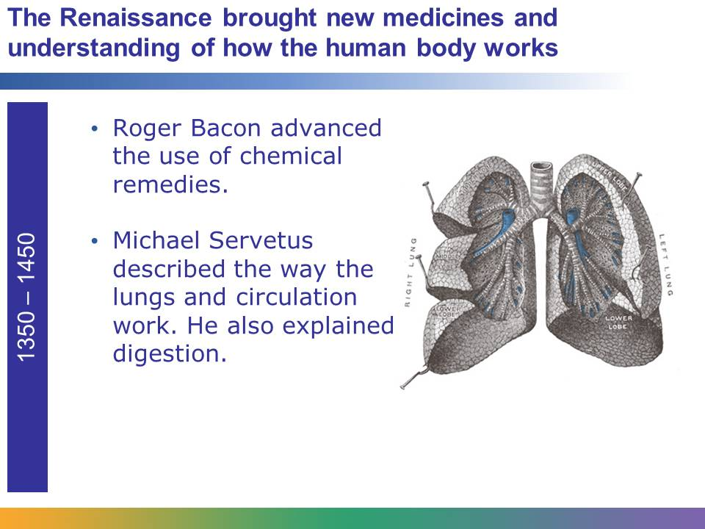
During the Renaissance, an understanding of the anatomy of the human body was developing, and this allowed more advancements to take place.
The type of medicine people used began to change. Roger Bacon advanced the use of chemical remedies, instead of herbal remedies, to treat illness. Also, the emerging study of anatomy allowed doctors to develop a more accurate understanding of how the human body worked. Michael Servetus accurately described the circulatory system in the lungs. He also explained how digestion is a source of heat for the body.
Image of human lungs retrieved from http://commons.wikimedia.org/wiki/File:Lungs_open.jpg on June 5, 2013. From Gray’s Anatomy, 1918.

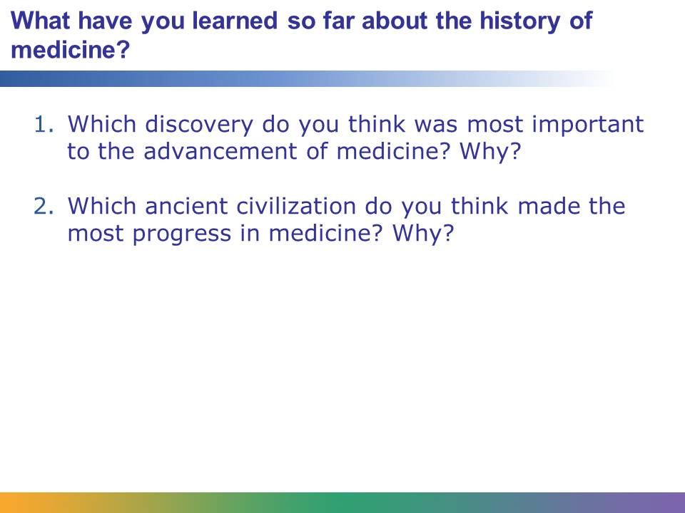
Talking about what you’ve learned so far will prepare you to learn about the great strides that have brought us to modern medicine.
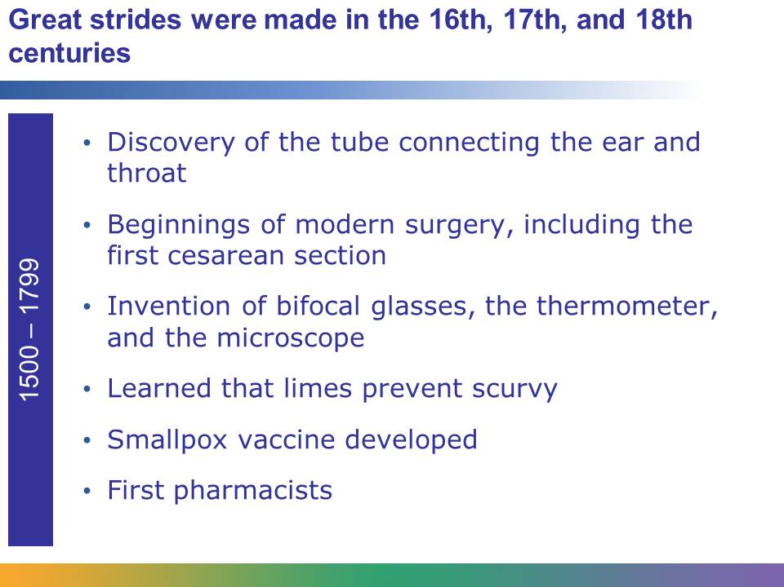
During this era, doctors and scientists still didn’t understand the basic causes of disease, but several discoveries increased their knowledge about the human body, including the discovery of the fallopian tubes and the tube between the ear and throat.
The foundations for modern surgery were also established, and the first cesarean section to deliver an infant was performed.
Benjamin Franklin invented the bifocal glasses, and Gabriel Fahrenheit developed the first thermometer. Anton Van Leeuwenhoek invented the microscope. This tool allowed scientists to see microorganisms, which are too small to be seen by the human eye. Van Leeuwenhoek called them “animalcules.”
It was discovered that limes, which contain Vitamin C, prevent scurvy. A vaccination against the deadly disease smallpox was also developed.
The first pharmacists, called apothecaries, opened for business during this era. Apothecaries made, prescribed, and sold medicine.
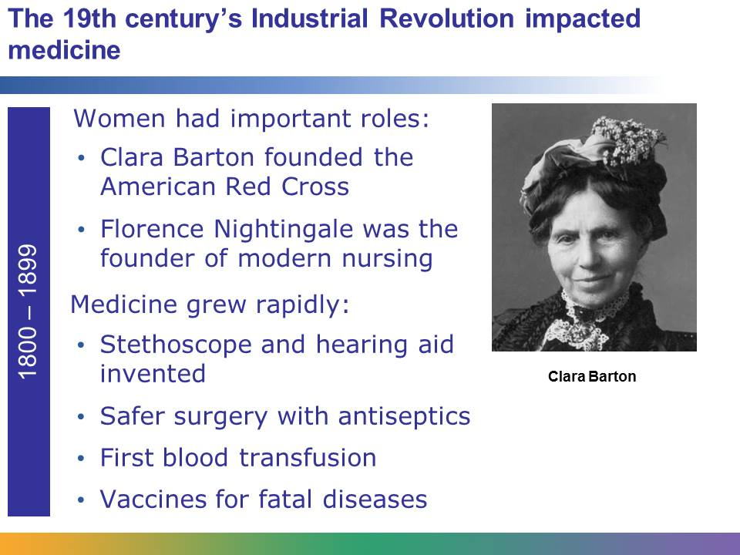
The Industrial Revolution began in the 19th century. The introduction of new machines and an increased access to books and information allowed for rapid growth in medicine. Inventions in this era include the stethoscope, which allows physicians to listen to internal body sounds, and the first electrical hearing aid.
During this century, the first formal training program for nurses was established. Florence Nightingale, one of its earliest graduates, was one of several figures who paved the way for women in medical care. Another influential woman in this era was Clara Barton, who founded the American Red Cross.
Methods for controlling infection were discovered, including the use of antiseptics and disinfectants during surgery. The first successful blood transfusion occurred during this era. Many medications and vaccines were discovered, including vaccines for typhoid fever, rabies, and diphtheria. In 1892, Dimitri Ivanofski discovered viruses.
Image of Clara Barton retrieved from http://commons.wikimedia.org/wiki/File:Wcbhatcr2.jpg on June 5, 2013.

Louis Pasteur lived from 1822 to 1895. The French chemist and biologist is responsible for a number of breakthroughs in the 19th century that permanently changed medicine. He proved that microorganisms cause most infectious diseases. He also discovered how to destroy harmful germs in perishable foods and developed a number of vaccines, including vaccines against rabies and anthrax. His theories about sanitation and his work on vaccines likely saved the lives of millions of people.
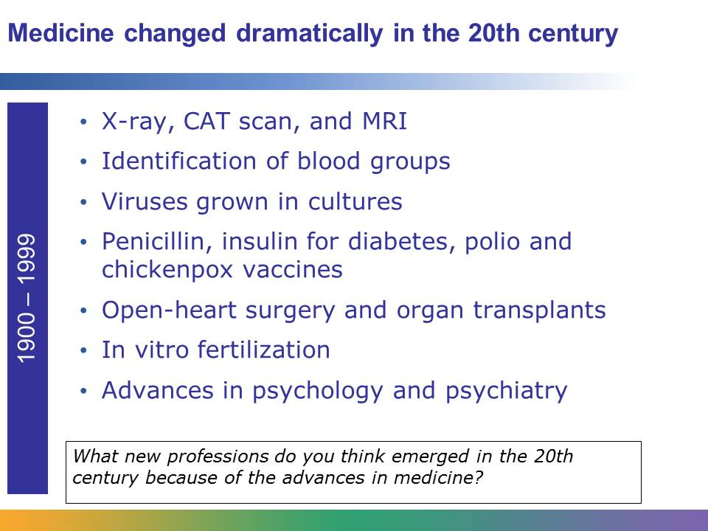
The most changes in medicine and health care in history occurred in the 20th century. By the beginning of the new millennium, computer technology had altered every aspect of health care.
Major inventions of the century include the X-ray, CAT scan, and MRI, which are used for diagnostic purposes.
Major discoveries included identifying the major blood groups, growing viruses in a laboratory, and understanding the structure of DNA and how it carries genetic information.
Groundbreaking treatments were discovered, including the antibiotic penicillin and the use of insulin to treat diabetes. The polio and chickenpox vaccine were also discovered.
Great strides were made in surgery. In this century, open heart surgery was performed for the first time. The first heart, kidney, liver, and lung transplants were also successfully performed. The century also witnessed the first successful larynx, or voice box, transplant.
Sigmund Freud ushered in a new era of mental health care by establishing the basis for psychology and psychiatry.
People began living longer. In the 18th century, the average life span was 40 to 50 years. By the end of the 20th century, the average life span was 60 to 80 years.
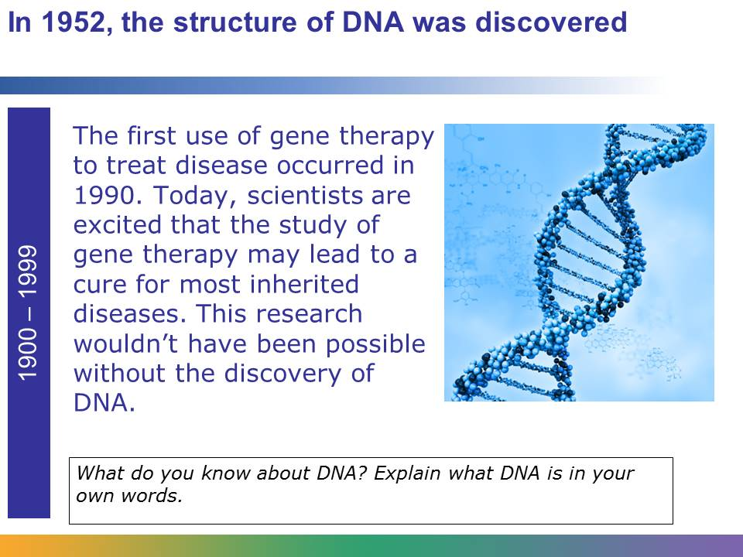
In 1952, Francis Crick and James Watson discovered the structure of DNA, or deoxyribonucleic acid, which carries hereditary material. Crick and Watson explained that the structure of DNA is a double helix, somewhat like a twisted ladder. They were given the Nobel Prize for their work. Their work forms the foundation for most genetic research conducted today.
In the 20th century, insurance plans that pay for the cost of health care were introduced, as were standards about the type of care people receive. There was ongoing discussion and debate about creating affordable health care insurance and the government’s role in paying for and providing health care. This debate continues into the 21st century.
Major milestones included the introduction of Medicare and Medicaid in 1965, the Americans with Disabilities Act in 1990, and the Health Insurance Portability and Accountability Act (HIPAA) in 1996, which protects patient privacy and made it easier to get health insurance.
Image retrieved from http://commons.wikimedia.org/wiki/File:Handicapped_Accessible_sign.svg on June 5, 2013.
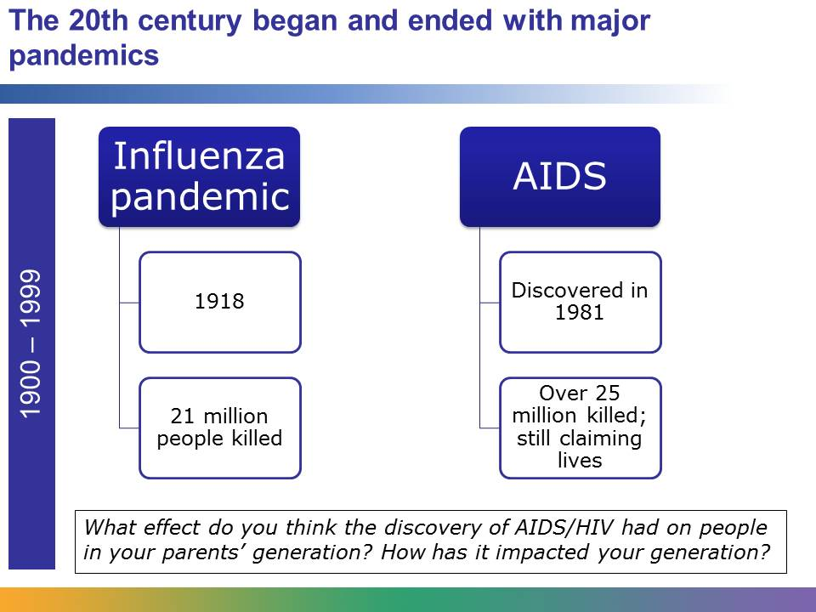
In the early part of the century, an influenza pandemic took the lives of 21 million people. This pandemic was a single outbreak of the same kinds of flu we deal with every year. Near the end of the century, AIDS was discovered. AIDS is caused by the virus HIV, which attacks the body’s immune system. The AIDS pandemic has claimed the lives of over 25 million people and orphaned millions of children. A treatment, which is a combination of drugs, can slow the progress of the disease, but there is still no cure.
On March 23, 2010, President Barak Obama signed into the law the Patient Protection and Affordable Care Act. The law represents the most significant change to the health care system in decades. The goal of the Affordable Care Act (ACA) is to increase access and quality of affordable health care for all Americans.
The ACA introduced several major changes. One change is that young adults under the age of 26 can now receive health insurance under their parents’ plans. Another change is that insurance companies cannot refuse to offer insurance because of pre-existing health conditions. This means that an insurance company cannot deny health coverage to a child because he or she has a serious—and costly—illness. The ACA also requires most insurance plans to include free preventive services, such as blood pressure and cholesterol screenings. Americans can use online Health Insurance Marketplaces to find and compare health insurance options and purchase coverage. They can also see if they qualify for lower costs through government assistance.
The ACA brought dramatic changes to the health care system. Experts think that it will take some time for these changes to be fully implemented and for Americans to see how the law may affect their lives.
There are unlimited opportunities for discovery in the 21st century. We have already witnessed the cloning of a human embryo. Even though the embryo didn’t survive, research with embryonic stem cells and cloned cells will continue.
Also, the Human Genome Project was completed. This project identified all of the approximately 20,000 to 25,000 genes in human DNA. The information from this project helps scientists who are researching gene therapy and a cure for inherited diseases.
National leaders are increasingly concerned about bioterrorist attacks, in which microorganisms or biologic agents are used as weapons. Because of this concern, in 2002, some military members were given a vaccine to protect them in the event of a bioterrorist attack.
Scientists are also concerned about new viruses causing pandemics. With people easily moving from continent to continent, there is a real and growing threat that a pandemic could spread quickly around the globe, taking millions of lives.
However, international health organizations continue to closely monitor health problems around the world, and they are using rapidly improving systems to share information and try to prevent disasters.
No one knows for certain what advances and major events in medicine will take place in the 21st century. With increasingly sophisticated technology and communications systems, anything seems possible.
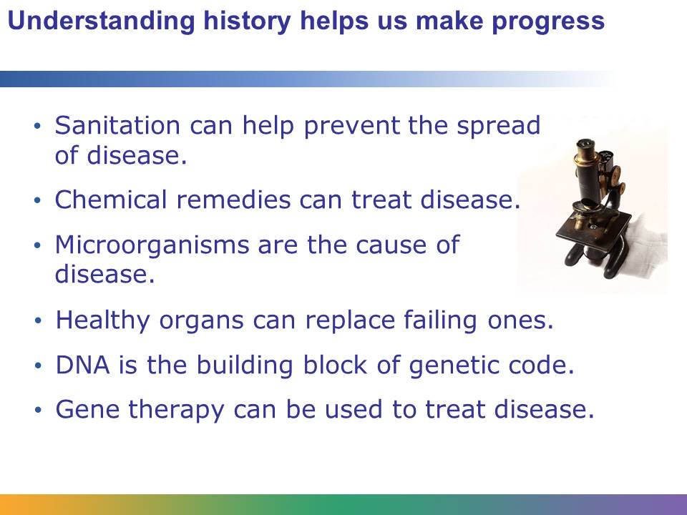
There was a time when the human body was a mystery. Although we’ve come a long way, there is still exciting and critical work to be done. Health care workers today need to have a basic understanding of the history of medicine to be successful in their work and make progress.
Everything we know about how the body works had to be discovered. We had to discover how the lungs work, how to fight basic infections through sanitation, and how to identify the symptoms of different diseases. We had to discover how to safely perform surgery, prevent epidemics, and replace failing organs with new ones. No one knows for certain what discoveries will be made next and who will be responsible for them, but without an understanding of the work of scientists, researchers, doctors, and nurses in the past, the future would not be possible.
Image retrieved from http://commons.wikimedia.org/wiki/File:Microscope.jpg on June 5, 2013, and reproduced her under the terms of the Creative Commons Attribution-Share Alike 3.0 Unported (http://creativecommons.org/licenses/by-sa/3.0/deed.en). Image courtesy of Zephyris at the English Language Wikipedia.

