Final exam
World and US History/English:

You are a traveler of time and space. You will travel to somewhere in each chapter of your history text and for each chapter, you will write a journal entry and include a relevant picture. You will map each place you visit and put the events on a timeline.
World History has 20 chapters and a prologue to choose from and you must each have 20 entries. You may only write one entry per chapter. US History has 26 chapters and an epilogue. You must do 20 entries, no more than one per chapter.

110 points are related to writing- ELA
100 points related to content- history

World/English
 | Comments | Points possible | Points earned
1 entry per chapter- 1 1/2 page double spaced and typed for each entry |  | 20  Hist/ELA
At least one example of figurative speech per entry | Possibilities include: alliteration, simile, metaphor, hyperbole, onomatopoeia, idiom, personification.  Each must by highlighted and labeled | 20  ELA
At least one example of dialogue per entry- correctly punctuated | Dialogue must be written within a sentence to show proper use of comma and period, and quotation marks. It can be something someone really said or made up, but must be appropriate to the character and the times. | 20  ELA
At least 4 historically accurate facts per entry | The four facts are in addition to date and place. You want to demonstrate a strong understanding of where you are and what is happening. | 40  History
Word choice- avoids repetition and redundancy |  | 10  ELA
Parallel structure correctly used throughout |  | 10  ELA
Correctly used subject-verb agreement |  | 10  ELA
Consistently written in 1st person |  | 5  ELA
Free of comma splices, fragments or run-on sentences. |  | 10  ELA
Free of spelling errors |  | 5  ELA
At least one appropriate picture for each entry- must be a place or event mentioned- and must have a caption |  | 10  History
Each entry must have a map marked for location of your visit |  | 10  History
Each entry entered correctly on a timeline | Timeline does not have to be to scale, but of course, it must be in chronological order. Each date must be labeled for date, location and event, not just “Spain”. What was happening? What did you visit? | 20  History

Sample journal entry
Day One:
I cannot believe I was lucky enough to be picked to use the new time travel machine. Waiting for my first adventure was excruciating. I couldn’t breath due to my excitement.
Stepping out of the machine an hour ago, I found myself in Ancient Greece, Athens to be precise. It was a beautiful day; dry and hot, but lovely. The air smelled of fresh fish, the men having just returned from the sea with a bountiful catch.
It must have been around 550 BC because that is when direct democracy started there and I had arrived in time to watch the citizens hold an important meeting. Watching this early direct democracy was fascinating. Their form of democracy was not quite what I was used to. Women, children, and slaves were not citizens, just free men. Only those lucky men could vote. In a direct democracy, the citizens vote on laws. They do not elect representatives to make decisions for them. I kind of like that. I had to stand off to the side, hidden by a great fig tree. After all, I am a woman and was not meant to be present.
Pericles was speaking before the men. He reminded them of the importance of voting, telling them the government of the land was “In the hands of the many and not the few.” I couldn’t believe I actually heard him say those famous words.
After the meeting I wandered the streets of Athens, hoping to get a look at the buildings that are only ruins today. I was lucky enough to watch the moon rise over the Acropolis. What a beautiful site. The trees cast shadows like ghosts dancing in the wind. The art of this old civilization is as amazing as the government. They were truly an advanced civilization.
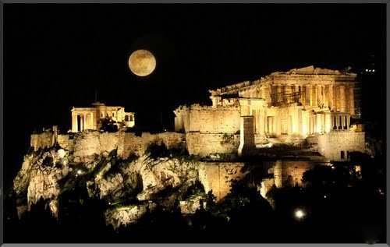
The moon over the Acropolis
Suddenly, I felt a weird pulling sensation against my entire body, as if I was being ripped from my skin. I guess I will get used to this as I continue jumping from place to place and time to time. I wonder where I will end up next.

