Student Resource 4.7
Reading: Vulnerable Populations
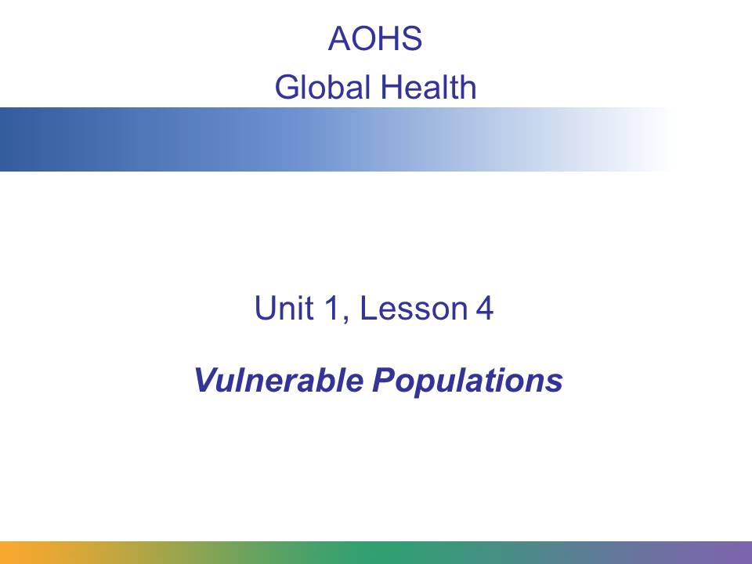
Many global health initiatives are focused on helping vulnerable populations. In this presentation, you will learn more about what a vulnerable population is and why these groups need special help.
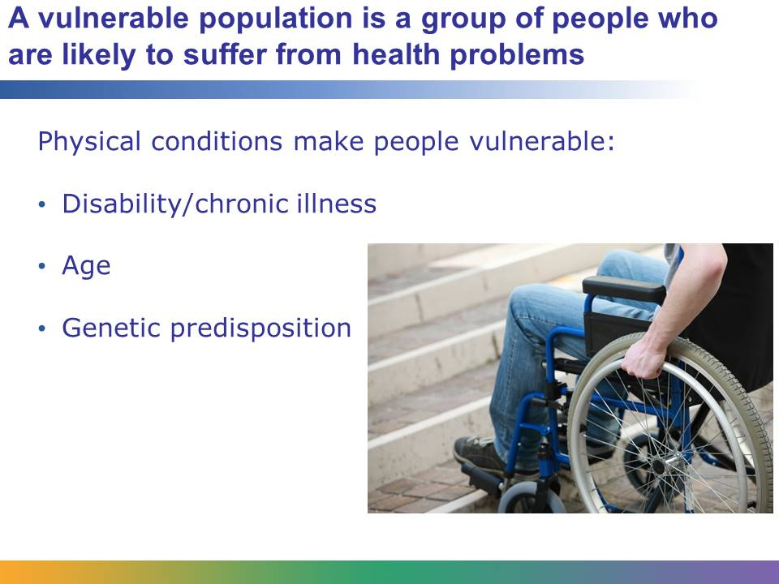
Many health care programs focus on vulnerable populations. These are groups of people that are more likely to suffer health problems and may be less able to get themselves the health care they need.
A group may be vulnerable because of age. Children and elderly people are both considered vulnerable groups; both have unique risks associated with their age, and both may not be able to get themselves to a doctor without assistance.
Genetic predisposition may also play a role. For example, some women have a specific gene mutation that makes them more likely to develop breast cancer. Women with this gene mutation are a vulnerable population. Certain ethnic groups also have a genetic predisposition to specific conditions.
People with disabilities or chronic illnesses are vulnerable to complications that result from their disability or illness. For example, people with diabetes or HIV can develop other conditions because of their primary illness. In the case of diabetes, people can go blind or need a limb amputated. People with a mental disability or with mental illness may not be competent to get themselves the medical treatment they need.
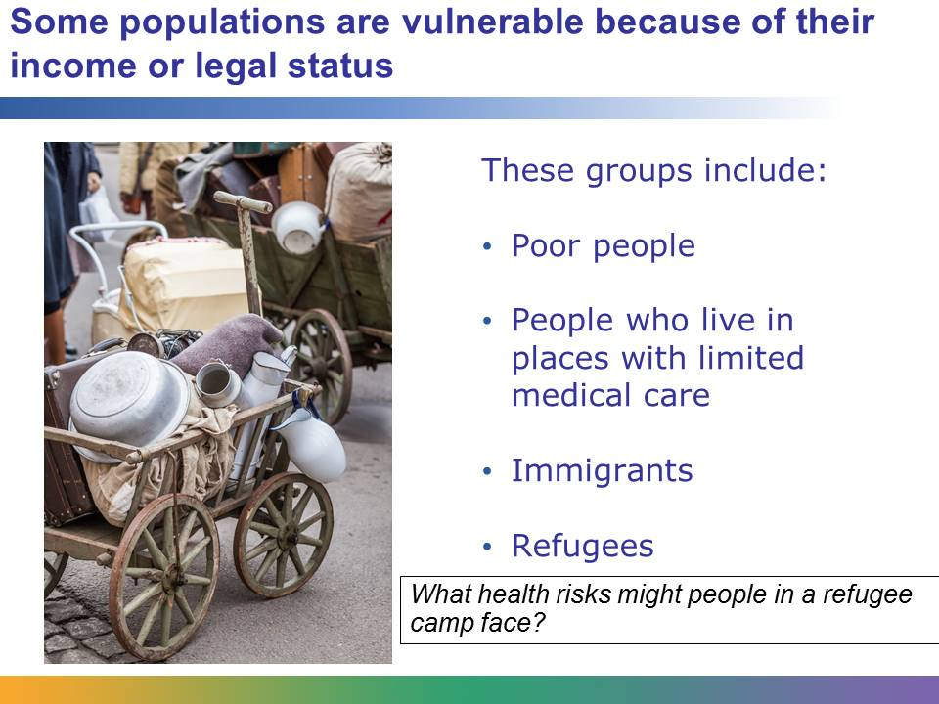
Poor people are a far more vulnerable population group. They may not be able to afford health insurance or medical care, and they may face risks from unhealthy lifestyles or work/living environments. In many countries, poor people are more likely to get malaria because they cannot afford the mosquito nets that protect them from being bitten.
People who live a long distance from medical care are also vulnerable, because they may not get help until a condition has become very serious.
Immigrants and refugees may struggle to get assistance because they do not speak the language of the country in which they are now living. They may also be afraid to ask for help because of their legal status. If they are in the country illegally, they don’t want to call attention to themselves by asking for medical care.
Refugees also frequently face dangerous and unhealthy conditions in refugee camps, which may increase the likelihood of catching an infectious disease like cholera.
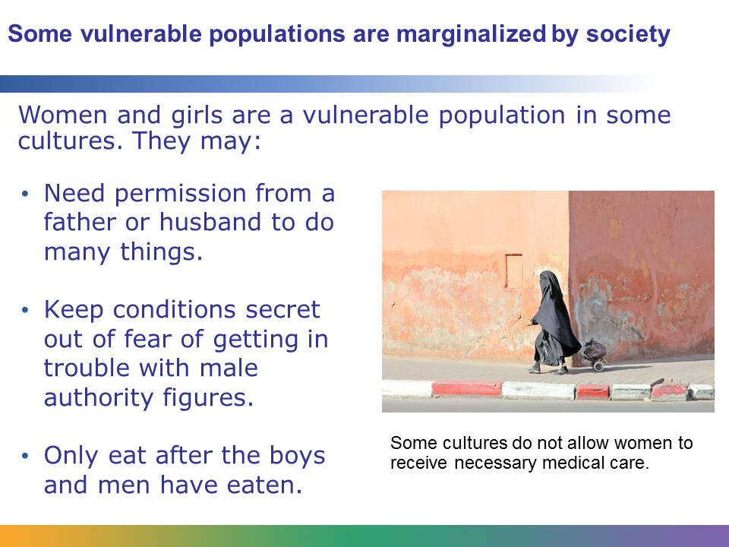
Groups that are discriminated against often face greater health risks and have more difficulty obtaining medical care. Vulnerable populations differ by society. A group that is vulnerable in one country might be very well cared for in another country.
For example, women are not universally a vulnerable population. Women in many developed countries have equal rights, the freedom to work and earn their own money, and the opportunity to seek their own medical care. So it’s important to remember that a vulnerable population in one country might not be vulnerable all over the world.
However, there are some populations that are universally vulnerable. For example, children are almost always a vulnerable population because they need special care.
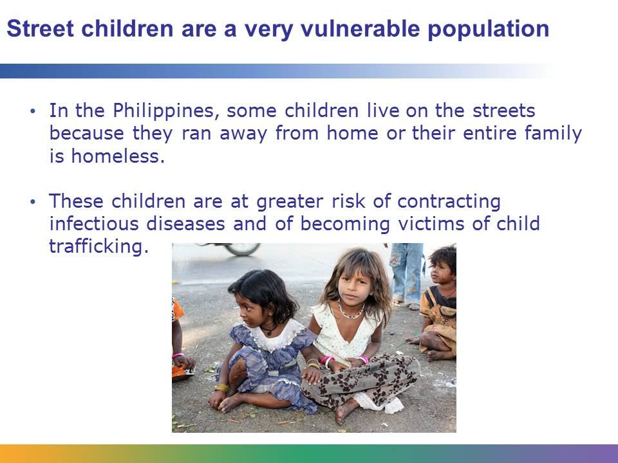
Homeless children are a vulnerable population all over the world. However, in places like the Philippines, street children are especially common. A 2010 UNICEF study estimated that there were 250,000 street children in the Philippines. They often work the streets to earn money by begging or, in some cases, working as child prostitutes.
These street children are at serious risk of contracting an infectious disease. Their living conditions are unsanitary and their nutrition is poor. They get limited medical care, so getting an ordinary childhood illness could be fatal. For children working as prostitutes, the risks are even higher, including the risk of contracting HIV. Worse still, these children are not educated about the risks of HIV. A UNICEF study found that 73% of children thought it was impossible to get HIV, and 28% believed that HIV was curable.
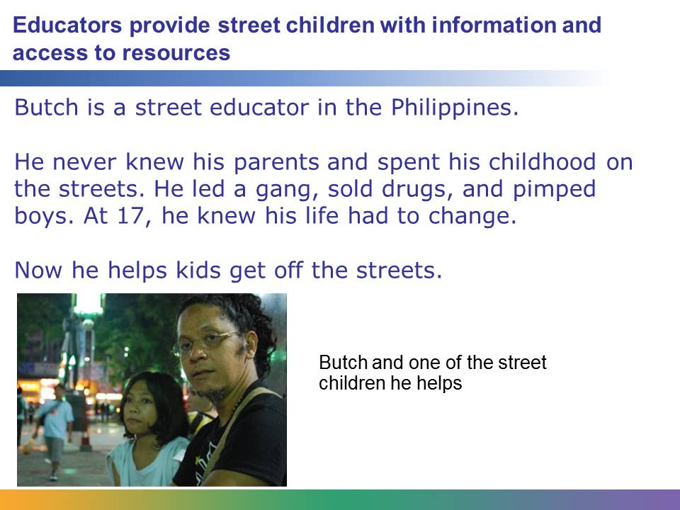
UNICEF works in the Philippines to improve the lives of children, particularly street children. UNICEF has worked with local governments to change laws so that street children convicted of petty crimes go to rehabilitation centers for counseling rather than to jail. It has many programs designed to reduce child prostitution and is also working on HIV education for these children.
In one program, educators go into the streets and make contact with children. They win their trust. They provide them with basic education. They help them access information and services that will hopefully lead to their getting off the streets.
Image retrieved from http://www.unicef.org/philippines/reallives_11786.html on August 29, 2013, and included here under fair-use guidelines of Title 17, US Code. Image © 2009 UNICEF Philippines/Andy Brown.
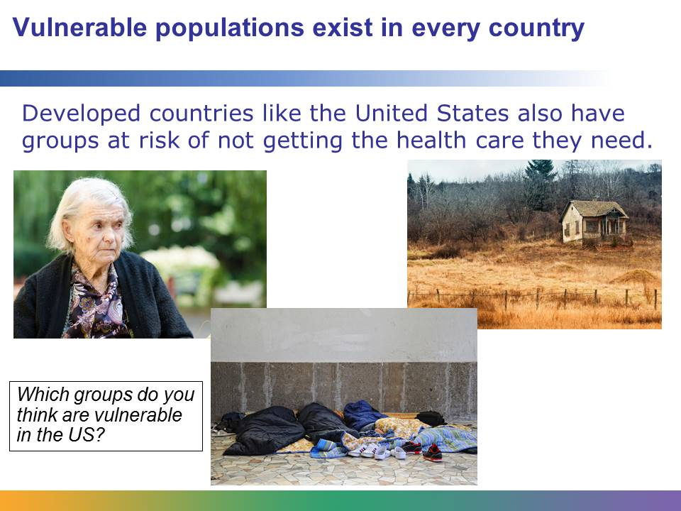
In the United States, the largest vulnerable population is people living in poverty. Ethnic minorities, the elderly, the homeless, and people living in rural areas are other vulnerable populations in the United States. What do many of these groups have in common? They are less likely to have health insurance or access to health care.
In some countries, a population is considered vulnerable because it is looked down upon or mistreated by many in that culture. But in the United States, one of the key characteristics of a vulnerable population is the lack of access to care or good health insurance.
One vulnerable population in the United States is African American men. They tend to have very high rates of hypertension, a key factor in cardiovascular disease. In 2003 approximately 32% of African American adults reported that they had hypertension. This compares to 20% of whites, 19% of Latinos, and 16% of Asians. African American men have a slight genetic predisposition to hypertension, but they are also more likely to live in areas with few places where they can safely exercise. And they are also more likely to live in communities with limited nutritional resources. In these communities, there are also fewer good jobs that pay well and provide health insurance. All of these factors put together mean that African American men are a vulnerable population for hypertension.
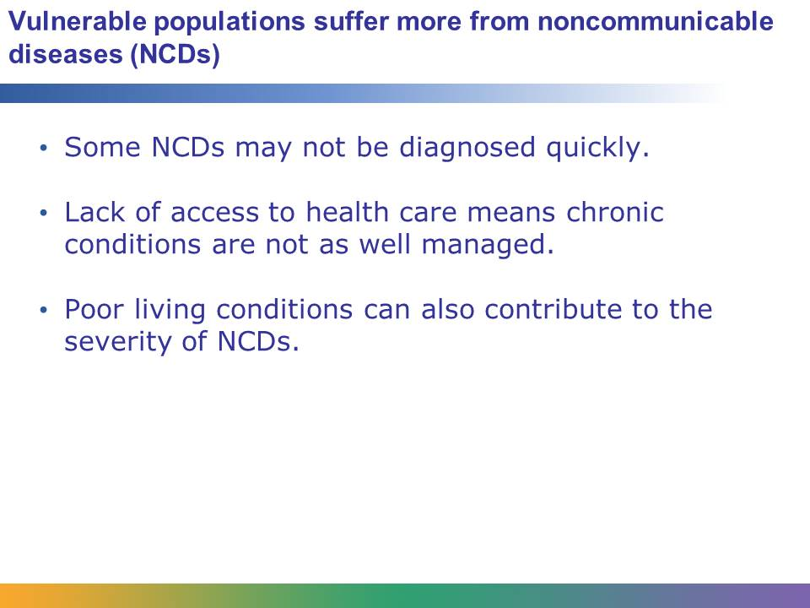
It seems obvious that vulnerable populations may suffer more from communicable diseases. Refugees or poor people may face unhealthy living conditions. As you just learned, street children may not realize the dangers they face from sexually transmitted diseases like HIV. However, noncommunicable diseases are also a serious problem for vulnerable populations.
These populations have less access to health care. So, in many cases an NCD will not be diagnosed as quickly as in populations that have better access to health care. While a person may know he doesn’t feel very well, he may dismiss it as “just a hard time catching my breath” or “pains in my chest once in a while,” without realizing that this could be the sign of something serious like chronic obstructive pulmonary disease (COPD) or heart disease.
Lack of access to health care means that even if an illness is diagnosed, the condition may not be managed as well as it should be. Imagine a poor child with asthma. She may be diagnosed and given an inhaler to treat her symptoms. Children with asthma can live very normal, comfortable lives with the proper treatment. But if money is tight in her family, they may not be able to afford the prescription refills. So the child simply suffers with the disease. If a child’s asthma becomes severe, her parents might take her to the emergency room, which then means they have a large bill to try to pay. In this case, a relatively manageable disease makes life much more difficult for someone who is part of two different vulnerable populations.
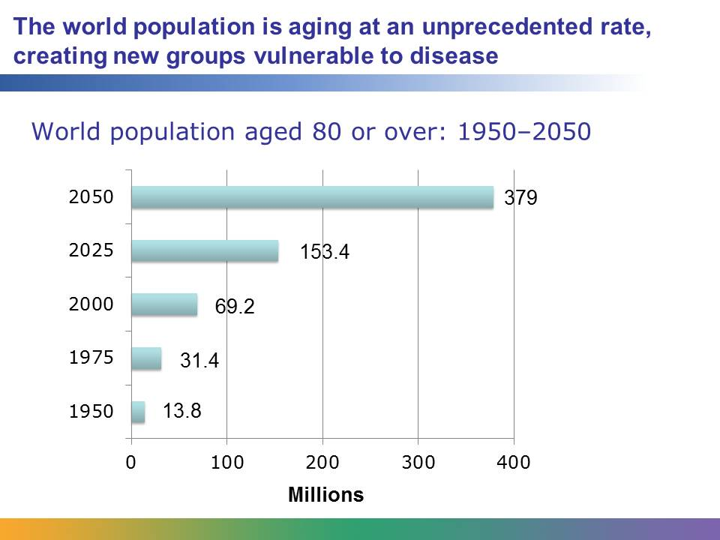
In the United Nations report “World Populations Ageing, 1950-2050,” researchers point out that not only are there more people living into their 60s and 70s, but more people are living into their 80s and even older. As the graph here shows, by 2050 researchers estimate that there will be close to 400 million people in the world who are over the age of 80.
As you already learned when you studied demographic transitions, a graying population can pose some serious challenges. This pattern of aging will create new vulnerable populations. Groups that are already discriminated against will now also be dealing with the increased health problems of old age. The strain of caring for older generations may also mean that fewer resources are available to help younger vulnerable groups. To make things even more complicated, the aging rate in developing countries is becoming more rapid than in developed countries. Developing countries, which are already struggling to meet the needs of their population, now have an additional challenge with growing vulnerable groups.
Data from UN publication “World Population Ageing, 1950–2050,” available online at http://www.un.org/esa/population/publications/worldageing19502050/pdf/90chapteriv.pdf.
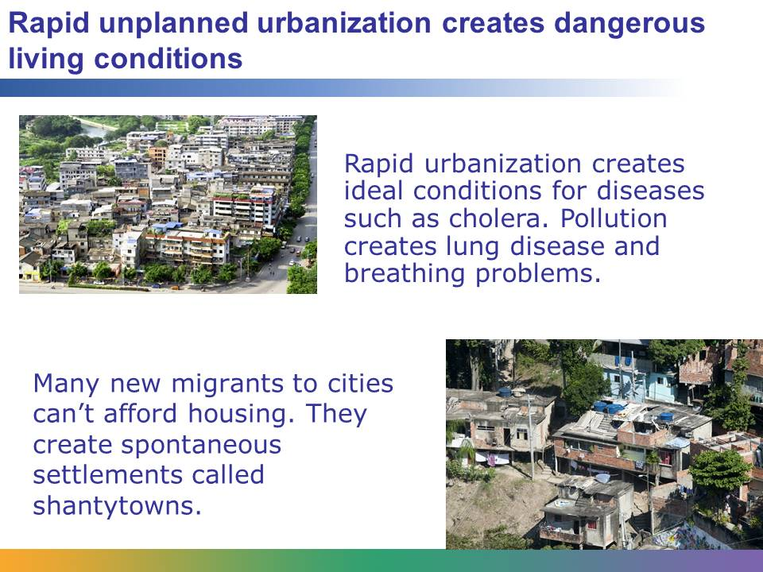
City dwellers face three major health risks: communicable diseases that thrive in crowded and unsanitary conditions, noncommunicable diseases that increase due to unhealthy lifestyles more common in the city, and an increased number of accidents and injuries due to violence and crime. However, well-planned urban environments can mitigate these problems, and city dwellers can also benefit from increased access to medical care, healthy food, and good sanitation.
Vulnerable populations are more likely to live in these slum environments. The existence of such living conditions may also lead to an increasingly large vulnerable population, as the people who live in these slums face an increased risk of health problems.
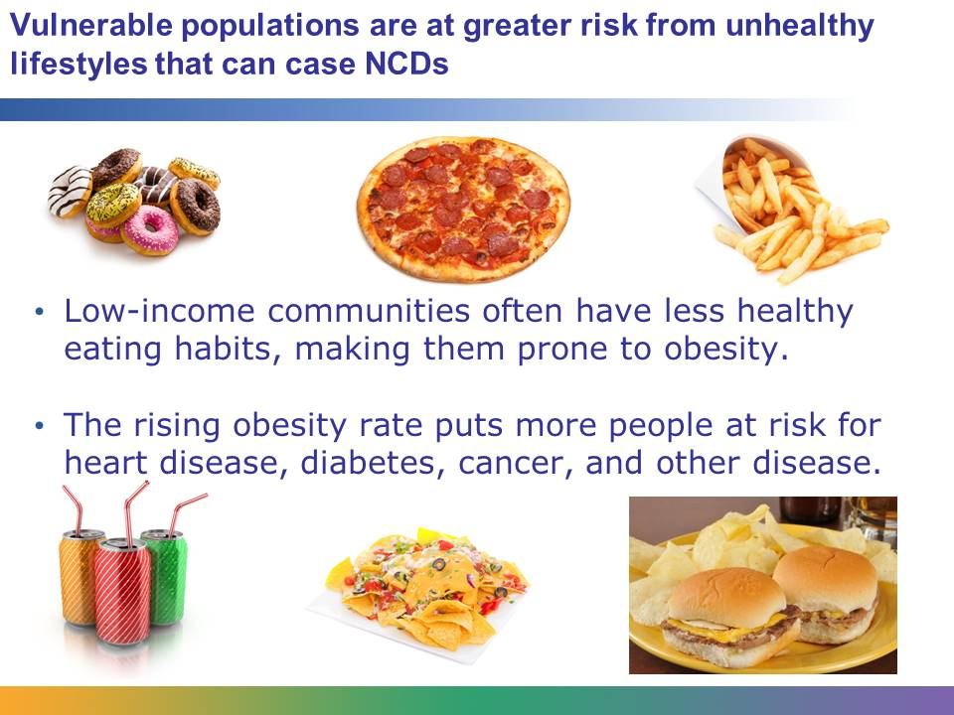
Vulnerable populations frequently have less healthy eating habits. They may not have adequate education to know what foods are better for them. They may not have access to healthier food, because in some low-income communities there are a lot of fast-food restaurants and not a lot of grocery stores or other sources of healthy foods such as vegetables and fruit. They may not have the money to buy healthier food, since it is often more expensive than unhealthy food.
The result is a worldwide epidemic of obesity. Today more than 40 million preschool children are obese or overweight. As you have learned, obesity increases the risk of heart disease, cancer, diabetes, and many other diseases. Vulnerable populations that already face higher risks for disease now have one more risk factor.
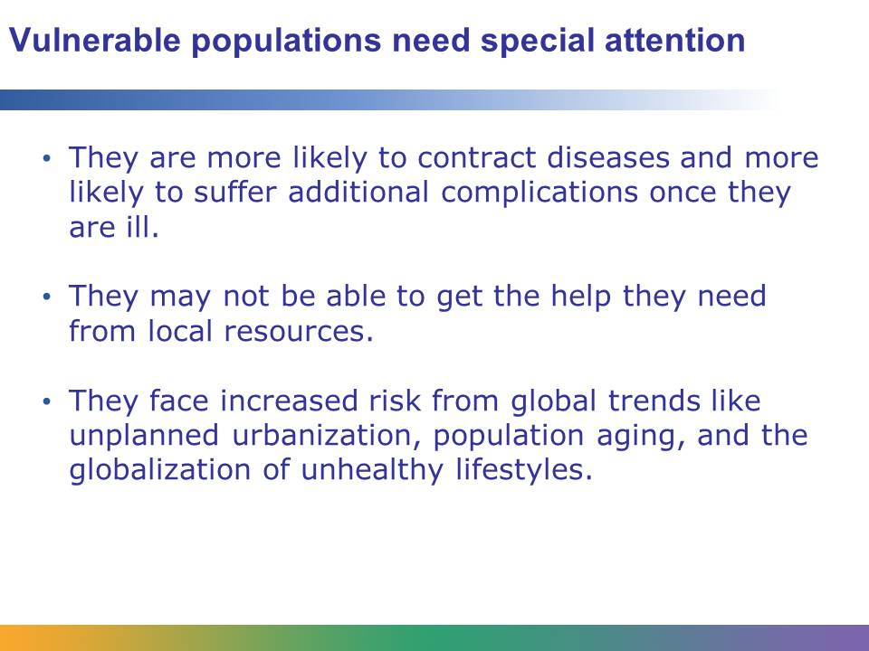
The United Nations, UNICEF, and other nongovernmental organizations (NGOs) focus much of their work on helping vulnerable populations. These populations are more likely to contract infectious diseases. If they already have a chronic disease, they may suffer more complications and setbacks because of their limited access to medical care. Since many of these groups are discriminated against in their community, they struggle to get the help they need. They are also at greater risk from the broad global trends of demographic aging and unplanned urbanization, and the global spread of unhealthy lifestyles.
It is important to remember that a vulnerable population in one community or country may not be vulnerable in another. However, vulnerable populations exist in every country in the world, and they need special help.
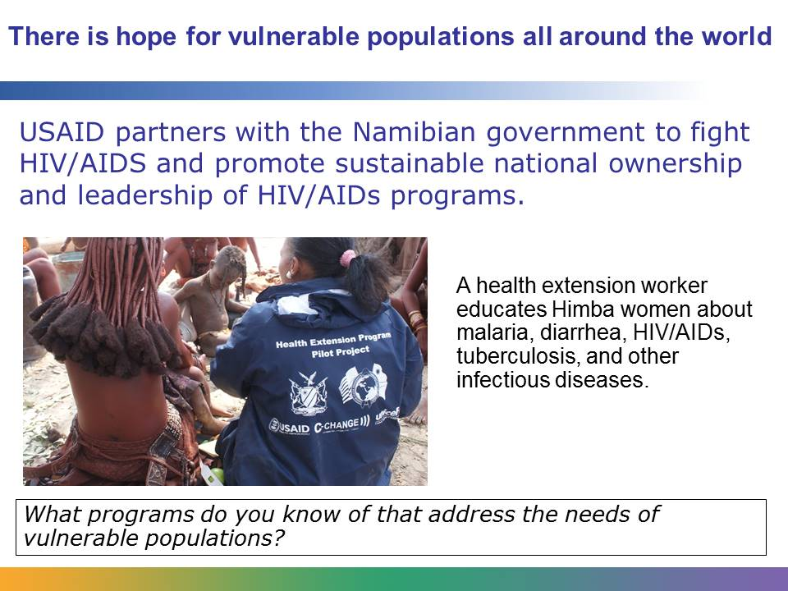
Dedicated global health workers are reaching out to the world’s vulnerable populations. For example, the children who live in the Kunene region of Namibia are especially vulnerable. The rural area where they live is very isolated and the terrain is rough. When medical help is needed, it often doesn’t get there fast enough. UNICEF worked with groups in Namibia to train community workers in health issues. These workers were then deployed to the region, where they could provide hands-on help.
Programs such as these are seeing success across the globe in the quest to reach and aid vulnerable populations.
Image retrieved from http://www.usaid.gov/namibia/global-health on October 23, 2013, and included here under fair-use guidelines of Title 17, US Code. Image copyright © USAID.

