The mythical story of Oedipus
by Josephine Preston Peabody
Behind the power of the gods and beyond all the efforts of men, the three Fates sat at their spinning.
No one could tell whence these sisters were, but by some strange necessity they spun the web of human life and made destinies without knowing why. It was not for Clotho to decree whether the thread of a life should be stout or fragile, nor for Lachesis to choose the fashion of the web; and Atropos herself must sometimes have wept to cut a life short with her shears, and let it fall unfinished. But they were like spinners for some Power that said of life, as of a garment, Thus it must be. That Power neither gods nor men could withstand.
There was once a king named Laius (a grandson of Cadmus himself), who ruled over Thebes, with Jocasta his wife. To them an Oracle had foretold that if a son of theirs lived to grow up, he would one day kill his father and marry his own mother. The king and queen resolved to escape such a doom, even at terrible cost. Accordingly Laius gave his son, who was only a baby, to a certain herdsman, with instructions to put him to death.
This was not to be. The herdsman carried the child to a lonely mountain-side, but once there, his heart failed him. Hardly daring to disobey the king's command, yet shrinking from murder, he hung the little creature by his feet to the branches of a tree, and left him there to die.
But there chanced to come that way with his flocks, a man who served King Polybus of Corinth. He found the baby perishing in the tree, and, touched with pity, took him home to his master. The king and queen of Corinth were childless, and some power moved them to take this mysterious child as a gift. They called him Oedipus (Swollen-Foot) because of the wounds they had found upon him, and, knowing naught of his parentage, they reared him as their own son. So the years went by.
Now, when Oedipus had come to manhood, he went to consult the Oracle at Delphi, as all great people were wont, to learn what fortune had in store for him. But for him the Oracle had only a sentence of doom. According to the Fates, he would live to kill his own father and wed his mother.
Filled with dismay, and resolved in his turn to conquer fate, Oedipus fled from Corinth; for he had never dreamed that his parents were other than Polybus and Merope the queen. Thinking to escape crime, he took the road towards Thebes, so hastening into the very arms of his evil destiny.
It happened that King Laius, with one attendant, was on his way to Delphi from the city Thebes. In a narrow road he met this strange young man, also driving in a chariot, and ordered him to quit the way. Oedipus, who had been reared to princely honors, refused to obey; and the king's charioteer, in great anger, killed one of the young man's horses. At this insult Oedipus fell upon master and servant; mad with rage, he slew them both, and went on his way, not knowing the half of what he had done. The first saying of the Oracle was fulfilled.
But the prince was to have his day of triumph before the doom. There was a certain wonderful creature called the Sphinx, which had been a terror to Thebes for many days. In form half woman and half lion, she crouched always by a precipice near the highway, and put the same mysterious question to every passer-by. None had ever been able to answer, and none had ever lived to warn men of the riddle; for the Sphinx fell upon every one as he failed, and hurled him down the abyss, to be dashed in pieces.
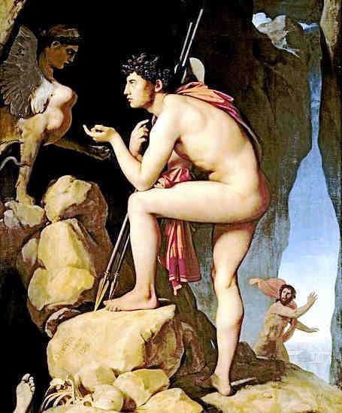
Picture of Oedipus and the Sphinx
This way came Oedipus towards the city Thebes, and the Sphinx crouched, face to face with him, and spoke the riddle that none had been able to guess.
"What animal is that which in the morning goes on four feet, at noon on two, and in the evening upon three?"

Oedipus, hiding his dread of the terrible creature, took thought, and answered, "Man. In childhood he creeps on hands and knees, in manhood he walks erect, but in old age he has need of a staff."
At this reply the Sphinx uttered a cry, sprang headlong from the rock into the valley below, and perished. Oedipus had guessed the answer. When he came to the city and told thebans that their torment was gone, they hailed him as a deliverer. Not long after, they married him with great honor to their widowed queen, Jocasta, his own mother. The destiny was fulfilled.
For years Oedipus lived in peace, unwitting; but at length upon that unhappy city there fell a great pestilence and famine. In his distress the king sent to the Oracle at Delphi, to know what he or thebans had done, that they should be so sorely punished. Then for the third time the Oracle spoke his own fateful sentence; and he learned all.
Jocasta died, and Oedipus took the doom upon himself, and left Thebes. Blinded by his own hand, he wandered away into the wilderness. Never again did he rule over men; and he had one only comrade, his faithful daughter Antigone. She was the truest happiness in his life of sorrow, and she never left him till he died.

Explanation: In mythology, gods are capable of inflicting evil and good . They controlled man's fate. If a person had problems, it was assumed he or she was on the bad side of the gods. Oedipus is referred to throughout Antigone, and an understanding of his story is essential to an understanding of the play.
Oedipus was the son of Laius and Jocasta, king and queeen of Thebes. An oracle predicted that the son was fated to murder his father. Therefore, Laius abandoned his infant son on Mount Cithaeron. But a shepherd discoved the boy and took the child to Corinth. There the baby was adopted by Polybus, king of the city.
When Oedipus reached manhood, he heard a prophecy that he would kill his father and marry his mother. Believing Polybus to be his real father and hoping to avoid that fate, Oedipus fled Corinth. On the road, he met with King Laius. The two men, not knowing one another's true identities, quarrelled. Oedipus killed Laius in the fight.
Oedipus arrived in Thebes to find the city under the curse of a riddling sphinx. Creon, who had assumed leadership of Thebes, proclaimed that he would give the throne to one who could save the city. Oedipus answered the riddle and, as a result, was made king. The prophecy he had feared was unwittingly fulfilled when he took Jocasta(Creon's sister) as his wife. The couple had four children: Eteocles, Polynices, Antigone, and Ismene.
A terrible plague and drought came over Thebes. The oracle foretold that the city would continue to be ravaged until the killer of Laius was found and punished. Oedipus relentlessly pursued Laius' killer until he ultimately discovered the murderer to be himself. A messenger announcing Polybus' death and telling Oedipus that he had been adoped onfirmed his worst fears: he had killed his father and married his mother. Jocasta, realizing the truth before Oedipus, took her own life.
A man of courage and determination, Oedipus took his punishment into his own hands. He blinded himself, turned power over to Creon, and went into exile.
After years of wandering in exile with Antigone, Oedipus arrived at a grove in Colonus, a village near Athens. In the meantime, an agreement between Oedipus' sons, Eteocles and Polynices, to alternately rule Thebes fell apart. Eteocles refused to give up the throne. Polynices retaliated by gathering an army to attack Thebes.
Then the brothers heard of a prophecy that promised victory in battle to the city in which Oedipus died. Suddenly the aged pariah had become of great value to any city which proved his final resting place.
Polynices and Creon both came to Colonus to take Oedipus away, but he chose to stay. He also cursed both his sons, predicting that they would die at each other's hands. Finally, the gods themselves summoned Oedipus to his mysterious death, delivering him from his suffering.
Polynices,with six others, attempted to invade Thebes. The seven men led attacks against the seven gates of Thebes. Eteocles defended the gate assaulted by Polynices. As Oedipus predicted, the two brothers died at each other's hands. The Theban army beat back the invaders and Creon assumed power. At this point, the story of Antigone begins.

