Student Resource 9.4
Reading: Health Determinants and Malnutrition
There are many health determinants that affect nutritional status. In this reading, we are going to look at some of the major determinants that affect malnutrition in individuals and communities.
Poverty and Rising Food Prices
Poverty is a major determinant that affects the nutritional status of people around the globe, especially people living in rural areas of sub-Saharan Africa and South Asia. The amount of food and the type of food available to families in these places is dependent on the family’s access to land, their ability to produce food on the land, and the amount of money they have to purchase food.  In recent years, the price of food has spiked around the globe. This has put a strain on the poor people of the world, who were already struggling to eat. One major spike in prices occurred during 2007 to 2008 and another occurred during 2010 to 2011. During these periods, the prices of common food commodities, like cereal, rose significantly. For example, in Somalia the price of red sorghum, a type of grain that is a staple food there, increased up to 240%.  Governmental and global polices affect agricultural production and the distribution of food. These determinants are often beyond the control of the people who are most affected by them. | 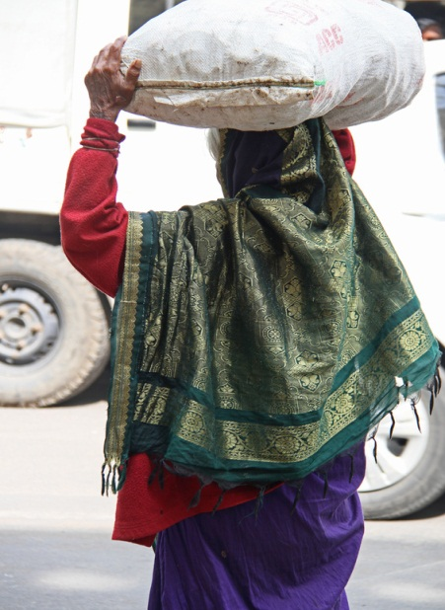  Many of the world’s poorest people spend half of their money on food.

Social Position and Cultural Practices
Social status can be a determinant of nutritional status. In some parts of the world, like rural Pakistan, the girls and women in a family eat less food, or less nutritious food, than the men and boys.
A 16-year-old girl named Amina lives in an isolated community in Pakistan. Amina was recently married. In the morning, it’s her responsibility to get water for chai, or tea. She drinks the chai with milk and sugar. Then she and her mother-in-law make breakfast for the family. The men eat. When they leave to work in the fields, Amina and the other women eat the food that is left. Amina’s share is one paratha, a whole-wheat bread fried in butter. Over the course of the day, she eats chapatti, a light bread, and vegetables from their garden cooked in ghee, or butter. With each meal, she waits until the men and boys have finished eating before she eats.
Cultural practices can be another determinant of nutritional status. In some cultures, it is expected that women will eat different foods when they are pregnant. Unfortunately, some of the foods that are excluded from their diet during pregnancy are critical to their health and the health of their developing babies. For example, before the 1980s, poverty and malnutrition were major problems throughout rural Thailand. Many women in these areas were undernourished when they entered their reproductive years, but their nutritional status suffered even more because of traditional customs. Some of these customs prohibited them from eating nutritious foods like eggs and other important animal proteins while they were pregnant. As a result, pregnant women gained about half the weight that was normal, and their babies were often born underweight.
Childcare Practices
A 17-year-old woman in Bangladesh gave birth to her first baby at home. Both the baby and the mother were underweight. The woman tried to breast-feed the baby, but she found the experience painful and difficult. She didn’t know who to ask for help. She lived with her husband and his family. Her mother-in-law told her that formula was better for the baby than breast milk. The woman stopped breast-feeding and began using formula, but the water she used to mix the formula was contaminated. The baby suffered from terrible bouts of diarrhea. She tried to breast-feed him again, but by this point her body was no longer making enough milk to feed her child. The child was severely malnourished and at risk of dying.
Childcare practices affect nutritional status. Breast-feeding, like in the story above, is one example. In 2013, fewer than 40% of infants under six months of age were exclusively breast-fed. According to the WHO, adequate breast-feeding support for mothers and families could save many lives, but because of misinformation and lack of support, many women don’t breast-feed.

Access to Appropriate Health Services
Illness and infection affect a person’s ability to properly absorb the nutrients that they need, so having access to medical services that help people fight illness and infection is important in maintaining healthy nutritional status.  Children who have access to health services like immunizations are better protected from illness and infection. Supplements of Vitamin A, an important micronutrient missing from the diet of many children, are often provided by health services. Intestinal worms, which can compromise a child’s ability to absorb nutrients, are treated by medication that is available through health services. | 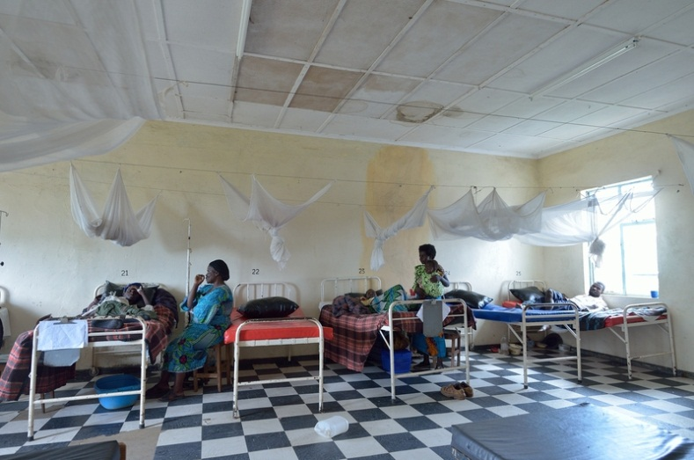  Many poor and rural communities around the world don’t have access to an adequate health clinic such as this one in Zambia.
Seasonal Hunger
In low-income countries, especially in rural areas where people live primarily by means of subsistence farming, communities may experience a “hunger season.” This can occur when a family has exhausted the food from the last harvest before more food can be harvested. If they don’t have income to buy food, they are forced to eat less or simply go without.
In these situations, climate is often a determinant. An agricultural area that receives too little rain, or too much rain, will produce fewer crops, which will affect both what community members earn and what they have to eat.
Even in years with normal rainfall, seasonal hunger can affect people whose work changes with the season. Take for example a family in northern Zambia. The family lives near a lake, and the father works by fishing in the lake. The mother grows vegetables, like sweet potatoes and pumpkins. During the dry season, the father has steady work. The family has enough to eat with meals like boiled sweet potatoes with roasted nuts and a thick porridge with boiled fish, but the wet season is difficult for the family. The lake is closed to fishing, so the father doesn’t have work. The family eats just one meal, at midday. At this time of year, the family does not get the energy they need for daily activities, health, and growth.
Millennium Development Goals
The determinants you have read about are just some of the factors that affect the malnourished around the globe. The determinants often interact, creating serious situations in which nutritional status is severely compromised.
In fact, addressing people’s nutritional needs and the determinants related to them are a critical part in meeting the United Nations Millennium Development Goals. These are eight goals that all of the member states of the United Nations have agreed to try to achieve by 2015. The first six of the Millennium Development Goals are closely tied to nutrition, as described below.
Goal 1: Eradicate poverty and hunger | Poverty is a determinant of nutritional status. Improving income will improve nutritional status.
Goal 2: Achieve universal primary education | Undernourished children enroll in school at lower rates. They also attend school for fewer years and don’t perform as well as properly nourished children. Improving nutritional status will improve children’s attendance and performance at school.
Goal 3: Promote gender equality and empower women | Women are often undernourished in part because of cultural and social determinants. Improving their nutritional status will cut down on conditions like anemia that interfere with their income-earning potential.
Goal 4: Reduce child mortality | In 2013, undernutrition was associated with 45% of child deaths. It’s impossible to reduce child mortality without improving children’s nutritional status.
Goal 5: Improve maternal health | Undernourished women are more likely to give birth prematurely or to have underweight babies. Improving maternal nutrition is directly linked to improving maternal health.
Goal 6: Combat HIV/AIDS, malaria, and other diseases | People with poor nutritional status are more vulnerable to illness and infection. Improving nutritional status is important to fighting serious diseases like AIDS and malaria.

