Student Resource 9.2
Reading: Causes and Effects of Malnutrition
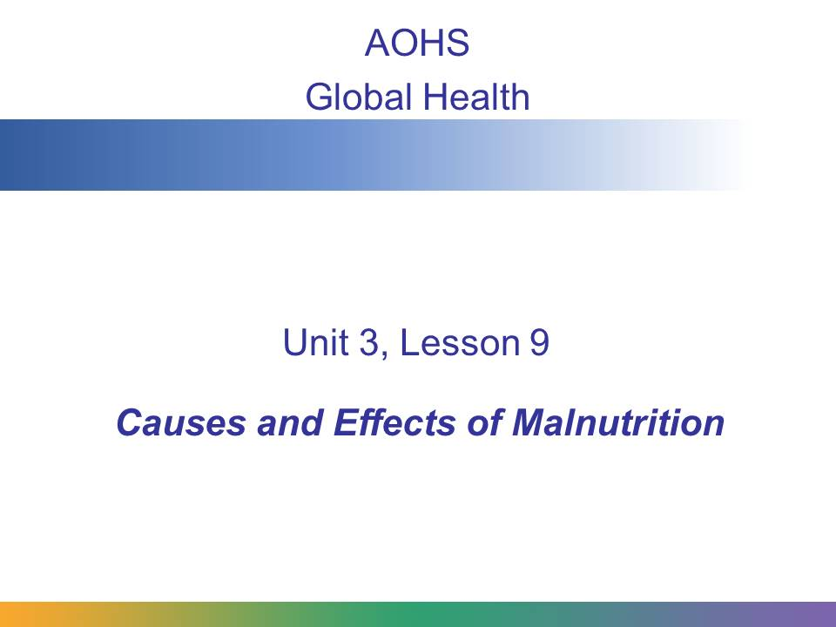
In this presentation, you will learn what malnourishment is, what causes it, what effects malnourishment has on people, and some ways that global health workers are successfully fighting malnourishment.
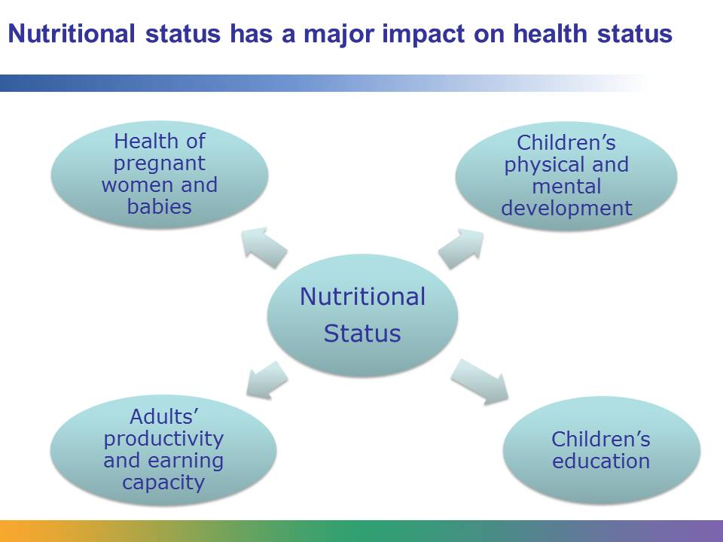
In global health, nutrition is very important. Nutritional status has a major impact on health status. Undernourished women are at an increased risk of delivering premature babies or babies with a dangerously low birth weight. These babies are at risk for not developing properly.
Nutrition is directly linked to the physical and mental development of children, and therefore it affects how healthy children will be as adults. Nutrition plays a role in determining whether children attend school, how well they do at school, and if they complete their schooling. Since it is linked to education, it is also linked to how productive people are as adults and what their prospects are for earning income.
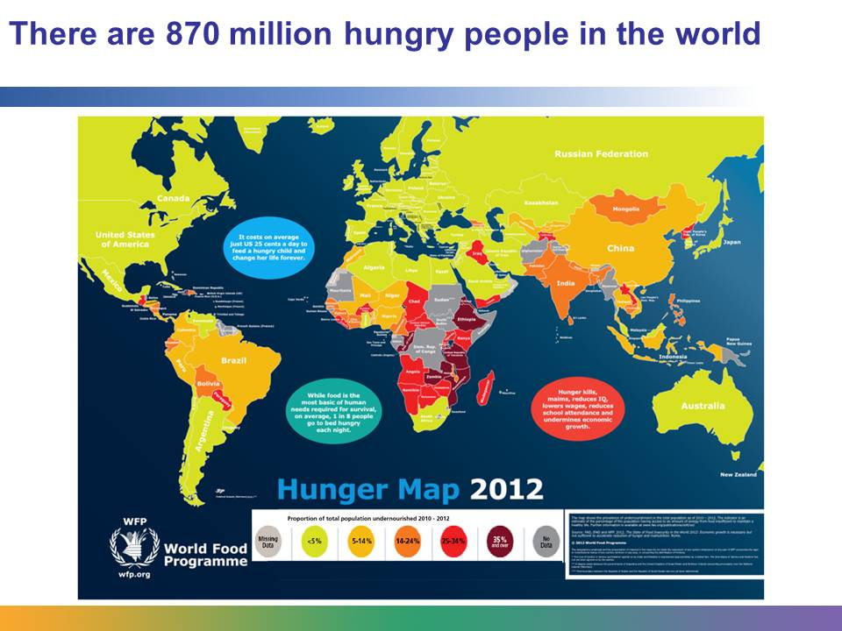
The number of undernourished people in the world is humbling. The United Nations Food and Agriculture Organization (FAO) estimated that in 2010–2012 one in eight people in the world suffered from chronic undernourishment. Almost all of them lived in developing countries.
Data from World Hunger Education Service’s “2013 World Hunger and Poverty Facts and Statistics”: http://www.worldhunger.org/articles/Learn/world%20hunger%20facts%202002.htm#Number_of_hungry_people_in_the_world.

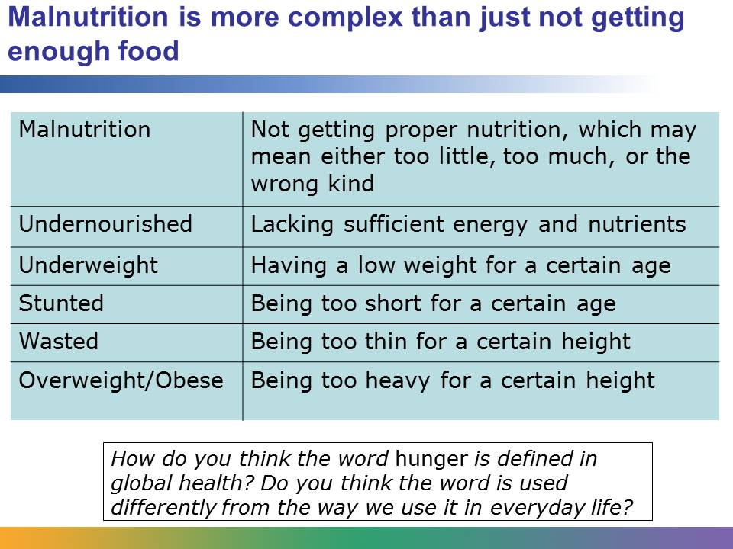
When we talk about malnutrition in global health, we are talking about a subject that is more complex than people not getting enough to eat. We are talking about people who do not get the proper nutrition. This may mean that they get too little nutrition, too much, or the wrong kind. Undernourished people lack sufficient energy and nutrients. People who have a low weight for their age are underweight. The term stunted refers to people who are too short for their age. People who are dangerously thin for their height are defined as wasted, and people who are too heavy for their height are defined as either overweight or obese, depending on the severity of their problem. You will learn more about obesity later in this lesson.
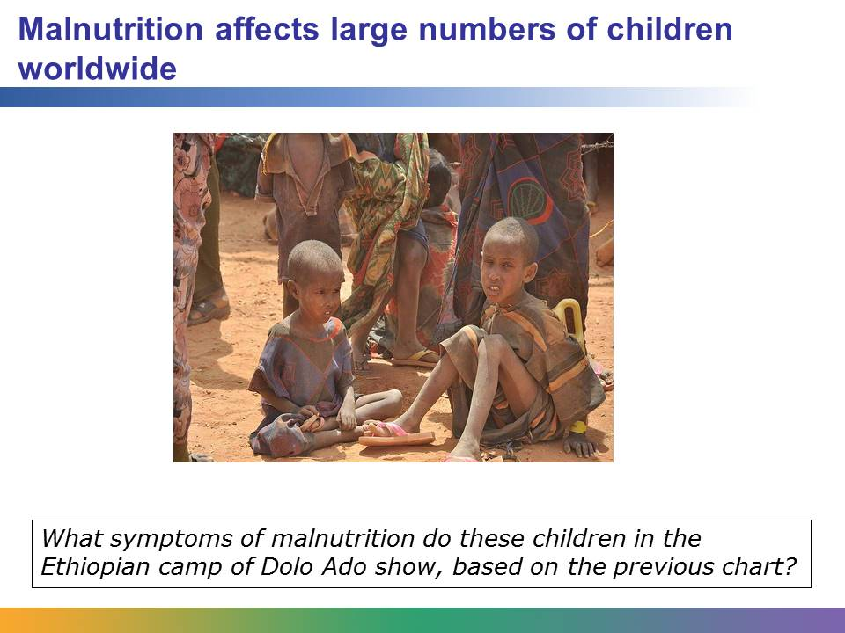
Most people arriving at Dolo Ado refugee camp in Ethiopia have little or no possessions or food. Children are especially at risk. Almost 50% of them are acutely malnourished. More aid is starting to get through.
Image retrieved from https://www.flickr.com/photos/dfid/5977576537/in/set-72157627161283625 on March 25, 2014, and reproduced here under the terms of the Creative Commons Attribution Unported 3.0 license (http://creativecommons.org/licenses/by/3.0/), in accordance with the Open Government license (http://www.nationalarchives.gov.uk/doc/open-government-licence/). Photo courtesy of Cate Turton/UK Department for International Development (DFID).
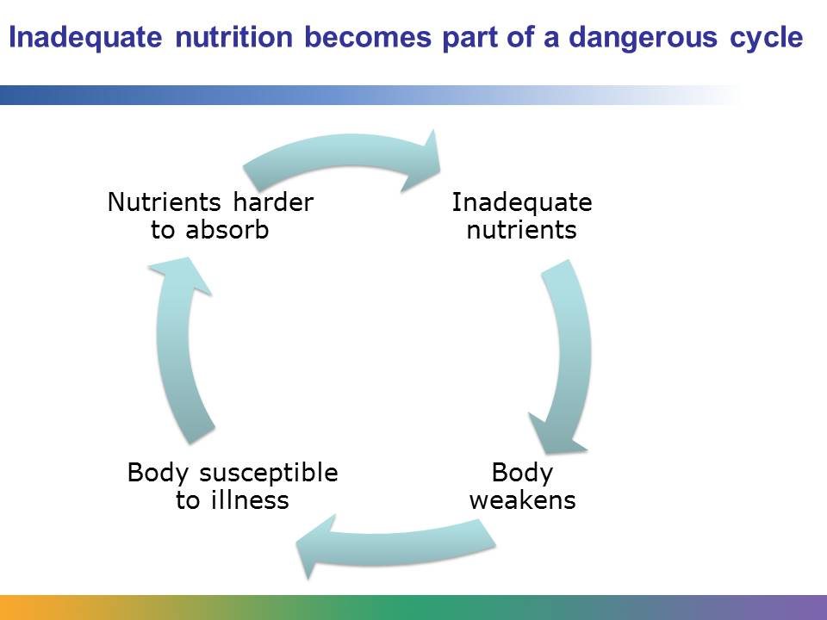
Malnutrition refers to getting too much or not enough food and the wrong types of food. But it is also about the body’s responses to infections and illness that result in the body not being able to use nutrients from food properly. When a person is malnourished, the person’s body isn’t able to fully utilize, or get the most out of, the food he or she eats. This may be the case if the person suffers from diarrhea. That person won’t be able to adequately absorb the nutrients that he or she consumes.
Whatever form it takes, malnutrition increases a person’s risk for both disease and early death.
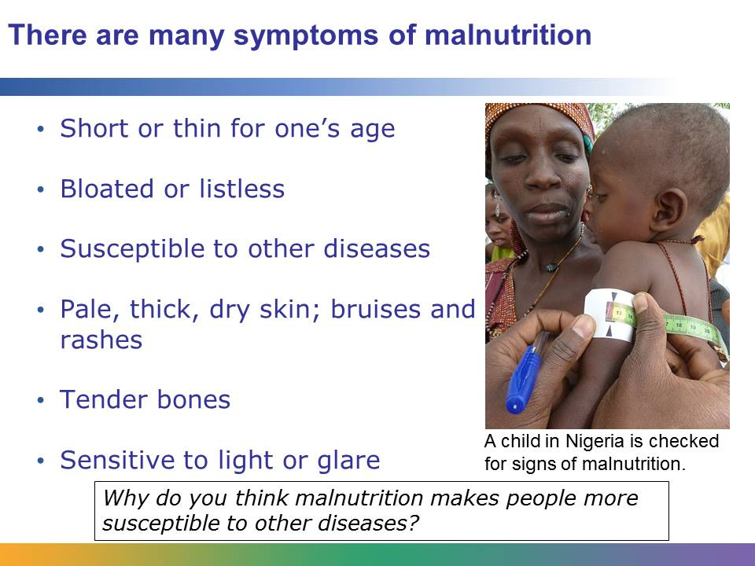
Malnourished children may exhibit many different types of symptoms. They may be short for their age or they may be thin. They may be bloated or listless. They often have weakened immune systems that make them vulnerable to other diseases. Malnutrition can affect their skin, which may be pale, thick, and dry. Their skin also may change color or bruise easily, or they may get rashes. Their hair may come out easily. Their bones may be more tender, and their gums may bleed easily. They may have an increased sensitivity to light or glare. Malnutrition can affect the way the organs function. Malnourished children may experience dizziness and fatigue.
Image retrieved from http://commons.wikimedia.org/wiki/File:A_child_is_checked_for_signs_of_malnutrition_in_Katsina_State,_Nigeria,_March_2011_(8406367308).jpg on September 11, 2013, and reproduced here under the terms of the Creative Commons Attribution 2.0 Generic license (http://creativecommons.org/licenses/by-sa/2.0/deed.en). Image courtesy of Jane Miller/DFID.
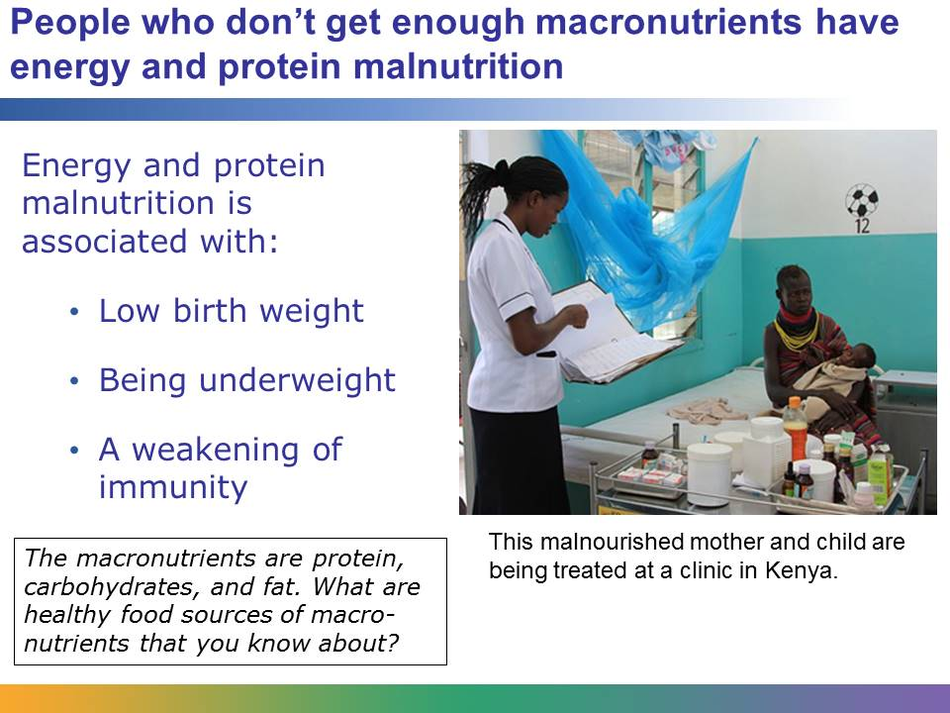
Nutrients that provide the protein and energy we need to survive are called macronutrients. The macronutrients are:
- Protein, which provides energy and also serves to build and repair the body
- Carbohydrates, which provide energy
- Fat, which provides energy
We need all three types of macronutrients. People who don’t get enough macronutrients have energy and protein malnutrition. Energy and protein malnutrition is associated with low birth weight, being underweight, failing to grow properly, and a weakening of immunity.
Image retrieved from http://commons.wikimedia.org/wiki/File:Getting_treatment_for_malnutrition_in_northern_Kenya_(6220164120).jpg on September 11, 2013, and reproduced here under the terms of the Creative Commons Attribution 2.0 Generic license (http://creativecommons.org/licenses/by-sa/2.0/deed.en). Image courtesy of Marisol Grandon/DFID.
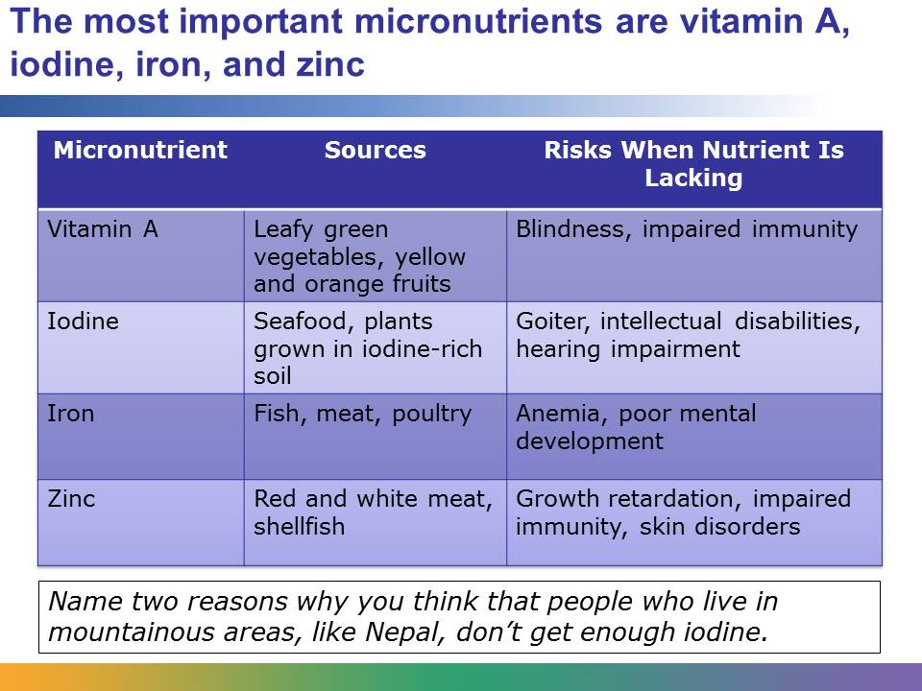
People who don’t get enough vitamins and minerals have micronutrient malnutrition.
Vitamin A is found in plants, particularly leafy green vegetables, like kale and chard, and in yellow and orange fruits that are not citrus, and carrots. Lack of vitamin A is associated with a condition that can lead to blindness. Vitamin A is also important for the health of the body’s immune system and for a child’s capacity to grow properly. Children who lack vitamin A may have a harder time surviving serious conditions like malaria and diarrheal disease.
Iodine is found in some seafood and in plants grown in soil that naturally contains iodine. Lack of iodine is associated with goiters, which are growths on the thyroid. It is also associated with intellectual disabilities, hearing impairment, and stillbirths. Many developed nations fortify their salt with iodine, but many countries don’t. In those countries, most people don’t naturally get the iodine that they need.
Fish, meat, and poultry provide iron. Lack of iron is linked to anemia, a blood disease that causes weakness and fatigue. It is also associated with poor mental development. Iron is a critical nutrient for children to develop motor skills and cognitive functions.
The best source of zinc is red and white meat and shellfish. A severe deficiency is associated with growth retardation, impaired immunity, skin disorders, and an increased susceptibility to infection.
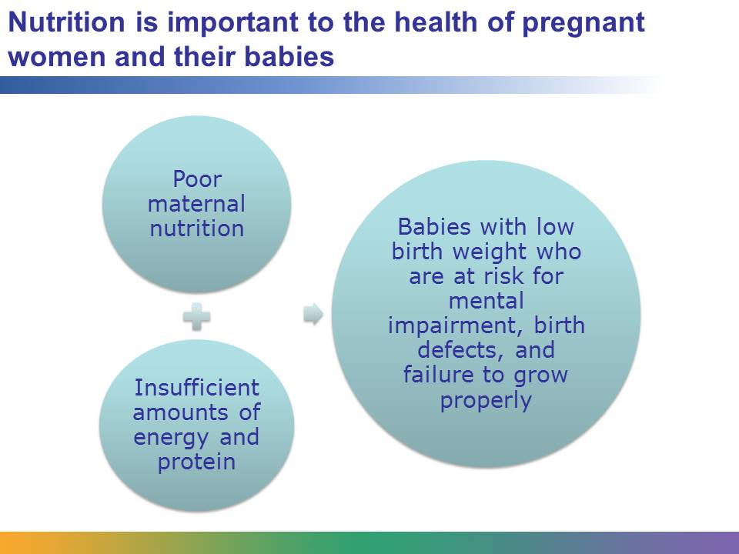
Good maternal nutrition is essential for good outcomes in pregnancy. For the health of both mother and child, pregnant women must stay well nourished. They need sufficient amounts of energy and protein. It is recommended that a pregnant woman consume about 300 more calories each day than she would consume when she’s not pregnant. Maternal nutrition is linked to healthy birth weight. Babies that don’t receive sufficient nutrients from their mothers in utero can suffer from mental impairment, birth defects, and a failure to grow properly in general.

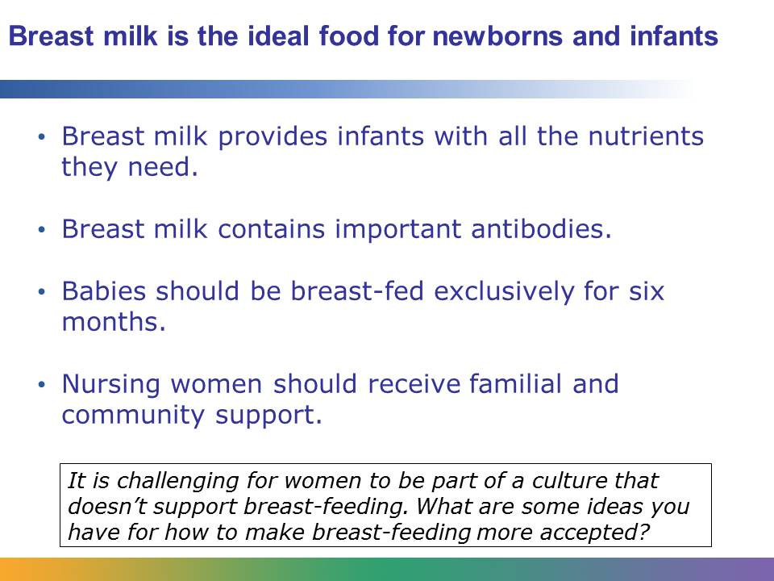
Breast milk is the ideal food for infants. It provides them with all the nutrients that they need to grow. It is safe and it contains antibodies that help protect infants from common childhood diseases, like pneumonia and diarrhea. Breast-feeding women need a healthy diet and plenty of liquids in order to produce a good supply of breast milk.
Even after babies are born, their health is still directly linked to the health of their mother. It is recommended that mothers exclusively breast-feed for the first six months of an infant’s life. This means that the infant should consume only breast milk and no water, food, or juice.
While there can be challenges, most women can breast-feed successfully. They need accurate information about breast-feeding and support from the people close to them, their health care system, and, in general, the society that they live in. Women may run into obstacles if they live in a culture that doesn’t support breast-feeding.
Infant formula is a good substitute for mothers who cannot breast-feed. However, formula doesn’t contain the important antibodies that breast milk does. There is also a risk that the water used to prepare the formula will be unsafe or the equipment used will be contaminated. Malnutrition can also result from overdiluting formula to prolong supplies.

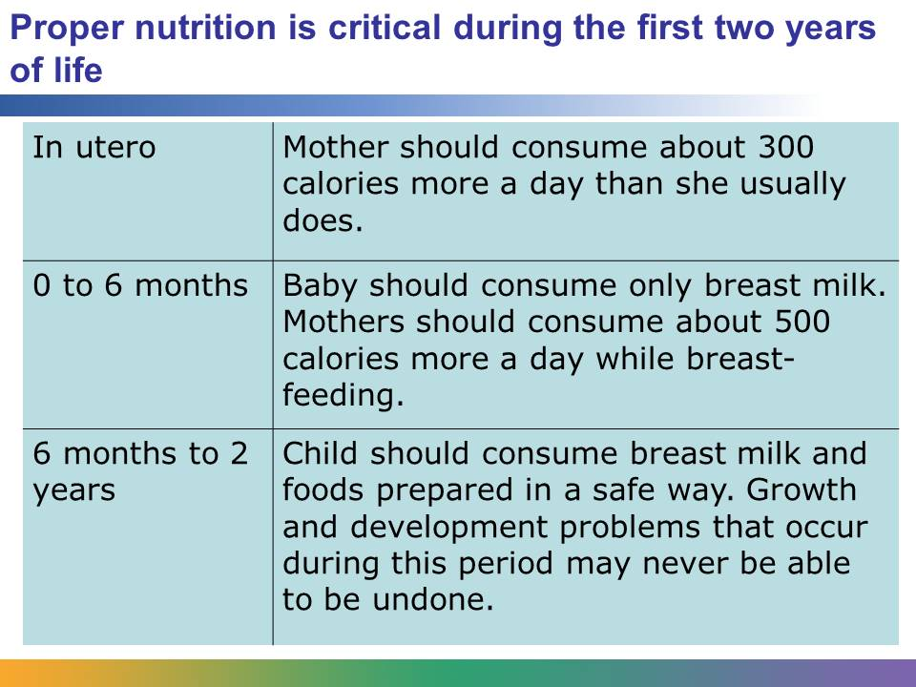
After the first six months of a child’s life, it is recommended that mothers continue to breast-feed while introducing appropriate complementary foods. This is considered to be a vulnerable time for babies and when many infants become malnourished. The foods given to babies should provide sufficient energy, protein, and micronutrients. They should also be prepared in a safe way that limits the risk of contamination. The foods should be prepared hygienically, and the water given to children or used to prepare the food should be clean and safe.
The time from when a child is conceived until that child is 2 years old, or about the first 1,000 days, is critical. This is considered to be a window of opportunity. It’s been found that nutritional deficits in fetuses and children under 2 can produce growth and development problems that can never be undone. For example, stunted children have very little chance to catch up in their growth.
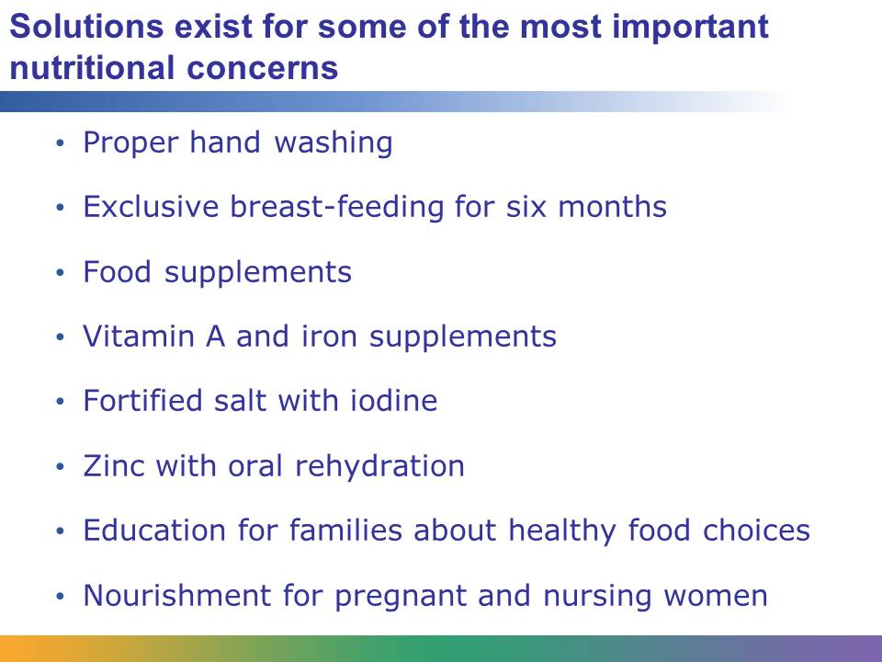
Global health workers believe that there are cost-effective solutions to address many of the world’s most serious nutritional concerns. These include the following:
- Promoting proper hand washing, which reduces infections that take a toll on nutritional status
- Promoting exclusive breast-feeding to infants for the first six months of life
- Providing food supplements to people who don’t get enough protein or energy
- Providing nutritional supplements to people who lack vitamin A and iron
- Fortifying salt with iodine, as is done in the United States and other developed countries
- Providing zinc with oral rehydration to reduce the severity of diarrheal disease
- Promoting educational campaigns that help families improve what they eat
- Ensuring that pregnant and nursing women are well nourished
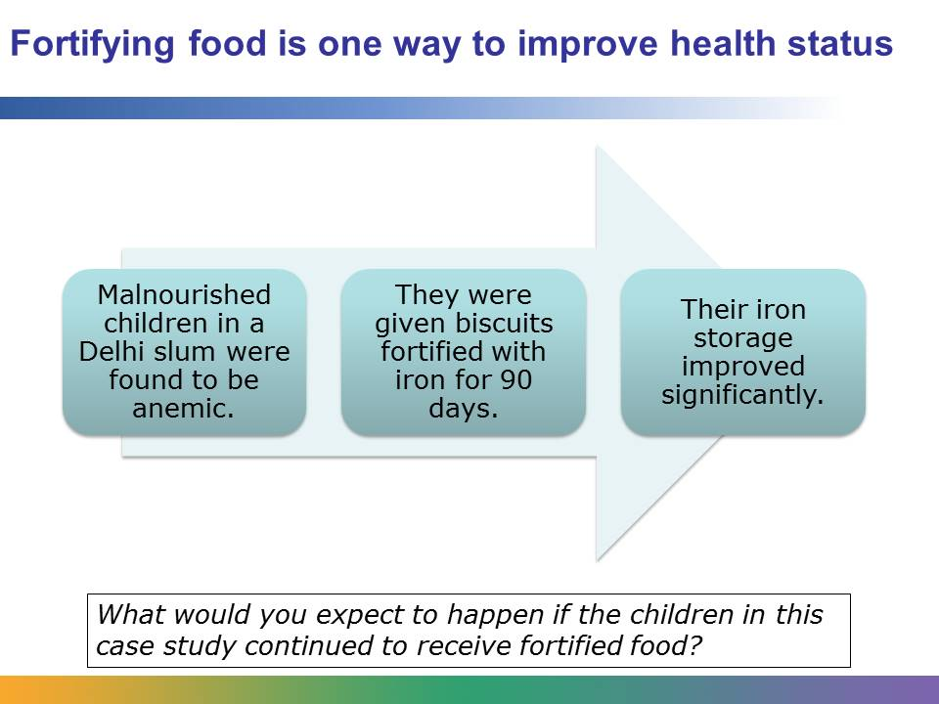
Fortifying food is one way to improve the health status of malnourished children and adults. Take this case study for an example. Health care professionals found that a significant number of children in a Delhi slum were anemic because of inadequate intake of foods with iron, a lack of diversity in their diet, and a high prevalence of infection. So, for 90 days the children were given biscuits fortified with iron. Biscuits were chosen because they are ready to eat, convenient, hygienic, and low-cost. After the intervention, those conducting the study found a significant improvement in the children’s iron storage capability.
Data from Navjyoti India Foundation / Britannia Nutrition Foundation study “Intervention with Iron Fortified Biscuits in Anemic children”: http://www.righttonutrition.org/downloads/NJFsymposium.pdf.
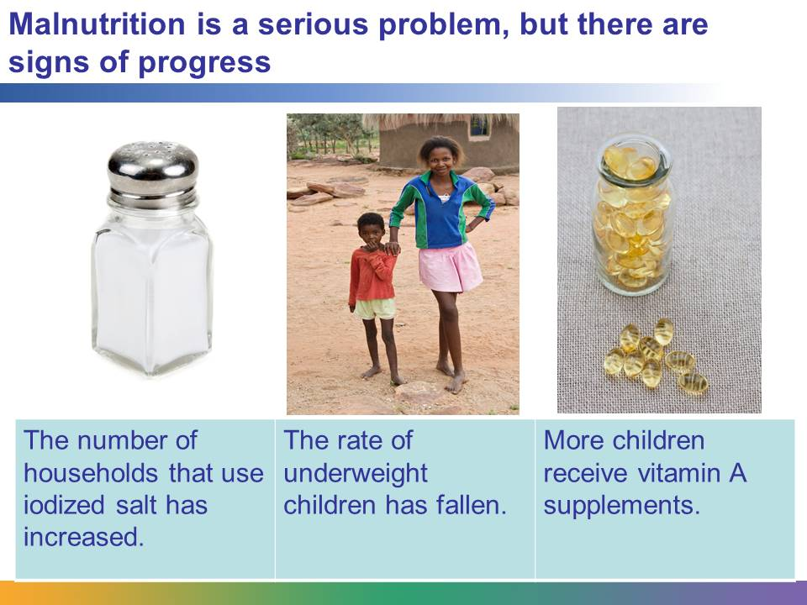
Malnutrition is a serious problem in global health, but because of global health programs, interventions, and campaigns, there is evidence that progress is being made. Households around the world that used iodized salt increased from about 20% in 1990 to 70% in 2011. The rate of children younger than 5 years old in developing countries who are underweight fell from 31% to 26% from 1990 to 2008. There has also been an increase in children who receive vitamin A supplements. In 2004, it was estimated that 72% of children received them.
Still, in spite of the progress, it was estimated in 2013 that over 800 million people were undernourished. The nutritional status of women and children in South Asia and sub-Saharan Africa continues to be a pressing challenge in global health.

