Student Resource 9.1
Note Taking: What Does It Take to Be a Nurse?
Student Name:_______________________________________________________ Date:___________
Directions: During the presentation What Does It Take to Be a Nurse?, use the chart below to take notes on the subjects listed in the left-hand column.
Providing physical care
Providing emotional care
Educating patients
Working as a team
Doing physically demanding work
Characteristics
Verbal skills
Nonverbal skills
Cultural differences
Professionalism

Student Resource 9.2
Reading: What Does It Take to Be a Nurse?
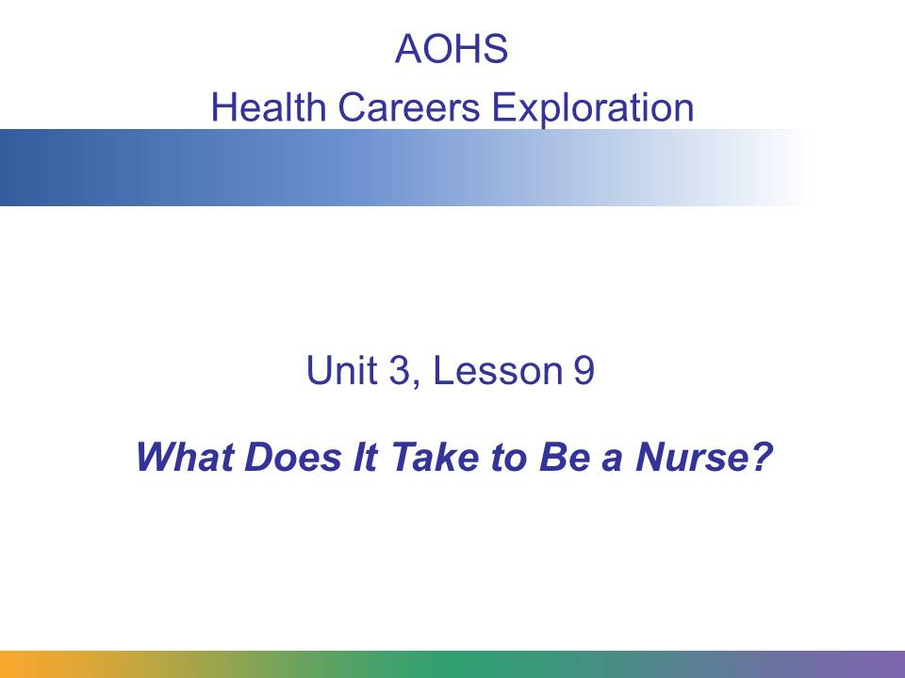
Registered nurses, or RNs, make up the largest health care occupation in the United States according to the US Department of Labor. Most registered nurses work in hospitals or clinics. Registered nurses have many responsibilities that include treating patients, providing public health education, and emotionally supporting patients and their families.
In this presentation we’ll take a look at the main responsibilities of RNs in more detail. We’ll also look at the nurse-patient relationship: what types of support do nurses provide? What skills and characteristics enable nurses to excel at their jobs?
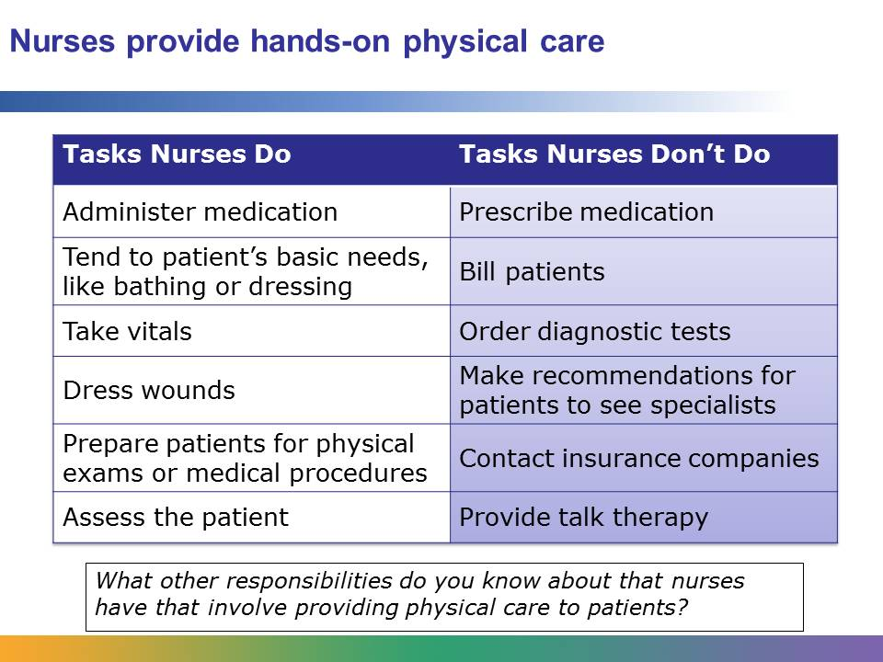
Regardless of where nurses work, whether in an emergency clinic, a jail, a ski resort, or a rural clinic, they are responsible for providing hands-on physical care to patients. Nurses’ responsibilities vary from state to state. Their responsibilities may include administering medication, which can involve ensuring medication is given on schedule, pouring the accurate dose of medicine, and watching for side effects of medication. A nurse may also be responsible for a patient’s basic needs, including bathing, toileting, feeding, dressing, and transporting. Nurses who are RNs are responsible for assessing the patient. Other duties can include preparing patients for physical exams or medical procedures, managing intravenous lines, dressing wounds, and taking a patient’s vitals.
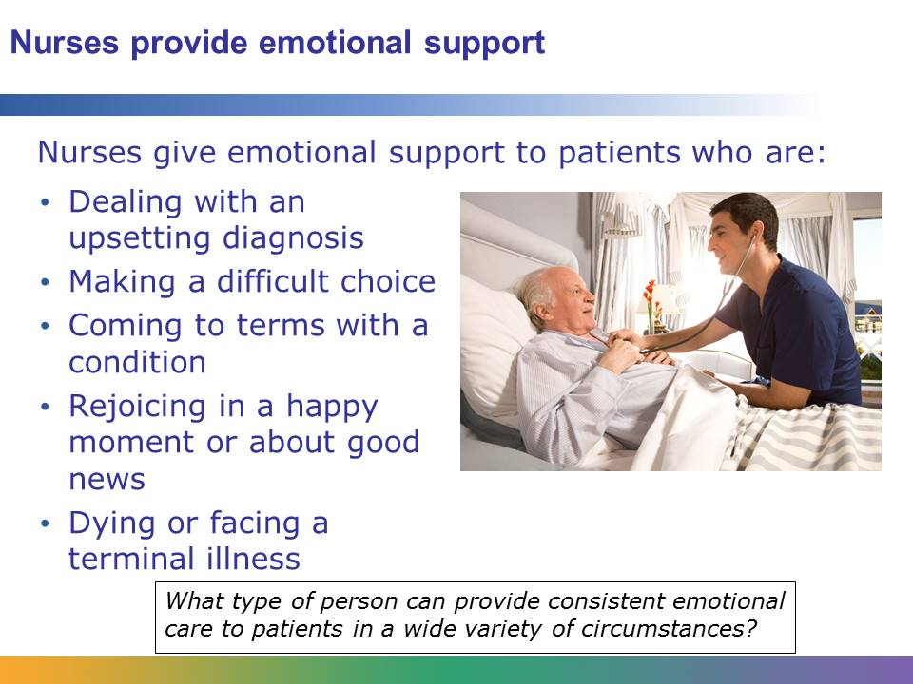
The emotional support that nurses provide patients is one of the defining features of their job. Nurses may be caring for a patient who has just received an upsetting diagnosis, such as a terminal diagnosis, or a patient who must make a difficult choice, such as whether to continue with cancer treatment. Part of a nurse’s job is to listen to the patient’s feelings and concerns, help put those concerns into perspective, and educate patients about their disease or condition. Also, many times nurses help families make the difficult choice of whether they want to continue life support or just provide supportive care for a loved one.
A person with a disease or injury, such as someone who loses a limb in a car accident, may struggle to come to terms with his or her condition and accept that he or she is going to need care. Nurses are there to help patients through these kinds of transitions.
Nurses also support patients and rejoice with them in positive moments, such as when a woman births a healthy baby or a patient is told that surgery was successful, or when a patient is having to celebrate a birthday or other special occasion in the hospital. Nurses also provide emotional care for patients who won’t recover from an illness or injury. They are trained to provide compassionate care to dying patients and their families.

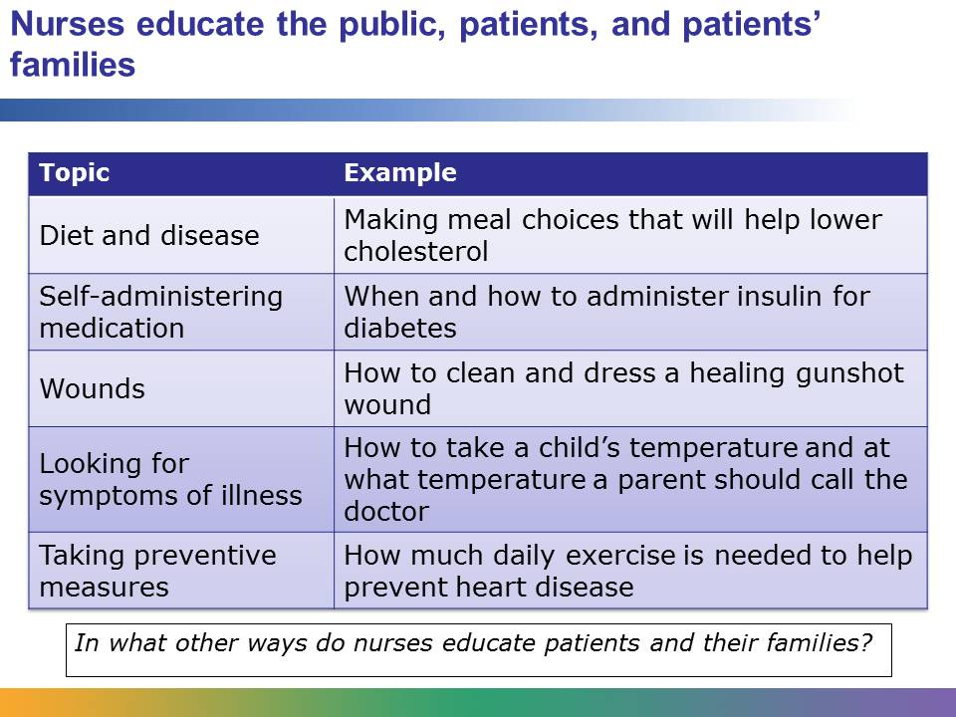
Education is an important part of a nurse’s job. Nurses provide public health education. They teach communities about nutrition, vaccinations, and preventable illness and injury.
Nurses also educate patients and their families. They teach patients how diet relates to disease, and they help families put together plans to make diet and lifestyle changes. They also provide patients and their families with information about home-care treatment, such as how to self-administer medication or clean and dress healing wounds. Nurses educate patients about how to look for signs and symptoms that may indicate illness, such as a fever or loss of appetite, and ways to prevent illness and injury, such as frequently cleaning their hands or properly using a child car seat.
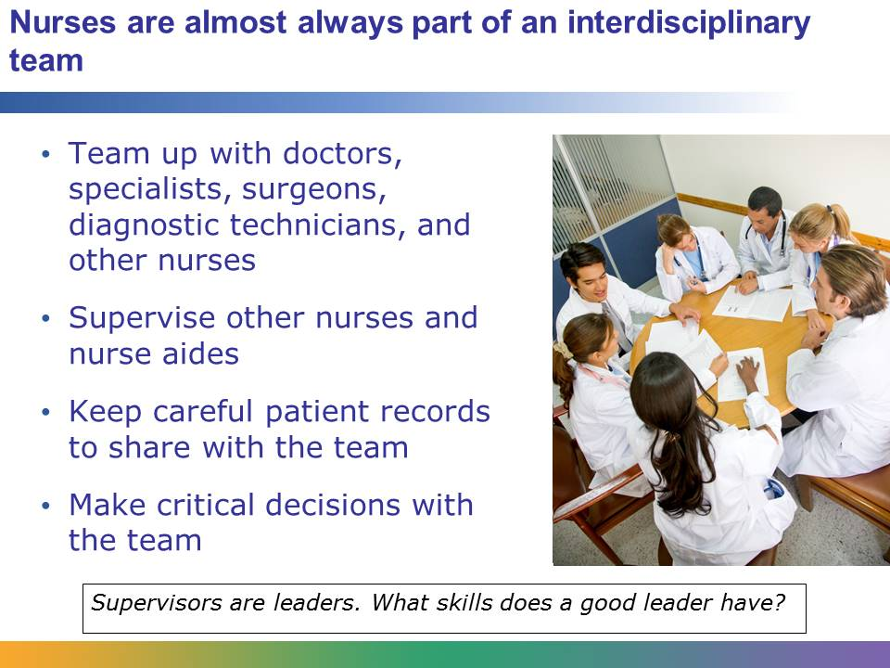
Nurses work as part of an interdisciplinary team. Depending on the department they work in, they may work with doctors, specialists, surgeons, diagnostic technicians, and other nurses.
Often RNs give direction and supervise the work of licensed practical nurses and nurse aids. They may be responsible for organizing the work of the other nurses and communicating with the physician in charge on behalf of other nurses.
Part of a nurse’s job is to observe changes in a patient and communicate those changes to the other members of the team. Nurses must keep careful records involving all interactions with patients.
Nurses may also be required to make critical decisions. For example, if a nurse observes a sudden change in a patient, such as a drop in blood pressure, the nurse may be responsible for providing immediate treatment and alerting the appropriate members of the team.
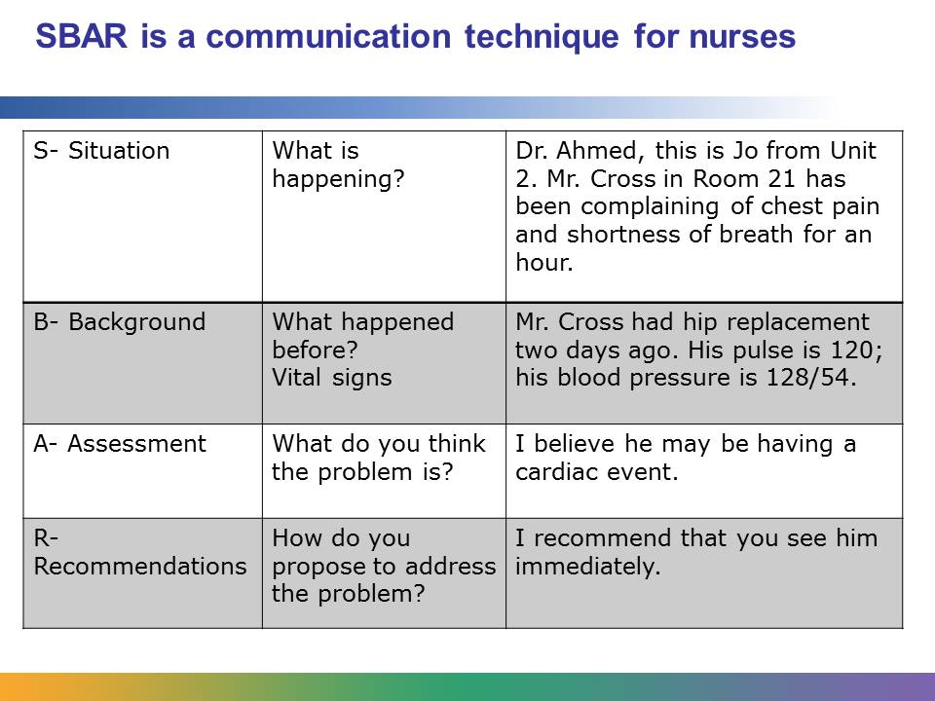
Clear communication between nurses and other health care workers is essential for both patient safety and for hospitals and clinics to run smoothly. SBAR is a standardized communication technique that nurses and other health care workers use to share information about patients. It is used when nurses communicate with each other, when they call a physician, or when a patient is transferred from one facility to the next. SBAR stands for situation, background, assessment, recommendations.
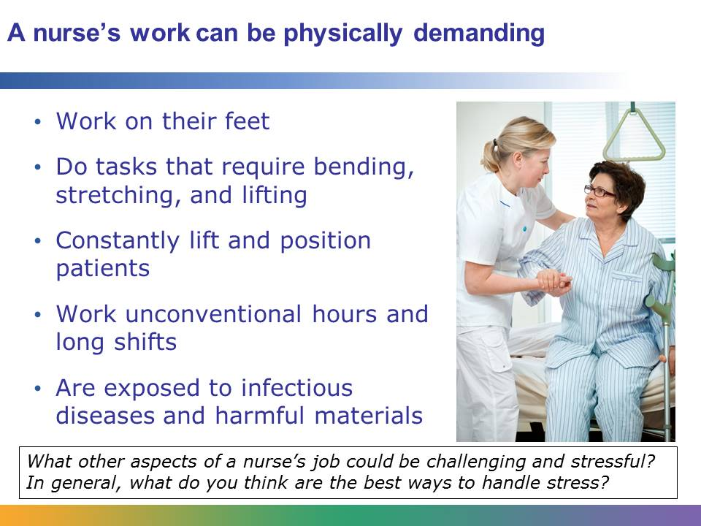
A nurse’s work can be physically demanding. Nurses spend a lot of time on their feet, standing and walking. Their work also requires them to bend, stretch, and lift heavy things. Nurses may need to lift and position patients, which can make them susceptible to back injury.
Hospitals provide care to patients around the clock, so nurses often keep unconventional schedules. They may be required to work nights, weekends, and holidays.
They are often in contact with patients who have infectious diseases, and they may work with potentially harmful materials. Consequently, they must observe strict guidelines to protect themselves, the other professionals they work with, and patients.

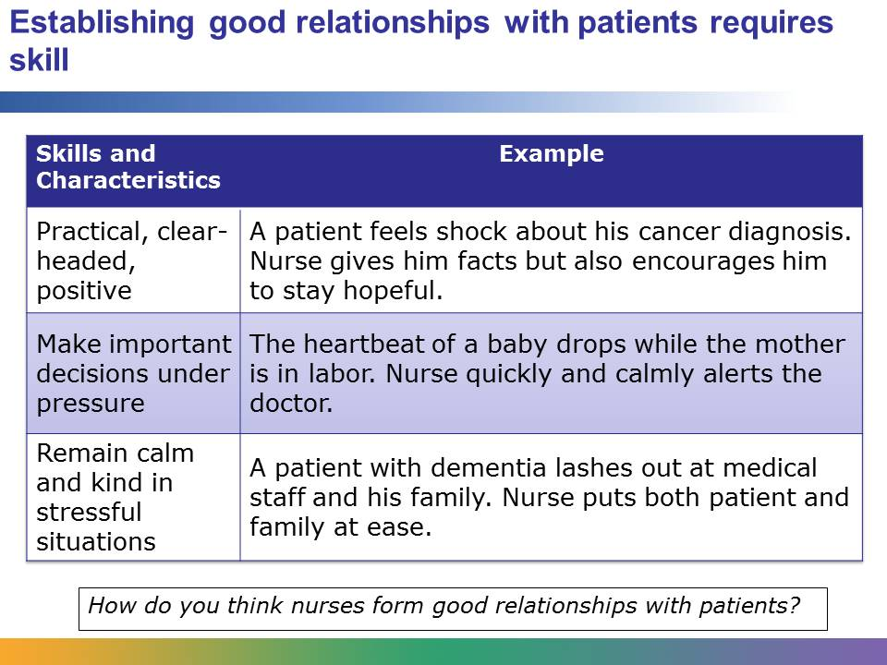
In spite of the job’s demands, nursing is a highly rewarding profession. Patients often form opinions of their experience in a hospital based on the interactions they have with the nursing staff. Patients rely on nurses to have their basic needs met, receive emotional support, and understand the details of their condition. When a nurse can provide these services for patient, the patient is often very grateful. Nurses can make a real difference in people’s lives at a time when they need it most.
Nurses are often friendly, patient, and positive. They are practical, clear-headed people who can make important decisions under pressure, remain calm in stressful situations, and remain kind even with irritable patients or in unpleasant circumstances.
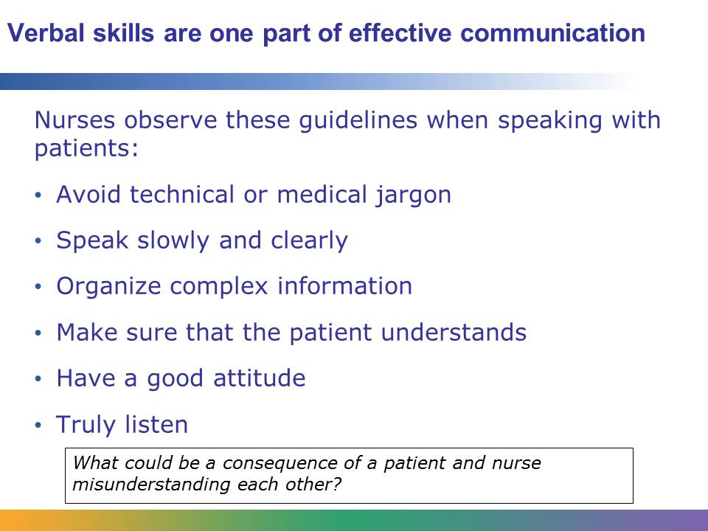
There are different ways that nurses form good relationships with patients. One way is through effective communication. There are two main types of communication skills: verbal skills and nonverbal skills.
Nurses need verbal skills to understand a patient’s medical history and condition, give a patient instructions, and give information to other health care professionals. The words a nurse chooses to use, or a nurse’s vocabulary, are an important part of having effective verbal skills. Nurses with good verbal skills won’t use technical or medical jargon when speaking to patients. They will use words that are familiar to the patient. They speak slowly and clearly, and they make sure that the patient understands what they are saying.
When nurses have to give a patient a complex explanation, they will organize their thoughts and be direct. They may explain things in a step-by-step manner. They will leave out unnecessary information that could overwhelm the patient.
The way nurses communicate is as important as what they say. In other words, having a good attitude helps nurses communicate effectively. Having a good attitude means being genuine, avoiding acting superior, being argumentative, or acting uninterested. Nurses need to always remember to speak to the patient at eye level, which may mean taking a seat or bending down.
Nurses avoid prejudging what they think their patients are going to say or how they are feeling. They listen carefully to their patients and allow their patients to express themselves.
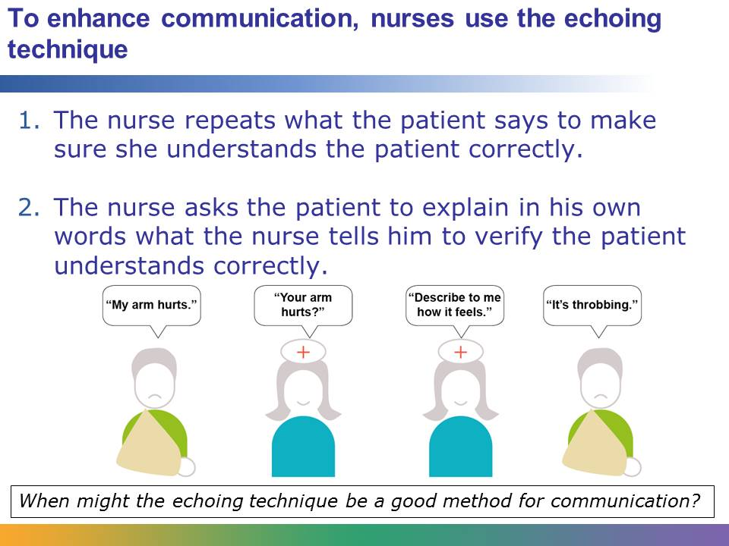
The echoing technique is one method that nurses use to make sure that both the nurse and the patient are clearly communicating.
Using the echoing technique, the nurse repeats what a patient has said to make sure that he or she understands the patient. Then the nurse asks the patient to explain in his or her own words what the nurse has said.
This technique ensures that both the nurse and patient understand each other.

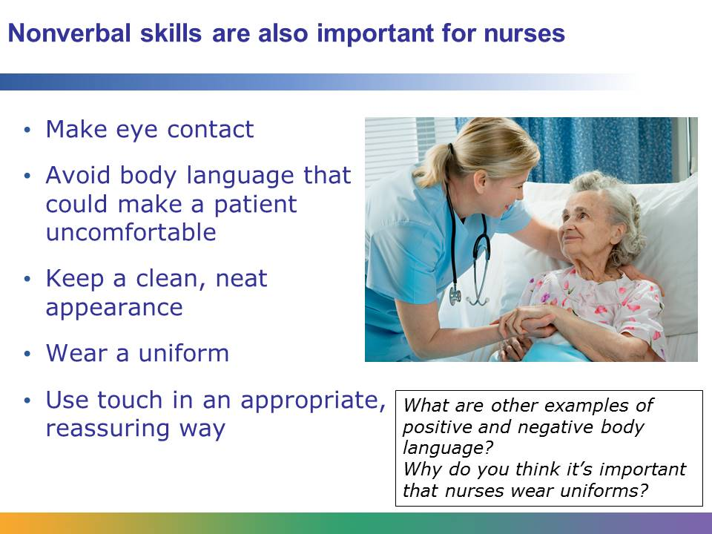
Good communication is not just about what a person says. Nurses use nonverbal skills to develop effective communication with their patients. They use eye contact and positive facial expressions. They are aware of their body language and avoid body language that may make a patient uncomfortable, such as raising their eyebrow questioningly or rolling their eyes. They keep a clean, neat personal appearance and wear a uniform. They may also use touch, such as gently patting a patient’s hand, to comfort or reassure a patient.
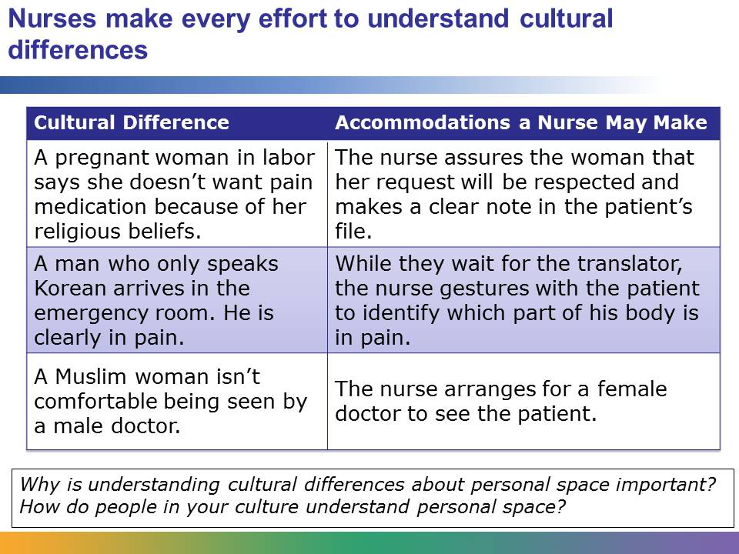
Nurses care for a variety of patients from different cultures, countries, and religions. Their patients may or may not speak English. For some patients, it could be their first time interacting with a health care professional in the United States, and they may be nervous or frightened. Nurses are aware of the cultural differences of their patients and try to accommodate them. For example, with a patient who doesn’t speak English, nurses may use a demonstrative approach in which they use gestures to explain what they are saying. Also, most hospital have certified interpreters available. If they are not available face to face, they have a telephone program available 24/7 so the patient can receive information in his or her language. This is a requirement of the health care facility.
Different cultures have different ideas about what constitutes personal space. When nurses are aware of this, it can help put patients at ease.
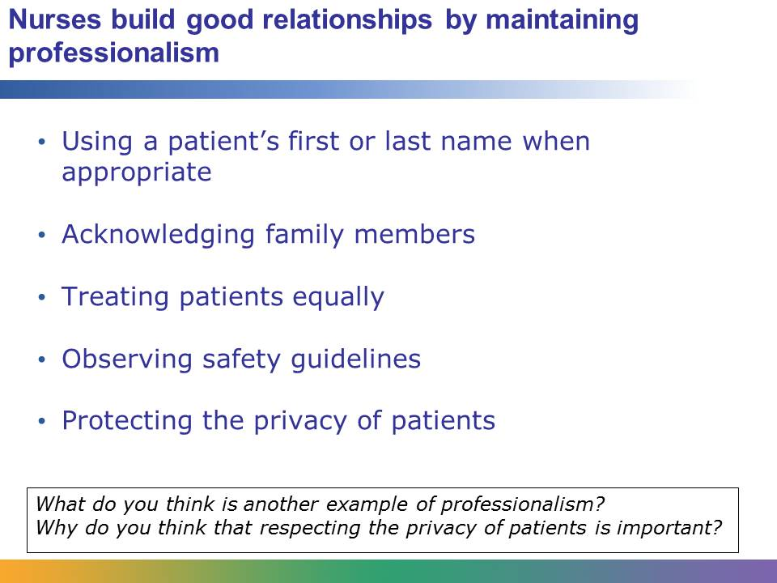
Sticking to professional standards helps nurses build good relationships with their patients. Some of the simple choices nurses make when interacting with patients contribute to their professionalism. These choices include whether or not to address a patient by his or her first or last name and acknowledging and showing respect for the concerns of the patient’s family members. Professionalism also includes treating all patients equally, observing safety guidelines, and protecting the privacy of patients.
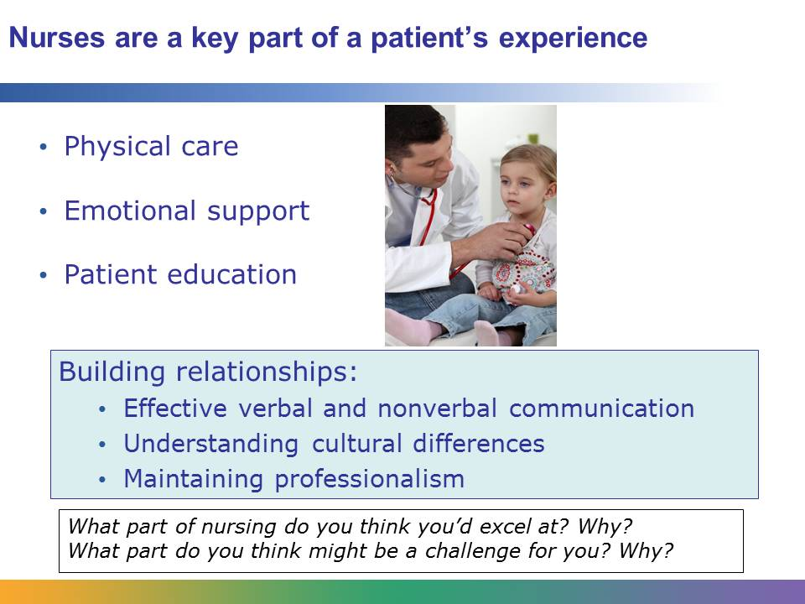
Nurses play an indispensible role in a patient’s experience in a hospital or other medical setting. Nurses provide patients not only with physical care but with emotional support and education, too.
Nurses have training and experience in building good relationships with patients. They use verbal and nonverbal skills to communicate effectively with patients. They take cultural differences into account when they interact with patients, and they always maintain professionalism.

