Student Resource 8.2
Reading: Diagnostic Tests
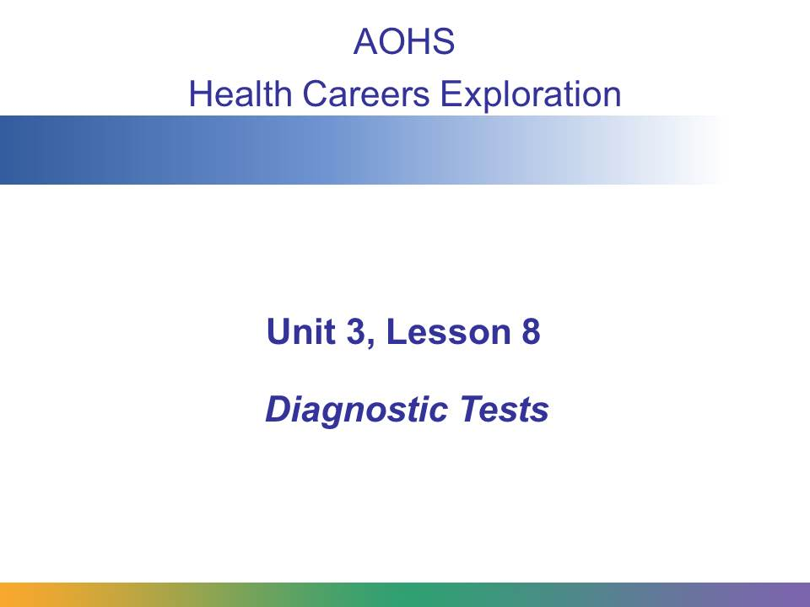
A medical test performed to help diagnose a patient or detect disease or illness is called a diagnostic test. In this presentation, you will learn about the purpose of common diagnostic tests, who performs them, and how they are performed.
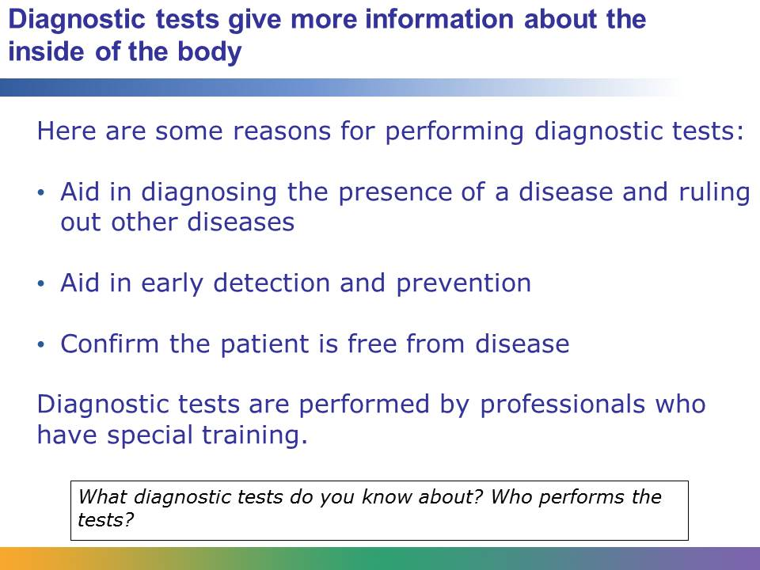
Imagine that on a routine visit to his primary care physician a patient mentions that for several months he has been having increasing problems falling asleep. The patient chalks up his problems to stress at work, but the doctor wants to rule out various sleep disorders. The doctor recommends that the patient see a specialist. The specialist orders an EEG for the patient, which will monitor the patient’s brain waves and give more information about his condition.
An EEG is one type of diagnostic test. Diagnostic tests give physicians more information about what is happening inside a patient’s body. They are tests performed by professionals who have specific training in operating machines and conducting the procedures necessary to do the test.
Diagnostic tests are important to help health care professionals diagnose diseases, but they are also extremely important in early detection and prevention. People in various age groups or with certain medical histories are routinely given diagnostic tests, even if they don’t have any symptoms of being ill. For example, an older man who has heart disease in his family will likely routinely be given diagnostic tests to monitor the health of his heart. Diagnostic tests are also given to confirm that a patient is free from disease. For example, a cancer survivor may be given routine diagnostic tests to confirm that he or she is still cancer free.
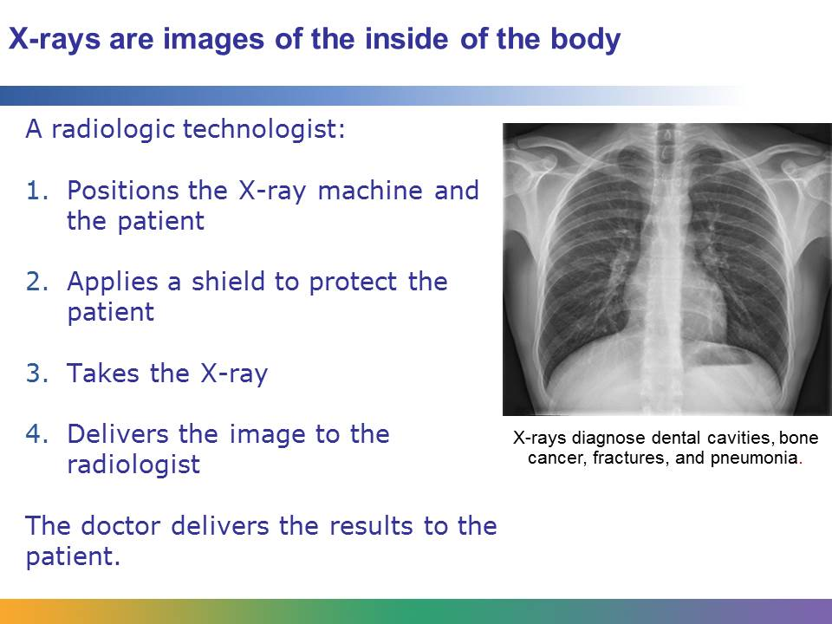
An X-ray is a common diagnostic test. It is used to produce images of the inside of the body and diagnose an array of problems that include dental cavities, arthritis, bone cancer, and lung infections, like pneumonia. X-rays are performed at doctors’ and dentists’ office and at hospitals. In an emergency room, X-rays may be used to determine problems like broken or fractured bones or swallowed objects.
An X-ray is a fast, safe, and painless procedure. A small burst, or ray, of radiation passes through the body and records an image of a body part on film or a specialized plate. A radiologic technologist performs an X-ray. First, the technologist will position the body appropriately. Then he or she will make sure that the X-ray equipment is at the correct height and angle. The technologist will protect the patient from unnecessary radiation exposure by using a special shield. After the image is taken, the technologist will make sure that the image develops properly, and he or she will deliver it a radiologist. The radiologist will interpret the results and given them to the patient’s doctor. The doctor will deliver the results to the patient. In an emergency room, the results of an X-ray can be obtained in just a few minutes.

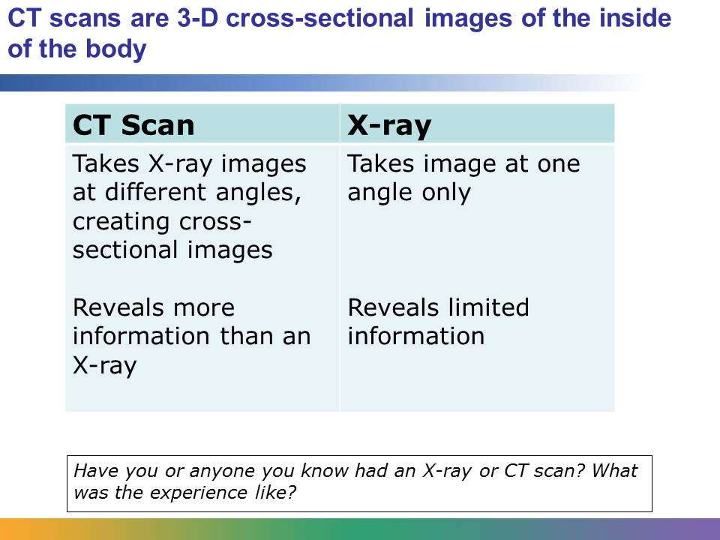
Like X-rays, computerized tomography scans, which are also called CT or CAT scans, take images of the inside of the body. But unlike X-rays, CT scans take many X-rays from different angles. A CT scan creates a cross-sectional image of the inside of the body.
CT scans are often compared to a loaf of bread. A physician can look at one slice, or part of the image, or he or she can put them together to create a 3-D image of the patient’s body. In this way, CT scans give much more information than X-rays. CT scans are frequently used to look for internal injuries after a car accident, to identify the location of a tumor or blood clot, or to detect signs of cancer and heart disease.
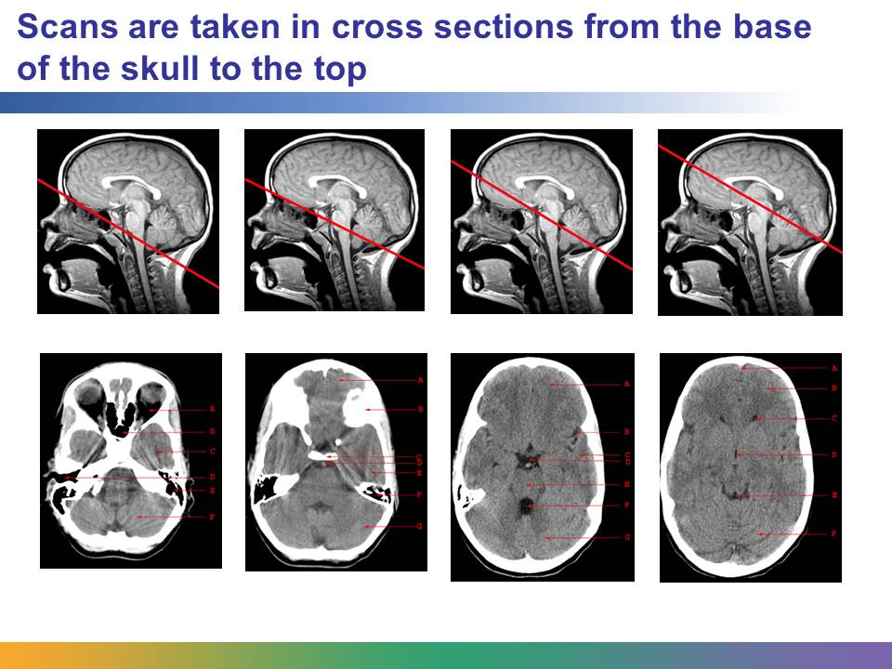
The red lines in the top row of images show the angle at which each cross section image was taken. The bottom row shows what the actual image of each slice looks like.
Images courtesy of http://www.med-ed.virginia.edu/courses/rad/headct/. The images are included under fair-use guidelines of Title 17, US Code. Copyrights belong to respective owners.
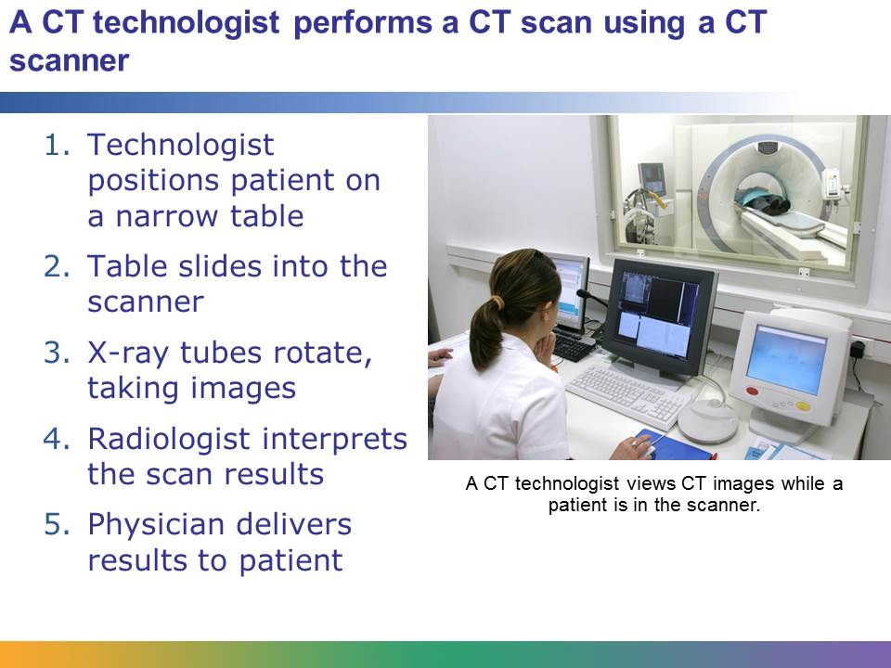
Like X-rays, CT scans are painless procedures. They are usually performed in a hospital or an outpatient facility. A CT technologist performs the procedure using a CT scanner. The technologist positions the patient on a narrow table. Sometimes the technologist uses straps or pillows to help the patient stay in the proper position. For the scan to be effective, the patient must stay still. Then the table slides into the a large hole of the scanner, which is often described as an upright doughnut hole. Inside the machine, X-ray tubes rotate around the patient’s body. These tubes take various images. During the procedure, the technologist is in another room viewing the images on a monitor. The patient inside the machine is able to communicate with the technologist through an intercom.
After the images are taken, a radiologist will interpret the results and submit them to a physician. Then the physician will deliver the results to the patient.
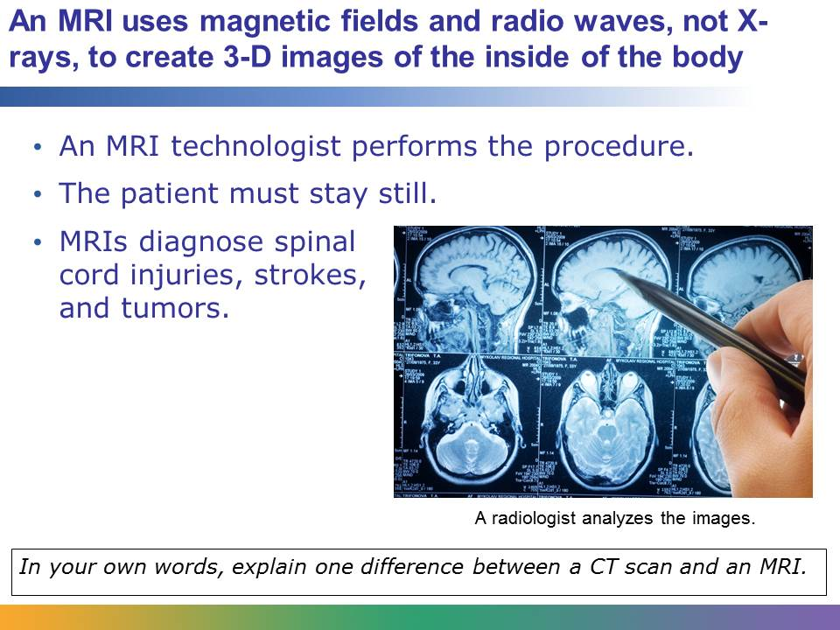
Like a CT scan, magnetic resonance imaging, or MRI, creates detailed images of organs and tissues, but an MRI machine doesn’t use X-rays. An MRI machine is a huge, tube-shaped magnet. It uses magnetic fields and radio waves to create high-resolution, cross-sectional 3-D images. It is used to diagnose a number of problems including spinal cord injuries, multiple sclerosis, stroke, damage caused by a heart attack, plaque in the blood vessels, and tumors on internal organs like the uterus, prostate, liver, and spleen.
An MRI is suited for examining soft tissue such as ligament and tendon injury, spinal cord injury, and brain tumors, while a CT scan is better suited for bone injuries, lung and chest imaging, and detecting cancers. CT scans are widely used in emergency rooms because the procedure takes less than 5 minutes. An MRI can take 30 minutes or more, and it costs more than a CT scan.
An MRI technologist performs the procedure. The MRI technologist has a patient lie on a table, which slides into the MRI machine, a tunnel that is open on both ends. During the procedure, the technologist monitors the images from another room. The procedure usually takes less than an hour. The procedure is painless, but the patient must stay still during the procedure. If the technologist is creating images of the patient’s brain, the patient may be asked to do simple actions inside the MRI machine, like tap his or her fingers or speak. As for other imaging tests, a radiologist will analyze the images and give the analysis to the patient’s physician, and the physician will deliver the results to the patient.
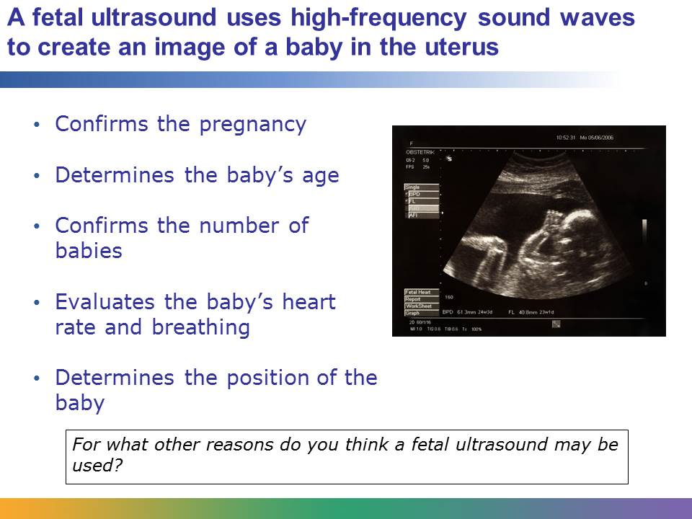
A fetal ultrasound, or a sonogram, uses high-frequency sound waves to create an image of a baby in a woman’s uterus. These images are used by the woman’s physician to evaluate the baby’s growth and development and to track the progress of the pregnancy. The ultrasound can be performed at any point during the pregnancy. It is used for a variety of reasons, including to confirm a pregnancy, to determine the baby’s gestational age, to confirm the number of babies, to evaluate the heart rate and breathing of the baby, and to determine the position of the baby before delivery.
An ultrasound is also used for other diagnostic purposes, such as to scan the gallbladder, liver, or lymph nodes, but the fetal ultrasound is the most common.
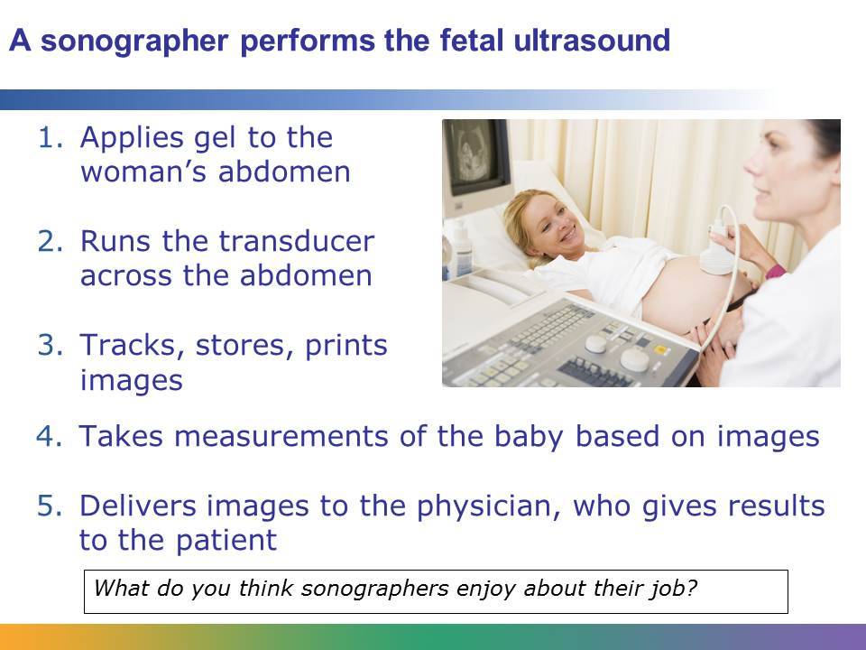
A sonographer performs the fetal ultrasound. First, the sonographer explains the procedure to the pregnant woman and asks her to lie down on the exam table. The procedure is not painful. Then the sonographer applies a special gel to the woman’s abdomen. The sonographer moves a transducer, a small device that sends out sound waves, across the abdomen. The sound waves are converted into a gray image of the baby on the monitor. Both the patient and the sonographer can see the images. The sonographer will likely point out to the woman the different parts of the baby, as they may be hard to decipher. Depending on the stage of development, the woman may be able to see her baby’s face, hands, and even fingers. The sonogarpher stores and prints the images. She may take measurements of the baby based on the images. She delivers the images to the woman’s physician, who will give the woman the results.

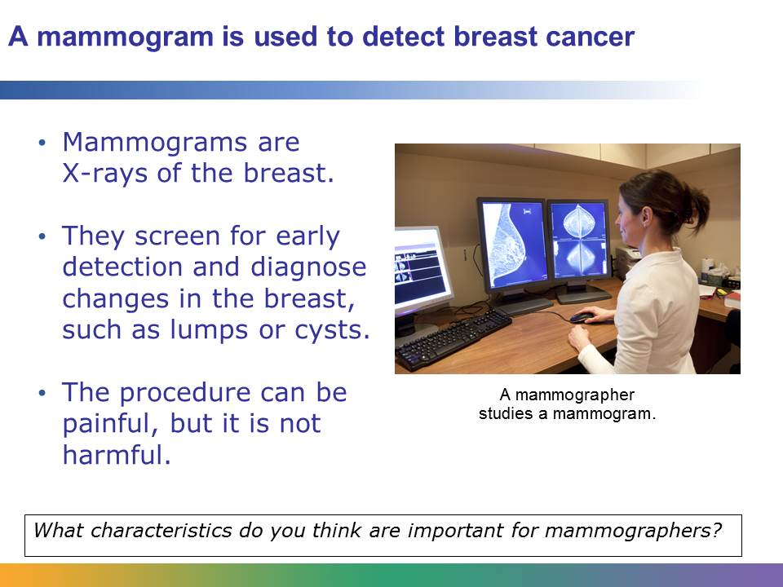
A mammogram is an X-ray image of a breast. It is used to detect tumors and other abnormalities in the breast. There are two main types of mammography: screening mammography and diagnostic mammography. Screening mammography is used for early breast cancer detection. It is used for patients who have no signs or symptoms of breast cancer. The frequency at which women receive screening mammograms is determined by their age and their risk factors for breast cancer. Diagnostic mammography is used to investigate suspicious changes in the breast, such as lumps or pain.
A mammographer performs the procedure. The mammographer explains the procedure and then helps position the patient, who will stand up at the mammography machine. During a mammogram, the patient’s breasts are compressed between two firm surfaces. The patient must stay still. An X-ray captures an image of the breast. The procedure can be uncomfortable or briefly painful, but it is not harmful. The mammographer will check the quality of the images and retake them if they are not clear. The procedure usually takes less than 30 minutes. A physician will deliver the results of the test to the patient.
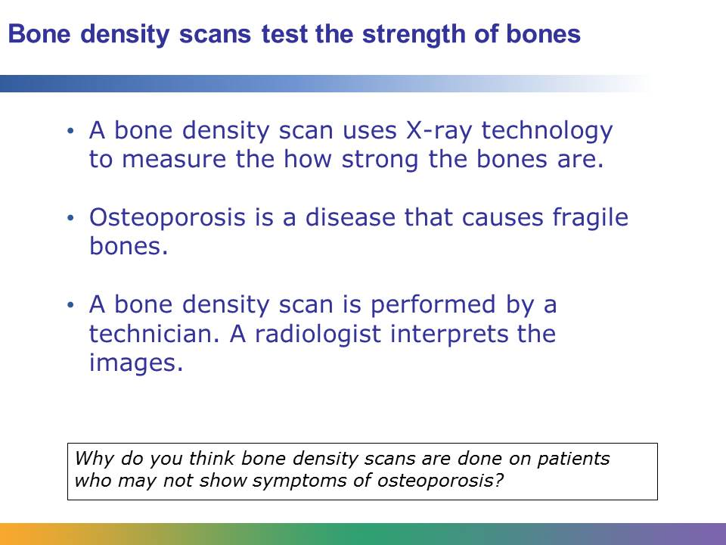
Osteoporosis is a disease that causes bones to become fragile and more likely to break. In the past, osteoporosis could only be detected after a patient broke a bone and the bones were already weak. But now bone density scans make it possible to know how at risk the patient is for the condition.
The bone density scan, or bone densitometry, uses X-ray technology to measure the thickness and strength of bones. The X-rays measure the amount of calcium and other minerals that are in a segment of a bone, usually the spine, hip, or forearm. A patient with strong bones will have a high mineral content.
The procedure is fast and painless. It is performed by a technician who is trained in bone density scans. The technician positions the patient on a padded platform. As with other diagnostic imaging tests, the patient must stay still. A mechanical arm, or detector, passes over the patient’s body, generating images on a computer monitor. A radiologist interprets the images, and then a physician delivers the results to the patient.
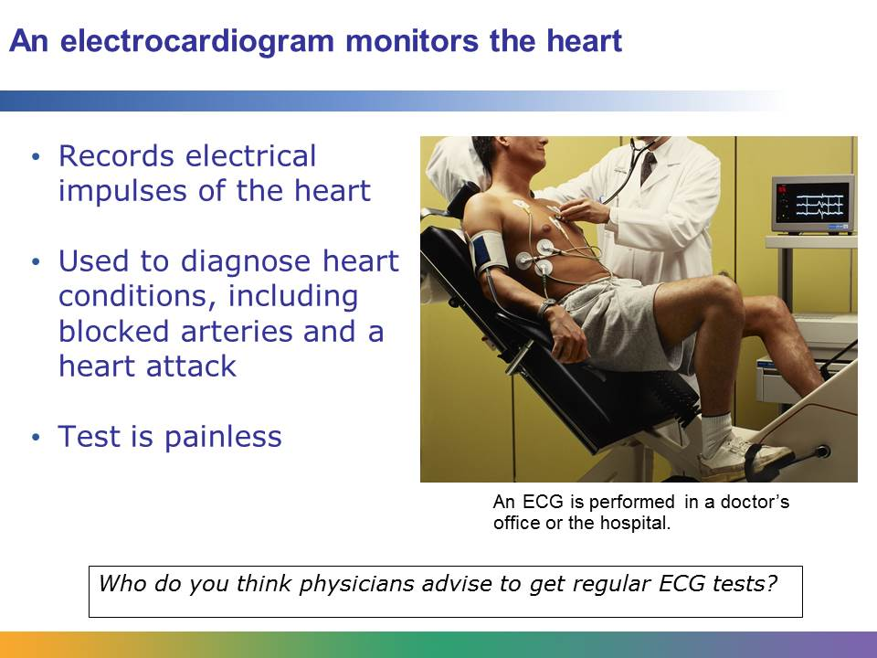
An electrocardiogram, or ECG or EKG, is used to monitor the heart. It records the electrical impulses generated by cells in the upper-right chambers of the heart. Physicians use the reports created by an ECG to diagnose heart conditions, including irregularities in heart rhythm, problems with the heart valves, blocked arteries in the heart, or a heart attack. An ECG is a painless test. It is typically done in the doctor’s office or in the hospital.
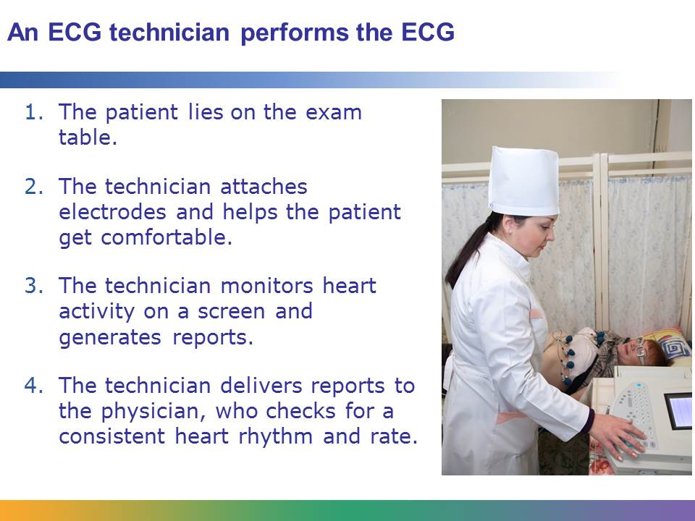
An ECG is performed by an ECG technician. First, the technician asks the patient to lie on the exam table. Then she uses a gel to attach 12 to 15 electrodes (small, flat metal discs) to the patient’s arms, legs, and chest. The technician may shave parts of the body where the electrodes will be placed. It’s important that the patient is warm and comfortable, because moving or shivering will interfere with the test. The technician monitors the heart’s activity on the screen for a few minutes, then she generates a report that will be analyzed by the patient’s physician. The physician looks for a consistent heart rhythm. The physician also looks for a heart rate that is between 50 and 100 beats per minute. If there are abnormalities, the physician will use the information to try to diagnose the problem.
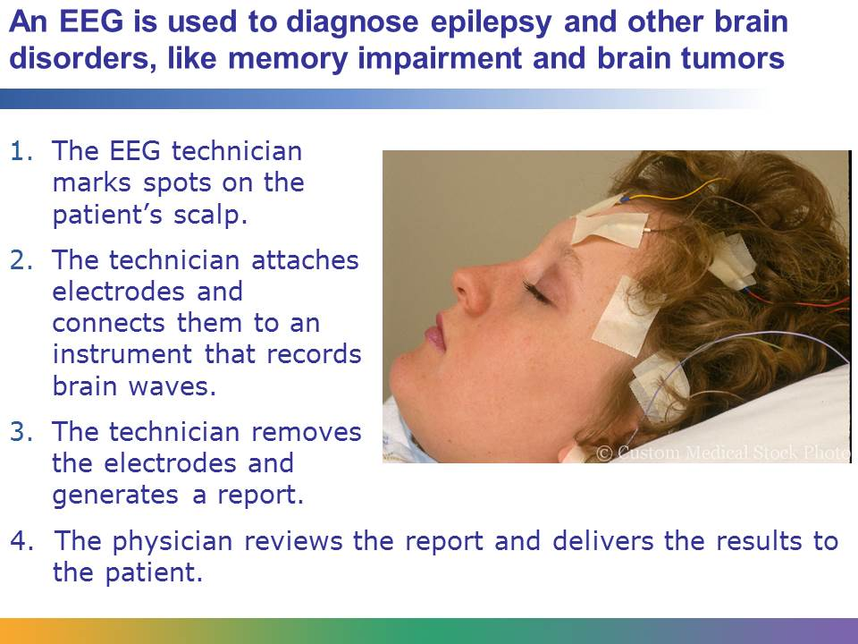
An electroencephalogram, or EEG, detects the electrical activity in the brain. It is one of the main diagnostic tests for epilepsy and other disorders such as inflammation of the brain, sleep disorders, brain tumors, memory impairment, and stroke. It can also be used to confirm brain death in a patient who is in a persistent coma.
An EEG is a painless procedure performed by an EEG technician. First, the technician marks the patient’s scalp. These marks indicate where the electrodes will be attached. Then the technician scrubs the spots. The technician attaches the electrodes to the scalp using a special adhesive. Wires attached to the electrodes are connected to an instrument that records the patient’s brain waves on a small computer. The patient is asked to relax during the test, which typically takes 30 to 60 minutes. Depending on what is being measured, the technician may ask the patient to do small tasks during the test, such as breathe deeply or look a picture. After the test, the technician removes the electrodes and delivers the reports to the physician, who reviews them and then delivers the results to the patient.
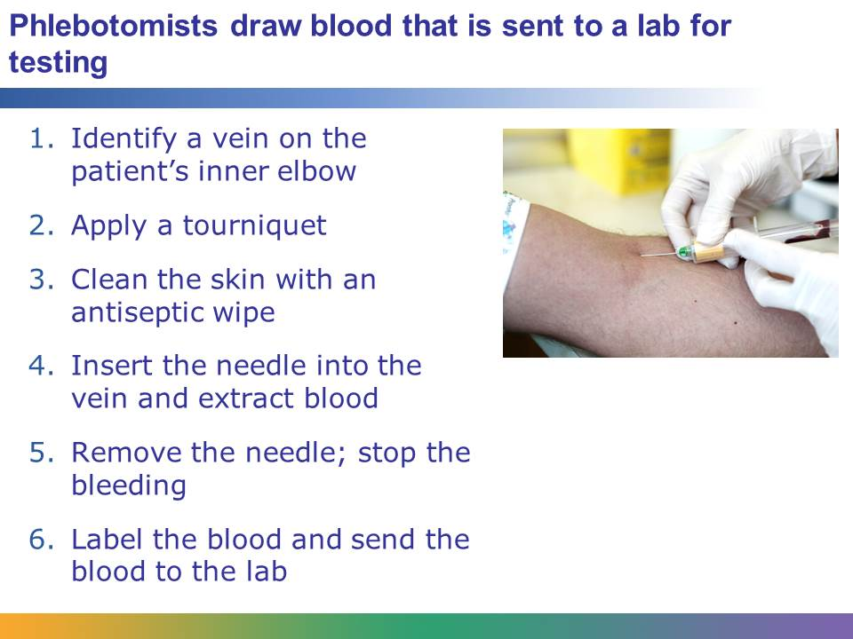
Physicians order blood tests for a number of reasons, ranging from confirming a pregnancy or a disease, like HIV, to checking how the body is responding to a type of medication.
A phlebotomist performs blood tests. First, the phlebotomist asks the patient to be seated in a comfortable position and expose the inside of the elbow. The vein in the inside of the elbow is used most frequently for blood sampling. Then the phlebotomist places a tourniquet, or a tight band, around the patient’s upper arm, making the vein fill with blood. The phlebotomist cleans the skin over the vein using an antiseptic wipe and then inserts a needle into the vein. A syringe is connected to the needle. The phlebotomist takes the required amount of blood and then removes the needle. The phlebotomist applies a piece of cotton to the area where the needle was inserted to stop the bleeding. Finally, he or she applies labels to the containers of blood, which is then analyzed in a lab. The results are sent to the patient’s physician, and the physician delivers the results to the patient.
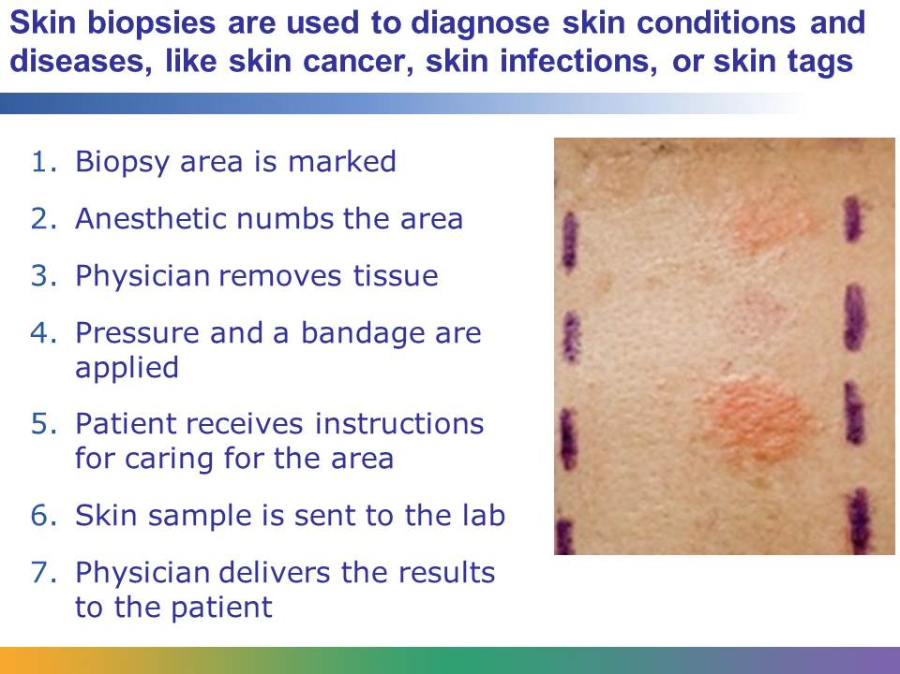
A physician uses a skin biopsy to diagnose certain skin conditions and diseases, including skin cancers, skin infections, blistering skin disorders, or skin tags, which are a benign tumor or growth. A skin biopsy removes cells or skin samples from the surface of the body.
Physicians perform skin biopsies. First, depending on the location of the biopsy, a physician may ask the patient to undress and change into a clean gown. Then the area of the skin that will be biopsied is marked. The physician applies a local anesthetic to numb the area so that the patient doesn’t feel pain during the biopsy.
There are different types of biopsy procedures. For the simplest procedure, the shave biopsy, the physician uses a sharp tool, double-edged razor, or scalpel to cut a sample of the skin. Then the physician applies pressure to stop the bleeding and topical medication and a bandage. Next, he or she gives the patient instructions on how to keep the area clean. All biopsies will likely cause scarring, but some scars will eventually fade. The physician sends the sample to the lab. Depending on the test, the results could take weeks or days. When the results are complete, the physician delivers them to the patient.
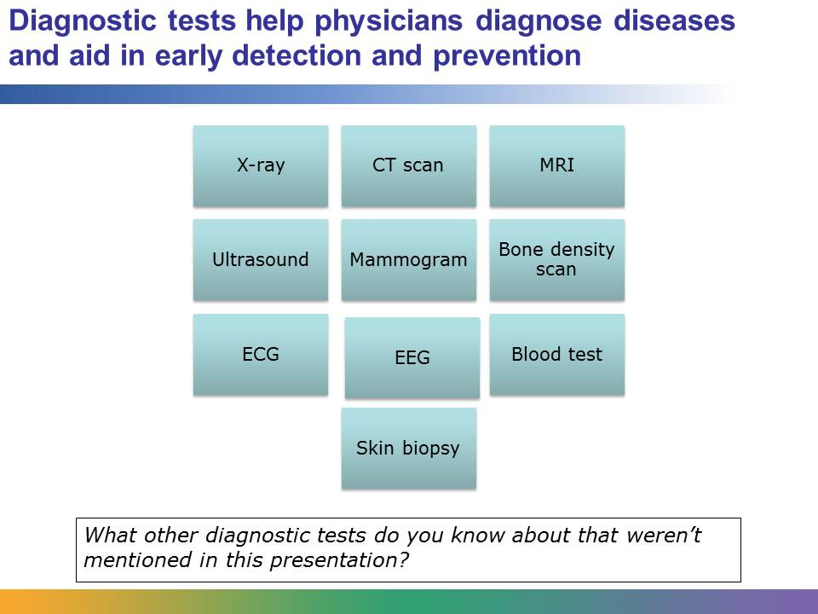
Diagnostic tests help physicians diagnose diseases and aid in early detection and prevention. The tests also confirm that a patient is free from disease. The technicians and technologists who perform diagnostic tests play an important role in caring for the patient.

