Student Resource 7.3
Reading: Health Care Professionals’ Roles in a Doctor’s Office
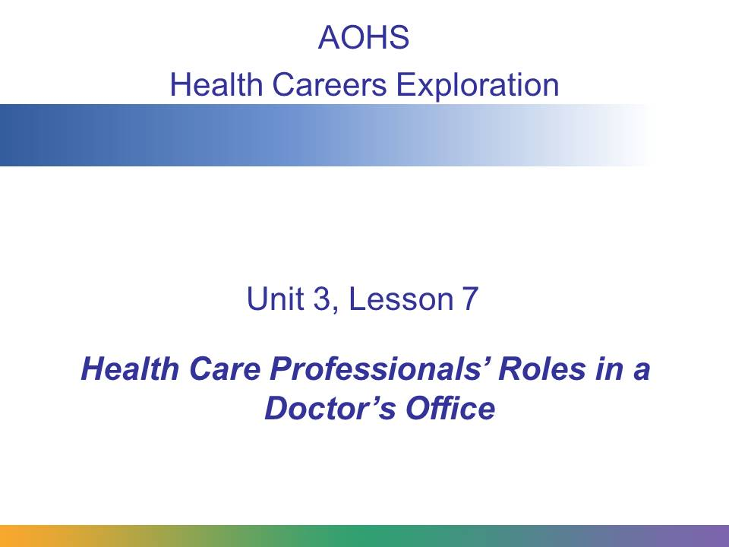
There are different ways to organize a doctor’s office. In small offices there may be just one doctor and a few people who are part of the staff. In larger offices, several doctors may work as partners. They may share office space and exam rooms and have a larger staff.
In this presentation, you’ll learn about the professionals who are typically found in a doctor’s office—large or small. You will learn about the various roles of these professionals and what interactions with patients and coworkers are like in a doctor’s office.

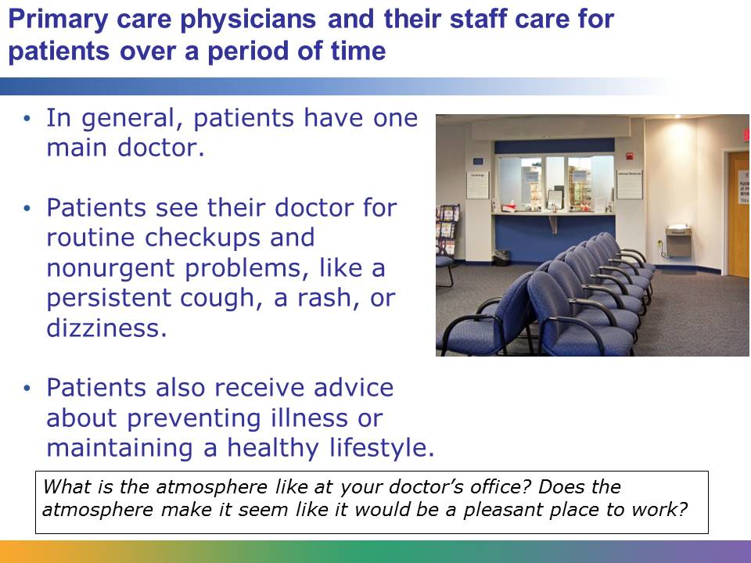
In general, primary care physicians, or doctors, have regular patients that they see over the course of years. Through these repeated visits, patients develop relationships with the professionals who work in a doctor’s office. These professionals have an interest in helping patients maintain good health and progress through periods of illnesses. Usually patients visit their primary care physician for a routine checkup and for nonurgent problems, such as the flu, a cough, a rash, dizziness, or shortness of breath. At a doctor’s office, patients are diagnosed and treated for various conditions and educated about ways to prevent illness. Patients may be given advice about making their diet more healthy or ways to quit smoking. In successful doctors’ offices, the staff is friendly, knowledgeable, supportive, and professional.
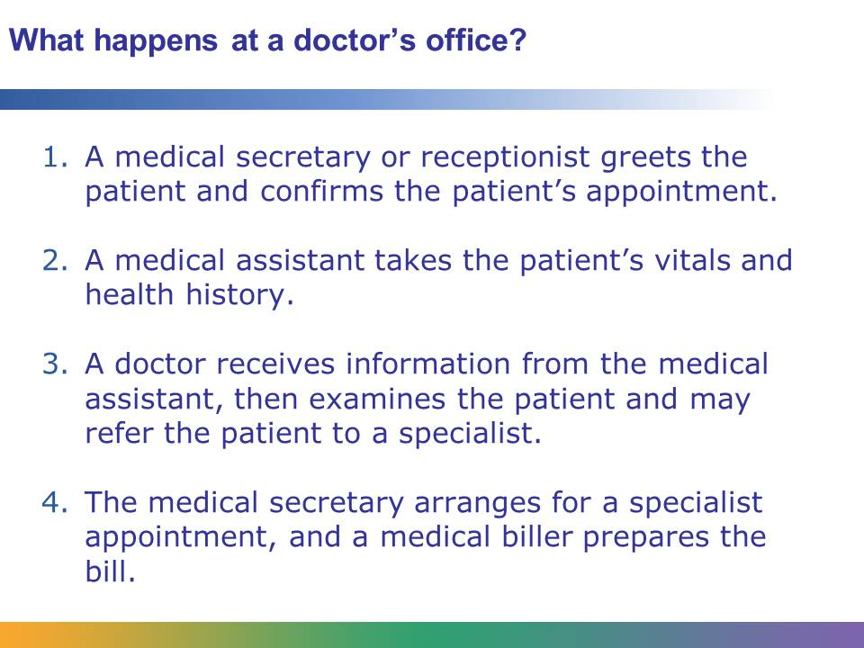
Let’s imagine that you are visiting the doctor because you have a burning sensation in your stomach after you eat. When you walk into the doctor’s office, you’re greeted by the medical secretary, who confirms your appointment and asks you to have a seat.
Five minutes later a medical assistant calls your name, takes you into a private exam room, and takes your weight and height. The medical assistant then takes your vital signs and records this information in your file. The medical assistant asks you questions about your health history and your current problem and records the information on a form, which also goes into your file.
Then a doctor comes in your room, reviews your file, does a physical examination, and asks you questions about the discomfort you are experiencing. The doctor decides that because of the specificity of your problem, you should see a doctor who specializes in digestive issues. He or she asks the medical secretary to give you the information you need to make an appointment with a gastroenterologist.
Meanwhile, a medical biller begins the paperwork to bill your insurance company for your visit. An office manager is doing behind-the-scenes work to make sure that the office runs smoothly.
Your doctor’s visit has involved interacting with multiple professionals. What are the roles of all these professionals with whom you’ve interacted? What tasks are these professionals responsible for?
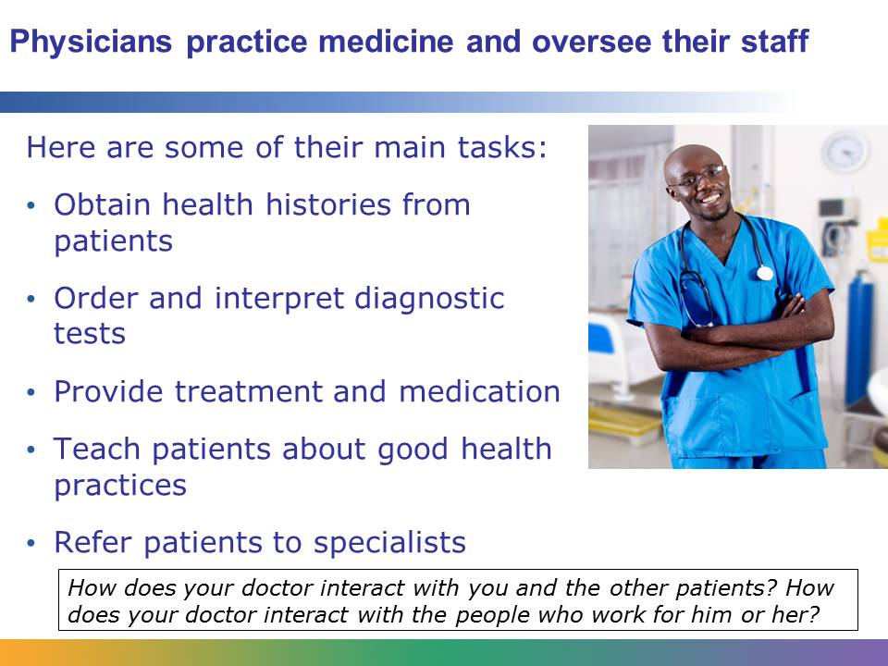
A physician’s main roles are practicing medicine and overseeing the work of the staff. (A physician who provides primary care for children is a pediatrician.) The physician is the person in the office who is ultimately responsible for the care of his or her patients. Physicians obtain the health history of their patients. They order and interprets diagnostic tests, provide treatment, and prescribe medications. They also teach patients about good health practices and provide health instructions. If a patient has a problem that is beyond the physician’s scope of expertise, the physician is responsible for referring the patient to the appropriate specialist. All of the professionals who work in the physician's office report to the physician. Successful physicians build trusting relationships with the people who work for them and with their patients. Physicians are typically clear thinkers who are able to make smart decisions under pressure. They are motivated by an interest in helping people.
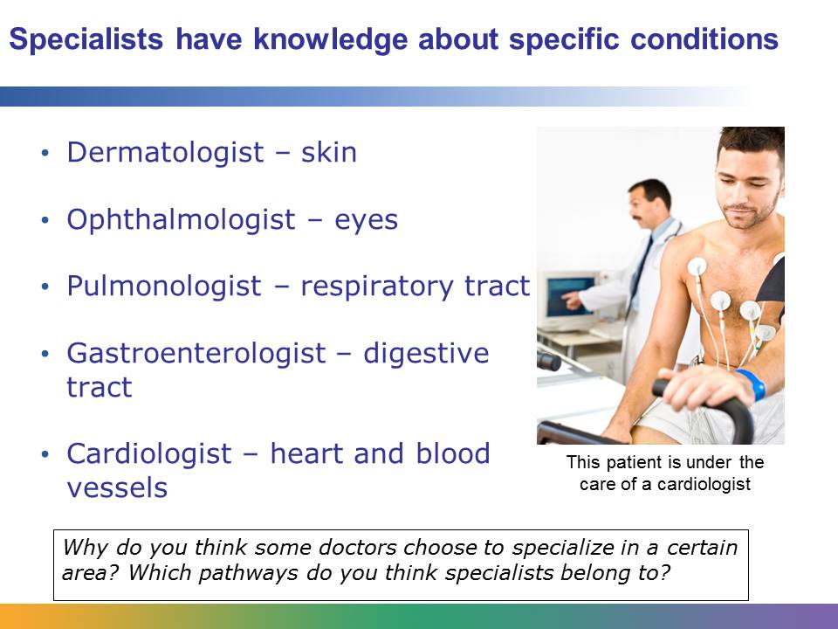
When a patient visits a doctor with a problem that is beyond realm of the doctor’s expertise and knowledge, the doctor will refer the patient to a specialist. Specialists are doctors who have a certain amount of training and certification for in diagnosing and treating a specific health condition or part of the human body. For example, if a patient is concerned about an abnormally shaped mole, the doctor may refer him or her to a dermatologist, who specializes in the treatment of skin diseases. If a patient is experiencing blurry vision, the doctor will likely refer him or her to an ophthalmologist, who specializes in the diagnosis and treatment of eye diseases. There are many kinds of specialists whose areas of expertise include respiratory diseases, digestive diseases, and heart and blood vessel diseases. Like general doctors, specialists have a staff of health care professionals who work for them.
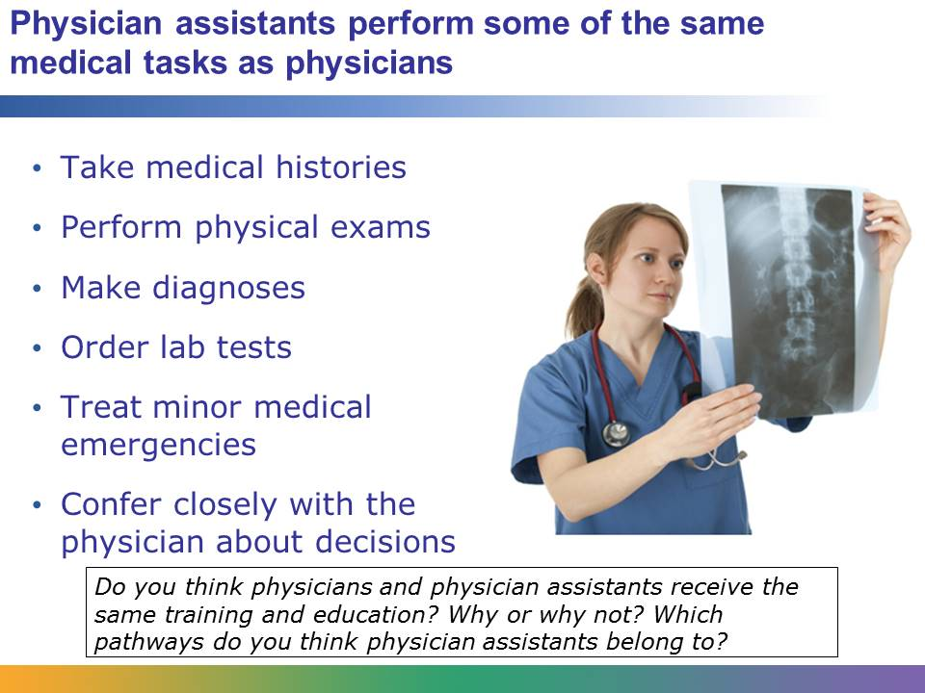
Physician assistants are responsible for carrying out specific medical duties that have traditionally been done by physicians. They work under the supervision of a physician. Physician assistants can take medical histories, which may involve recording information about illnesses in the patient’s past or specific health conditions that may run in the patient’s family. They can perform physical exams, and they can make preliminary diagnoses. They can also order common lab tests and prescribe medication. Physician assistants may be involved with treating minor medical emergencies. In rural areas where doctors may not be available, a physician assistant often provides the main medical care for the community. Like physicians, physician assistants can also have specialties, such as an orthopedic physician assistant.
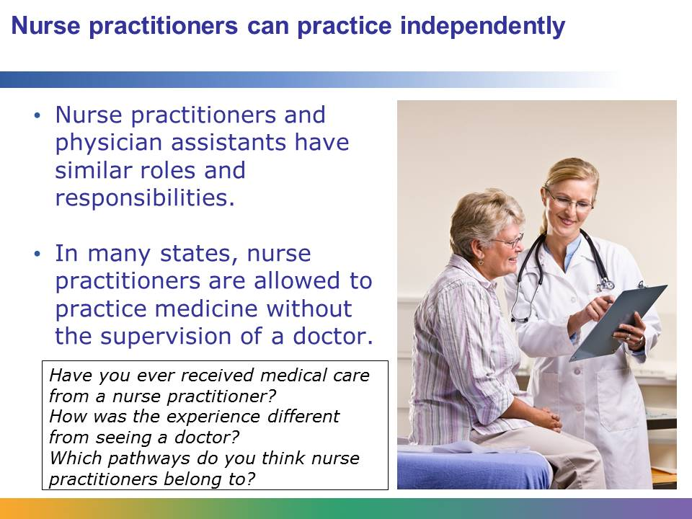
In many ways nurse practitioners and physician assistants are alike. Like physician assistants, nurse practitioners can order lab tests, take medical histories, and treat common injuries. They also can specialize in a certain condition. This allows doctors to focus on treating more critical and complex cases. While nurse practitioners have similar responsibilities to physician assistants, historically nurse practitioners have had more professional independence. In many states, nurse practitioners are allowed to prescribe medication and treat patients without the direct supervision of a doctor. The laws that say what physician assistants and nurse practitioners are allowed to do vary from state to state.
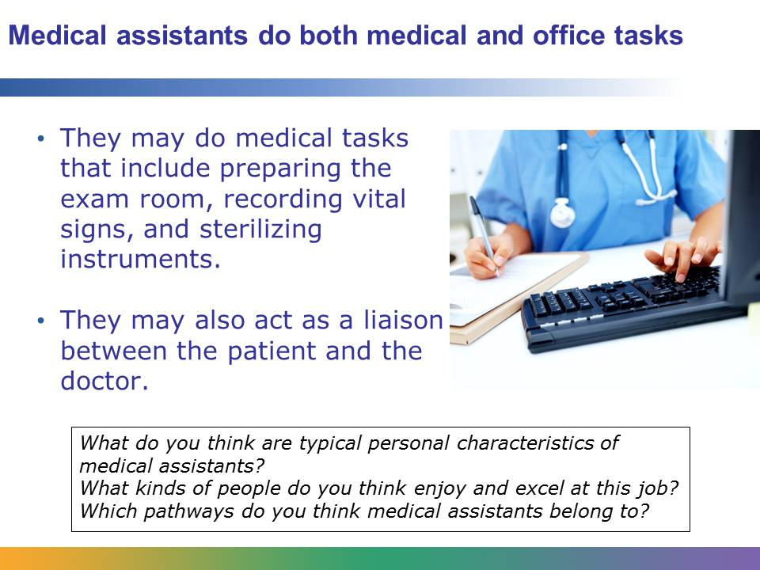
A medical assistant may do both medical and administrative work in a doctor’s office. Like a physician assistant, the medical assistant is supervised by the doctor. The clinical, or medical, roles that the medical assistant takes on in the doctor’s office are determined by state law, but they may include preparing the examination room for a patient, recording a patient’s vital signs, and cleaning and sterilizing instruments.
The administrative tasks depend on the specific organization of the doctor’s office, but they usually involve acting as a liaison between the patient and the doctor. For example, let’s say a patient calls the doctor’s office because he or she has a rash on his or her foot. The patient will speak to the medical assistant, who will take down the appropriate information about the patient’s condition. Then the medical assistant will speak to the doctor and explain the patient’s problem. Finally, the medical assistant will call the patient back to deliver the doctor’s advice and book an appointment, if necessary.
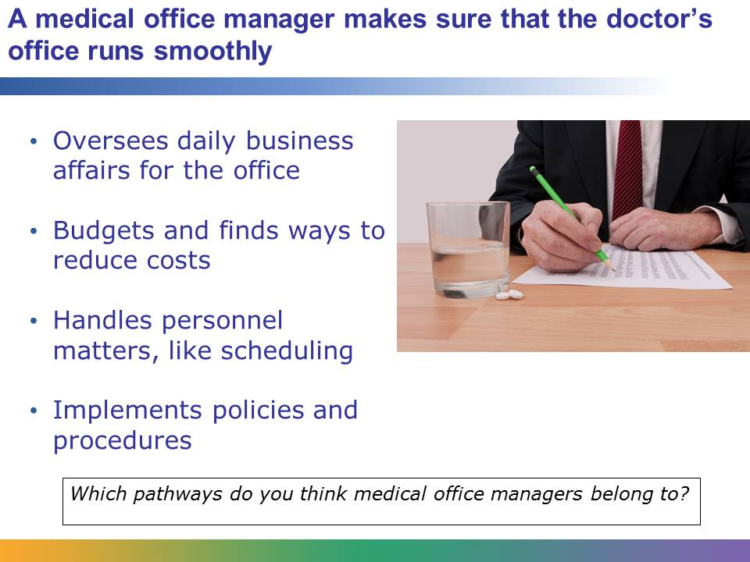
The medical office manager is responsible for overseeing the daily operations, or the business side, of the doctor’s office. He or she makes sure that the office is running smoothly and coordinates day-to-day business matters. The medical office manager may be responsible for budgeting and for looking for ways to cut back on costs while maintaining high-quality services. The medical office manager may also oversee personnel matters like scheduling, and implementing policies and procedures for the office. In an office of a large group of doctors, there may be more than one manager, or administrator, running the business of the office.
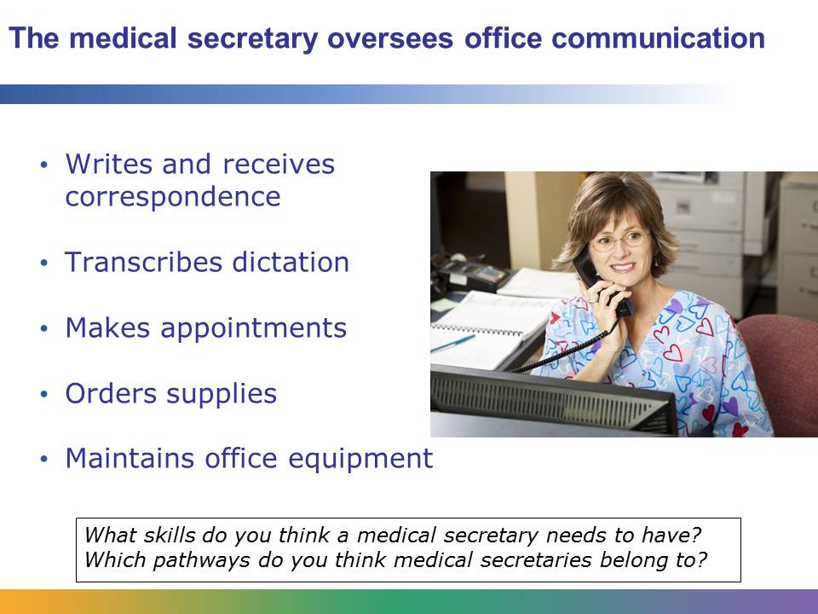
The medical secretary coordinates the communication activities of a doctor’s office. The medical secretary is responsible for typing letters and emails, transcribing dictation, setting appointments, ordering supplies, and making sure that office equipment, like fax machines, are working efficiently. In some small offices, the medical secretary is also responsible for billing patients and insurance companies. In larger doctor’s offices, a receptionist is usually responsible for greeting patients and answering calls, and a medical secretary may be responsible for the rest of the communication-related tasks. In some offices, the medical secretary may be responsible for billing.
The medical biller oversees the billing process for a doctor’s office. Patients may not have direct interactions with the medical biller unless they have an issue with their bill or insurance company and need assistance. The medical biller is responsible for making sure that patient bills are accurate and complete. He or she has extensive knowledge about complex insurance guidelines and handles insurance claims and correspondence with insurance representatives. The medical biller responds to patient calls regarding bills and insurance issues.
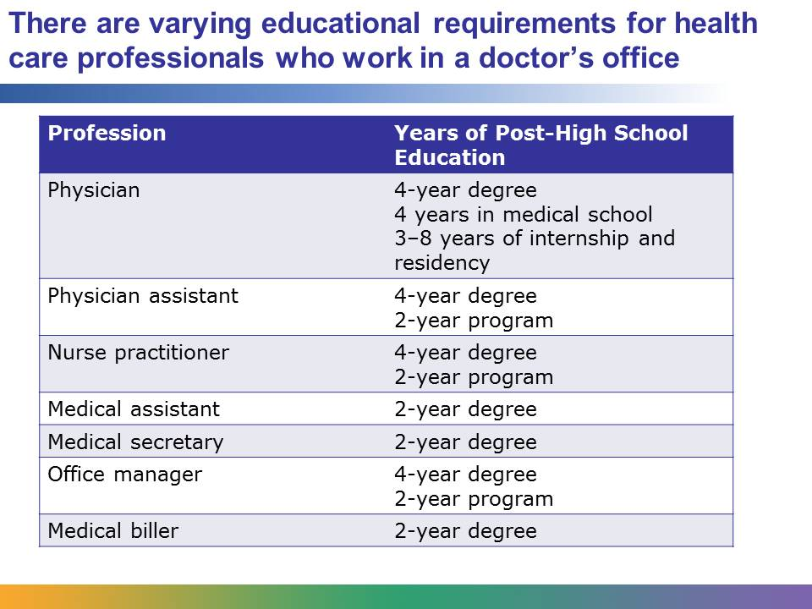
There are varying levels of educational requirements for health care professionals who work in a doctor’s office. The most involved requirements are for physicians. Physicians first must attend a four-year college, where they take courses that will prepare them for medical school. After they complete four years of medical school, they are required to do an internship and residency, which can take between three and eight years. To become a physician, you must commit to completing many years of education and training, but at the end of the experience, you are able to practice medicine, one of the most valued and respected professions in our society.
Becoming a physician assistant or nurse practitioner requires less education than a physician, but the requirements are still rigorous. To become a nurse practitioner, you must first be a registered nurse and have bachelor’s degree in nursing, or a BSN. You must complete a nurse practitioner program that lasts 18 months to two years, and then you must become certified. To become a physician assistant, you must have a bachelor’s degree, complete a two-year program, and also earn certification. An associate degree is required for medical assistants, medical billers, and medical secretaries. They will take both medical- and business-related courses in a community college or a vocational program that will prepare them for their jobs.
In small offices, a bachelor’s degree may be adequate for an office manager. However, in larger offices and departments a master’s degree is usually required. Many office managers have a master’s degree in health services administration, and they also have previous work experience in health care.
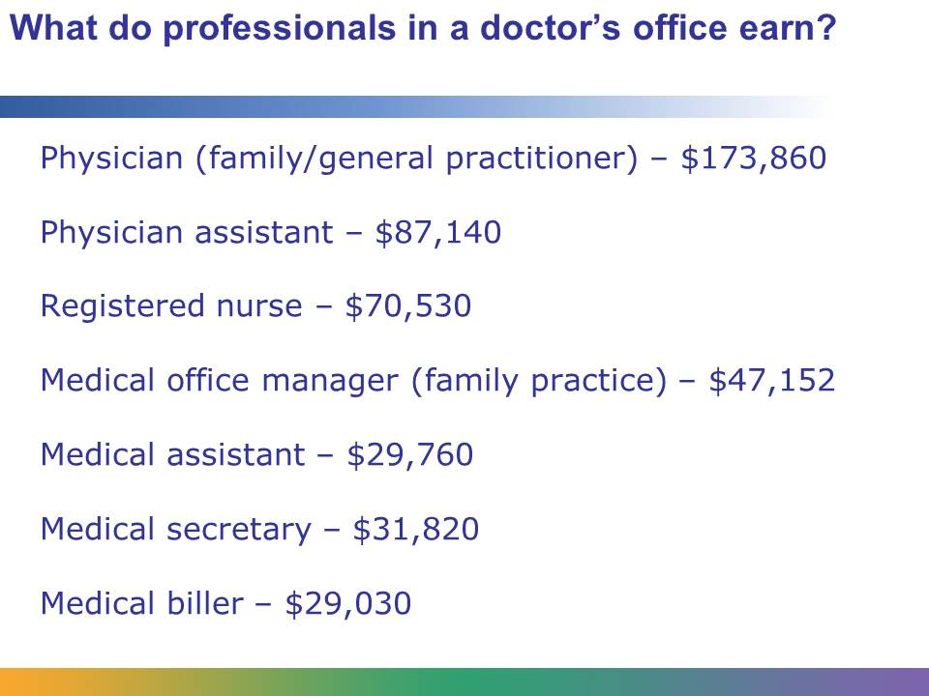
Physicians have one of the highest earning jobs in our society. According to the US Department of Labor, in 2010 the mean annual wage for physicians who were family and general practitioners was $173,860. Physician assistants earned $87,140. The US Department of Labor averages out the wages for all registered nurses, which includes nurse practitioners. The mean annual wage for registered nurses in physician’s offices was $67,720, but for nurse practitioners it is likely to be slightly higher. Medical assistants earned $29,760, and the mean annual wage for medical secretaries was slightly higher at $31,820. According to a survey by the Professional Association of Health Care Office Management, the average compensation for office managers in family-practice offices in 2009 was $47,152. Medical billers are included in the category of medical records and health information technicians; according to the US Department of Labor, in 2010 their annual mean wage in physician’s offices was $29,030.
The salary for all health care professionals varies depending on the place they work, the state that they work in, and the size of the office.
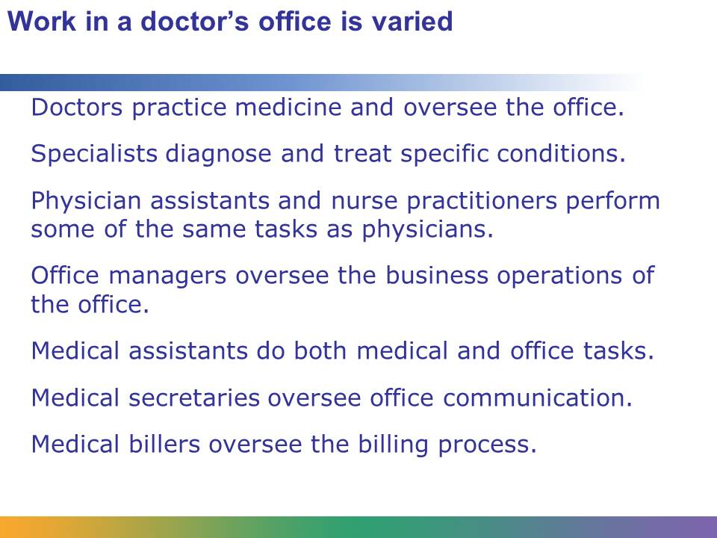
Most of the health care professionals who work in a doctor’s office find it to be a pleasant place to work. The professionals enjoy working on a team. Each plays his part in providing excellent care to patients—from the doctor, who is ultimately responsible for the patient’s care, to the medical assistant, who carefully records the patient’s vital signs, to the medical secretary, who greets patients and makes sure the office runs smoothly. The work of each professional is valuable and ensures patients will receive the care they require.

