Student Resource 5.4
Reading: Health Ethics and Human Rights
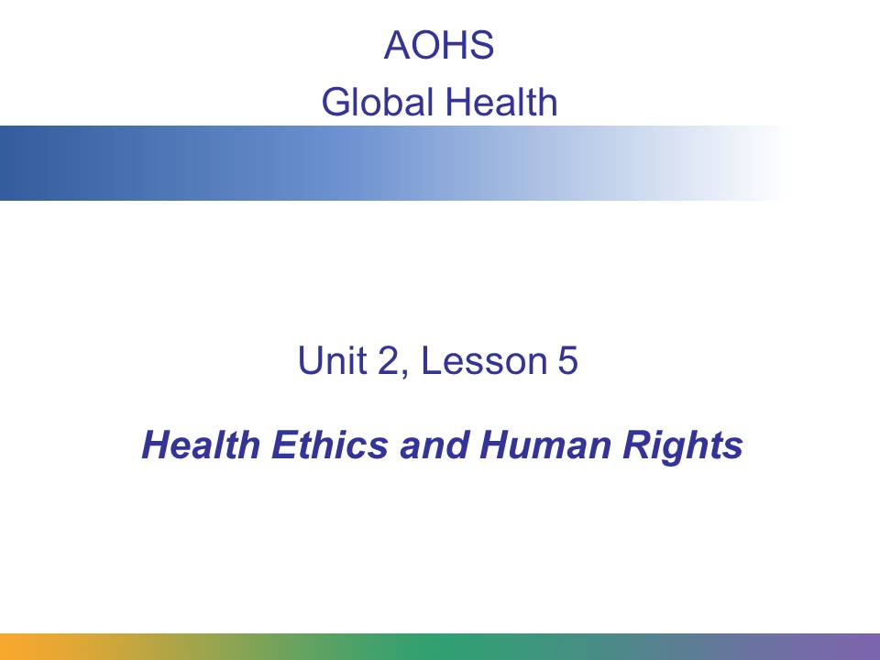
What are ethics? How are ethics different from human rights? In this presentation, you will learn about how ethics and human rights impact the work of global health professionals.
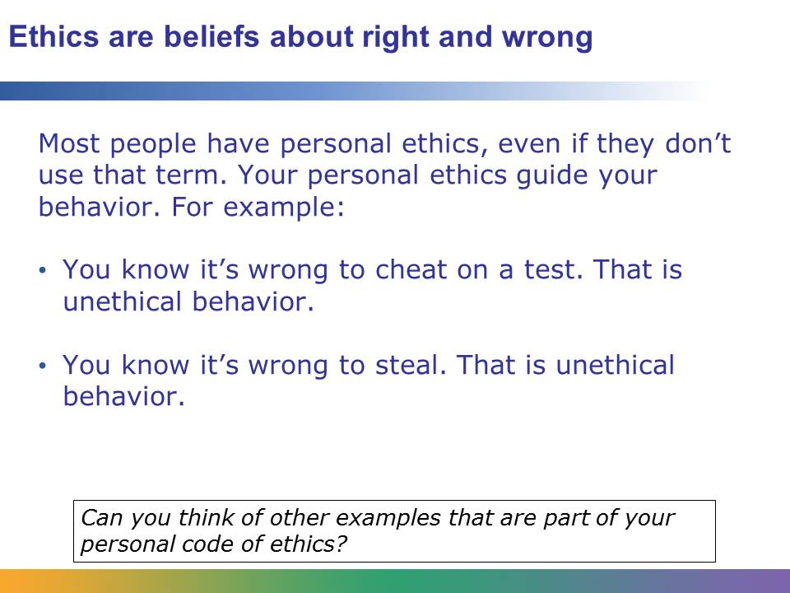
People learn and develop their own personal set of ethics in various ways.
Most people learn their basic ethical foundation from family members. These childhood teachings shape our most fundamental attitudes about what is right and what is wrong. Sometimes a person’s ethics come from a spiritual or religious belief or a certain way of doing things in their community.
Culture also affects a person’s ethics. Imagine a business in the United States where a salesperson uses a bribe to influence somebody to use the business. In the US, that practice would be considered unethical. But in many countries, bribes are seen as “gifts” and are a customary part of a business transaction.
Most people in the United States would say their personal code of ethics includes things like:
- Don’t hurt anybody (unless it’s self-defense).
- Be kind to children and animals.
- Don’t discriminate against people because of their race, religion, or gender.
Some people also have a specific code of ethics for their job. For example, firefighters, police officers, and soldiers have a code of ethics that reflects the dangerous job they do. Teachers have ethical guidelines—for example, a teacher shouldn’t flunk a student based on his or her dislike of that student.
Doctors, nurses, and health professionals have their own code of ethics, too. You may have heard the phrase, “First, do no harm.” That means that a health professional’s first job is to make sure not to make things worse by his or her treatment of the patient. That is part of a code of medical ethics.
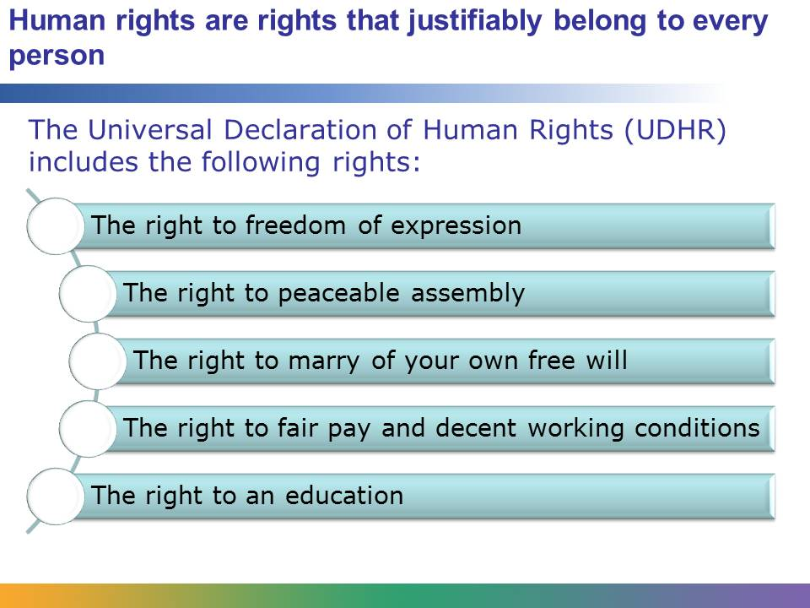
In a world where millions of people and communities face discrimination and violence, it is essential to have a shared value system that calls on governments, institutions, and individuals to respect the fundamental rights of all people. Human rights are intrinsic and belong to everyone. There are no exceptions based on religion, caste, gender, class, sexuality, geographic location, or any other factor. Human rights are part of our everyday lives, and each one of us is responsible for their protection and promotion.
The Universal Declaration of Human Rights is a statement of human rights principles that was adopted by the United Nations on December 10, 1948. It says that “all human beings are born free and equal in dignity and in rights” and covers a wide range of different types of rights, including political rights, legal rights, equality rights, and economic rights.
Adapted from International Human Rights Funders Group, interviews conducted with board members, 2011. https://www.ihrfg.org/human-rights-funding/faqs-about-human-rights#faq4 (retrieved April 18, 2014).
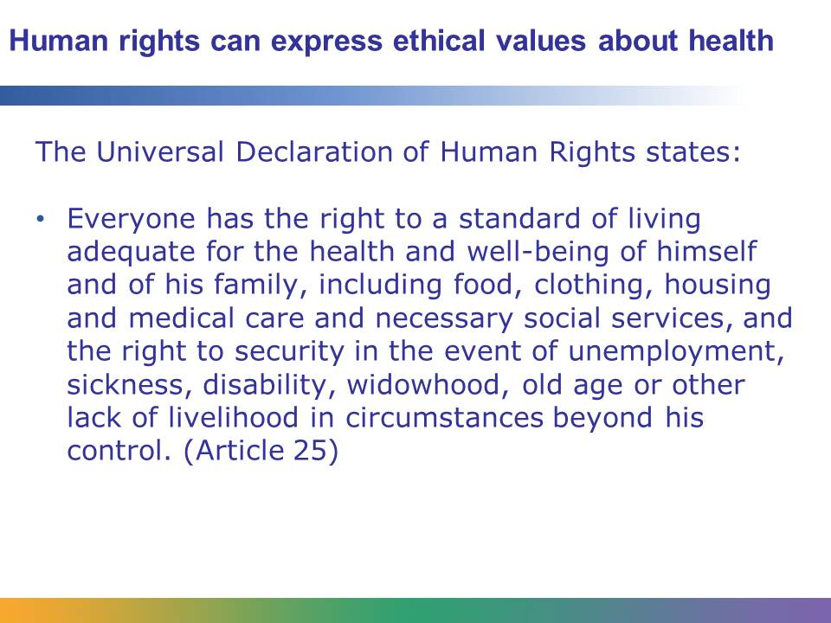
Human rights are an expression of ethical values. It is unethical to deprive someone of his or her human rights. The UDHR clearly states that medical care is a human right, so refusing to treat someone is a violation of that individual’s human rights. But what if a patient doesn’t want to be treated? What is the ethical thing to do in that situation?
What do you do if a patient has a serious illness and no way to pay for the expensive drugs or treatment? Does that patient simply not get treated? Is that a violation of the patient’s rights? If patients receive treatment they cannot afford, who pays for that cost? And what do you do in situations where there are hundreds or thousands of sick people who cannot pay? There are not enough resources to treat them all. What is the ethical thing to do in that situation?
You just heard about the idea of “First, do no harm.” But what if a dangerous operation gives a surgeon the chance to cure a patient of an otherwise incurable illness? What is the ethical thing to do in that situation?
Health ethics or medical ethics can serve as a guide when managing difficult situations like these.
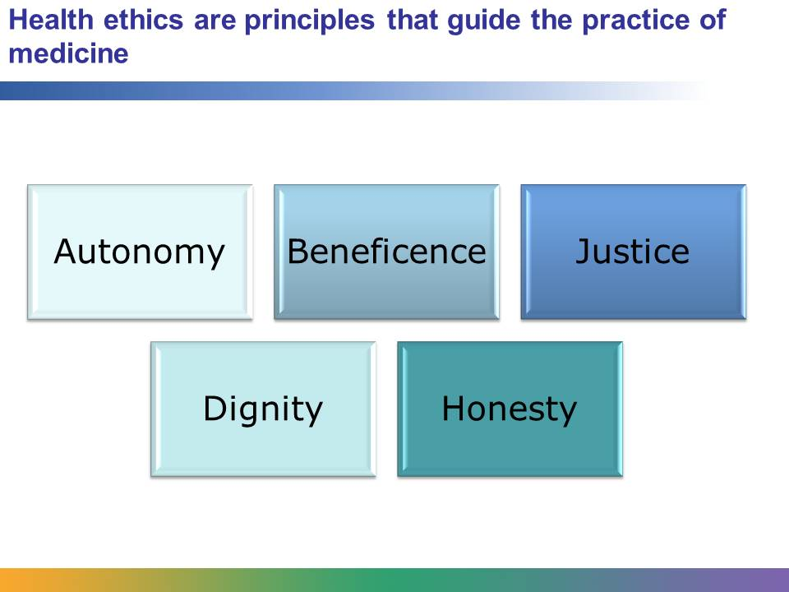
These five principles are common throughout medical practices around the world. Many countries have laws about medical practice that are based on these principles.
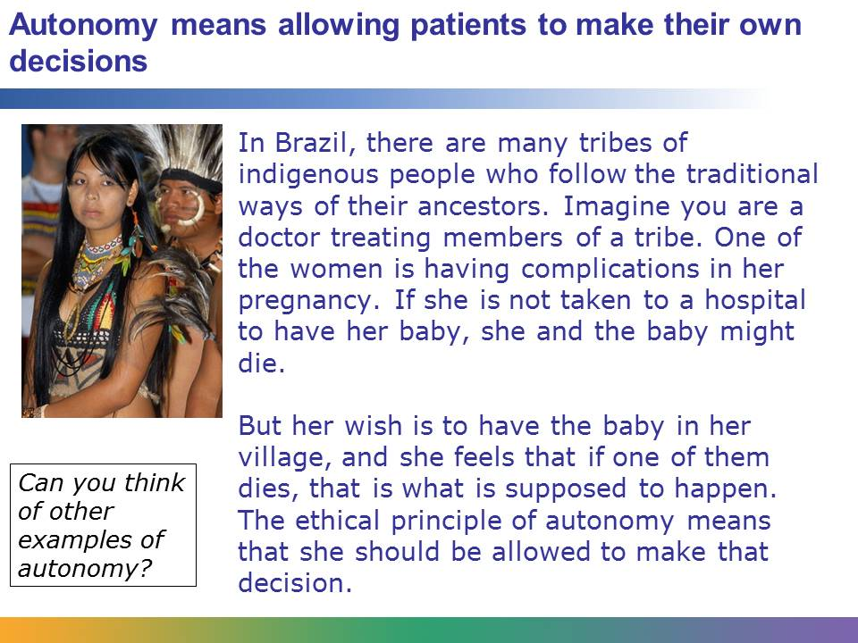
Autonomy means patients have the right to refuse or choose their treatment. This requires that medical professionals respect the wishes of their patients. This may be difficult under some circumstances. What if someone with a terminal illness has also become depressed? This patient might not be in the right frame of mind to make a good decision. Or what if a patient is mentally ill or disabled? The person might not be able to make good decisions. And what if someone is in a coma? That patient is unable to make decisions for him- or herself and may need a family member to make difficult decisions. However, if a patient is conscious and in his or her “right mind,” medical professionals have a responsibility to present an overview of choices and then let the person make the decision about the course of treatment.
Image retrieved from http://commons.wikimedia.org/wiki/File:%C3%8Dndia_da_etnia_Terena.jpg and reproduced here under the terms of the Creative Commons Attribution 3.0 Brazil (http://creativecommons.org/licenses/by/3.0/br/deed.en). Image courtesy of Valter Campanato/ABr.
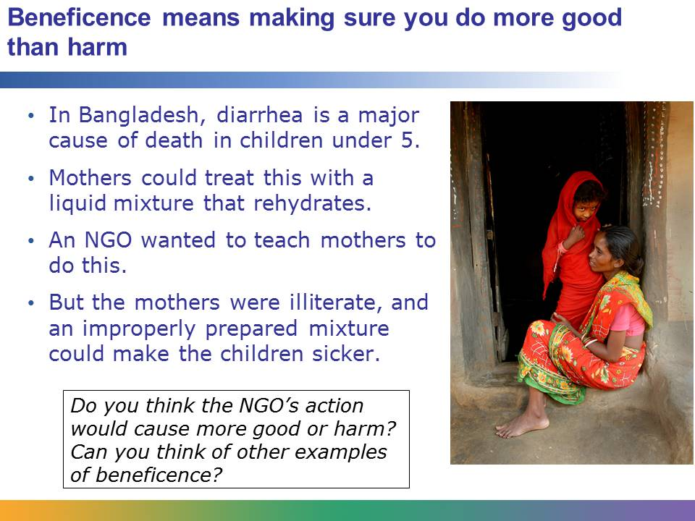
There are two parts to the concept of beneficence: (1) taking actions that serve the best interest of a patient and (2) balancing benefit against risk. In the example here, providing the liquid mixture to sick children is clearly in the children’s best interest. However, the NGO had to find a way to balance the benefit against the risk.
In this case, the NGO decided to try to find a way to educate the mothers so they would make the mixture properly. They created a chart that used pictures to demonstrate how to make the solution. Then they practiced with the mothers, showing them how to make the correct liquid mixture, and they had the mothers make it under supervision. Once they were satisfied that the mothers understood, the NGO workers moved on to another village, but they came back to check up on the mothers and to make sure they remembered how to make the solution correctly. This approach worked. When tested later, approximately 90% of the women remembered how to make the solution. Within the next decade, experts estimate that close to 50% of the cases of diarrhea in the country were treated with this solution.
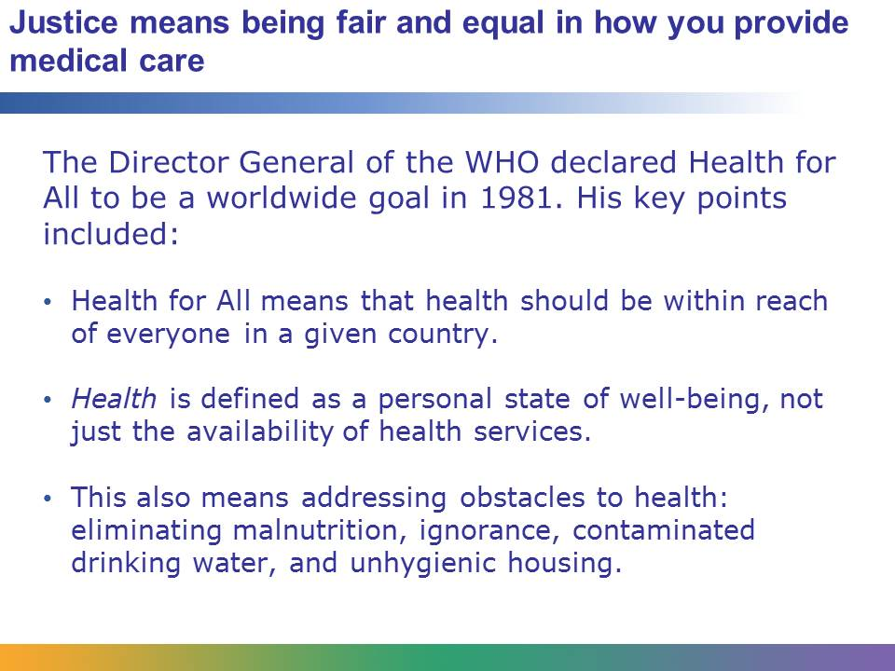
Justice means providing medical care to everyone, no matter who they are. It is about fairness and equality among all groups of society. It requires thinking about how to use health resources that are in short supply so that they reach as many people as possible. Justice also means that health care professionals treat every patient the same, regardless of age, race, sex, personality, or income.
Justice is often difficult to achieve because of competing needs, rights, and obligations. Sometimes ignorance and prejudice get in the way. For example, in some countries in Africa, people are ignorant about how HIV is passed from one person to another. Many local hospital workers are scared that they can catch it, so they have refused to treat people with HIV. In order to follow the ethical principle of justice, you would need to educate all the local workers so that they understand that they can safely treat the patient.
Providing justice in health care is often difficult or impossible because of many other factors, too: poor nutrition, bad housing, war, or discrimination. One doctor, nurse, or health care worker cannot solve these massive problems alone. But ethically, medical professionals are obligated to do their part to help make sure that health care is distributed as fairly and as equally as possible.
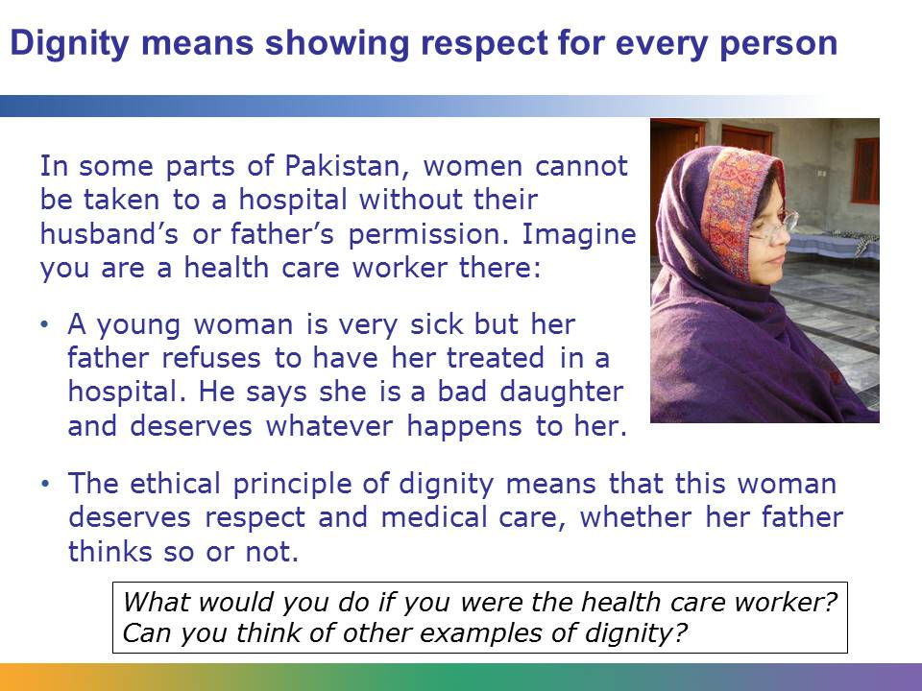
The ethical principle of dignity means that every person is born with the right to be treated with respect and to receive medical care. But right now in many places in the world, poor people, illiterate people, and people of various races and religions do not receive the health care they need. Or they may receive undignified treatment while seeking health care.
Dignity also means respecting other people’s beliefs, even if they are different from yours. For example, by 2005 polio was almost wiped out globally. But people began to refuse the vaccine in Nigeria because of rumors that the vaccine would sterilize patients, or make them unable to have children.
Health care workers in Nigeria knew that the vaccine would protect people from polio, but they also understood the need to show respect for the local people. So the health care workers treated the patients with dignity and explained why the vaccine was safe and effective. Yet in spite of their efforts, polio remains a problem in some parts of the world today.
Sometimes medical professionals have to find a balance between respecting beliefs and doing what is right, and ethical values do not always give the answers. But they do provide a useful framework for dealing with difficult situations like the ones on this slide.
Image courtesy of Khalid Mahmood and retrieved from http://commons.wikimedia.org/wiki/File:A_Pakistani_Woman.JPG. Reproduced here under the terms of the GNU Free Documentation License (http://commons.wikimedia.org/wiki/Commons:GNU_Free_Documentation_License_1.2).
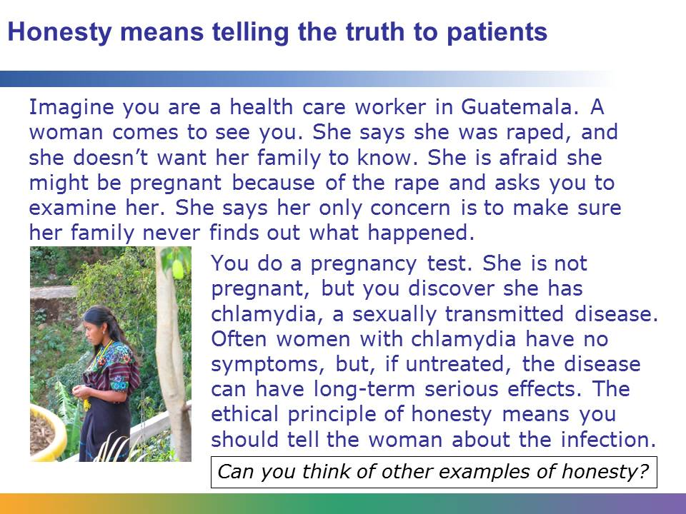
How much information is a patient entitled to receive before accepting or refusing treatment? Is a physician or other health provider ever permitted to deceive or withhold information from a patient? In years gone by, information was given or withheld as doctors thought best.
People have a right to know what is happening to their own bodies. WHO guidelines for treating diseases like tuberculosis and HIV/AIDS make it clear that people need to be informed about risks to themselves as well as risks to the community.
Honesty is also connected to the principle of autonomy. Autonomy means people have the right to make their own decisions about their health care, but they need to understand their conditions and their treatment options before they can make a good decision. This is called informed consent or informed refusal. It means a patient has enough information to make an informed decision about his or her treatment.
In the case of the young woman in Guatemala, the ethical obligation as a health care worker is to be honest with her and tell her about her condition and treatment options. You would also have an obligation not to share this information with other people—that is doctor-patient confidentiality.
Honesty also plays a role in medical research, which you will learn about later in this lesson.
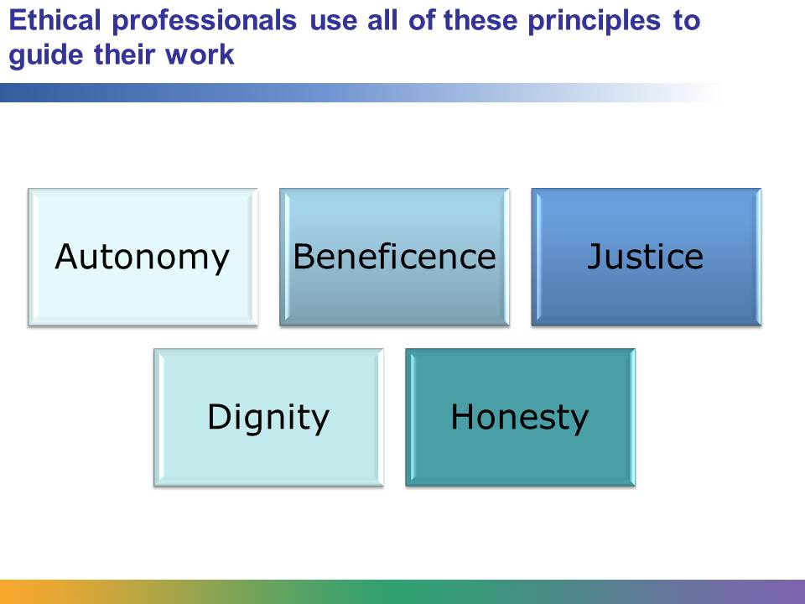
Remember the story of the tribal woman in Brazil whose pregnancy was threatened if the birth did not take place in a hospital? Autonomy would be an ethical factor, along with application of all of the ethical principles.
Beneficence: This is the balancing of good vs. risk. If the woman is part of an isolated tribe, bringing her into a city hospital would expose her and the baby to germs they have no resistance to. Not only could the woman or her baby get sick, but they could bring those germs back with them to the vulnerable tribe. So bringing her to the hospital could do good, yet it could also do a lot of harm.
Justice: This woman and her baby deserve medical treatment, even though they are part of an isolated and poor tribe. If the woman cannot be taken to a hospital, the principle of justice means she deserves the best medical care possible under the circumstances.
Dignity: The woman’s refusal has to do with ancient traditions that may not make sense to our modern perspective, but she deserves to be respected and treated with dignity.
Honesty: The woman cannot make an informed decision unless medical professionals are honest with her. If you tell her truthfully that she or the baby might die, and if she would rather take that risk than go to a hospital, then you have behaved ethically and she has made an informed refusal. All of these principles together guide medical professionals in decision making every day.

