Student Resource 4.1
K-W-L Chart: Public Health Issues
Student Name:_______________________________________________________ Date:___________
Directions: In the first column of this chart, write what you already know about each topic. In the second column, write what you would like to learn about the topic in the form of a question. Then, as you read Student Resource 4.2, Reading: What Is Public Health?, fill in the What I Learned column.
What I Know | What I Want to Know | What I Learned
Public health:

Public health workers:

Obesity:

Influenza:

Motor vehicle injuries:

Teen pregnancy:

Food safety:

Student Resource 4.2
Reading: What Is Public Health?
Public health is an area of science and medicine that works to prevent disease and protect and improve the health of an entire population. The population in question can be as small as a high school or as large as a region of the world.
Public Health in Your Life
7 a.m. You wake up and brush your teeth. The water flowing from the tap is clean and safe to drink.
7:30 You eat eggs and fruit for breakfast. You know that a healthy breakfast will give you energy for the day.
8:00 On the way to school, you wear a seat belt, significantly cutting down the chance of injury if there’s an accident.
12:00 The cooks in the cafeteria follow safety regulations to prepare the enchiladas you eat for lunch. The produce they use has passed inspection.
3:00 You play basketball after school. Heart disease runs in your family, and you’ve learned that you need 30‒60 minutes of daily exercise to maintain a healthy heart and weight.
4:30 You sit on your friend’s porch chatting. None of your friends smoke. You know what a dangerous habit it is.
6:00 Your family eats dinner out. A sign in bathroom reminds all employees that it is state law to wash their hands.
7:30 You read the news online. A new asthma medication is showing positive results. You make a mental note to tell your cousin, who has asthma, about it.
If you go to the doctor to receive treatment for a sprained ankle, you are the patient. But in public health, professionals see the community as the patient. This means that public health creates education programs, develops policies, regulates health systems, and does research to try to improve the health of a community or prevent health problems from occurring. Public health wants all members of the community to receive quality health care.
A high standard of public health is essential for a community to function properly. Take your school community as an example. Imagine if there were serious health problems plaguing your school community. The health problem could be unsafe drinking water, widespread respiratory infections among students and teachers, or tragedies due to motor vehicle accidents. What would the effect be on the community? Would students be able to perform well in classes? Would athletic teams succeed? Would teachers be able to fully support students? Public health is important because a community can only thrive if its members are healthy and safe.
What Are Public Health Issues?
In order to protect and improve the health and quality of life of a population, public health workers focus on issues that put the health of the public at risk. The issue might be a disease, a risky behavior, or even an environmental hazard. This reading gives you a sample of some of the important public health issues we face in the United States. As you work through this lesson, you will learn about additional public health issues. The sidebar on this page gives you clues about some of the many public health issues you encounter every day.
Obesity
The concerns of public health in a society are constantly changing. There was a time in American history when polio was a major public health concern. Now polio has been eradicated. Obesity wasn’t an issue many Americans were concerned with 50 years ago, but times have changed.
About one-third of American adults are obese. These people are at risk for serious health conditions that include high blood pressure, type 2 diabetes, heart disease, some cancers, complications during pregnancy, and dying at an early age.
Obesity is not caused simply by eating too much. In fact, body weight is the result of many factors. These factors include genes, metabolism, behavior, environment, culture, and socioeconomic status.
The health and quality of life of people in communities across the United States are suffering because of obesity. Public health workers know that behavior and environment are the areas that provide the greatest opportunity for prevention and treatment. So, they are working in communities to promote lifestyle changes that will help prevent and decrease obesity. They are trying to raise awareness about the dangers of eating unhealthy foods, overeating, and a lifestyle in which people are inactive.
Health educators are working with schools to provide students with food that is low in saturated and trans fats. Corporate medical directors are trying to increase the opportunity for physical activity at work. Policy advisors are putting pressure on the food industry to provide appropriate food and beverage portions.
What do you think? Can Americans, working as a community, beat the obesity epidemic? Why is this a challenging problem to solve?
Influenza
One of public health’s greatest concerns is something most of us have been infected with at least once in our lives: the flu, or influenza.  Influenza is a contagious respiratory illness caused by a virus. It can spread in different ways. You can contract the virus by being near an infected person who is coughing, or by touching an object that has the virus on it and then touching your own mouth, nose, or eyes. There are certain vulnerable populations that can experience serious complications from the flu. These populations include young children, older people, and people with certain health conditions. People easily travel from community to community and country to country. The ease with which people move around the globe makes controlling the spread of influenza even more important.  Public health workers believe that the flu vaccine is the best way to prevent the illness from spreading in a community. Public health nurses visit communities where people are most vulnerable, such as senior citizen centers, and set up clinics for people to receive the vaccination | 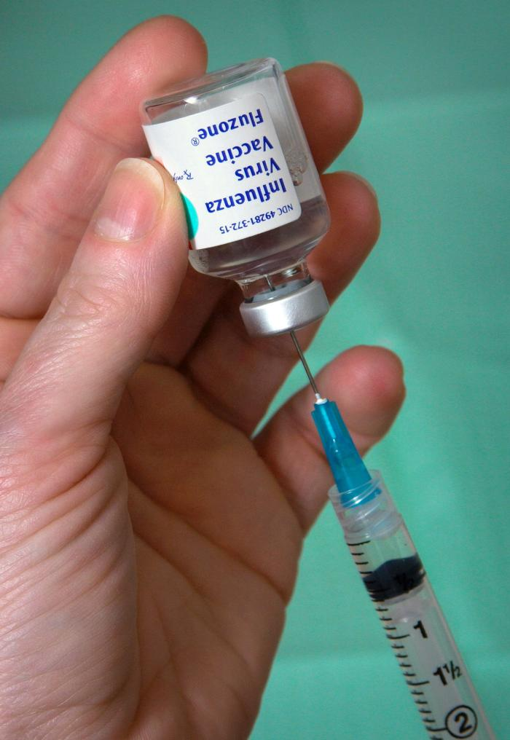  Image courtesy of Wikimedia Commons  A nurse is extracting Influenza Virus Vaccine, Fluzone® from a 5 ml vial.
Communication specialists write press releases about free vaccination clinics at hospitals during flu season. Media reporters receive the press releases and inform the public. Epidemiologists work on ways to contain the virus, and scientists develop new and more effective vaccinations.
What do you think? If experts think that vaccination is the most effective way to control the spread of the flu, why do people still get sick every flu season? What else can public health workers do?
Motor Vehicle Injuries
What do you think the leading cause of death is for young people in the United States? Here’s a clue: it is entirely preventable. If you guessed car crashes, you’re correct. Car crashes are the leading cause of death in the United States among people aged 5 to 34.
Car accidents can be caused by many types of behavior, ranging from drunk driving to distracted driving to speeding. Texting while driving is increasingly becoming a cause of accidents. The Centers for Disease Control and Prevention (CDC), a government organization that is concerned with safety and health, estimates that at least 16,000 people are killed each year because of a texting-related accident.
Public health workers are attacking this problem from different angles. Policy advisors are working to pass legislation. In 2011, 30 states had passed laws banning texting while driving. Health educators develop programs for teens and adults to raise awareness about the problem.
What do you think? Why do people text while driving if they know it is dangerous? Why are texting laws so difficult to enforce?
Teen Pregnancy
Public health workers have found that teen pregnancy prevention is important to the health and quality of life for young people and the health of society at large. Since the early 1990s, the number of teen pregnancies has declined. This is good news to public health workers. Teen mothers are less likely to graduate from high school. In fact, only about half of teen mothers receive a high school diploma by the age of 22, according to the CDC. The children of teenage mothers are more likely to have more health problems. They are also more likely to drop out of high school, face unemployment as young adults, and not be able to provide a home for their children. Then the problem becomes cyclical. This means that children who grow up without a stable home life are more likely to become pregnant teenagers themselves. These are problems that can have a negative impact on the economy of an entire community.
Public health workers use education and awareness campaigns. Successful teen prevention programs look at what teens know about pregnancy, the skills they have to prevent pregnancy, and attitudes and beliefs about pregnancy. These programs are offered by schools, community centers, and religious organizations.
What do you think? How does teen pregnancy affect other people in a community, other than the mother and child? Is teen pregnancy the most important public health issue facing teens?
Food Safety
Think about all the places we purchase food: fast food restaurants, farmers' markets, vending machines, food trucks, and supermarkets. The food we eat is grown all over the world. Unfortunately, sometimes unsafe food can make us sick. Each year in the United States millions of food-borne illnesses occur. Chemicals and pathogens, such as bacteria, viruses, and parasites, cause food-borne illnesses.
If two or more people get sick from eating the same contaminated food or drink, it is called a food-borne outbreak. The CDC believes that more than 250 pathogens and toxins are known to cause food-borne illnesses. When a major outbreak occurs, public health agencies investigate it. Epidemiologists, microbiologists, and environmental health specialists work to try to figure out what caused the outbreak and how to contain it. Public health workers also try to prevent outbreaks. Inspectors visit food companies to make sure that facilities are following health and safety standards. Health educators inform the public about how to avoid food-borne illnesses by doing things like washing fresh fruits and vegetables, properly cooking meat and fish, and avoiding unpasteurized milk.
What do you think? How could an outbreak affect people over a wide geographical area, such as a whole country? What are the most effective measures for preventing outbreaks?
Public Health Professionals Are Critical to Our Society
Obesity, influenza, motor vehicle injuries, teen pregnancy, and food safety are just five of many of public health issues that professionals address in communities across the country. They also work to solve problems related to asthma, toxic waste, skin cancer, HIV/AIDs, and other issues. The work they do is critical to helping our society function properly.

