Student Resource 3.2
Reading: Health Career Pathways
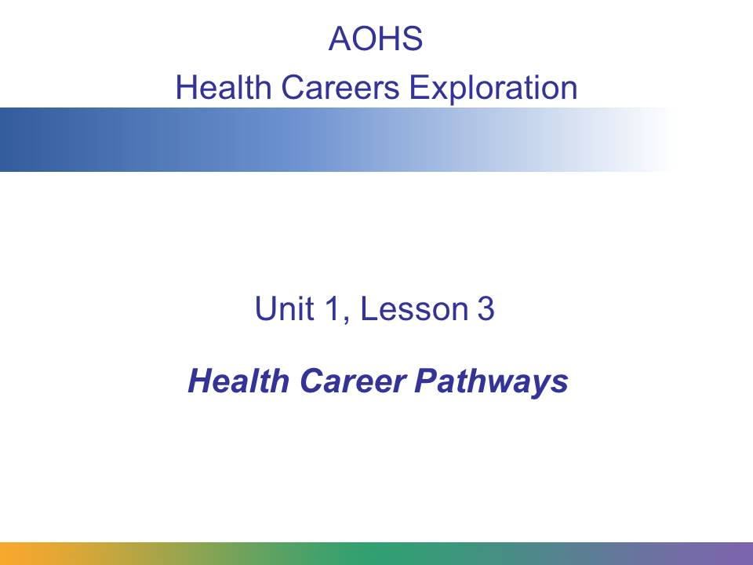
In this lesson, we’ll take a look at the five health career pathways and discuss their distinguishing features and some of the careers in each.
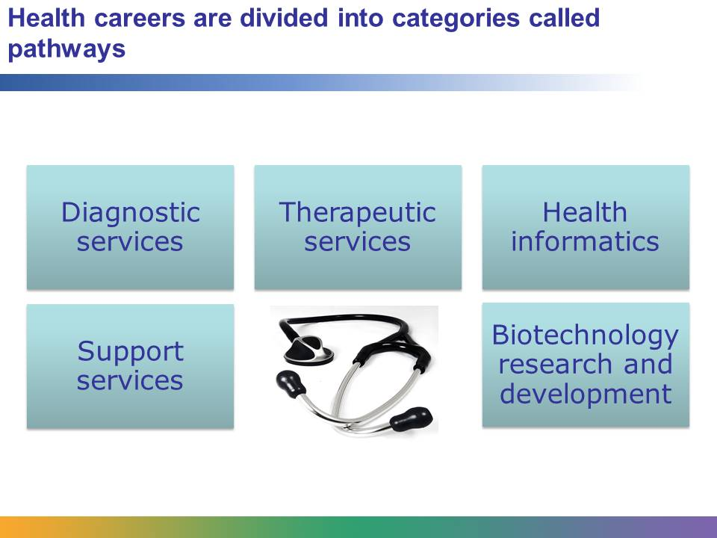
Health care is one of the largest and fastest growing industries in the United States. There are over 250 health careers. People with a wide range of interests, skills, education, and experience work in the industry. Health care workers are surgeons, chemists, lawyers, nurses, and engineers. They are employed in rehabilitation centers, hospitals, schools, and health insurance companies.
Health care careers are divided into five major categories. These categories are called pathways. The careers in a pathway have something in common, such as a common knowledge or skill set. The five pathways are diagnostic services, therapeutic services, health informatics, support services, and biotechnology research and development. In this presentation, we will learn about each.
Image retrieved from http://commons.wikimedia.org/wiki/File:Doctors_stethoscope_2.jpg on June 5, 2013 and reproduced here under the terms of the Creative Commons Attribution-Share Alike 3.0 Unported license (http://creativecommons.org/licenses/by-sa/3.0/deed.en).
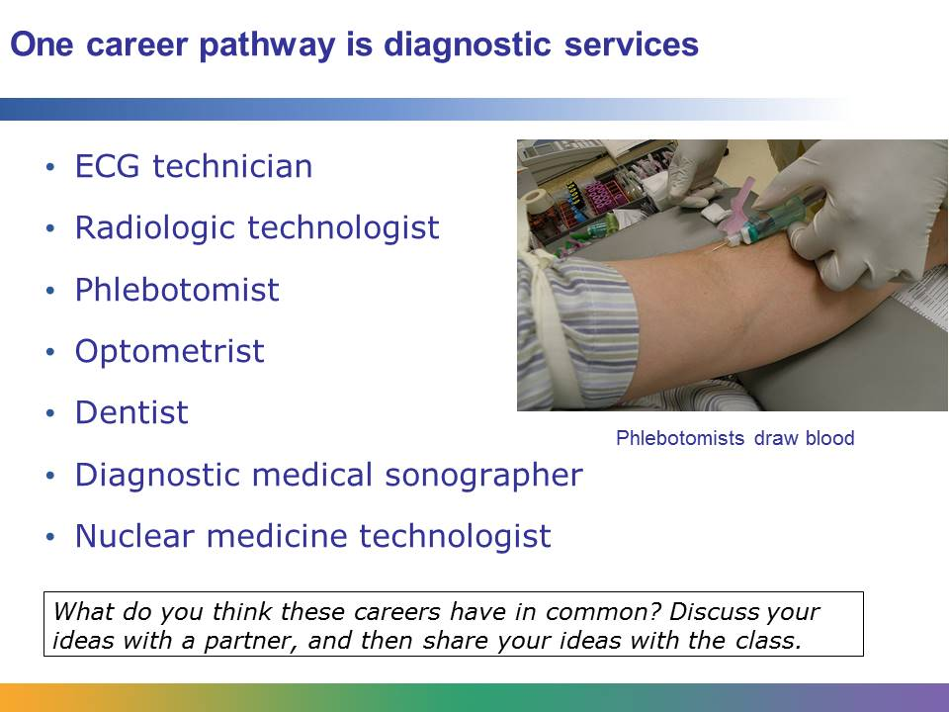
An ECG technician, radiologic technologist, phlebotomist, optometrist, dentist, diagnostic medical sonographer, and nuclear medicine technologist are all on the same pathway. Why do you think they are part of the same pathway? Read these descriptions of some of the careers and think about what they have in common.
An ECG technician controls an electrocardiogram, a machine that monitor’s a patient's heart. The ECG technician is responsible for attaching the machine to the patient and then controlling the machine to get the best possible reading. The technician gives the reading to a physician, who will interpret the results. The procedure is done to help diagnose cardiovascular problems, or problems of the heart and blood vessels.
Radiologic technologists use special diagnostic equipment, including X-rays, CTs, and MRIs, to diagnose medical problems such as broken bones or tumors. The radiologic technologist’s responsibilities may include explaining the procedure to the patient, preparing the patient for examination, keeping records, and maintaining equipment.
A phlebotomist, or venipuncture technician, collects blood from patients and prepares the blood for tests. The results of the tests are used by physicians to diagnose patients for a number of conditions, including how the organs are functioning, the effectiveness of medication, and pregnancy.
Other careers in diagnostic services include clinical lab technician, pathologist, and mammographer.
Image retrieved from http://commons.wikimedia.org/wiki/File:DrawingBloodUnitedStatesVacutainer.jpg , courtesy of Richardelainechambers.

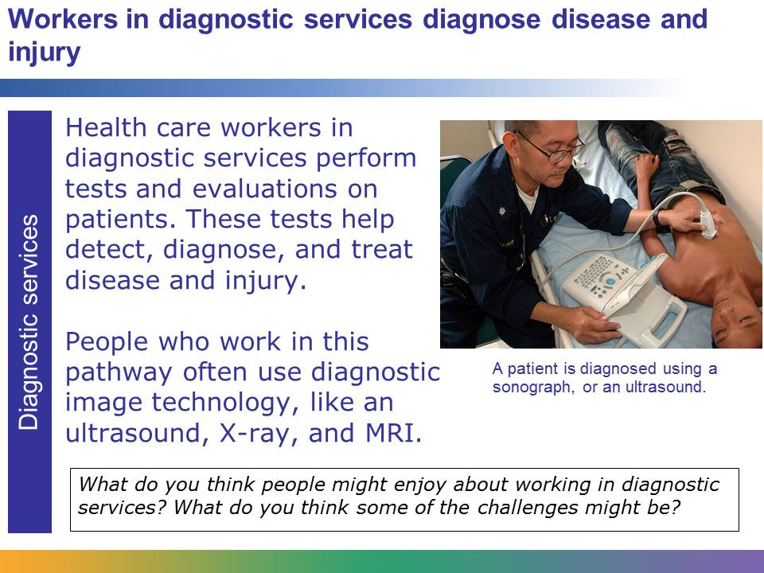
Health care workers in diagnostic services are responsible for helping to diagnose a patient’s injury, disease, or other physical condition.
Let’s say that a soccer player is injured during a game. She’s taken to the hospital, where a radiologic technologist, who works in diagnostic services, performs an X-ray that shows a fractured bone in the soccer player’s leg. This health care worker has played an important part in diagnosing the patient’s injury.
Diagnostic services is a rapidly growing area of health care. Many careers in this area involve using diagnostic image technology, like ultrasound, X-ray, and MRI, that is constantly changing and improving. This technology is allowing health care workers to diagnose patients earlier and more accurately than ever before.
Image retrieved from http://commons.wikimedia.org/wiki/File:Medical_ultrasound.jpg on June 5, 2013. Image courtesy of Joseph Caballero, US Navy.
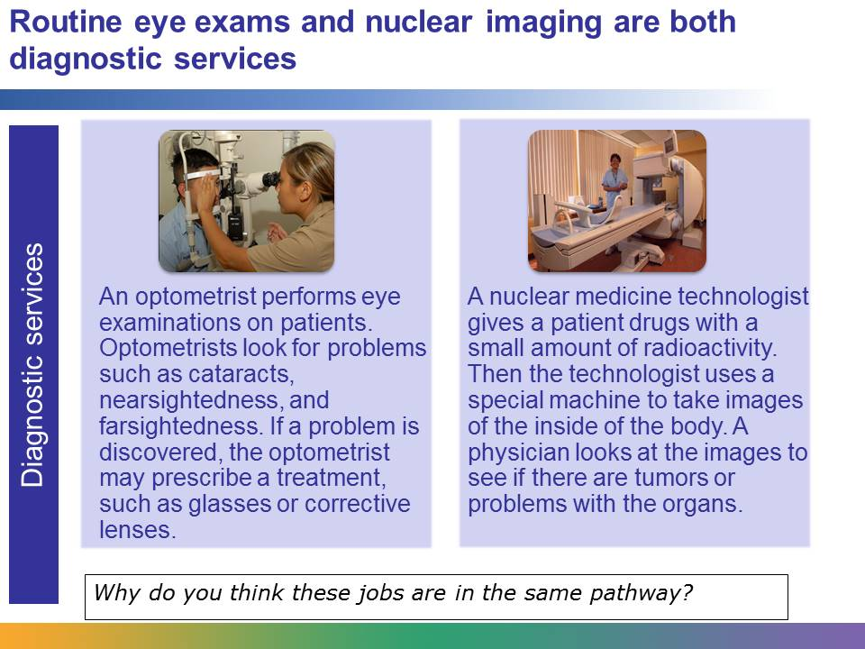
The job skills of optometrists and nuclear medicine technologists are quite different. A nuclear medicine technologist is concerned with internal organs, whereas an optometrist is concerned with the eyes. A nuclear technologist has a very specific job: to give a patient drugs and then operate a sensitive machine to obtain images of the inside of the patient’s body. An optometrist uses different methods and machines to study the eyes.
However, both jobs involve identifying problems, and this is why they are both in diagnostic services.
Image (left) retrieved from http://commons.wikimedia.org/wiki/File:US_Navy_090901-N-5617R-056_Navy_optometrist_Lt._Thuong_Le,_from_Dallas,_administers_a_slit_lamp_eye_exam_to_Ship%27s_Serviceman_Seaman_Alfernan_Fernandez_at_Branch_Medical_Clinic_Naval_Base_San_Diego.jpg on June 5, 2013. Courtesy of Mass Communication Specialist 3rd Class Rialyn Rodrigo. Image (right) retrieved from http://commons.wikimedia.org/wiki/File:Gamma_camera.jpg on June 5, 2013 and reproduced here under the terms of the Creative Commons Attribution –Share Alike 3.0 Unported license (http://creativecommons.org/licenses/by-sa/3.0/deed.en). Image courtesy of Brendaicm.
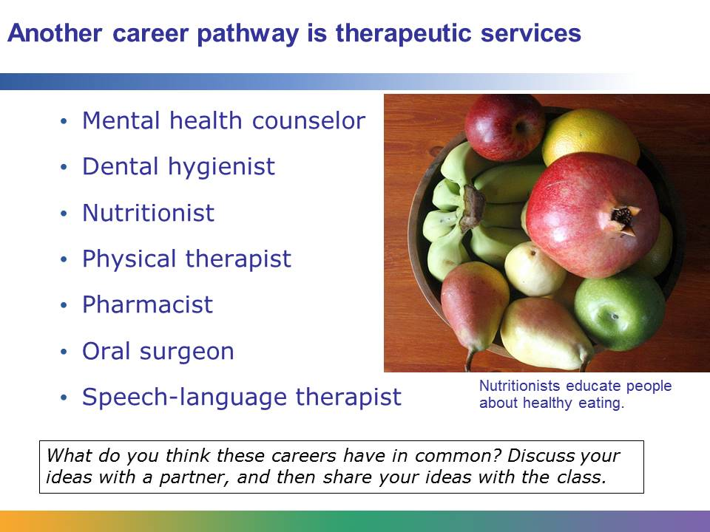
A mental health counselor, dental hygienist, nutritionist, physical therapist, pharmacist, oral surgeon, and speech-language therapist are all on the same pathway. Why do you think they are part of the same pathway? Read these descriptions of some of the careers and think about what they have in common.
Mental health counselors work with individuals to promote optimum mental health. They help people deal with addictions, family issues, self-esteem, suicide, stress management, emotional health, and issues related to aging. Mental health counselors may work in facilities for people requiring mental health treatment or in hospitals providing support for patients who have had injuries or are very ill.
Dental hygienists work with dentists and dental assistants to care for a patient’s teeth and mouth. Their responsibilities include taking X-rays, cleaning teeth, and educating people about how to care for teeth. They try to help patients develop habits that will give them the best chance to have healthy teeth throughout their lives.
Nutritionists are experts in using nutrition to treat and prevent diseases and to maintain nutrient balance for optimum health. They do jobs like planning menus or managing food service at facilities like hospitals or schools.
Other careers in therapeutic services include acupuncturist, physician assistant, home health aide, nurse midwife, and certified nursing assistant.
Image retrieved from http://commons.wikimedia.org/wiki/File:Fruit_bowl.jpg and reproduced under the Creative Commons Attribution-Share Alike 3.0 Unported license. Image courtesy of Yosarian.
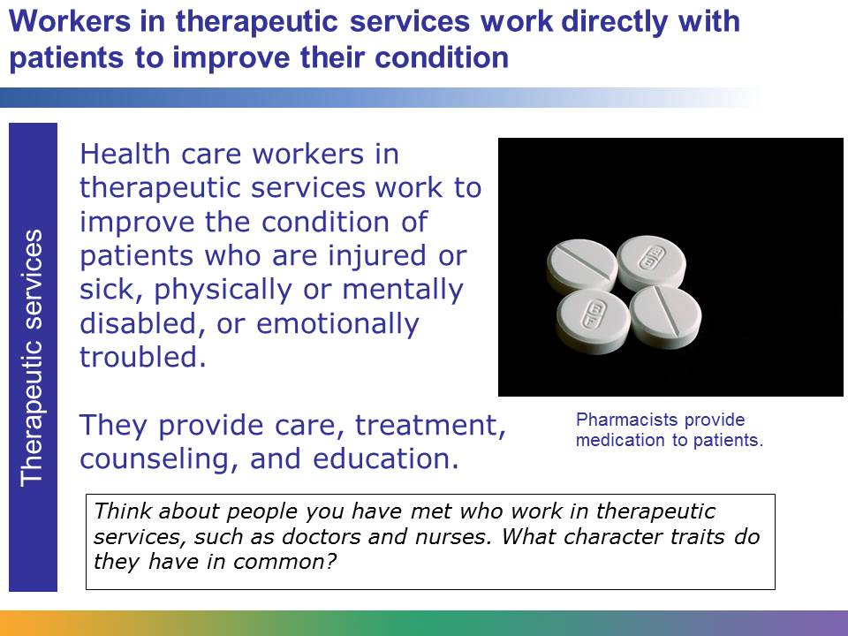
Health care workers in therapeutic services provide direct care, treatment, counseling, and education to improve the condition of patients. They work with people who are injured or sick, physically or mentally disabled, or emotionally disturbed.
Let’s recall the professional soccer player who was in the unfortunate accident. A person in diagnostic services diagnosed the problem: a fractured bone. Now health care workers in therapeutic services will work to fix the problem.
The soccer player will likely need health care over a period of weeks, or perhaps months, from a number of professionals in therapeutic services. In the process of healing, she may receive care from physicians and nurses, and she may receive medication from pharmacists. She may visit a physical therapist to help her rebuild the strength in her leg so that she can play soccer again. She may also see a massage therapist to help relieve stress of the injury or a mental health counselor to discuss the impact the injury has had on other parts of her life.
Image courtesy of Wikimedia Commons
http://commons.wikimedia.org/wiki/File:Medication_Paracetamol.jpg

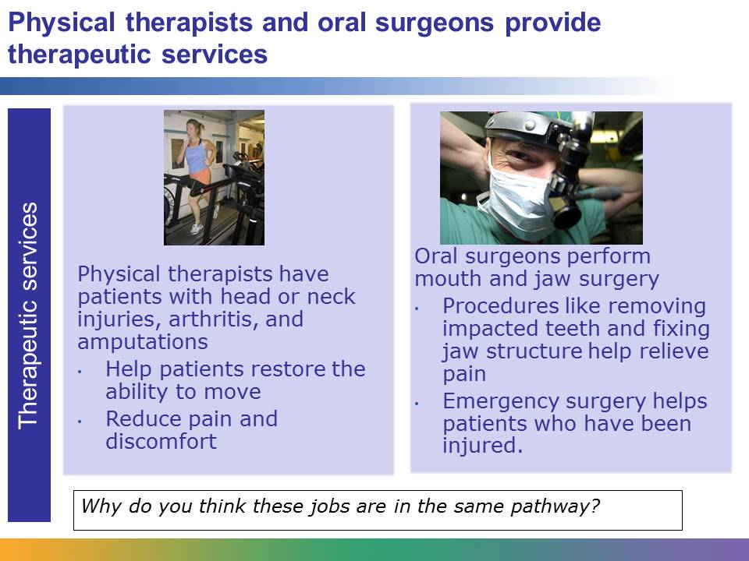
A physical therapist helps patients with their rehabilitation, whereas an oral surgeon’s work focuses on the mouth and jaw. The physical therapist may work with people who have physical disabilities or injuries to move with more ease and reduce pain. The surgeon performs procedures like removing impacted teeth or fixing structural problems. The two jobs appear to have little in common.
However, both jobs involve working directly with patients, and both involve helping to relieve pain or discomfort. Both the physical therapist and the oral surgeon want their patients to be able to function at their maximum capacity. This is why they are both in therapeutic services. People who choose a career in therapeutic services are interested in helping patients live healthy lives.
Image (left) courtesy of Kristan Hutchison and National Science Foundation, and included here under fair-use guidelines of Title 17, US Code. Copyrights belong to respective owners.
Image (right) retrieved from http://commons.wikimedia.org/wiki/File:US_Navy_020719-N-2781V-005_USS_Washington_-_oral_surgeon.jpg on June 5, 2013. Image courtesy of Journalist 2nd Class David Valdez.

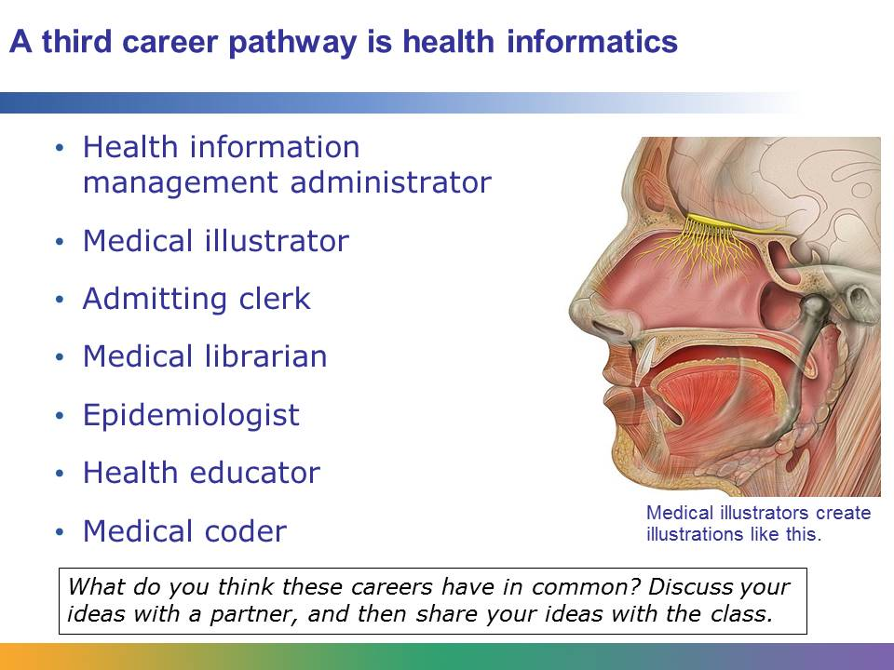
A health information management administrator, a medical illustrator, an admitting clerk, a medical librarian, an epidemiologist, a health educator, and a medical coder are all on the same pathway. Why do you think they are part of the same pathway?
Health information management administrators use a variety of computer programs to do their work. They create systems for storing medical information and are responsible for preparing medical information for law suits and insurance claims. They put together statistics used by government agencies and other organizations. Also, they manage medical records departments.
Medical illustrators are professional artists who work in health care. They create illustrations, diagrams, and graphics for scientific journals, textbooks, advertisements, or educational videos. Many medical illustrators use computer animation and computer graphics programs to create their work. Medical illustrators are usually trained in both art and life sciences.
Admitting clerks work in the admissions department of a hospital or other health care facility. When a patient arrives at the hospital, the admitting clerk is responsible for collecting the necessary information from the patient. The admitting clerk is also responsible for processing the necessary information when the patient is discharged.
Other careers in health informatics include medical historian, patient advocate, and performance improvement and quality coordinators and directors.
Image retrieved from http://commons.wikimedia.org/wiki/File:Head_olfactory_nerve.jpg, courtesy of Patrick J. Lynch, and reproduced under the Creative Commons Attribution 2.5 Generic license.

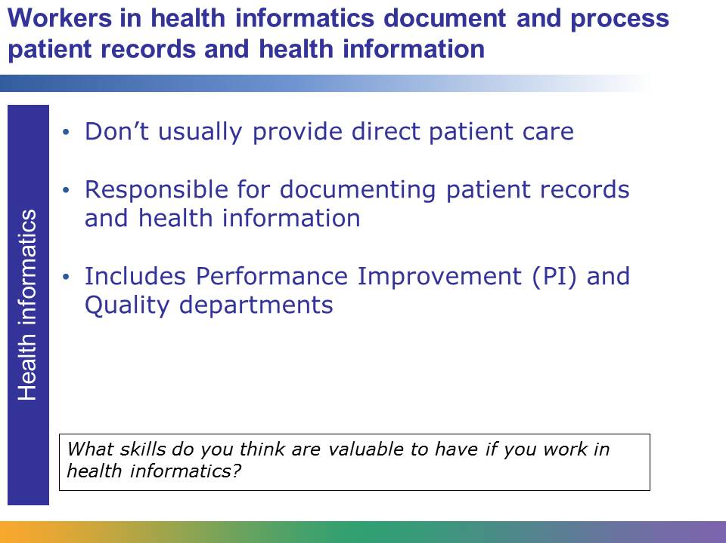
People who work in the health informatics area document patient records and health information. They usually aren’t involved with providing direct care for patients.
Working with information is an important part of health care. Imagine that you are setting up a routine visit with your physician. You need to book the appointment. When you arrive at the office, your records must be retrieved. After the visit, notes must be added to your file about your current condition and a bill must be issued. These tasks, and more like them, are all responsibilities of workers in health informatics. Patients’ records need to be documented, appointments need to be booked, and bills need to be issued and tracked. Information systems need to be set up so that health care workers can share and access information.
Think about brochures that you’ve looked at in your dentist’s office, your health science textbook, or a human anatomy poster that is hanging in your biology classroom. These things were created by people in health informatics. Computer technology is a part of health informatics in all fields.
Medical facilities are always concerned about improving their performance and the quality of their care. Professionals with titles such as quality facilitator, quality improvement specialist, or improvement advisor work in Performance Improvement and Quality departments which are part of health informatics. These professionals work on tasks such as improving the quality of care, reducing costs while maintaining or improving quality, and expanding patient or customer satisfaction with the development of new services or innovative ways of providing existing services.

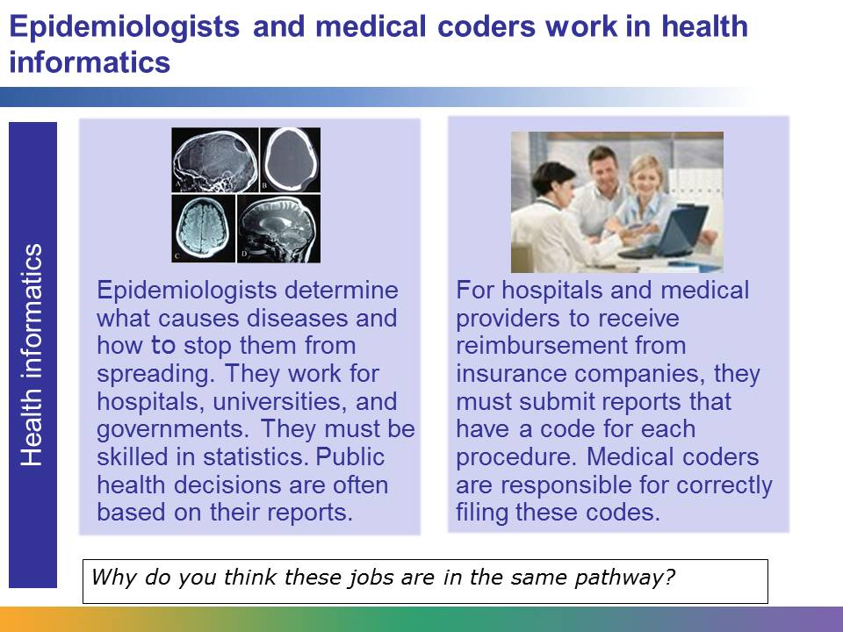
The jobs of epidemiologists and medical coders are quite different. An epidemiologist is responsible for tracking diseases and drawing conclusions about what causes them and how to stop them. They often work on location, collecting data about people who are infected, and the work can be dangerous. The reports they write are used to make important public health decisions. Medical coders work in offices. They are responsible for inputting codes into reports. The codes are used by insurance companies to determine the reimbursement that hospitals and medical providers will get for their work.
But both jobs have something in common. They both involve working with health information. They both require excellent computer skills.
Image on the left retrieved from http://commons.wikimedia.org/wiki/File:Gorham%27s_disease.jpg on June 5, 2013 and reproduced under the Creative Commons Attribution 2.0 Generic license (http://creativecommons.org/licenses/by/2.0/deed.en). Image courtesy of Parihar, V., Yadav, Y.R, and Sharma, D.
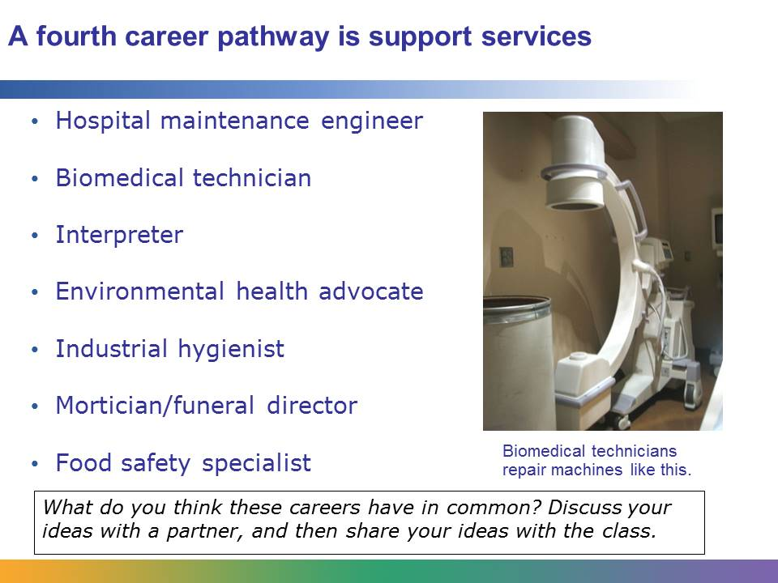
Hospital maintenance engineers, biomedical technicians, interpreters, industrial hygienists, morticians, and food safety specialists are all on the same pathway.
Hospitals never close. They are open all day and night, on holidays and weekends, during severe heat waves and brutal blizzards. To be able to provide 24/7 care, hospitals need fully functioning heating, air-conditioning, refrigeration, and ventilation systems. Hospital maintenance engineers are responsible for keeping these systems running. They must regularly test equipment to make sure that everything is working safely and efficiently.
Industrial hygienists are concerned with the safety of people’s workplaces. They examine workplaces for potential risks and make recommendations about how to make improvements. They are concerned with things like asbestos, problems caused by mold, and ergonomic stress.
Food safety specialists monitor places that make and sell food to make sure that safety standards are met. They work to ensure that the food the public consumes is safe and won’t make people sick. They monitor how pesticides are used, how meat is processed, and when food products are taken off the shelves at grocery stores. Other careers in support services include facilities manager and occupational health and safety expert. Workers on an emergency response team at a hospital who are on the front lines responding to disasters like earthquakes and floods are also in support services.
Image retrieved from http://commons.wikimedia.org/wiki/File:Mobile_X-ray_machine.jpg and reproduced under the Creative Commons Attribution 2.0 Generic license, courtesy of Ben Stephenson.
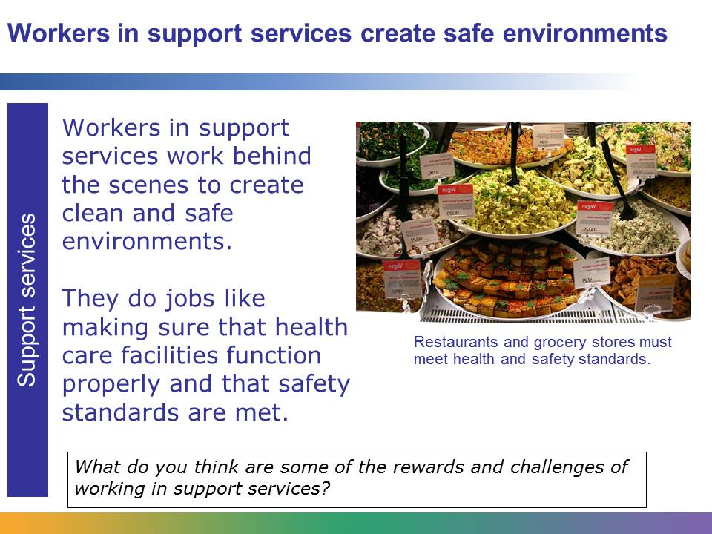
Without the work of people in support services, we wouldn’t have properly functioning hospitals, physician offices, surgery centers, or labs. Workers in support services create therapeutic, clean, safe, and aesthetically appealing environments in which health care workers can provide the best care possible.
Workers in support services are often found behind the scenes. Think about the environment of a hospital. Who fixes a broken blood-gas analyzer or a respirator? Who supplies the facility with clean linens? Who sterilizes the instruments used by physicians, surgeons, and nurses? Who supervises the people who work in a hospital and manages the budget? Who tests new equipment, such as an incubator or a pacemaker? The people who are responsible for all these tasks work in support services.
Image retrieved from http://commons.wikimedia.org/wiki/File:Vegan_Gardein_Tofu_Foods_Display_%28cropped1%29.jpg and reproduced under the Creative Commons Attribution 2.0 Generic license. Image courtesy of Zeetz.

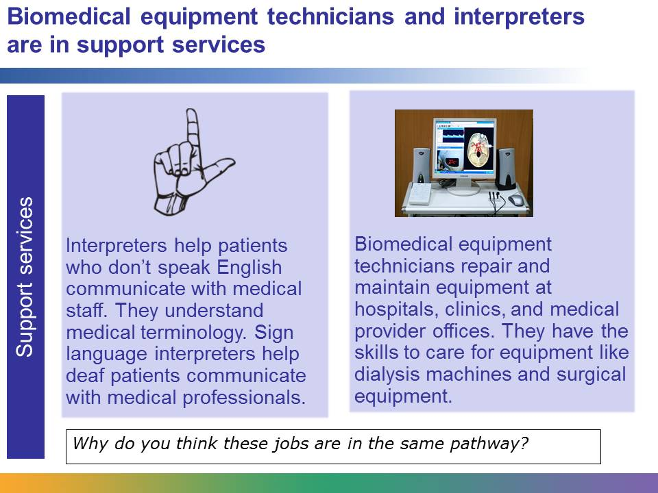
Biomedical equipment technicians and interpreters do very different jobs. To provide quality care around the clock, hospitals also need to have functioning medical equipment. Biomedical equipment technicians, or medical equipment repairers, are responsible for repairing and maintaining the equipment, such as electrical wheelchairs, patient monitors, or optometric equipment. If a patient is admitted to a hospital who does not speak English, an interpreter helps the patient communicate with doctors, nurses, and other medical staff. Interpreters are fluent in another language, such as Korean, Arabic, or Spanish. They also have a strong grasp of medical terminology in both English and the other language they speak.
People in both jobs do work that keeps medical facilities functioning properly. Without the work of interpreters, hospitals would face challenges communicating and providing care to patients who don’t speak English. Without the work of biomedical equipment technicians, hospitals wouldn’t have properly functioning machines that are needed to provide care, and even save lives.
Image (left) retrieved from http://commons.wikimedia.org/wiki/File:Sign_language_L.svg. Image (right) retrieved from http://commons.wikimedia.org/wiki/File:Doppler_ultrasound_analyzer_of_blood_velocity.jpg and reproduced here under the Creative Commons Attribution-Share Alike 3.0 Unported (http://creativecommons.org/licenses/by-sa/3.0/deed.en) license. Image courtesy of Yury Petrovich Masloboev.
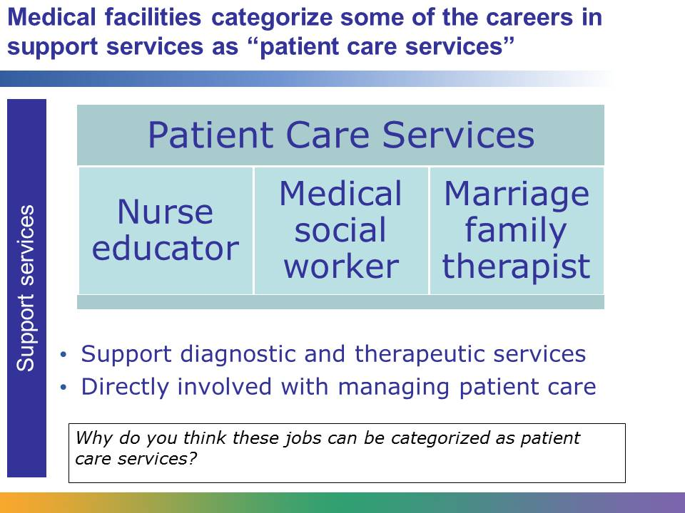
Nurse educators are often part of a patient care plan. For example, a diabetic would have a nurse educator teach them about diabetes, healthy eating and exercise related to their illness. Usually this would be a physician referral to have a patient see the diabetes nurse educator. Biomed (which is part of support services) would service a broken blood sugar/accucheck machine that the diabetic patient needs to monitor their blood sugars. The biomed department wouldn't need a physician referral to service the machine, but the nurse educator would need a referral to provide services because their services are considered patient care.
Medical social workers also can be licensed for counseling and provide the same services as a marriage family therapist. Both of their services would be considered therapeutic because their services are primary care treating a mental health condition or disease versus supporting the primary care providers.

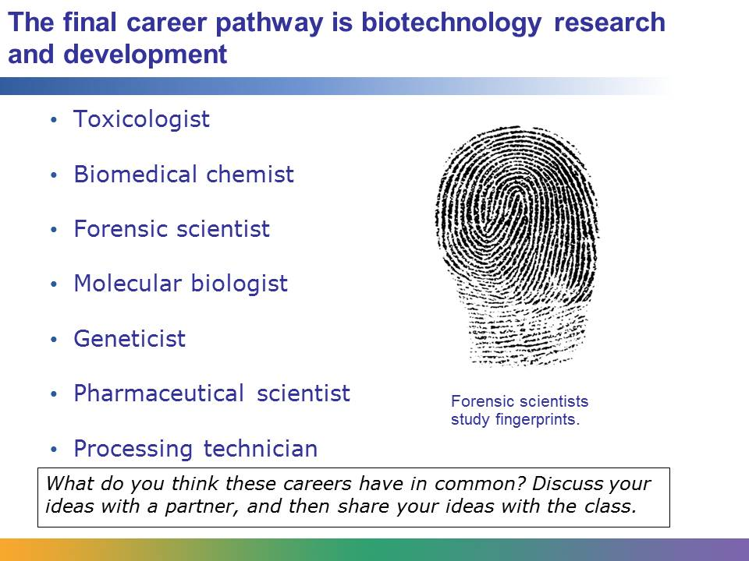
Toxicologists, biomedical chemists, forensic scientists, molecular biologists, geneticists, pharmaceutical scientists, and processing technicians are all on the same pathway. Here are descriptions of three of them. What do you think these careers have in common? Why are they on the same pathway?
Biomedical chemists study human diseases, their origins, and how to best treat them. They are also responsible for creating new vaccines, medicines, and treatments for disease.
Forensic scientists, or criminalists, assist detectives in investigating crimes. They use biotechnology to collect, analyze, and preserve physical evidence, such as hair, blood, fingerprints, and body tissues, to help find the perpetrator of a crime.
Processing technicians operate and monitor the machines that are used to produce biotechnology products. They work with biological scientists and research physicians.
Other careers in biotechnology research and development include product safety scientist, cancer registrar, and genetic counselor.
Image retrieved from http://commons.wikimedia.org/wiki/File:Fingerprint_%28PSF%29.png on June 5, 2015. Image courtesy of Pearson Scott Foresman.
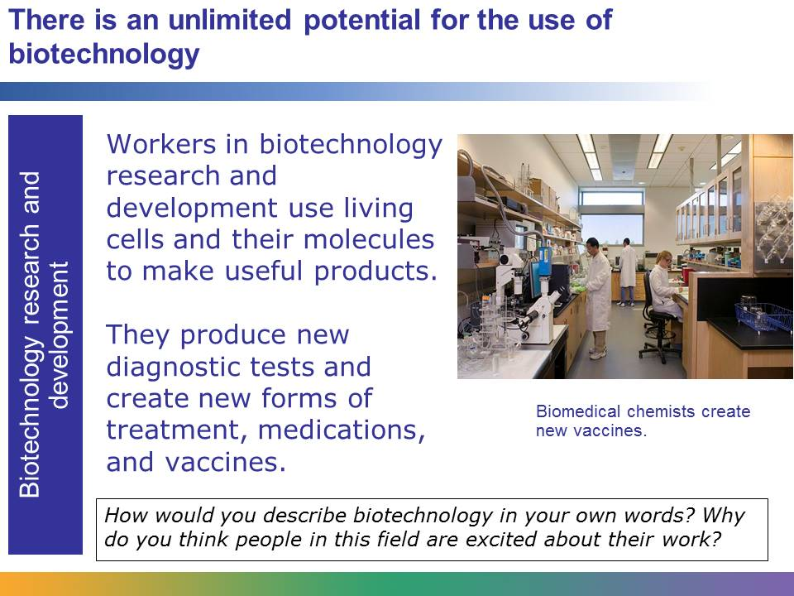
The people who work in biotechnology research and development use living cells from humans, animals, plants, and microorganisms to make useful products, like new diagnostic tests, treatments, medications, and vaccines. They also are involved in coming up with food products and methods to deal with environmental contamination.
In some ways, the future of medicine depends on the work being done in this area. Think about some of the advancements in medicine that we hope will occur in the future, such as an AIDS vaccine, a cure for Parkinson’s, artificial organs, or tools to fight bioterrorism. These discoveries won’t be possible without the research being conducted in biotechnology.
This is an exciting area of work with unlimited potential for discovery.
Image retrieved from http://commons.wikimedia.org/wiki/File:Biomedical_Engineering_Laboratory.jpg on June 5, 2013 and reproduced under the Creative Commons Attribution 2.0 Generic license (http://creativecommons.org/licenses/by/2.0/deed.en). Image courtesy of UC Davis College of Engineering.
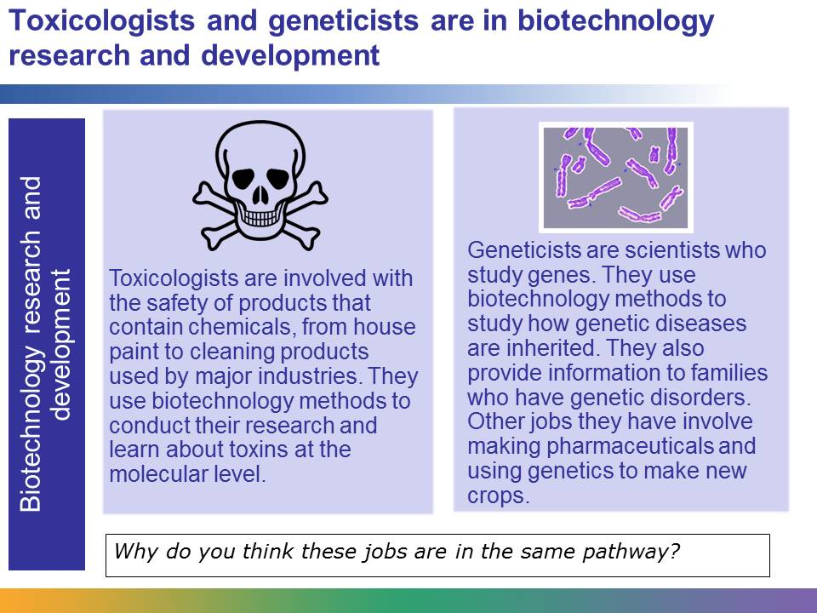
The research of toxicologists is quite different from the research of geneticists. Toxicologists use sophisticated biotechnology methods to research the safety and potential harm caused by chemicals. Think about the shampoo that you used this morning, the water that you drank from your tap, or the pesticides that you used to kill the slugs in your garden. Toxicologists are responsible for ensuring that these products are safe to use and won’t cause harm to us or the environment. Geneticists are involved with the study of genes. There are different types of geneticists. Some study how genetic diseases are inherited. Others use genetic research to make new pharmaceuticals and new crops.
However, both toxicologists and geneticists use biotechnology in their work. They are both scientists with an in-depth knowledge about how to use living cells to make useful products. They are part of an exciting field that will determine the future of medicine and health care.
Image (left) retrieved from http://commons.wikimedia.org/wiki/File:Toxic.png, and image (right) retrieved from http://commons.wikimedia.org/wiki/File:Brokechromo.jpg and reproduced under the Creative Commons Attribution-Share Alike 3.0 Unported license (http://creativecommons.org/licenses/by-sa/3.0/deed.en) on June 5, 2013.

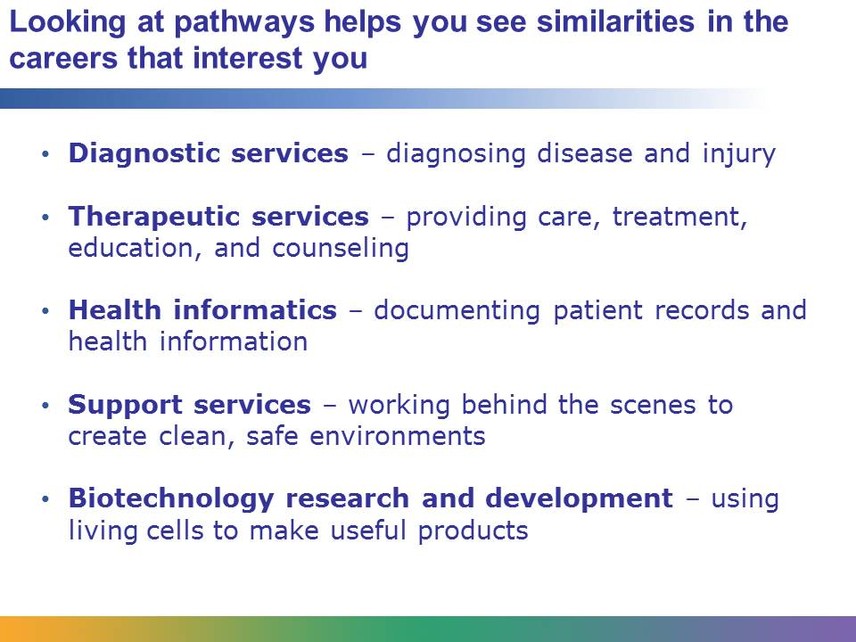
As you learn about different careers in this course, you will often be asked to think about which pathway a career fits into. Categorizing careers by the type of work involved will help you to see the similarities in the types of careers that interest you. Even though many careers don’t fit neatly into just one pathway, it is useful to think about careers in terms of the types of skills, knowledge, and interaction with patients that they require.

