Student Resource 12.1
Reading: Natural Disasters and Complex Humanitarian Emergencies
The people of Sierra Leone suffered greatly during a civil war from 1991–2002. The fighting left more than 50,000 people dead. During the war, women were raped, people were tortured and enslaved, and children were forced to be soldiers. Many people were displaced from their homes, and families were torn apart.
Haiti is one of the poorest countries in the world. In January 2010, a 7.0 magnitude earthquake violently shook the capital city. Major devastation followed. Over half of the existing health facilities were destroyed. The estimated death toll ranged from 200,000 to as high as 316,000. Even more people were injured. The earthquake damaged the country’s already burdened infrastructure (basic services and facilities like roads and water supply) and many people lost their homes. A cholera epidemic followed the earthquake, sickening about half a million people. Years after the catastrophe, people were still living in inadequate tent camps and broken buildings. | 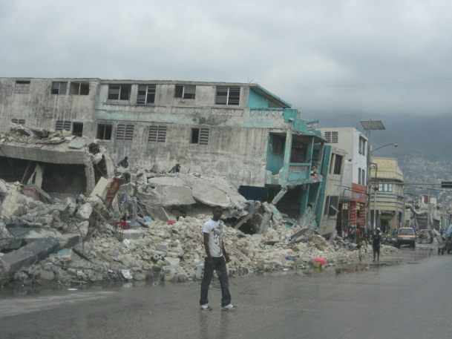  Port-au-Prince was in rubble after the earthquake.
The earthquake in Haiti was a natural disaster. The civil war in Sierra Leone was a complex humanitarian emergency (CHE). Both situations have a significant effect on global health. Earthquakes and armed conflict both lead to death, illness, disabilities, and severe economic consequences. Both natural disasters and CHEs require a cooperative effort of multiple countries, organizations, and agencies to alleviate the suffering of the victims.
Natural Disasters
A natural disaster causes damage, ecological destruction, and death. Global health is concerned with natural disasters that cause large-scale destruction that can only be addressed by global cooperation. In a natural disaster like the Haiti earthquake, the suffering of the people is so great that assistance from outside the country is vital. People and organizations from all over the world gave aid to Haiti.
A natural disaster can be related to weather, such as a drought, hurricane, typhoon, cyclone, or heavy rain. It can also be a natural occurrence like a tsunami, volcano, or earthquake. Earthquakes are the natural disasters that kill the most people. More than 90% of deaths caused by earthquakes occur in low- and middle-income countries.
Examples of Natural Disasters
- In 2007, a cyclone in Bangladesh killed 3,500 people.
- In 2008, a 7.9 magnitude earthquake in western China killed 67,000 people.
- In 2009, a typhoon caused mudslides that buried at least 600 people in southern Taiwan.

Natural disasters often have a bigger impact on people in low-income countries. There are several reasons for this. Housing in poor areas is not built to standards needed to withstand the damage caused by a natural disaster. For example, buildings in Los Angeles or Tokyo are constructed to withstand the effects of a moderate earthquake. That is not the case in Haiti. Also, in poor areas a natural disaster often damages elements of the infrastructure. Reservoirs used for clean water can become polluted. Roads that are used to transport sick or hurt people are often damaged, as are hospitals and health clinics.  People can die as a direct result of a natural disaster. For example, they can get buried in the rubble after an earthquake or they can drown during a flood. | 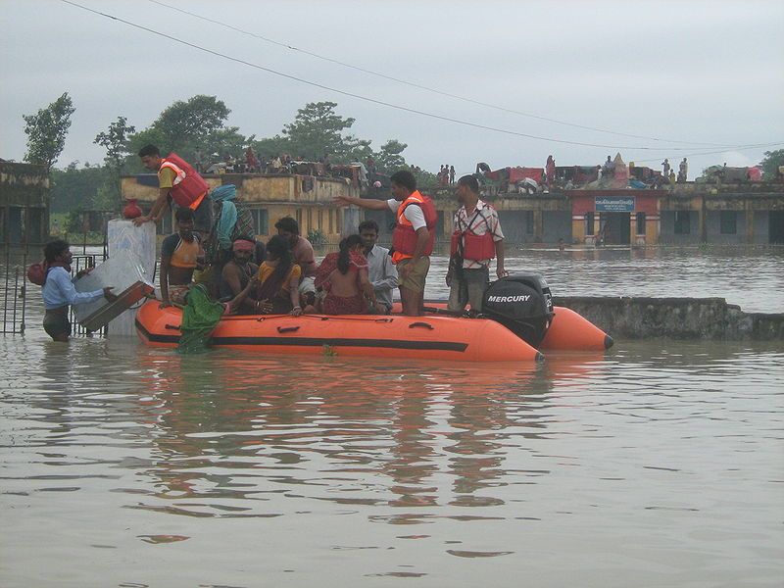  The flooding of the Kosi River in India in 2008 killed at least 75 people and displaced over 2 million.
But many people also become ill or die from indirect events related to the natural disaster. For example, if an earthquake damages a sewage system, people could develop sanitation-related health problems. Other long-term risks for natural disaster survivors include physical disabilities, mental health problems, diarrheal diseases, respiratory infections, and skin diseases.
Complex Humanitarian Emergencies (CHEs)
CHEs, like the civil war in Sierra Leone, account for more deaths each year than all natural disasters combined. Conflicts, wars, or political situations that threaten regional or international security are CHEs. During a CHE, institutions, like banks, schools, or even governments, often collapse. Law and order break down. In a CHE, people are unable to pursue normal activities. Portions of the population are often forced to migrate in an effort to seek safety. Food, water, and safe shelter become limited or unavailable. CHEs are linked to death, illness, and injury that would not have occurred if the conflict hadn’t happened. Conflicts often last for long periods of time, compromising the health of people over years or even decades. Like a natural disaster, a CHE can require the response of outside groups.
CHEs affect health in many ways. Often the groups involved in the conflict will not allow humanitarian assistance provided by global organizations to reach opposing groups, so people who are sick or injured do not get the medical treatment or food or water that they need. Combatants intentionally harm or kill civilians. Torture and rape are used as weapons of war. People suffer from nutritional issues and mental health issues, like depression and post-traumatic stress disorder (PTSD).
Refugees and Internally Displaced People (IDP)
CHEs create refugees. Refugees are people who flee their country because they fear persecution based on their race, religion, nationality, or membership in a social or political group. These people are unable or unwilling to return to their country.
People who flee for safety during a CHE often end up in refugee camps, which are crowded and may not have appropriate sanitation systems. Disease can spread quickly in these conditions. For example, in 1994 there was genocide, or mass murder, in Rwanda. Almost a million people were killed during a short period of time. Because of the violence, tens of thousands of Rwandan refugees fled to the border town of Goma in the Democratic Republic of Congo. In one month in 1994, many refugees died in Goma, and almost all of the deaths were from cholera spread by contamination of the lake where the refugees were getting their water.
An internally displaced person, or IDP, is a type of refugee. IDPs also flee their homes, but they stay in another region of their country. For example, because of the armed conflict in Afghanistan between the Taliban and international and Afghanistan forces, in 2011 almost half a million people were internally displaced in the country. These people were forced to leave their homes because of violence or the threat of violence, but they remained in the country. They mostly lived in refugee-type camps or informal camps set up around urban areas.  In 2011, there were 15.2 million refugees and 26.4 million IDP around the world. Afghanistan was the country with the largest number of refugees, followed by Iraq, Somalia, Sudan, and the Democratic Republic of Congo. | 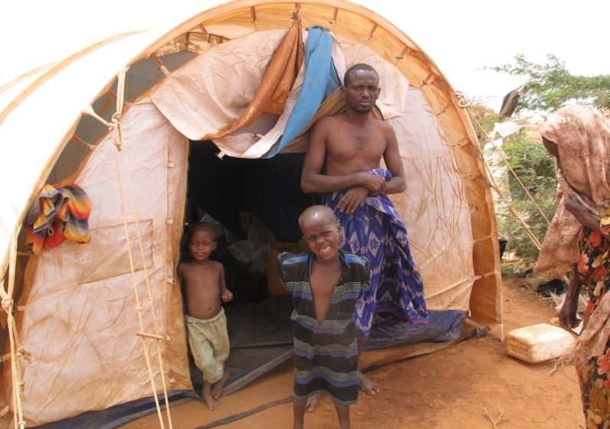  In 2011, a family that fled from the civil war in Somalia inside the Dadaab refugee camp in Kenya.
Vulnerable People
All refugees and internally displaced people are vulnerable, but people are vulnerable in different ways. Women and girl refugees often face discrimination, harassment, and sexual abuse, even after reaching refugee camps. Pregnant and nursing women are at risk for maternal and reproductive health problems.
Being forcibly displaced, and possibly separated from their families, increases children’s exposure to violence, abuse, and neglect. They have nutritional needs that must be met to ensure normal growth and development. When food is scarce, they face health issues related to growth and development.
Men and boys are often most directly affected by armed conflicts. They are at risk of being forced to participate in armies and militia groups. If they are refugees in countries that ban them from being a part of the workforce, they face not being able to provide for themselves and family.
Military Recruitment of Children
The UN outlaws children from participating in military activities, but unfortunately at least 200,000 children and teens have fought in wars around the world since 2000.
Sometimes children and teens are forced to become soldiers. Armies and rebel groups have been known to take children from their schools or villages. Some children decide to fight because they need food, clothing, and shelter. They may think that participating in the conflict will help protect their families.
Child soldiers face serious health risks. They can be wounded, disabled, or killed. They suffer severe psychological damage. Many find that it is impossible to lead a normal life after the fighting has stopped.

Natural disasters and CHEs have a profound impact on the state of people’s health around the globe. Hurricanes, droughts, and earthquakes, as well as wars, genocide, and tribal conflict, can lead to death and illness. Understanding how global health professionals from different nations and different relief organizations work cooperatively to address such catastrophes is a vital part of global health.
Student Resource 12.2
Note Taking: Natural Disasters and Complex Humanitarian Emergencies
Student Names:_______________________________________________________ Date:___________
Directions: Complete this resource as you read Student Resource 12.1, Reading: Natural Disasters and Complex Humanitarian Emergencies. First, use the Defining Format chart below to define the terms natural disaster and complex humanitarian emergency. The first category is filled in for you.
Then use a Venn diagram to compare and contrast the characteristics of refugees and internally displaced persons (IDPs). Finally, use a Venn diagram to explain the differences in the risks faced by displaced women, men, and children.
Term | Category | Characteristics
A natural disaster | is a catastrophe caused by nature  that | 1.  2.  3.  4.
A complex humanitarian emergency | is a _______________________  that | 1.  2.  3.  4.

Refugee and IDP Venn Diagram
In the left part of the Venn diagram, list characteristics that apply only to refugees. In the right part, list characteristics that apply only to IDPs. In the overlapping part, list characteristics common to both.
IDPs
Refugees

Risks Faced by Men, Women, and Children Venn Diagram
Think about the risks brought on by natural disasters and CHEs. In the left part of the red circle, list risks faced only by men. In the right of the blue circle, list risks faced only by women. In the bottom part of the orange circle, list risks faced only by children. In the overlapping areas, list risks that are common to the groups whose circles are overlapping.
Risks children face
Risks men face
Risks women face

Image retrieved from http://commons.wikimedia.org/wiki/File:NDRF_in_Bihar_Flood.jpg on August 22, 2012, and reproduced here under the terms of the Creative Commons Attribution Share Alike 3.0 Unported (http://creativecommons.org/licenses/by-sa/3.0/deed.en). Image courtesy of Kumarrakajee.

