Student Resource 11.4
Investigative Questions: Motorcycle Helmet Laws
Directions: As you complete this reading, follow the instructions that accompany each letter.
Introduction
A US Senate committee is considering enacting a federal law that would require all motorcycle drivers and passengers to wear helmets. The committee has received letters from two powerful organizations. One organization supports the law and the other is against it. The committee will meet soon with representatives from both organizations. As Senate committee aides, your group has been asked to read the letters and prepare a list of investigative questions that committee members can ask the organizations’ representatives. Your questions should force the organizations to defend their position with factual information and reasoned arguments. The senators need to acquire facts and figures that will enable them to develop policy that is in the best interest of all Americans.
Letter Against the Law
As you read the letter below, circle any section that gives you an idea for a question the committee could ask. Write the question in the margin next to the pertinent section. Try to think of at least two questions.
August 17, 2014  Dear Committee Members,  Americans Against Federal Helmet Laws strongly urges you to not enact a law that would require all motorcycle riders to wear helmets. We represent tens of thousands of Americans who believe that wearing a helmet is a personal choice, which should not be legislated.  Our opponents say that in states where strict helmet laws have been passed, accidents have decreased. But these decreases are not related to the laws. They are related to training and education programs, which we wholly support. Laws do not change people’s behavior, but education does.  Our opponents also say that if there is an accident, helmets protect riders from head and neck injuries. But do they really? | 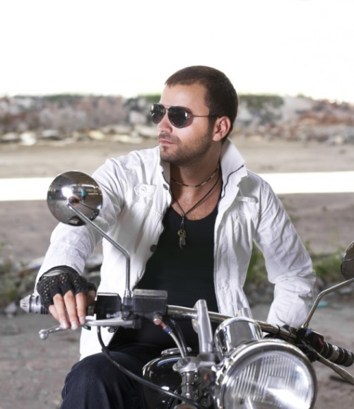  The best way to protect riders is training and responsible riding.
We don’t believe that enough research has been conducted to draw conclusions on this point. In fact, we believe that helmets may even cause head and neck injuries in the case of an accident and that they impair riders’ vision and hearing.
Finally, when states have passed laws requiring helmets, motorcycle sales have immediately dropped. Imagine the effect a national helmet law would have on the motorcycle industry. Imagine how many people’s jobs would be at stake!
Thank you for considering our position. We look forward to discussing this important issue.
Sincerely,
Marissa Santiago and John Nell, Presidents of Americans Against Federal Helmet Laws

Letter in Support of the Law
As you read the letter below, circle any section that gives you an idea for a question the committee could ask. Write the question in the margin next to the pertinent section. Try to think of at least two questions.
August 3, 2014

To Senate Committee Members,
We are writing on behalf of all Americans who have lost loved ones in cases where a fatality could have been prevented by the wearing of a motorcycle helmet. Please consider moving forward with a law requiring all motorcycle riders to wear helmets.
For over 30 years, it’s been found that when states enact strict helmet laws, deaths and injuries decrease. And when states repeal such laws, deaths and injuries go up. Here are just two examples:
- In 1992, California adopted an excellent law requiring helmets for all riders. The result was that the number of fatalities decreased by 37%.
- In 1977, Texas weakened its helmet laws. The new law said that only people under the age of 18 were required to wear helmets. Fatalities spiked by 35%.
Motorcyclists and their families are not the only ones who pay in the absence of a national all-rider helmet law. Society pays big time. One study estimated that in 2002, $853 million in costs would have been saved if all motorcyclists had worn helmets. These costs include medical care, rehab, lost productivity, and legal and insurance costs.  We are facing a national epidemic that we believe requires swift action. Thank you for your support.  Best regards, | 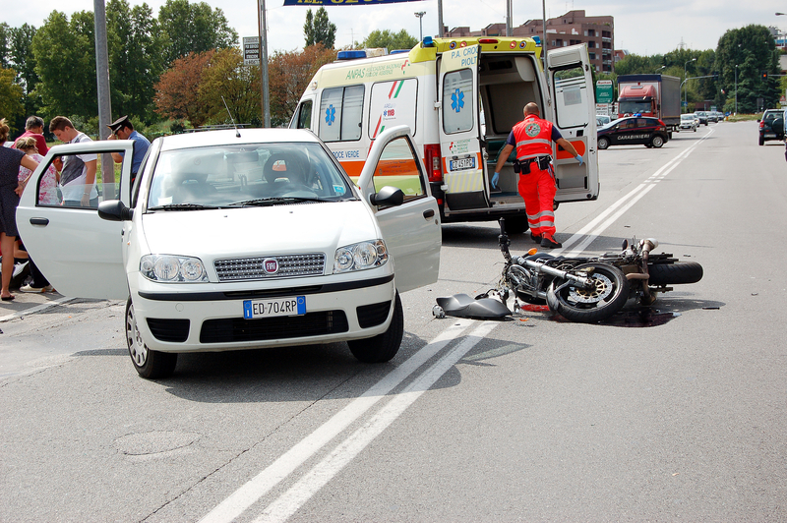  Helmet laws save lives and protect less skilled riders.
Bob Martin and Gregory Wang
Board members of Helmets Now!

