Student Resource 11.1
Note Taking: Types and Levels of Global Interventions
Student Names:_______________________________________________________ Date:___________
Directions: Below is a graphic showing different levels of health interventions. You will learn more about the topics in the graphic as you watch the presentation “Types and Levels of Global Health Interventions.” Write important things that you learn about each topic in the corresponding box.

Student Resource 11.2
Reading: Types and Levels of Global Health Interventions
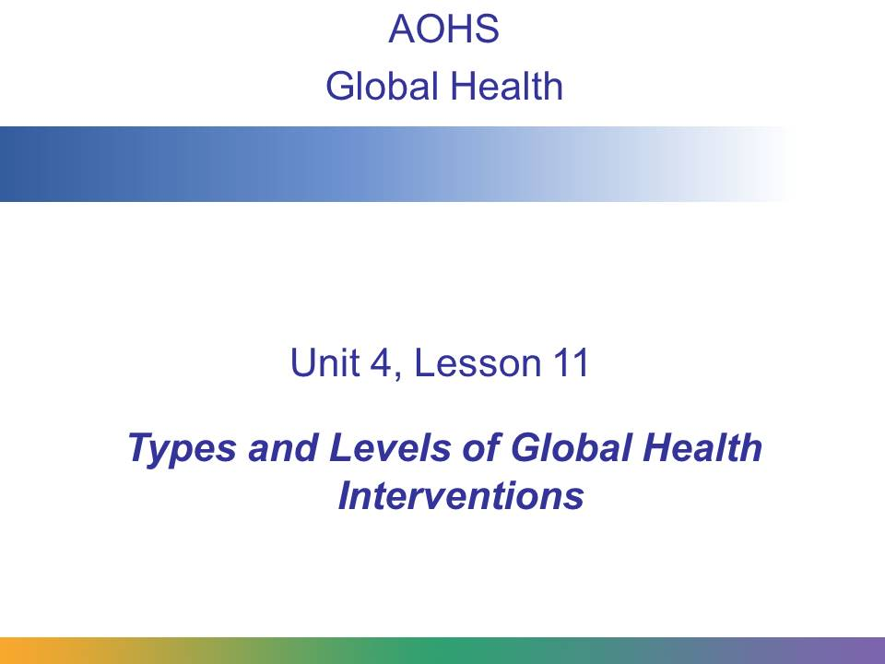
In this presentation, you will learn about the different types and levels of global health interventions.
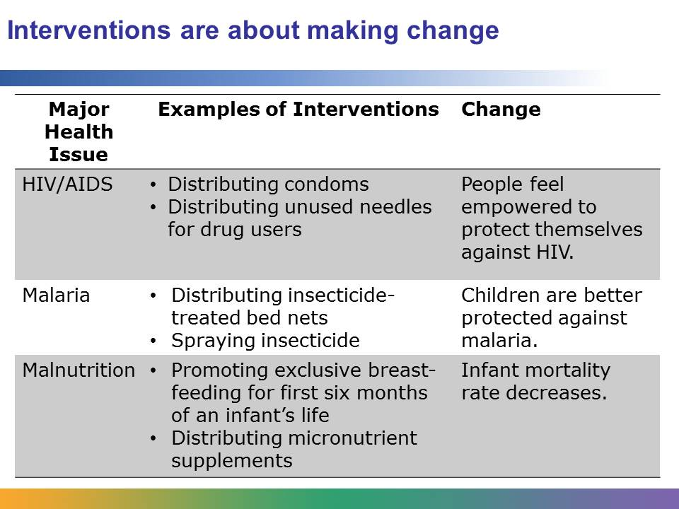
The purpose of global health interventions is to bring about change. You’ve learned about various interventions so far in this course. For example, you learned about policy changes in Rwanda to make the roads safer. These policy changes were interventions.
An intervention is an organized effort made by health professionals to address a health-related problem. Interventions are often programs, such as a cancer-screening program or a program that teaches mothers about the benefits of breast-feeding.
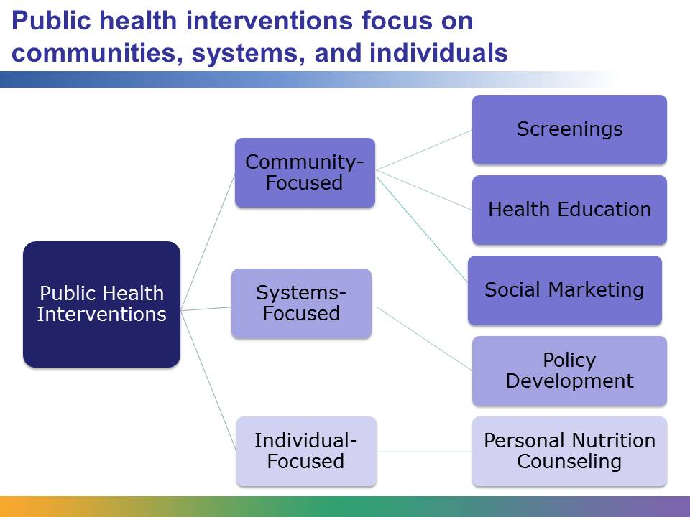
This graphic shows one way of understanding the scope of public health interventions.
There are three categories of public health interventions:
- Community-focused interventions, which change the way communities think and act.
- Systems-focused interventions, which use government agencies, policies, and laws to bring about change.
- Individual-focused interventions, which change the way individuals think and act. These interventions focus on changing unhealthy behaviors into healthier ones.
The right-hand column in the graphic gives examples of specific types of interventions. For example, a screening program, such as one for skin cancer, is a type of intervention that focuses on a community that may be at risk.
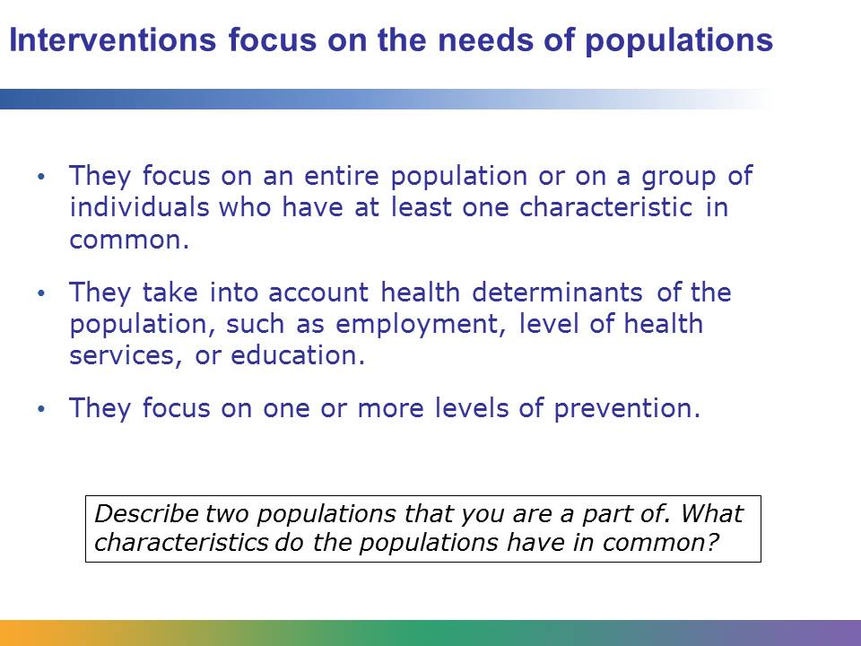
Interventions focus on entire populations. A population is a collection of individuals who have at least one characteristic in common. For example, you are part of a population of American high school students. While there are many things that set you apart from a high school student in another state, or even from the student sitting next to you, what you have in common is that you go to high school in the same country. That makes you part of the same population.
Another characteristic of interventions is that they consider the health determinants, such as education and health services, that are linked to a health problem. For example, an intervention addressing obesity would consider a population’s ability to access healthy foods.
Interventions also focus on different levels of prevention. This means that some interventions focus on keeping problems from occurring. Other interventions might focus on detecting and treating problems early, or they might try to keep problems from getting worse once they have occurred.
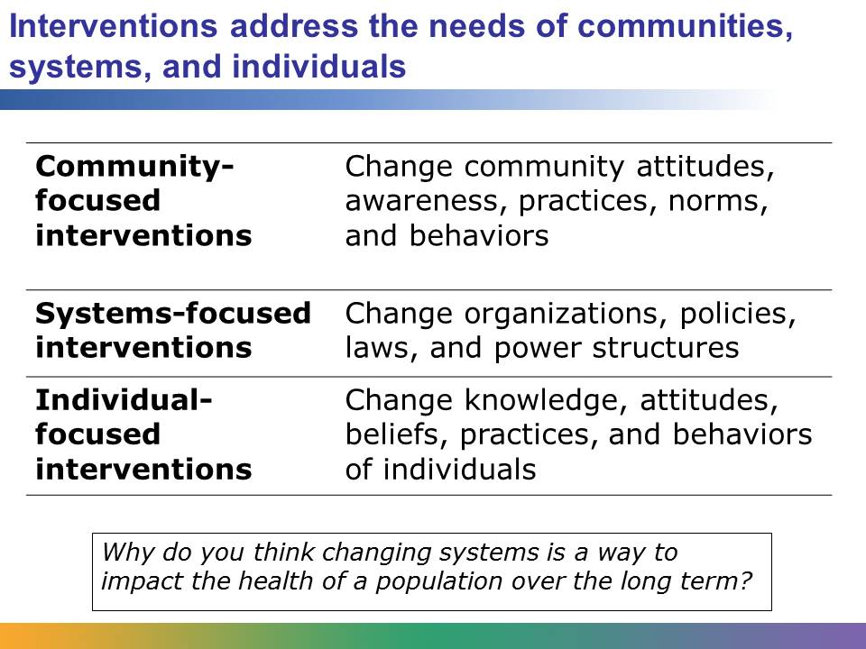
A community-focused intervention is directed at an entire population in a community. For example, there might be a community-focused intervention in your community that aims to vaccinate children for whooping cough. These interventions change community attitudes, awareness, practice, norms, and behaviors.
A systems-focused practice does not focus directly on individuals and communities. Rather, it looks at the systems that affect health. These interventions change organizations, policies, laws, and power structures. For example, an intervention that implemented traffic laws, such as a speed limit or a requirement about motorcycle helmets, would be a systems-focused intervention.
Individual-focused interventions are directed at individuals and families. These interventions change the knowledge, attitudes, beliefs, practices, and behaviors of individuals. For example, a nurse advising an individual with family history of high blood pressure on diet and lifestyle changes is an example of an individual-focused intervention.
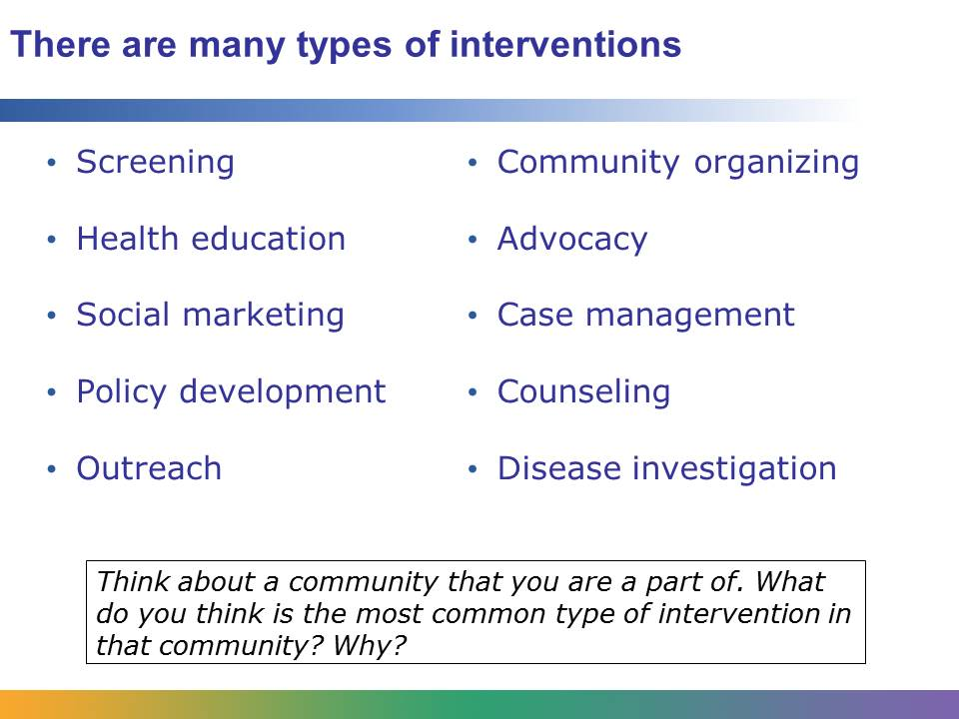
There are many specific types of interventions. In this presentation, we are going to focus on four types and look at examples of each. The types are screening, health education, social marketing, and policy development.
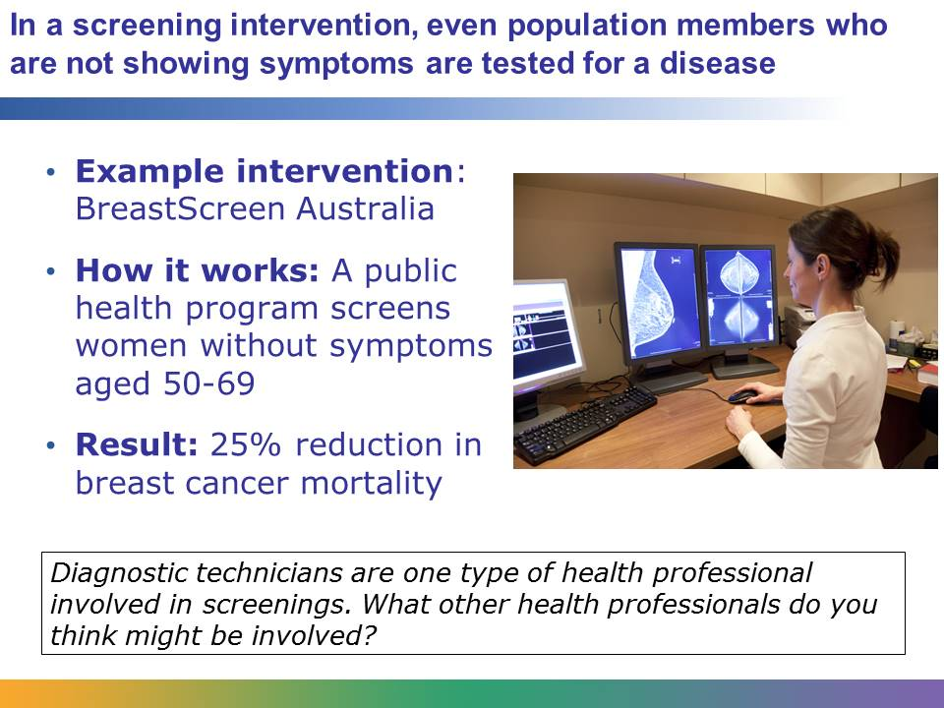
Screening is a type of intervention in which members of a population are tested for a specific disease known to be a major health issue. Members of a population who are showing symptoms for the disease will be screened. The screening is also meant to identify individuals who may have the disease but are not experiencing symptoms. With many diseases, early detection of a disease is key to effectively treating and managing it.
Public health screening is an intervention that is used in Australia and other countries to address breast cancer. Breast cancer is the second most common cause of cancer-related death in Australian women. Government officials and other health workers believed that well-organized mammograms would substantially reduce the number of deaths from breast cancer, so in 1990 a new intervention program called BreastScreen Australia began. The program targeted a specific population: well women without symptoms between the ages of 50 and 69. Since the program began, there has been a reduction in breast cancer mortality of about 25%.
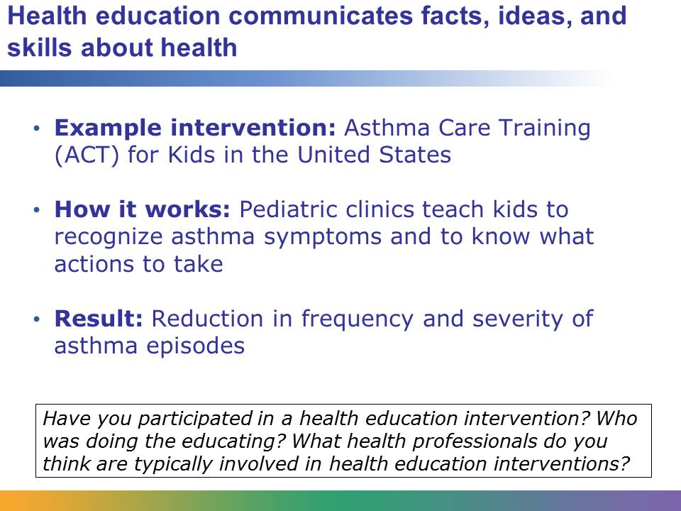
Health education is a type of intervention in which communicating facts, ideas, and skills about health helps to change health knowledge, attitudes, values, beliefs, behaviors, and practices.
The Asthma Care Training (ACT) for Kids is an example of a health education intervention. In three educational sessions in pediatric clinics across the United States, children ages 7–12 and their families learn asthma self-management skills. The program is based on the idea that children should be active participants in the prevention and control of their symptoms. This means that they should be able to recognize asthma symptoms and know what actions to take. Parents participate too, learning about things like how to control environmental pollutants and irritants. The result of the program was that the frequency and severity of asthma episodes was reduced.
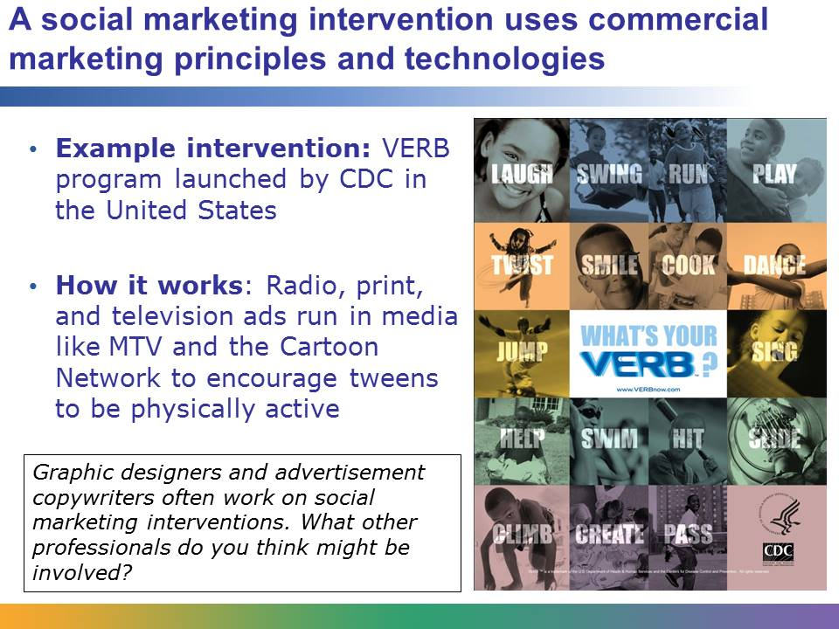
Social marketing is another type of intervention. In this type of intervention, commercial marketing principles and technologies are used to influence the health knowledge, attitudes, values, beliefs, and behaviors of population members.
In the United States, the CDC launched a social marketing intervention called the Verb. For four years this intervention used print, radio, and television ads to encourage increased physical activity in the tween population. Commercials were aired on stations like MTV, the Cartoon Network, and Nickelodeon, and advertisements were placed in national magazines like Teen People, Family Circle, and YM. The campaign was geared toward both parents and kids. One ad showed a basketball. It encouraged parents to be physically active with their kids, saying that kids who are physically active aren’t just healthier but feel better about themselves. On the basketball were the words “Inflate your child’s self esteem.”
Image courtesy of Centers for Disease Control; retrieved from http://www.cdc.gov/youthcampaign/ on April 23, 2012, and reproduced under fair-use guidelines of Title 17, US Code. Copyrights belong to respective owners.
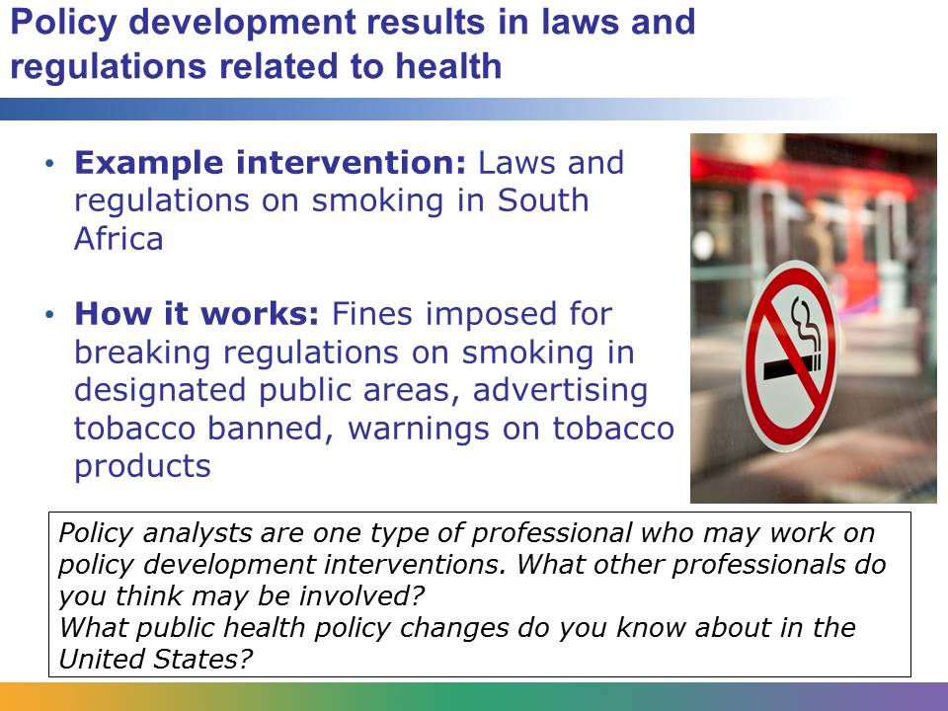
Policy development is another type of health intervention. Policy development results in laws, rules, regulations, ordinances, and policies about issues related to health. Policy development is a type of intervention that is aimed at systems as well as individuals and communities.
South Africa is a country that has used policy development as a form of health intervention. Like many countries, South Africa has passed into law a number of measures aimed at creating smoke-free environments and reducing the number of tobacco-related health issues in the population. For example, smoking is only allowed in designated areas in work places, public places, and public transportation. Tobacco advertising is mostly banned. All tobacco products, like cigarette boxes, contain warnings.
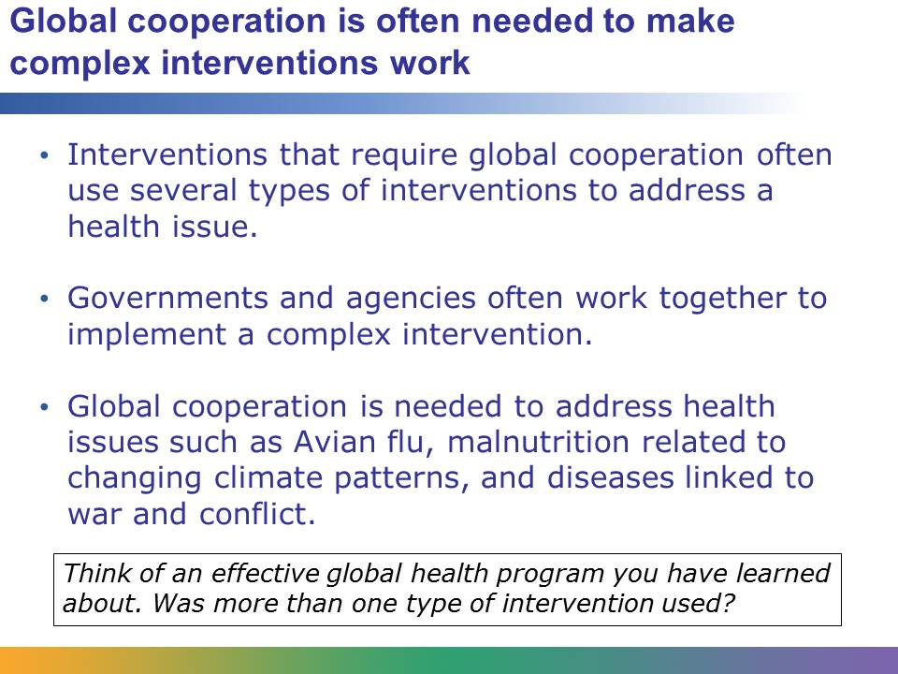
When tackling a health issue, it is often the case that more than one intervention is used. For example, while policy development is helping to change smoking behavior in South Africa, there are also programs that use health education as an intervention to educate communities and individuals about the effects of smoking.
Comprehensive interventions often use multiple techniques. They also often require global cooperation from multiple governments and health organizations and agencies, like WHO, the Red Cross, or the Bill and Melinda Gates Foundation. Health issues that require global cooperation include diseases that spread around the globe, like Avian flu, malnutrition related to changing climate patterns and global warming, and diseases linked to war and conflict. You will learn more about global cooperation later in this course.
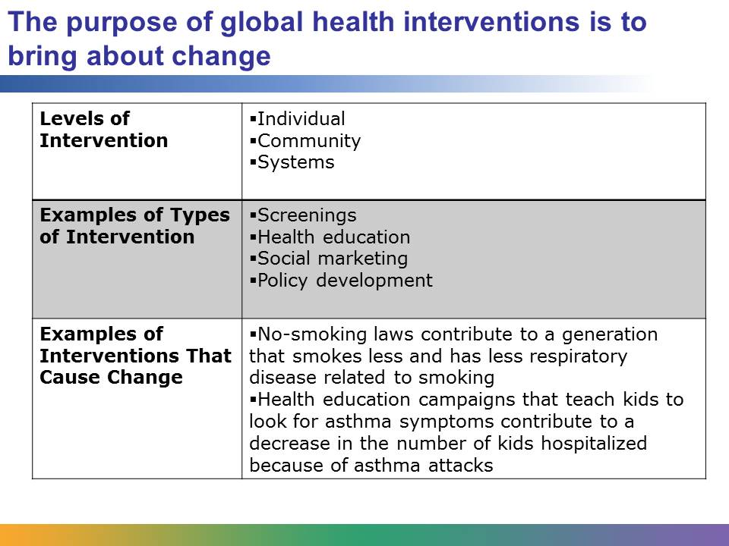
Interventions are about making change. They focus on individuals, communities, and systems. There are many types of successful interventions, including screenings, health education, social marketing, and policy development. Governments and global health organizations use interventions to tackle pressing global health concerns around the world.

