Student Resource 10.3
Note Taking: Infection Control in a Hospital
Student Name:_______________________________________________________ Date:___________
Directions: During the presentation Infection Control in a Hospital, take notes on the chain of infection using the chart below. Then, in the space below the chart, take notes on ways that health care workers break the cycle of infection.
Ways that health care workers break the chain of infection:
Student Resource 10.4
Reading: Infection Control in a Hospital
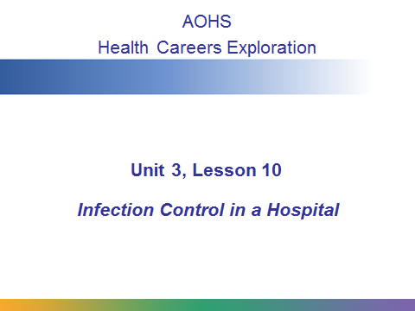
The chain of infection refers to the conditions that must be met for disease to spread from one person to another. In this presentation we’re going to look at the different parts of the chain of infection and explore the ways that health care professionals in a hospital setting work to break the chain.
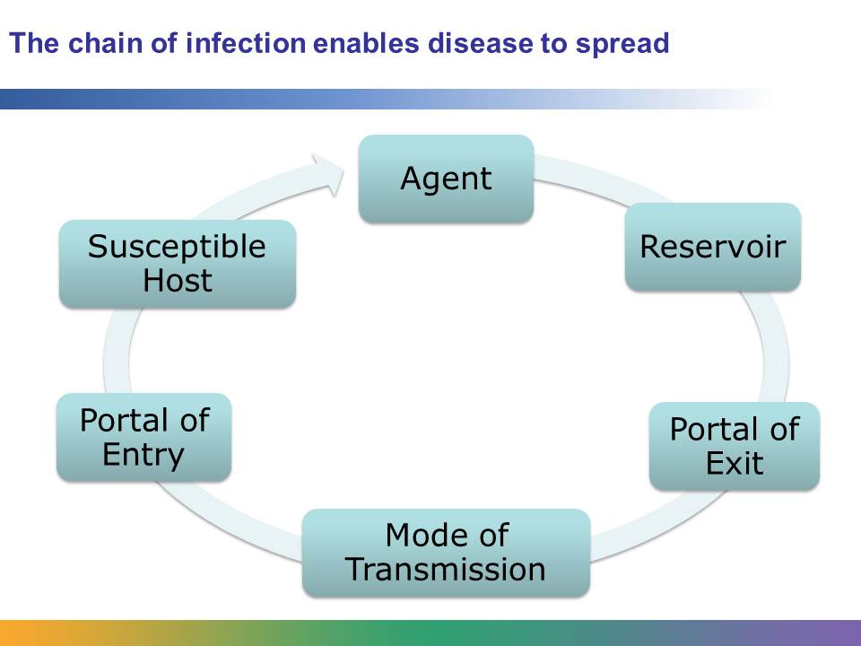
The spread of disease doesn’t just spontaneously happen. There is a process of events that enables infection to spread from one person to another. This process is called the chain of infection. There are six parts of the chain: an agent, a reservoir, a portal of exit, a mode of transmission, a portal of entry, and a susceptible host. If the chain is broken at any one of these links, infection will not occur.
A very important responsibility of all health care workers in a hospital is to understand each link in the chain and to take measures to break the chain. Breaking the chain of infection protects hospital workers, patients, and visitors.
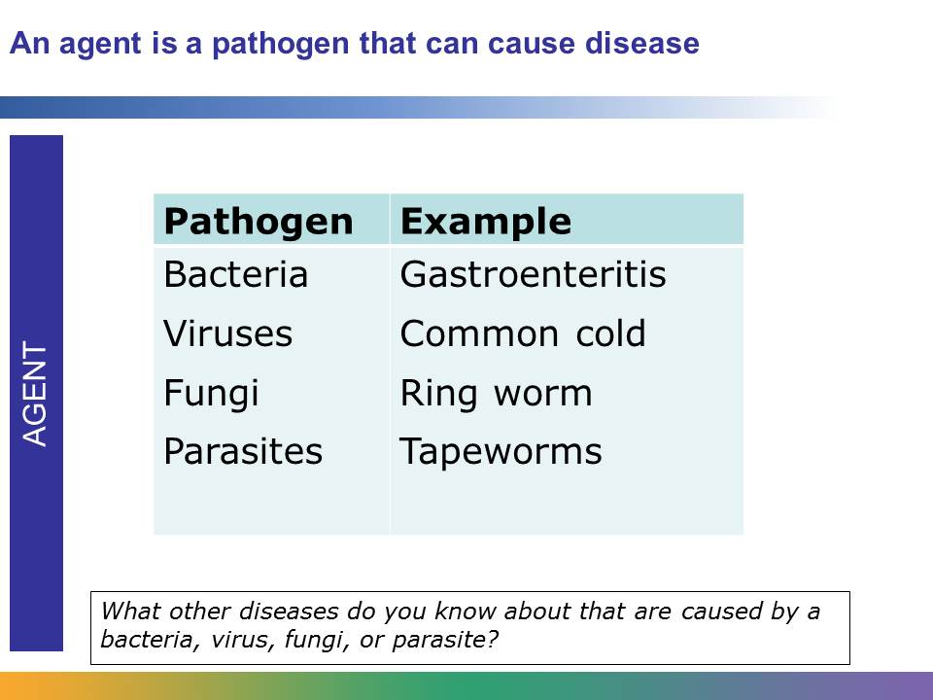
An agent is a pathogen that has the capability of causing disease or infection. Infectious agents (or pathogens) are bacteria, viruses, fungi, and parasites. Infectious agents can cause many types of disease and infection. For example, fungi can cause tinea, or ringworm, which is a skin infection. Bacteria can cause gastroenteritis, which causes inflammation of the stomach and intestines. Viruses are smaller than bacteria. Viruses can cause the common cold. Parasites can cause tapeworm infections.
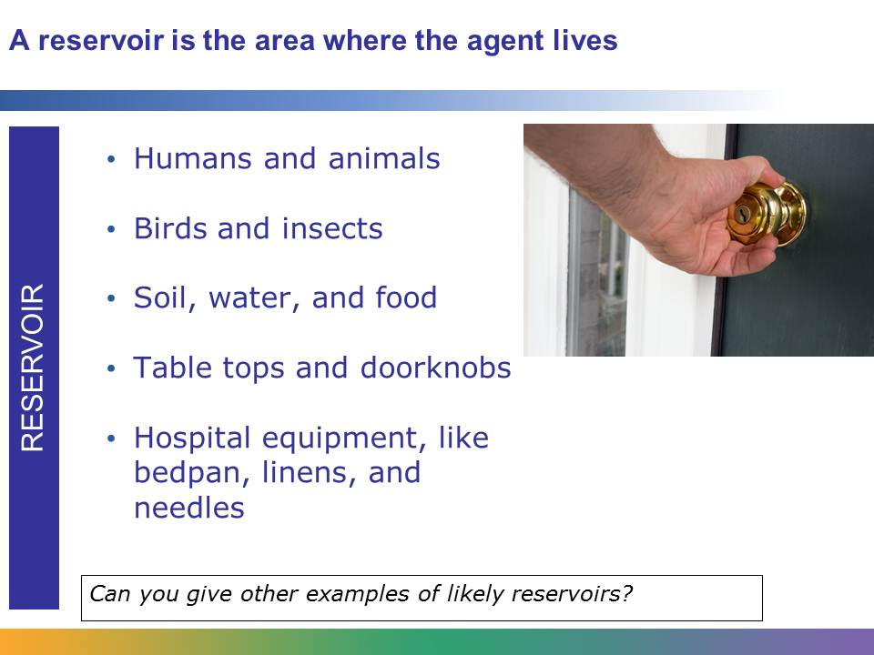
A reservoir is the place where pathogens live. Agents thrive and reproduce in humans, animals, birds, and insects. For example, the influenza virus can live in humans, and typhus can live in the fleas of rodents. Agents can also live on inanimate objects, like water, food, table tops, linens, and doorknobs. Hospital equipment, like bedpans and needles, can also be a reservoir.
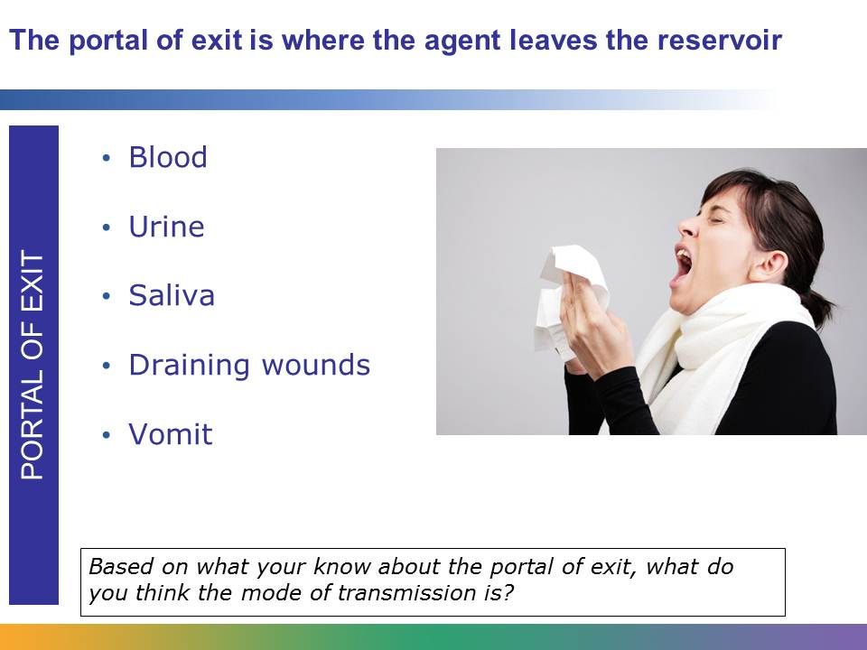
The portal of exit is where the agent leaves the reservoir. In the human body there are many ways for an agent to leave, including through blood, urine, vomit, saliva, and draining wounds. Pathogens frequently escape the human body through the nose or mouth when people sneeze or cough. This is called droplet transmission.
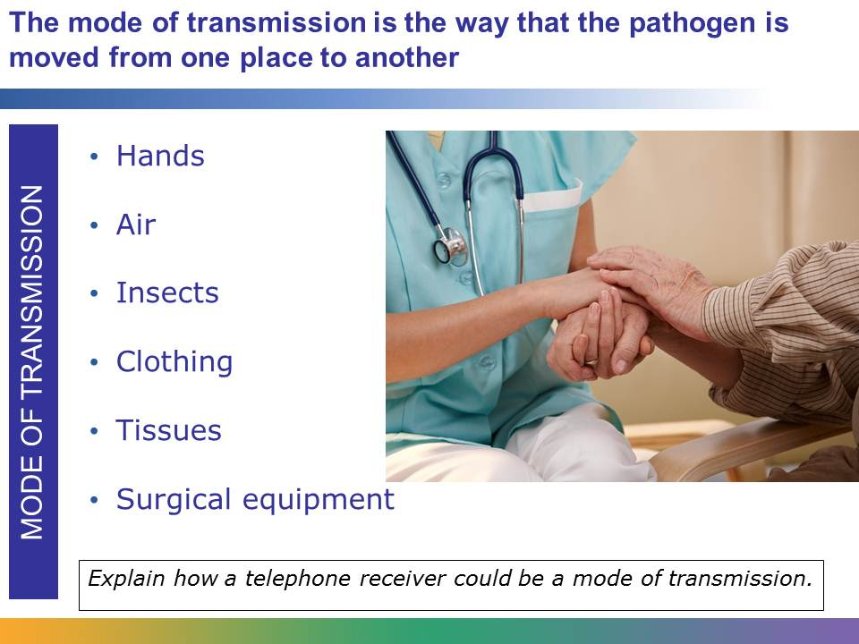
Once the agent has exited the reservoir, it needs a way to move. This is called the mode of transmission. The mode of transmission is the way that the pathogen is moved from one place to another.
Imagine another reservoir: a contained body of water. Water leaves the reservoir through canals. The mode of transmission is like the canals. It is the way that the pathogen leaves the reservoir and moves to another place.
Contaminated hands are one of the most common means by which pathogens move. Air is another mode of transmission. If a person sneezes, air serves as the mode of transmission, carrying the contaminated droplets. Other modes of transmission include the clothing of health care workers, used tissues, and contaminated surgical equipment. Insects are also a mode of transmission. For example, mosquitoes can carry malaria and West Nile virus.
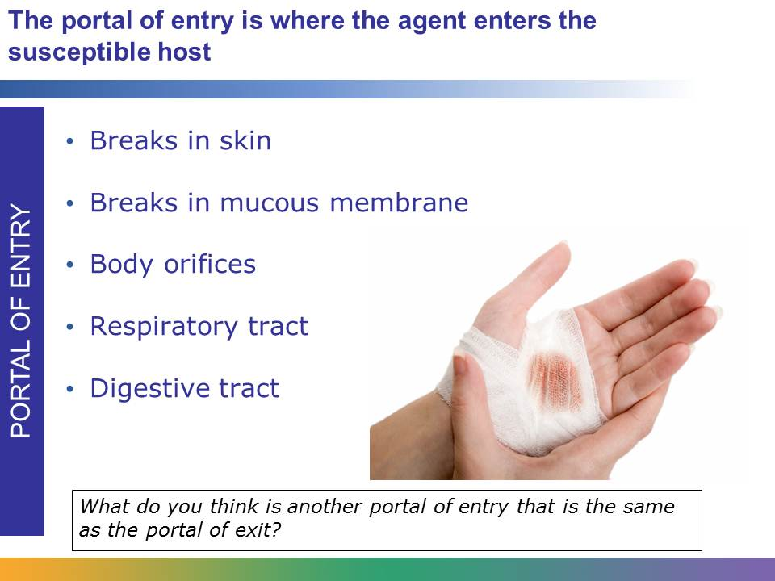
The portal of entry is where the agent enters the susceptible host. It is often the same place from which the agent exited the reservoir. For example, if a pathogen leaves one person’s body when he sneezes, it may enter another person’s body as she breathes through her nose. Portals include body orifices, or openings, like the nose and mouth; mucous membranes found at places like the nostrils, eyelids, and lips; breaks in the skin, such as through a needle; the respiratory tract; and the digestive tract.
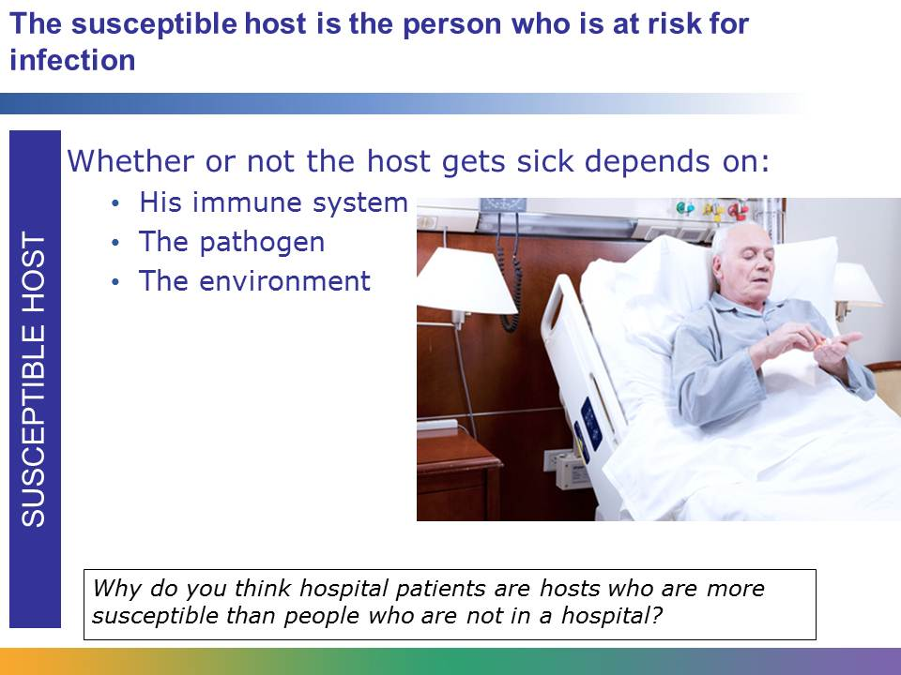
The susceptible host is the person who is at risk for getting infected by the agent. Just because an agent enters a new host doesn’t mean that person is going to get sick. If the person is healthy and has a strong immune system, he may be able to fight off the agent. Whether or not a person gets sick depends on his immune system and the pathogen. It also depends on the environment. For example, if the susceptible host is in an environment where he is breathing contaminated air and is exposed to more than one agent, his body may have a harder time fighting off the agent.
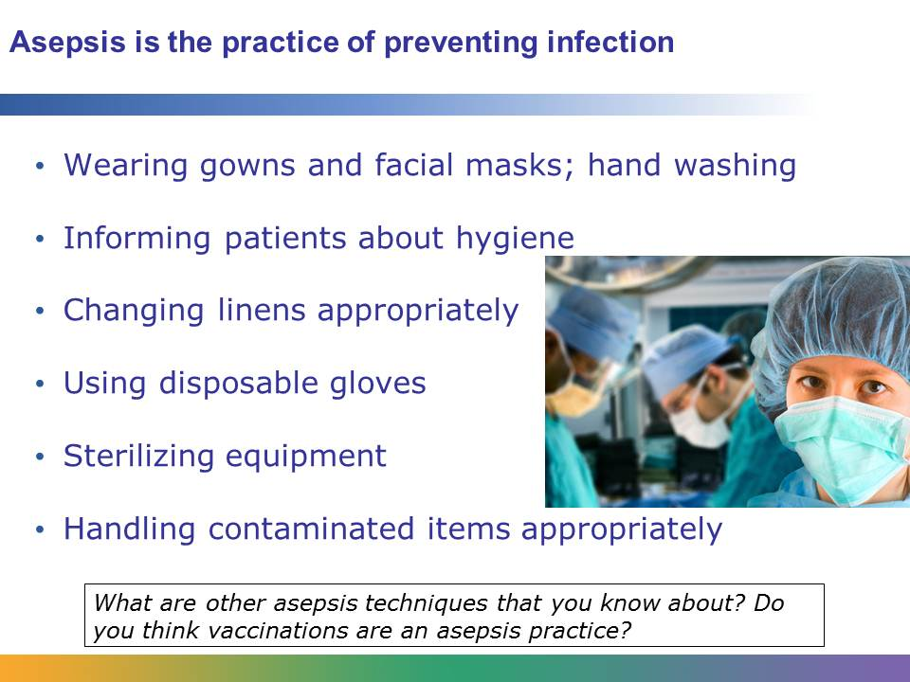
Health care workers in hospitals use a practice called asepsis to break the chain of infection. By practicing asepsis, health care workers protect both themselves and patients from getting infected. This practice includes techniques such as wearing gowns and facial masks, hand washing, and providing patients with information about basic hygiene. Techniques also include using a detailed process for changing linens on hospital beds, using disposable gloves when contacting body secretions, and properly cleaning and sterilizing equipment. Asepsis also involves appropriate handling and discarding of contaminated items.
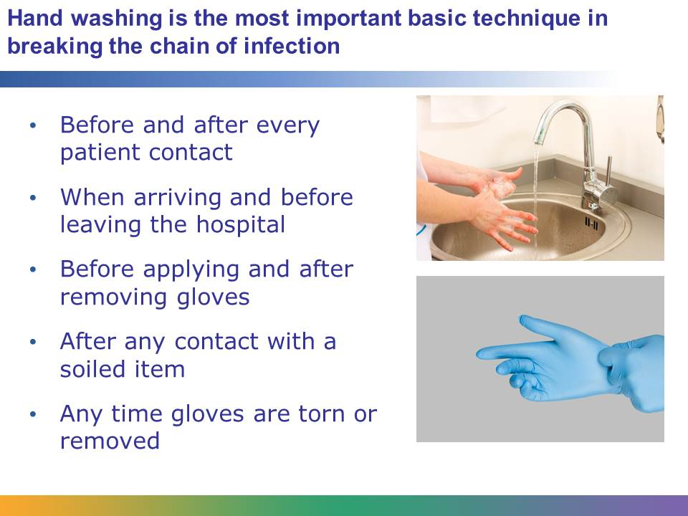
Hand washing by both health care workers and patients is the most important basic asepsis technique in preventing infections from spreading. Health care workers should wash their hands frequently. There are many times in the daily routine of a health care worker when hand washing is necessary, which include before and after every patient contact, when arriving and before leaving the hospital, before applying and after removing gloves, after any contact with a soiled item, and any time that gloves are torn or removed.
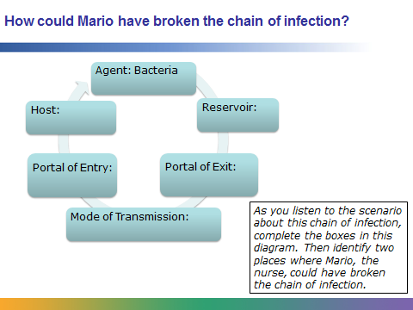
Mario, an LPN, was changing the dressing of a wound on Tara’s leg. He used the proper asepsis technique to change the dressing. After he was finished, he removed his gloves and then washed his hands. Then he noticed that he had left a piece of the soiled dressing outside of the waste bag. He picked it up and deposited it into the waste bag, and then he left to visit his next patient, Amanda. The RN asked Mario if he could help change Amanda’s catheter, a tube that drains urine from the bladder, and he got right to work.
In this scenario the agent is a bacteria living in Tara, who is the reservoir. The portal of exit for the agent is the wound on Tara’s arm. After Mario changed the dressing, he picked up the soiled dressing with his bare hands and didn’t clean them after. At that point, Mario’s hands became the mode of transmission. His hands became the way that that the bacteria would move from Tara to the host. In the scenario, Amanda is the susceptible host. The portal of entry for the pathogen entering Amanda’s body is the end of the catheter that Mario is handling with contaminated hands.
If Mario had washed his hands after touching the soiled dressing or used gloved hands to pick up the dressing, he could have broken the chain of infection. He had another opportunity to break the chain of infection. He could have washed his hands before he began the procedure in Amanda’s room.
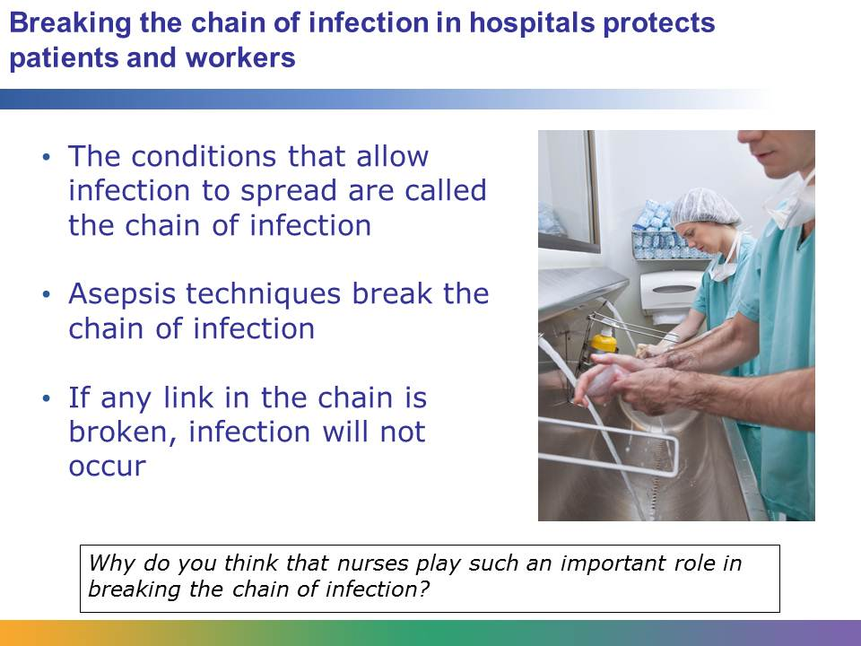
All professionals who work in hospitals are trained to understand and break the chain of infection. It is one of the most important hospital procedures. By breaking the chain of infection they protect patients, their colleagues, and themselves.

