Student Resource 10.1
Note Taking: Risky Behaviors and Health Outcomes
Student Names:_______________________________________________________ Date:___________
Directions: In the left column of the chart below is a list of risky behaviors. With your partner, decide what health outcomes (injury or disease) you believe could result from the behavior. An example is given for you. You will fill in the third column as you watch the presentation “Risky Behaviors and Health Outcomes.”
Risky Behavior | Health Outcomes I Know About | What I Learned
Driving without seat belts; driving motorcycles without helmets; speeding in urban areas | Paralysis
Inappropriate sexual behavior
Eating foods high in fat, sugar, and salt; physical inactivity
Alcohol abuse
Smoking tobacco

Student Resource 10.2
Reading: Risky Behaviors and Health Outcomes
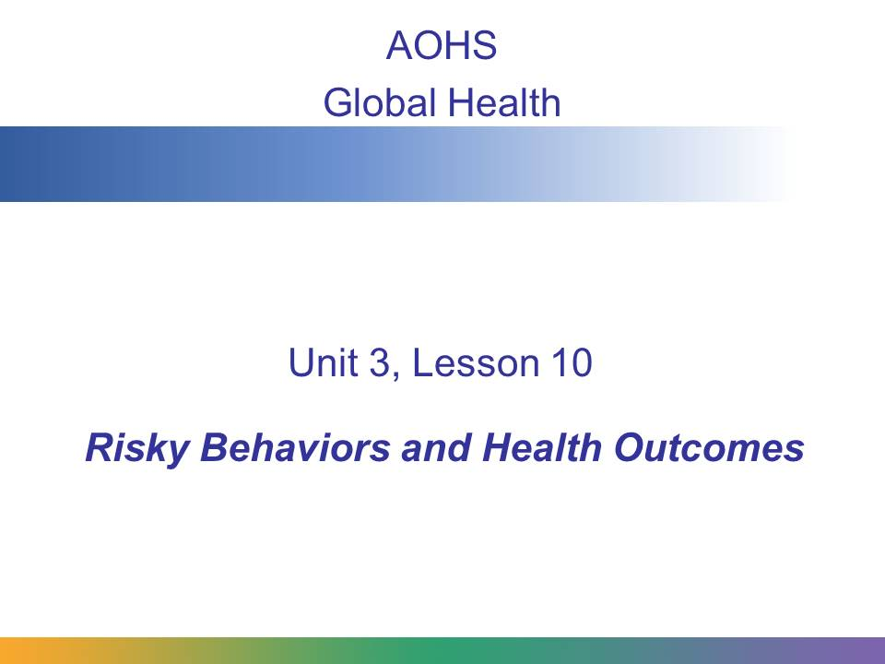
In this presentation, we will focus on high-risk behaviors and the health outcomes related to them. We will look at some of the reasons why people engage in risky behaviors and the methods that are used to help people change their behaviors.
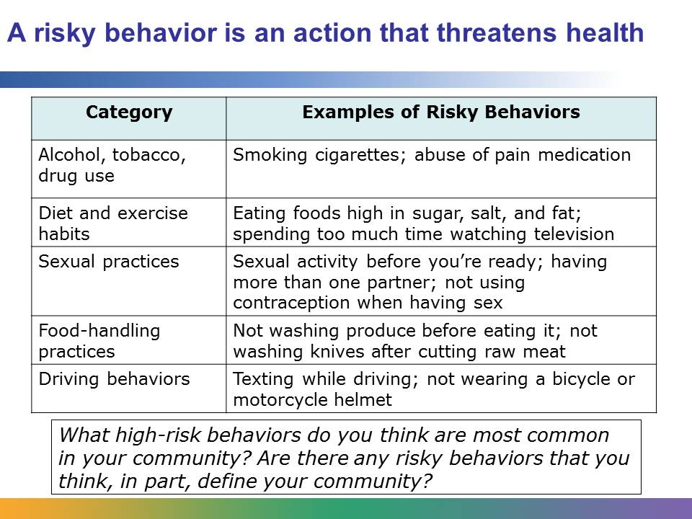
A risky behavior is an action that can threaten the health of the person who performs the behavior or the health of others. For example, drinking and driving is a risky behavior. People who drink and drive risk not only getting into an accident and injuring themselves, but also injuring other drivers or pedestrians. The range of risky behaviors that affect global health in the world is wide. It spans personal choices about exercise to choices about contraception.
A behavior is different from an outcome. The outcome is the result of the behavior. For example, texting while driving is a behavior. A possible outcome is an accident-related injury.
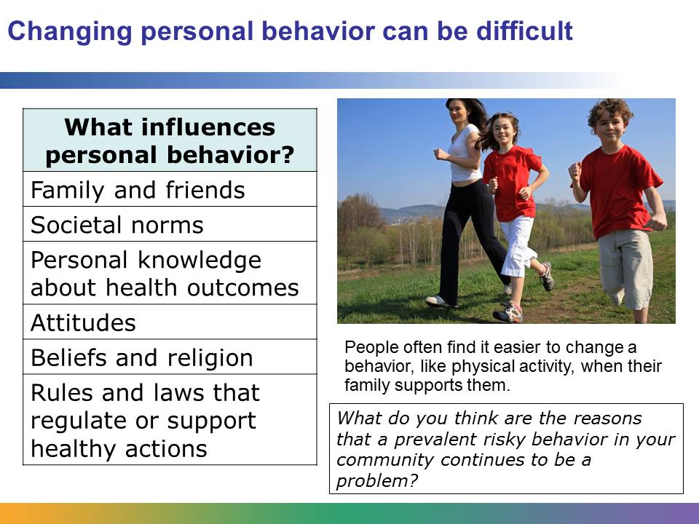
A risky behavior is linked to personal choice. Finding solutions to risky behaviors is usually about helping people change their choices and, therefore, change their behavior. For example, a person may choose not to exercise. This behavior can be modified, and the person can choose to begin exercising. But changing personal behavior is not easy. It’s a lifestyle change.
Changing a behavior can be difficult if it goes against what family and friends are doing or what is considered normal in a society or community. For example, if a person is a member of a family where no one exercises, changing this behavior may be especially hard. On the other hand, if the entire family decides to be more physically active, the person may feel more positive and capable about making the change in his or her behavior.
Many forces influence a person’s behavior. These include family, friends, and societal norms. They also include personal knowledge about health outcomes related to the behavior, attitudes, beliefs, and religion. For example, the health outcomes of smoking cigarettes are widely known in the United States, but other countries lack public health campaigns to educate people about the risks of smoking. Without this knowledge, people might choose to smoke, not fully understanding the dangers.
Forces that influence behavior also include the rules and laws in a society that regulate or support healthy actions (e.g., whether or not underage smoking is illegal). Financial status is another force that can influence a person’s behavior. For example, someone might feel that healthy food is not affordable.
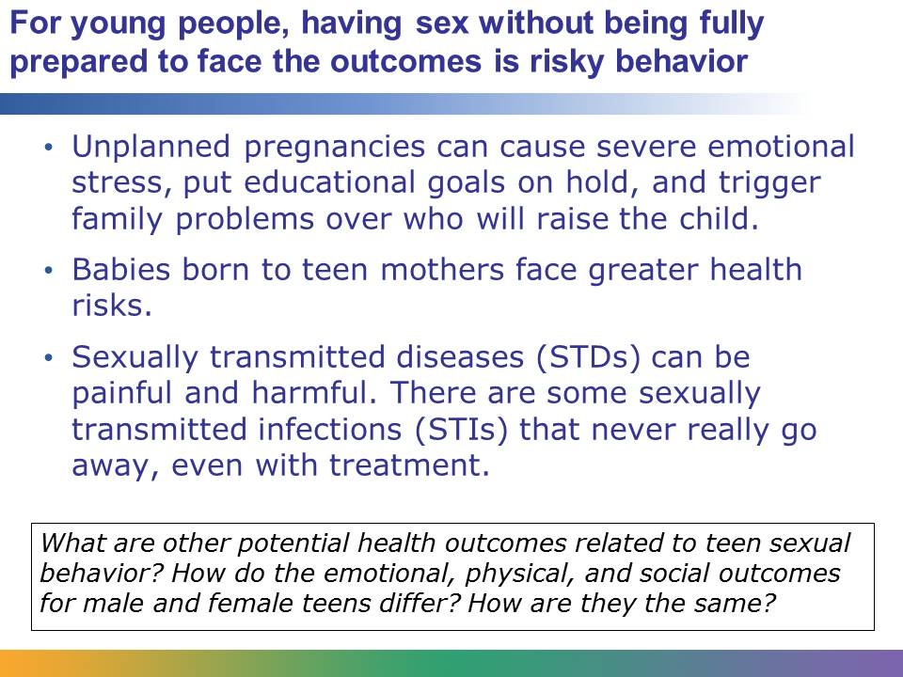
There are many serious health outcomes related to teens having sex before the time is right. One of those outcomes is unplanned pregnancy. In the United States in 2011, a total of 329,797 babies were born to women aged 15–19 years. An unplanned pregnancy can cause emotional and financial stress on anyone, yet may be especially difficult for a young person. An unintended pregnancy will affect the rest of a teen’s life. Teen mothers are less likely to go to college, and the babies born to teen mothers face greater health risks. Teen fathers face the responsibility of supporting their children.
Painful and harmful sexually transmitted diseases (STDs) and sexually transmitted infections (STIs) are another potential health outcome. There are 19 million new cases of STDs every year, and almost half of them are among young people between 13 and 24 years old. An estimated 8,300 young people aged 13–24 years in the 40 states reporting to CDC had HIV infection in 2009. Although STDs can be treated, there are some STIs that do not go away, even with treatment.
Trends in rates of active teenage sexual activity show an overall decrease. This may be attributed to improved access to sex education and contraception, and an increased understanding of the consequences of unprotected sex.

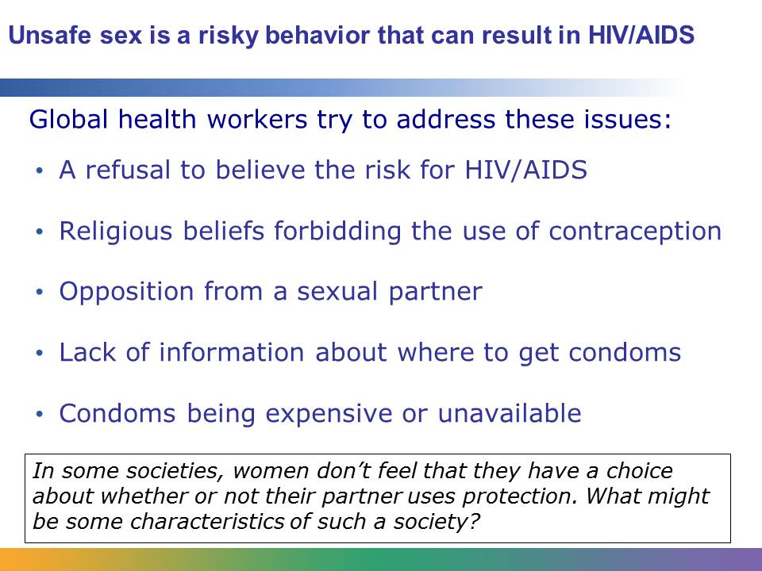
Another potential health outcome of having sex is getting HIV/AIDS. HIV/AIDS can be transmitted through unprotected sexual activity.
HIV/AIDS is one of the most pressing global health concerns facing the planet. In 2012, 35.3 million people worldwide were living with HIV. In that same year, 2.5 million people became newly infected, and 1.7 million people died of AIDS.
Abstinence is the best way to protect against HIV/AIDS. Condoms limit the risk of contracting HIV through sex, but many sexually active people around the world don’t use condoms. Why do people engage in this high-risk behavior? Some people, like commercial sex workers, may be forced into having sex without condoms. But what about people who are not forced?
There are many reasons why people engage in this risky behavior. Cultural norms in some societies or communities may make talking about contraception embarrassing. A person’s religion might forbid the use of contraception. A person’s partner may be opposed to using contraception, or a person may feel scared about his or her partner’s reaction to a request to use condoms. Married women may feel social pressure to have children, so they don’t use condoms. People may believe myths and perceptions about the side effects of contraception, such as the perception that condoms decrease pleasure or intimacy. Some people may think that they are not at risk for HIV or AIDS and don’t use condoms for that reason.
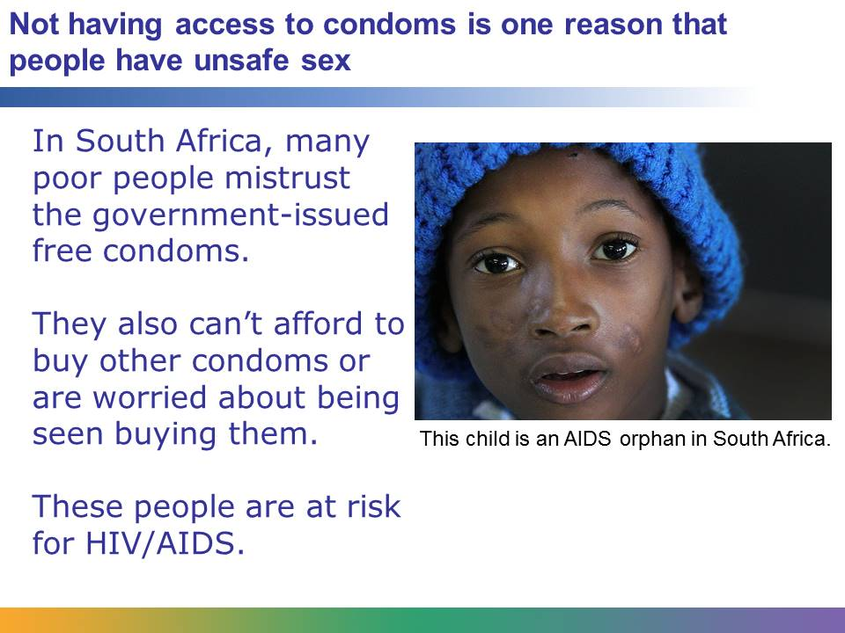
Not having access to condoms is one reason that people around the world have unsafe sex. For example, South Africa has the world’s highest number of AIDS victims at 5.6 million, and AIDS is the leading cause of death. The South African government responded to the crisis with a program that distributes free condoms. However, in 2012 the government had to recall 1.35 million condoms that were given away. The condoms were defective and breaking, which did not protect the users from exposure to HIV/ AIDS. The event made many people mistrust the government-issued condoms, and they don’t want to use them. Many people don’t have the money to buy condoms or are worried about being seen buying them. If these people choose to have sex without a condom, they are at risk for contracting HIV/AIDS.

Image retrieved from http://commons.wikimedia.org/wiki/File:KwaZulu-Natal_(South_Africa)_004_(5329410146).jpg on September 18, 2013, and reproduced here under the terms of the Creative Commons Attribution 2.0 Generic license (http://creativecommons.org/licenses/by-sa/2.0/deed.en). Image courtesy of Steve Evans.

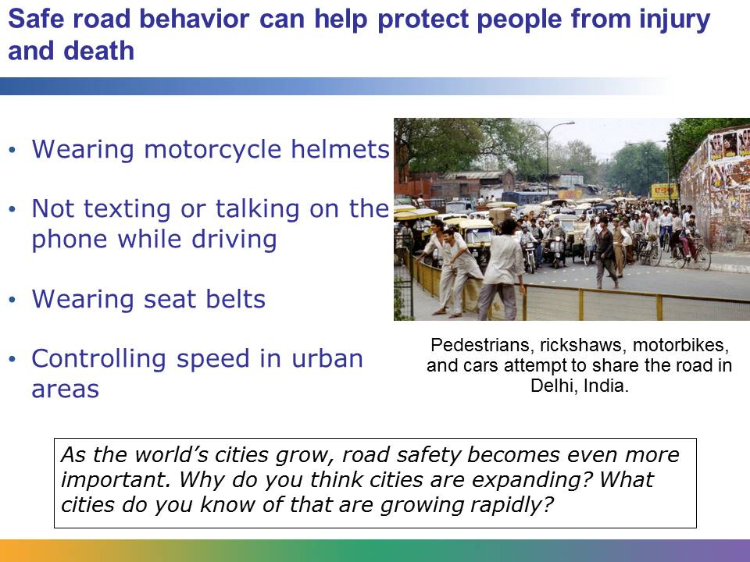
Injuries that result from accidents on the road are a serious global health problem. By 2030, road traffic injuries are predicted to become the fifth leading cause of death. Many of these injuries are the outcome of risky behavior.
These injuries can be prevented. Studies show that wearing a quality helmet can reduce the risk of severe injury from a road crash by over 70%, but only 40% of countries have helmet laws that apply to both riders and passengers. Only 28 countries, covering 7% of the world’s population, have comprehensive road safety laws on five key risk factors: drinking and driving, speeding, and failing to use motorcycle helmets, seat belts, and child restraints.
Texting or talking on the phone is increasingly becoming a problem around the world. Some places, like California, have passed laws about these issues, but many places have not.

Image retrieved from http://commons.wikimedia.org/wiki/File:Delhi_India_traffic_1997.jpg on May 10, 2012, and reproduced here under the terms of the Creative Commons Attribution 2.0 Generic license (http://creativecommons.org/licenses/by-sa/2.0/deed.en). Image courtesy of David Bleasdale.
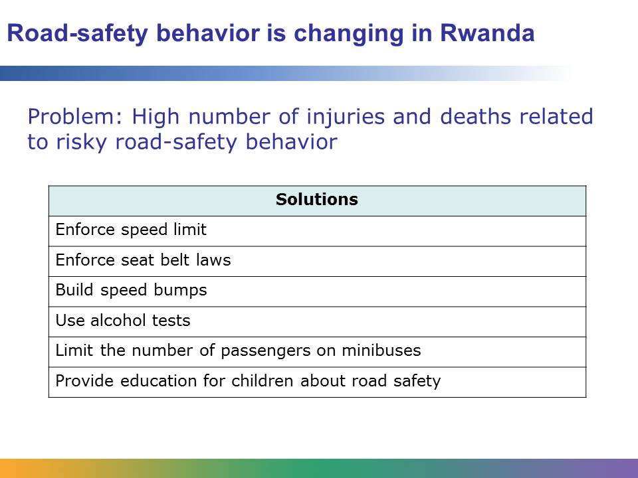
Rwanda once faced a severe road safety problem. It had one of the worst road safety records in the world, and thousands of people were hurt each year because of risky behavior on the road. Beginning in 2001, the country started a comprehensive road-safety initiative by offering its population many aspects of road safety. The program has been successful in changing people’s behavior in part because of the enforcement of traffic laws.
The country initiated a national speed limit of 60 kilometers per hour on open roads and 40 kilometers per hour in villages and towns. Drivers are fined if they speed and if they don’t wear seat belts. Speed bumps have been constructed. A number of studies have shown that speed bumps are one of the most cost-effective methods to reduce road injuries and death in developing countries like Rwanda. Police also now give breath tests to measure alcohol levels. Drivers are fined if the test shows that their alcohol level is over the legal limit. Drivers of minibuses are now required to allow only a certain number of passengers in their vehicle. If they carry more passengers, they can be fined. Police also supervise school crossings and teach children about road safety.
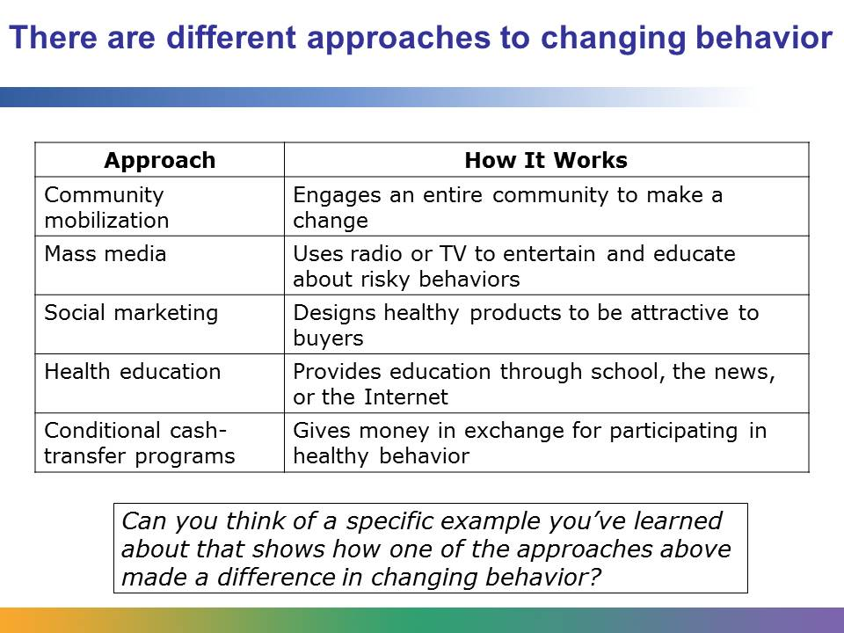
As you saw in the Rwanda example, rules and regulations can make a big difference in affecting people’s behaviors. Here are some other methods that are widely used:
- Community mobilization – engages an entire community in making a healthy change in behavior. It utilizes community leaders or representatives to mobilize their communities.
- Mass media – uses media, like radio or television, to both entertain and educate people about risky behavior. For example, in Myanmar there is a popular soap opera featuring a famous actress who educates people about leprosy.
- Marketing – uses the tools of commercial marketing to make a healthy product attractive. For example, designing condoms so that they appeal to a certain population, selling them at an affordable price, and selling them in convenient places.
- Health education – provides education through classrooms, the news media, or the Internet.
- Conditional cash-transfer programs – uses economic incentives to help people change their behavior. For example, some Latin America countries have paid families to send their female children to school on a regular basis.
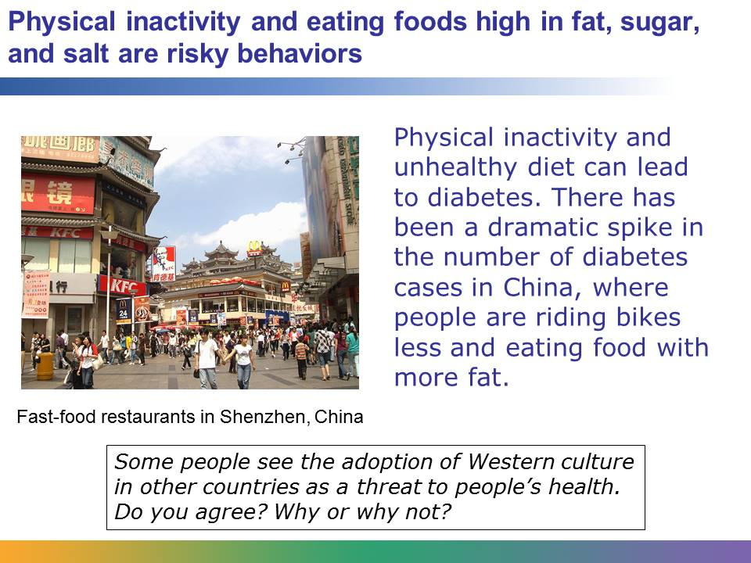
Many serious health outcomes are related to being overweight, obese, and physically inactive. These include high blood pressure, high cholesterol, coronary heart disease, and some cancers.
Adult-onset or Type II diabetes is generally caused by poor diet and lack of exercise. Evidence shows that often diabetes can be prevented through a healthy diet that is free from foods high in sugar, salt, and fat, and through physical activity. But around the world, including in developing countries, poor diet and physical inactivity are on the rise. The result is more cases of diabetes. In 2013, more than 347 million people worldwide had diabetes. Diabetes is considered to be an emerging global epidemic.
Researchers have found that as a country become wealthier, the lifestyle of its people can change for the worse. Their diet can change, resulting in unhealthy weight gain, and they can become less physically active. China is one example. The diet in China is changing to include more saturated fat than it used to, and people are less inclined to walk or ride bikes as their primary mode of transportation. In China, Type II diabetes grew 30% in seven years. Researchers consider this an alarming increase. In one study in China, rural residents had a 60% increase in the same time period.
Image retrieved from http://commons.wikimedia.org/wiki/File:Dongmen.JPG on April 12, 2012, and reproduced here under the terms of the Creative Commons Attribution-ShareAlike 3.0 Unported license (http://creativecommons.org/licenses/by-sa/3.0/deed.en). Image courtesy of Chintunglee.
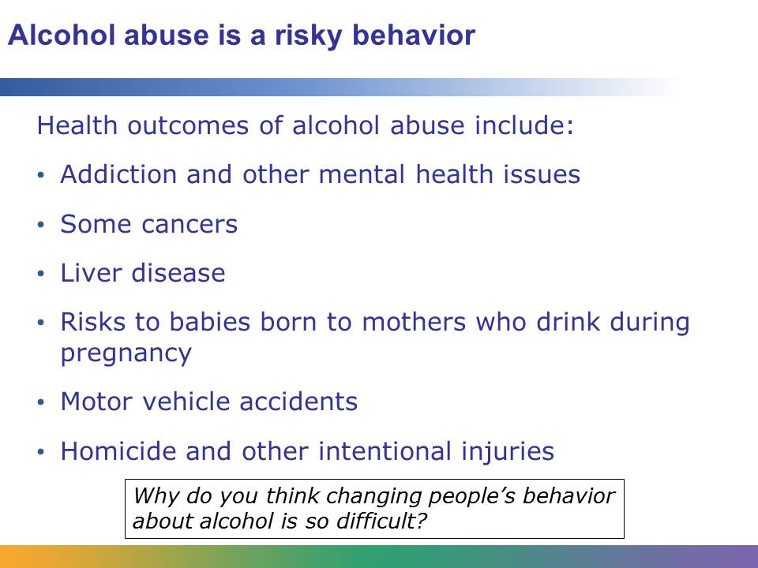
In 2011, the harmful use of alcohol resulted in 2.5 million deaths. The health outcomes of harmful alcohol use are serious. They include esophageal cancer, liver disease, motor vehicle accidents, homicide, and other intentional injuries. Babies born to mothers who drink while they are pregnant are at risk for serious health conditions such as fetal alcohol syndrome. Alcohol is associated with many serious social issues, including violence, child neglect and abuse, and absenteeism in the workplace.

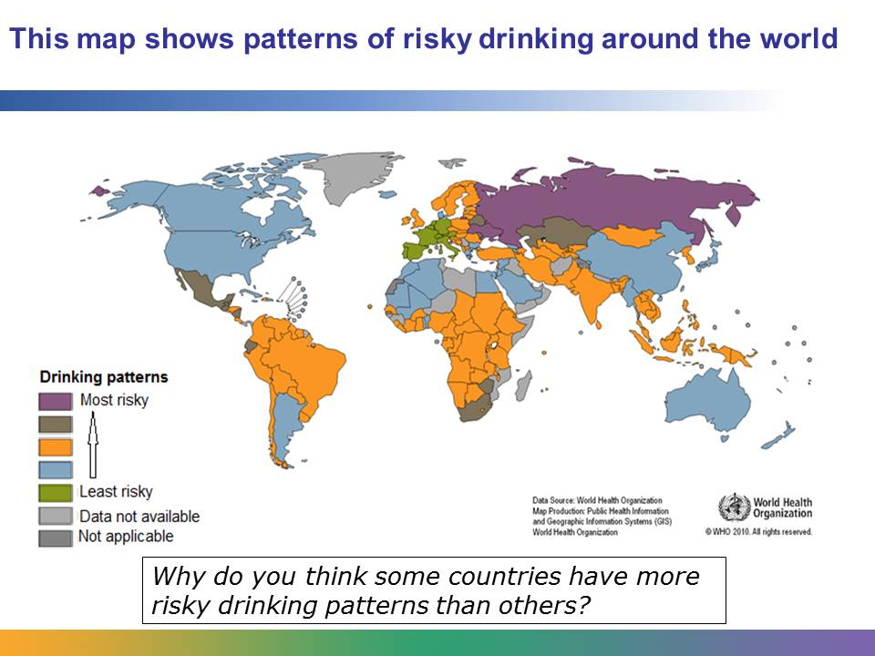
Alcohol use is considered a risky behavior around the globe, but the problem is worse in certain areas. According to a WHO report released in 2011, one in five men in the Russian Federation and neighboring countries die due to alcohol-related deaths.
Data from http://www.who.int/mediacentre/news/releases/2011/alcohol_20110211/en/index.html and http://www.who.int/mediacentre/factsheets/fs349/en/index.html and http://gamapserver.who.int/mapLibrary/Files/Maps/Global_patterns_drinking_score_2005.png.
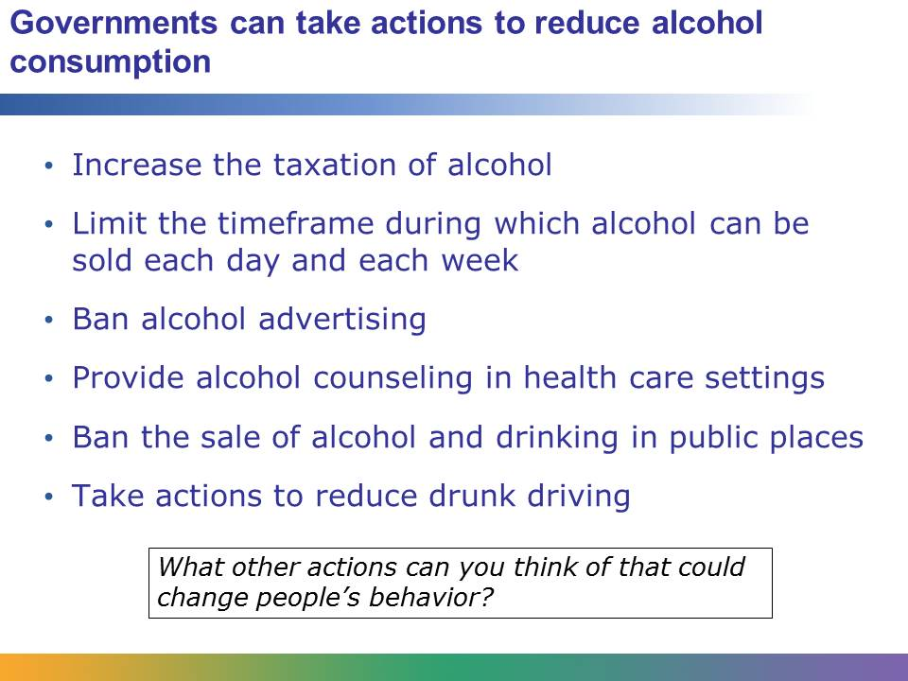
In spite of the problems related to alcohol, few countries have taken a strong stance on reducing alcohol consumption. However, researchers believe that there are various actions that could make a difference. One action is to increase the taxation of alcohol. A higher tax on alcoholic beverages would likely lead to a decrease in the purchase of alcohol. This has been the result in instances where taxation on cigarettes was increased.
Another action would be to reduce the number of hours in a day that alcohol can be sold. Restrictions on both the sale of alcohol and drinking in public places, like parks or sports stadiums, is another action. Banning alcohol advertising or limiting the type of advertising used can affect alcohol consumption and may reduce its use. Studies have also shown that providing alcohol counseling in health care settings can have a positive effect on decreasing consumption.
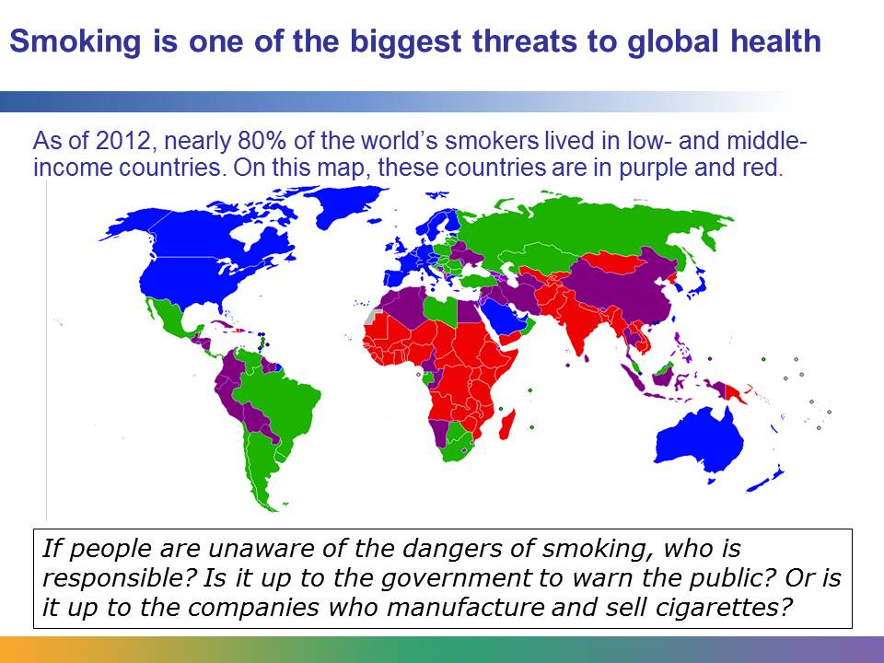
Tobacco product use is one of the most serious public health issues affecting global health. In 2013, tobacco was responsible for the death of 6 million people per year. It’s believed that by 2030, smoking will be related to the deaths of 6 in 10 people. The possible health outcomes of smoking include cancer, cardiovascular disease, and low birth weight. While the consumption of tobacco products is decreasing in some countries, it is steadily increasing globally.

Image retrieved from http://commons.wikimedia.org/wiki/File:World_Bank_income_groups.png on May 22, 2012, and reproduced here under the terms of the Creative Commons Attribution-ShareAlike 3.0 Unported license (http://creativecommons.org/licenses/by-sa/3.0/deed.en). Image courtesy of Ronline.
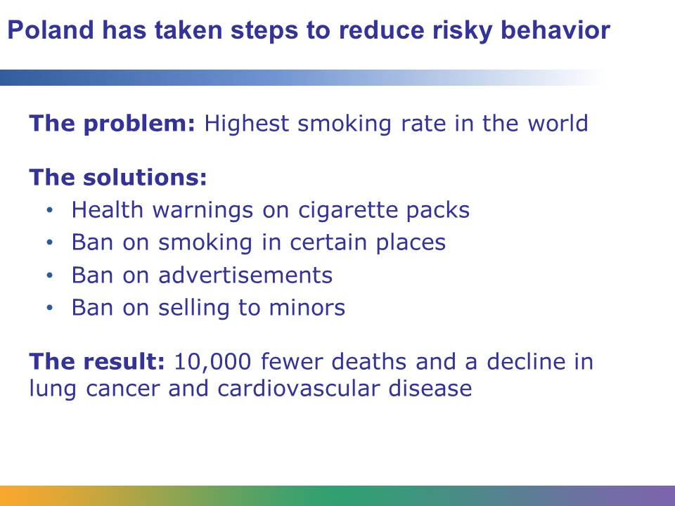
In the 1980s, Poland faced what seemed to be an insurmountable problem. It had the highest smoking rate in the world. Almost three-quarters of Polish men smoked every day, and the result was that middle-aged Polish men had one of the highest rates of lung cancer in the world.
In 1995, the Polish government took action. They passed legislation aimed at reducing the number of smokers in their country. The new laws required a large health warning on cigarette packs. In fact, the warning on the package was one of the largest of its kind in the world. They banned smoking in health centers and enclosed workspaces. They also banned tobacco-related electronic media advertisements, and they banned selling tobacco products to minors. In addition, they launched a health education campaign.
The efforts to reduce smoking were effective. In an eight-year period, cigarette consumption dropped 10%. The reduction in smoking led to 10,000 fewer deaths per year and a decline in both lung cancer and cardiovascular disease.
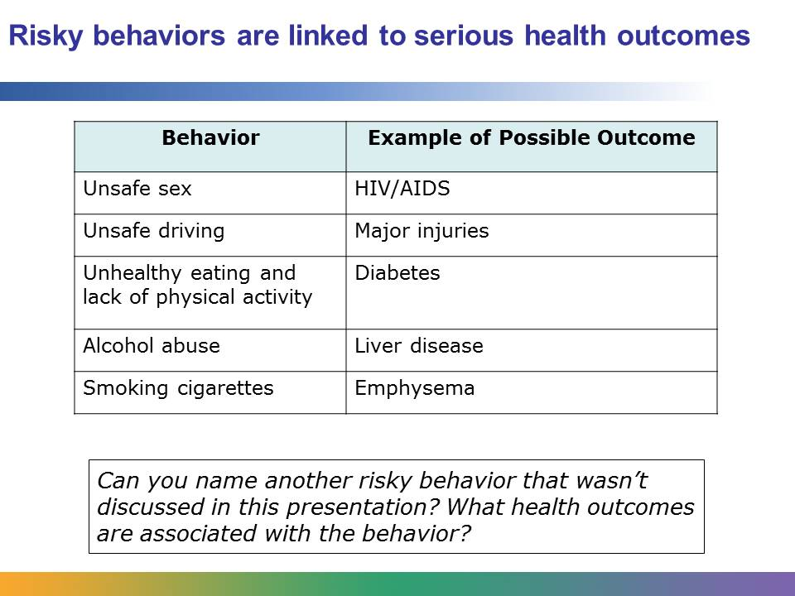
Risky behaviors are actions that threaten the health of the people who engage in them and the health of others around them. High-risk behaviors are associated with dangerous health outcomes ranging from injury to HIV to death. The control of risky behaviors involves helping people to change their behavior through regulations, education, and community participation.

