Student Resource 3.1
Investigation: The Chain of Infection
Directions: Read the story below and think about how infection can be passed along a chain, from one person or object to another. Then study the chart on the next page of this resource that describes the chain of infection, and match up elements from the story with links in the chain of infection. Throughout the course, refer to this resource when you need information about the chain of infection.
The Chain of Infection in Everyday Life
On Saturday Angela woke up with a cold, but she still decided to go to her weekend job at a popular lunch restaurant.
Angela kept tissues in her back pocket and blew her nose as she worked. When she ran out of tissues, she just wiped her nose on the back of her sleeve. Throughout the busy lunch hour, Angela refilled ingredients in the salad bar, like shredded carrots and sliced tomatoes. She didn’t wear gloves, and she didn’t wash her hands until the end of her shift.
Tony came into the restaurant. Angela knew him from school. She waved at him before going into the kitchen to get some more spinach.
Tony was really hungry, so he grabbed an empty plate and piled up lettuce, carrots, beans, and avocado from the salad bar. His salad was delicious.
Two days later, Tony woke up with a sore throat and a stuffy nose. He couldn’t figure out how he got sick.
The Chain of Infection

The chain of infection has six links, as shown in this illustration. If the chain is broken at any point, infection will not occur. The table below tells about each link in the chain. Read the description of each link, and then fill in the third column with an example of the link from the story you read. The first one has been completed for you. | 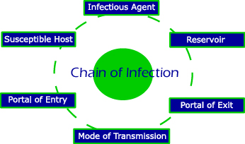

Link in the Chain of Infection | What It Is/What It Does | Example from the Story
Infectious agent | Any microorganism capable of producing an infection (bacteria, virus, fungus, etc.). | Angela’s cold germs
Reservoir | Where the microorganism lives—it could be within the human body, in food or water, or in waste products like feces.
Portal of exit | How the microorganism leaves the reservoir. In the human body, portals of exit include mouth, nose, genitals, or open wounds.
Mode of transmission | How the microorganism gets from one place to another. This can include direct contact between people, airborne transmission (through sneezing or coughing), or transmission by an inanimate object (for example, a medical instrument that is not sterilized).
Portal of entry | How the microorganism enters a new body—for example, through an open wound or the mucous membranes.
Susceptible host | Person who carries an infection. This person may or may not show signs of illness.

