Student Resource 6.1
Health Log: Food Intake and Physical Activity
Student Name:_______________________________________________________ Date:___________
Directions: Use this chart to record everything you eat and drink over the next five days. At the end of the lesson, you will play the role of a dietitian and analyze your diet based on what you have learned in the lesson. It is important to keep a careful record of everything you eat, including snacks. For example, if you have half a bag of chips on the way to school or a few orange slices after a soccer game, make sure to include this. In the last column, record the number of minutes of physical activity you did each day. Physical activity includes sports, like basketball and soccer, but it also includes activities like heavy yard work, bike rides, or dancing. You won’t be asked to share the information on this chart with anyone. A sample entry is shown.
Day | Food and drinks before 9 a.m. | Food and drinks between 9 a.m. and 3 p.m. | Food and drinks between 3 p.m. and 12 a.m. | Minutes of physical activity
 | One glass of chocolate milk; bagel and cream cheese; half of a donut; two glasses of water | One cup of chicken noodle soup; glass of orange juice; 10 BBQ chips; an apple; a sports drink | Plate of spaghetti and meatballs; small bowl of steamed broccoli; thin slice of chocolate cake; an orange soda | 45
DAY 1
DAY 2

DAY 3

DAY 4

DAY 5

Student Resource 6.2
Reading: Healthy Eating
The History of a Plate
In 2010 the US Department of Agriculture (USDA) released a simple image intended to help Americans make healthy food choices. It is an image of a plate.
But this plate isn't just any plate. It is MyPlate. The name carries a clear a public health message: a healthy diet is unique to the individual. It depends on many personal factors like age, sex, weight, and health conditions. In general, all healthy diets emphasize similar things. They focus on fruits, vegetables, whole grains, and low-fat milk products. They include lean meats, poultry, fish, beans, eggs, and nuts, and they are low in fat, salt, and added sugars. The specifics vary with the individual.
Another thing that makes the plate image stand out is that it shows moderate portions. The image doesn’t show a super-sized glass for drinks or a side plate for seconds. Instead, it communicates this message: “Enjoy your food, but eat less.” As obesity becomes an increasingly serious public health problem, this message is more important than ever.
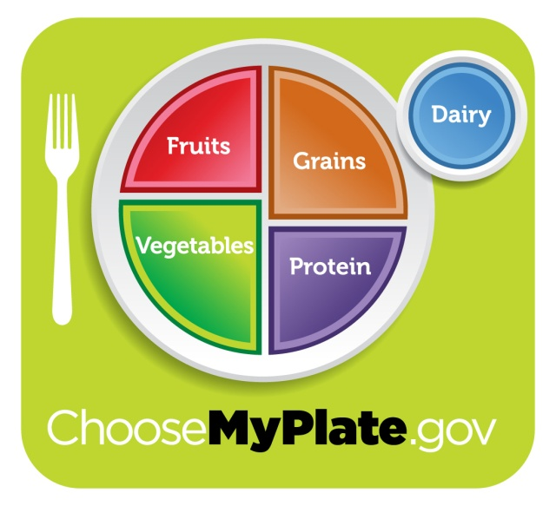
Many Americans have responded positively to MyPlate. It resembles the place setting many of us use to eat our meals. This makes it easier to imagine how we can appropriately divide up our portions of food from each of the food groups. The personalization of the plate also makes sense to many Americans, who have varying tastes and enjoy food from different cultures. For example, fish is a protein that many Americans eat, but the type of fish and the way it is prepared varies. A Japanese American family may enjoy grilled chicken, while a Cuban American family may enjoy chicken stew. Both tasty dishes, if eaten in moderation, satisfy MyPlate’s protein recommendation.
MyPlate is another development in the tools that the government has used in the past to educate the public about healthy food choices. In 1984 the government released a food wheel. Then, in 1992, it released a food pyramid. The base of the pyramid represented grains, like bread, rice, cereal, and pasta. At the time, these were the foods that that Americans were advised to consume the most of. That is no longer the case. In 2005 a new version of the pyramid was released. This pyramid had an image of a person climbing steps. This image communicated that physical activity is as important of a part of healthy living as the food we consume.
Government recommendations change over time. Recommendations are based on new research, behaviors, and the food products available. Dietary guidelines now encourage people to make smart food choices from every food group, be physically active, and eat in moderation.
What’s on MyPlate: Vegetables
MyPlate recommends making half of each meal fruits and vegetables. A diet that is rich in vegetables may reduce the risk heart disease and protect against certain types of cancer, among other benefits.
MyPlate recommends varying vegetables and focusing on dark green ones, like kale, and orange ones, like acorn squash. A variety of vegetables is important because each vegetable contains different nutrients and vitamins, like vitamin C and fiber, which are important to our health. Varying vegetables also makes meals more interesting. Incorporating more vegetables into meals can be a challenge for many Americans. MyPlate gives tips like these:
- Eat vegetables that are in season. They will taste the freshest and will likely be the least expensive.
- For lunch, eat a hearty salad. Remember to go light on the dressing.
- Make vegetables the centerpiece of a meal, like in a chunky vegetable stew or veggie stir fry.
What’s on MyPlate: Fruit
Remember, MyPlate recommends making half of each meal fruits and vegetables. Fruits, like kiwis, plums, and cherries, can be fresh, canned, frozen, or dried. Fruits can also be whole, cut up, or pureed. It’s important to choose fruit that is canned in 100% fruit juice or water, not syrup. Like vegetables, fruits differ in nutrient content. So, varying choices is important. For example, many Americans don’t get enough potassium in their diet. This means that choosing potassium-rich fruits, like bananas, prunes, and dried peaches, is important. MyPlate recommends tips like these for people who want to introduce more fruit into their diet:
- Try meat dishes that incorporate fruit, such as chicken with apricots.
- For dessert, stick with fruit. Try something different, like baked apples or pears.
- Blend frozen fruit and low-fat yogurt, milk, or water for a fruit smoothie, a refreshing snack.
What’s on MyPlate: Grains
Foods made from wheat, rice, oats, cornmeal, and barley are grain products. Examples of grain products are bread, pasta, cereal, and tortillas. Most Americans consume enough grains but not enough whole grains. MyPlate recommends that whole grains be at least half of the grains we consume.
Grains are divided into two subgroups, whole grains and refined grains. Whole grains contain the entire grain kernel―the bran, germ, and endosperm. Oatmeal, whole-wheat flour, and brown rice are examples of whole grains. Refined grains have been milled. This process removes the bran and germ. The bran and germ contain the dietary fiber, iron, and many B vitamins that make grains healthy. White bread and white rice are refined grains.
How do Americans know how to choose? MyPlate suggests looking at nutrient labels on bread to see if whole-wheat flour is the first ingredient on the list. MyPlate also suggests choosing brown rice over white rice and trying whole-wheat pasta as a healthy alternative.
What’s on MyPlate: Dairy
All fluid milk products and many foods that are made from milk are part of the dairy group. Healthy dairy products contain calcium, which is important for bone growth. Active teens should consume three cups of low-fat or fat-free milk a day. MyPlate stresses that the most important thing to remember about selecting foods in this group is to choose low-fat or fat-free options, like low-fat yogurt or fat-free milk.
When choosing dairy products, MyPlate cautions against picking foods with empty calories. Empty calories are calories from solid fats and added sugars. These foods have few or no nutrients. They include flavored milk, drinkable yogurt, and ice cream.
What’s on MyPlate: Protein
All foods made from meat, poultry, seafood, beans and peas, eggs, processed soy products, nuts, and seeds are part of the protein group. (Beans and peas are also part of the vegetable group.) Proteins include lamb, lentils, pork, chicken, lima beans, and tuna. The human body benefits from healthy proteins in many ways. Protein provides energy and builds strong bones, muscles, and blood.
Many Americans consume too much protein (imagine a triple-decker hamburger) and protein prepared using unhealthy cooking techniques, such as deep-fried chicken.
Healthy protein choices are lean and low-fat meat and poultry, like chicken breast without the skin or lean ground beef. Also, it is important to avoid adding solid fat when cooking proteins. For example, instead of frying eggs in butter, boil them. Processed meats, like deli meats and sausage, are also not the healthiest choice. These processed meats often have added sodium, or salt.
Snacks Count, Too
Planning balanced meals is one critical step toward a healthy lifestyle. But it’s important not to forget what happens between the meals: snacks. Many processed snacks are high in added sodium, sugar, and fat. Even snacks that seem healthy, like a granola bar, can have just as much sodium, sugar, and fat as those that obviously aren’t, like a chocolate bar or bag of chips.
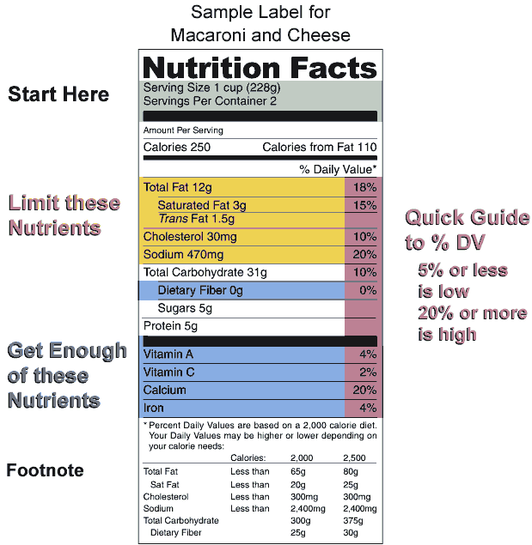 | The one way to tell which snacks and processed foods like frozen dinners and canned soup are healthy is to read nutrition labels. One important thing to notice about a nutrition label is the number of servings per container. This is a label for macaroni and cheese. The label shows that there are two servings per container. That means that if someone ate the entire container of macaroni and cheese, he would be consuming twice the amount of the nutrients and calories as on the label. Also pay attention to the nutrients listed on the label. It’s important to limit consumption of the first set of nutrients, which include fat, cholesterol, and sodium. It’s also important to make sure to get enough of the second set, which includes dietary fiber, vitamins, calcium, and iron. The label shows that one serving contains 20% of the daily recommended serving of sodium. While the Percent Daily Values are different for everyone, in general, if a food has 20% or more of a nutrient, it’s considered to be high. If it has 5% or less of a nutrient, it’s considered to be low. So, the macaroni and cheese is high in sodium.
Don’t Forget about Drinks
What people drink is as important as what they eat. Drinks that may appear healthy—like energy drinks or fruit drinks—may contain just as much sugar as less healthy options, like soda. After physical activity, an energy drink can actually dehydrate a person, and diet sodas have actually been shown to promote weight gain! Again, the only way to check what is truly a healthy drink is to pay close attention to the nutrition labels.
Healthy drinks include 100% fruit juice and low-fat and fat-free milk. The healthiest drink is free: water. Teens need about eight glasses of water a day.
Keep Moving
Even people who make wise food and drink choices still need physical activity to stay healthy. Teens should do at least 60 minutes of physical activity every day. This can include walking briskly, bicycling, or dancing. They should also do vigorous physical activity, like heavy yard work or competitive basketball, at least three days a week.
Focus on Choices
A healthy diet and lifestyle varies from person to person. But key components include making food choices from every food group, being physically active, and eating in moderation.

Student Resource 6.3
Note Taking: Healthy Eating
Student Name:_______________________________________________________ Date:___________
Directions: As you read Student Resource 6.2, Reading: Healthy Eating, use the chart below to list important facts you learn about each of the topics. An example is given for the topic Vegetables.
Topic | Important Information
Purpose of MyPlate
Vegetables | Half of each meal should be fruit and vegetables.  Vegetables reduce the risk of certain diseases.  Vary vegetables in the diet; focus on dark green and orange vegetables.
Fruit
Grains
Dairy
Protein
Snacks and drinks
Nutrition labels
Physical activity

