Student Resource 14.1
Sample: Medical Bill
Directions: You are a patient advocate working at a hospital. An elderly man comes to your office. He says he just got a bill from your hospital, and he doesn’t understand what he is being billed for. He would like to know what parts of his hospital visit are included in this and what he will have to pay. As a patient advocate, your responsibility is to explain the bill to him. The bill is below. Use Student Resource 14.2 to help you read it. Then, in your notebook, write down how you would explain the bill to him in easy-to-understand language.
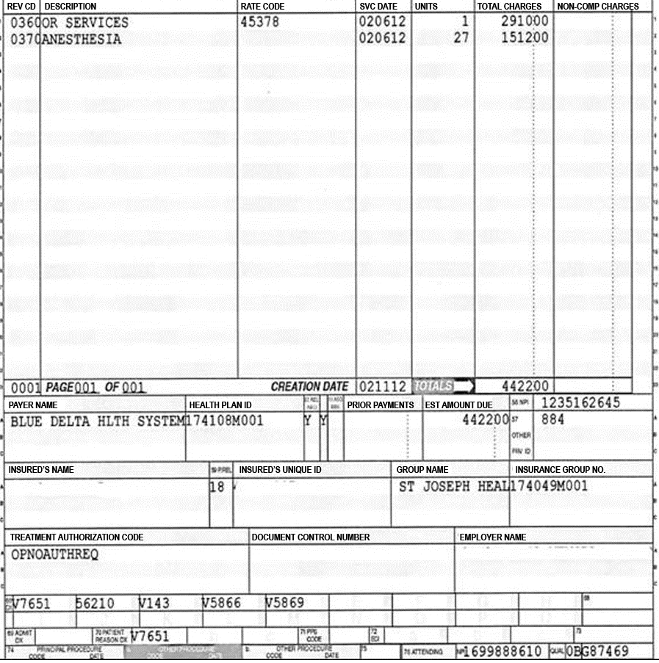
Student Resource 14.2
Reference: Interpreting a Medical Bill
Directions: Use this information to help you understand the bill in Student Resource 14.1, Sample: Medical Bill.
Procedural Codes
The bill contains some codes that explain what procedures were performed. If you look up the procedural codes, you will find that the patient is being billed for a sigmoidoscopy and a colonoscopy. Sigmoidoscopies and colonoscopies are a way to examine a person’s bowels with a flexible camera. A sigmoidoscopy looks only at one part of the colon, whereas a colonoscopy looks at the entire colon. The American Cancer Society recommends that people over 50 years of age get regular colonoscopies.
The codes on the bill refer to the following procedures. It’s okay if you don’t understand what all of the words mean; you can still get a general idea what the bill is about.
45341 | Sigmoidoscopy, flexible; with endoscopic ultrasound examination
45342 | Sigmoidoscopy, flexible; with transendoscopic ultrasound guided intramural or transmural fine needle aspiration/biopsy(s)
45350 | Sigmoidoscopy, flexible; with transendoscopic stent placement (includes predilation)
45355 | Colonoscopy, rigid or flexible, transabdominal via colostomy, single or multiple
45378 | Colonoscopy, flexible, proximal to splenic flexure; diagnostic, with or without collection of specimen(s) by brushing or washing, with or without colon decompression (separate procedure)
Diagnostic Codes
The bill also contains diagnostic codes that explain why the procedures were performed. Diagnostic codes that begin with V indicate that the reason for performing the procedure is preventive.
If you look up the diagnostic codes, you will find the following information:
V76.51 | Screen Colon
562.10 | Diverticulosis Colon
V14.3 | HX-Anti-Infect Allergy
V58.66 | Long-term (current) use of aspirin
V58.69 | Other medication, long-term, current use
The first code (V76.51) explains the main reason the procedure was done. In this case, it is a routine screening for cancer. The other codes make note of other things to check out during the colonscopy, including whether the patient is developing diverticulosis, another disease of the colon, and how the medications the patient is taking (including aspirin) are affecting the colon.

Charges
There is a charge for each procedure, and then a total. The hospital will submit the bill to the patient’s insurance (in this case, Medicare, because the patient is an elderly man). Insurance companies and Medicare have a predetermined amount they will pay for each procedure, based on the code. Medicare will pay its agreed-upon amount.
Sometimes older people have additional insurance to cover what is not covered by Medicare. If this patient has additional insurance, that will help him pay the rest of the bill. If the patient can’t afford to pay his bill, he needs to talk to the hospital billing staff. All hospitals have policies about how to work with patients who cannot afford to pay their entire bill. In some cases, the patient may qualify to have part of his bill written off, meaning he won’t have to pay it.
Student Resource 14.3
Note Taking: Medical Coding
Student Name:_______________________________________________________ Date:___________
Directions: Use this resource to take notes as you view the presentation on medical coding.
What are the three types of information in a patient’s medical record?

Fill in the following chart to explain the purpose of each type of code, give some examples of professionals who use the code, and give one example of the code.
Code Type | Purpose | Which professionals use this type of code and why | Example
ICD Codes

CPT Codes

Level 1 HCPCS Codes

Level 2 HCPCS Codes

Post-Presentation Coding Practice
Directions: Read the medical scenario. Then work with a partner to answer the questions.
A man brings his 92-year-old mother to the emergency room. The woman lost her balance and fell down in her home. She is complaining of hip pain. The doctor examines her and sends her for a hip X-ray to see if she has any fractures.

Which types of codes would be used, and what might each type of code indicate?

Are there any codes that would not apply to this situation?

Student Resource 14.4
Reading: Medical Coding
In this presentation, you will learn about medical coding, including the types of codes that are used and why they are important.
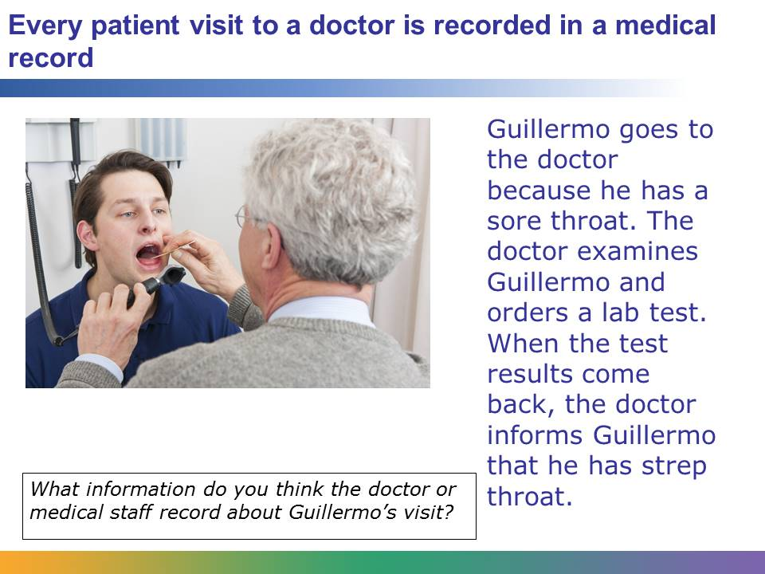
Every patient has a medical record, a file of all the times the patient has seen a medical professional, why the patient needed medical attention, and what the medical professional did. These used to be paper files, but now they are usually kept electronically.
In this case, Guillermo’s file should include the following details:
- He requested an appointment because of a sore throat.
- The doctor examined him.
- The doctor ordered a lab test.
- The lab test results said that Guillermo has strep throat.
Information about Guillermo's age, height, weight, blood pressure, any existing conditions, current medications he is taking, and insurance will also be noted in his medical record. Noting this information is standard procedure for any visit.
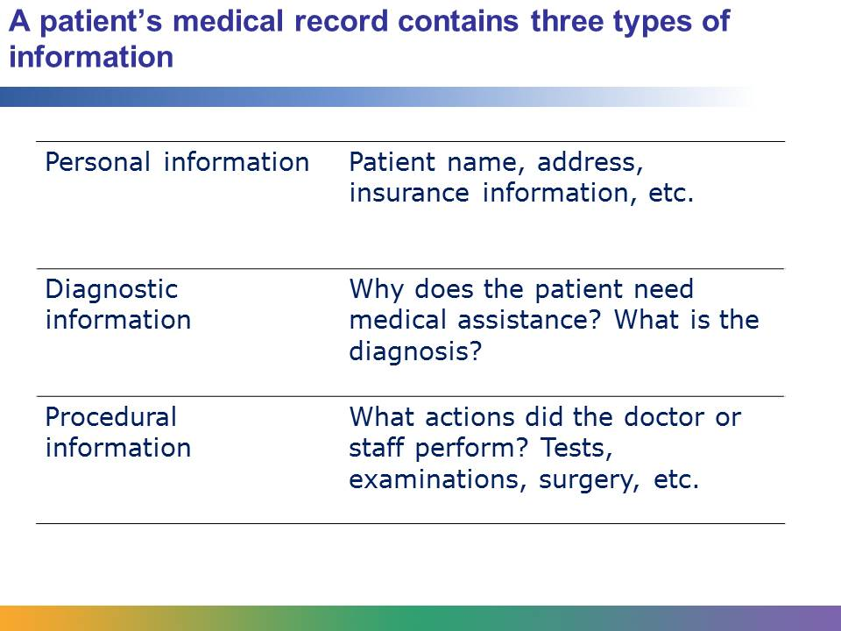
Personal information is an important part of the medical record because it identifies the patient. Later in this lesson you will learn how a patient's personal information is protected by law.
Diagnostic information answers the question “why?” It explains why the patient is seeking medical assistance.
A woman goes to the emergency room with a broken leg. Why did she go? Because her leg is broken. That is diagnostic information.
A man with diabetes goes to the lab to have blood drawn. Why is he getting blood drawn? Because he has diabetes. That is diagnostic information.
Procedural information answers the question “what?” It explains what the medical professionals do for the patient.
A woman goes to the emergency room with a broken leg. The emergency department staff takes an X-ray and puts a cast on the leg. What did the staff do? Took an X-ray. Put on a cast. That is procedural information.
A man with diabetes goes to the lab. The phlebotomist draws the blood. What did the professional do? Draw blood. That is procedural information.
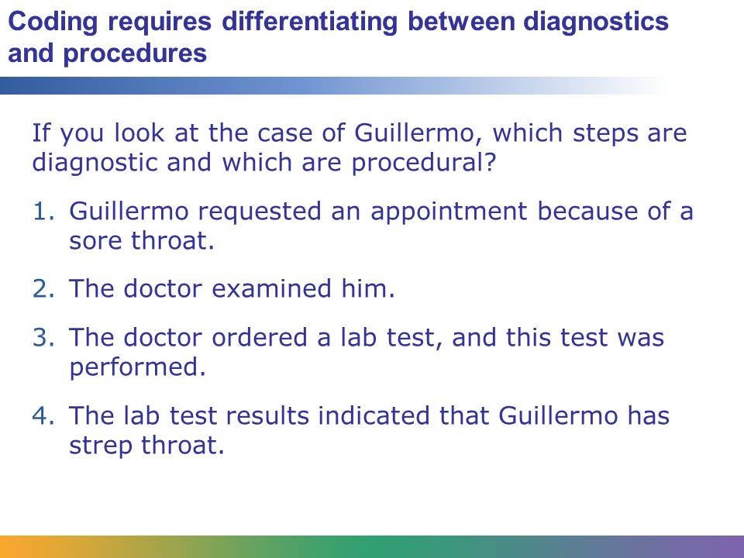
In this case, Steps 1 and 4 are diagnostic, and Steps 2 and 3 are procedural.
Guillermo didn’t come into the office saying “I have strep throat.” He said he had a sore throat. So that’s the first piece of diagnostic information we have. The doctor has to determine why his throat is sore. Did Guillermo go to a great concert last night and scream until his throat hurt? Does he have strep throat? Does he have throat cancer? Until the doctor examines him and does tests, all we know is “sore throat.”
Once the test results come back, we have more diagnostic information. Now we know: it’s strep throat. If the strep throat test came back negative, the documentation must be very clear as to why the test was done and what the doctor plans to do next, or the insurance company may not reimburse the physician and patient becomes responsible for the entire bill. Typically, the doctor would have to do more tests to determine what is wrong with Guillermo’s throat, and all those test results would also be diagnostic information.
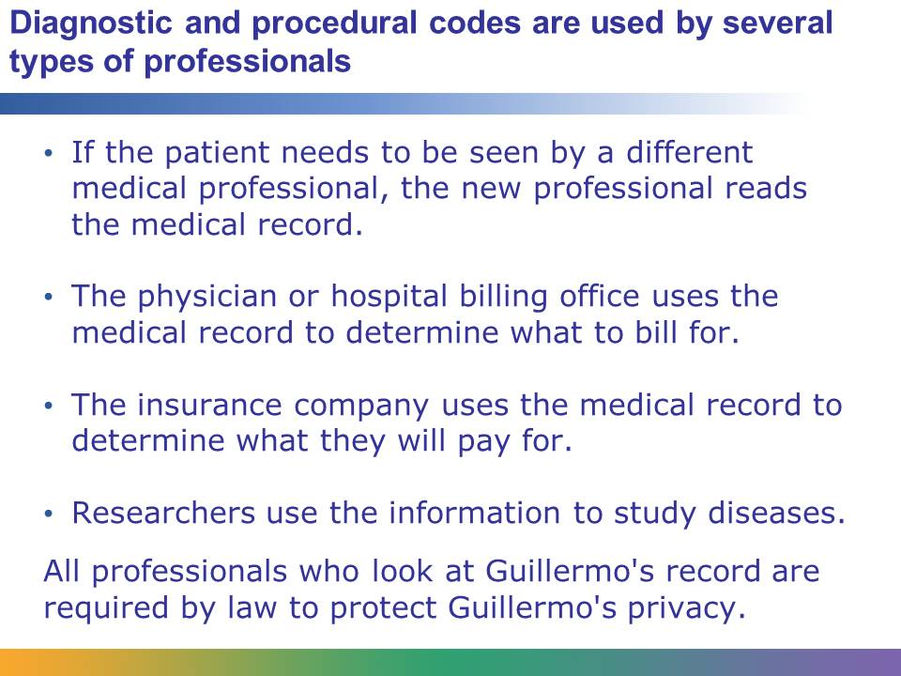
Imagine that Guillermo’s test results were negative: he did not have strep throat. His regular doctor isn’t sure what’s wrong with him, so he sends Guillermo to an ear, nose, and throat specialist. That new doctor needs to know what has already been done. The new doctor would read Guillermo’s EMR to see what diagnostic and procedural information is already in there, and know not to bother testing him for strep throat again.
That’s not the only way this information is used. The doctor’s billing office needs to know what was done to and for Guillermo, because that’s how they bill. So they use the procedural information to create a bill.
Guillermo’s insurance company wants to see both the diagnostic and procedural information. They want to know what was done to Guillermo because that’s what they have to pay for. But they also want to know why it was done. If Guillermo was complaining of a sore throat and the doctor removed his appendix, the insurance company wouldn’t pay for that―and they’d probably get the doctor investigated for bad medical practices!
Researchers also use diagnostic and procedural information to find out what diseases/medical conditions are occurring in what locations and how those diseases/conditions are being treated.
Before EMRs, codes would be handwritten and then sent to the appropriate places, such as the insurance company or the billing department. Now once the codes are entered, they populate the patient’s EMR, and then the information is automatically sent to the appropriate places.
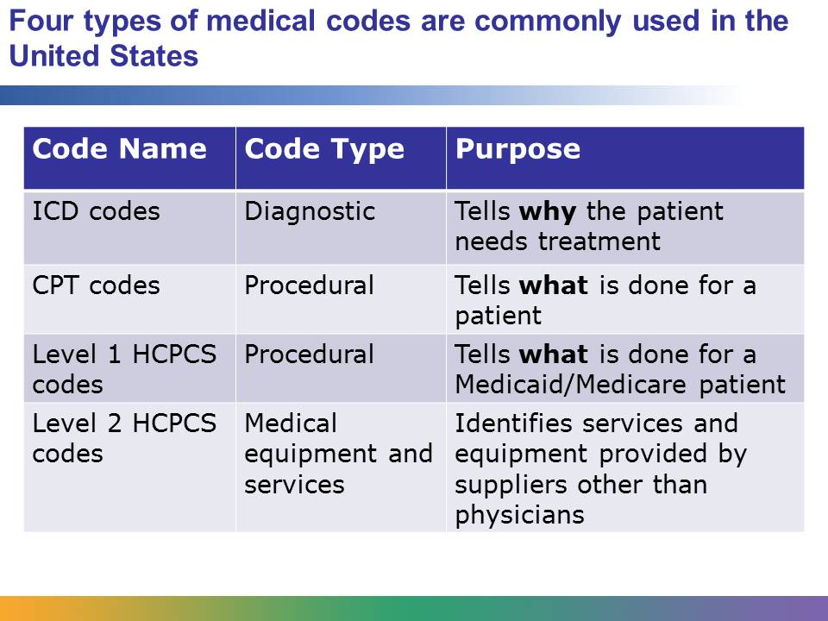
All health care organizations in the United States use the same types of codes, which makes it easy for insurance companies or researchers to compare data from different organizations.
In the United States, there is only one type of diagnostic code, called an ICD (International Classification of Disease) code. This presentation shows ICD-9 codes, but the deadline for the United States to begin using ICD-10 coding is October 1, 2014.
There are two types of procedural codes:
- CPT (Current Procedural Terminology) codes
- Level 1 HCPCS (Healthcare Common Procedure Coding System) codes are assigned to procedures medical practitioners provide to Medicaid and Medicare patients. This includes medical, surgical, and diagnostic services. These are based on and identical to the CPT codes used for patients who are not on Medicaid or Medicare. HCPCS is often pronounced “hick-picks.”
- Level 2 HCPCS codes are used by medical suppliers other than physicians, such as ambulance services or providers of durable medical equipment. These codes are for items that are not covered by CPT codes. Medicaid, Medicare, and private insurers use these codes for billing purposes.
Usually codes are entered during a patient’s visit. Many medical practices and hospitals use computers so medical professionals can enter information into the patient’s medical record right away. These systems often have a built-in tool to help doctors or other staff enter codes while they are seeing the patient.
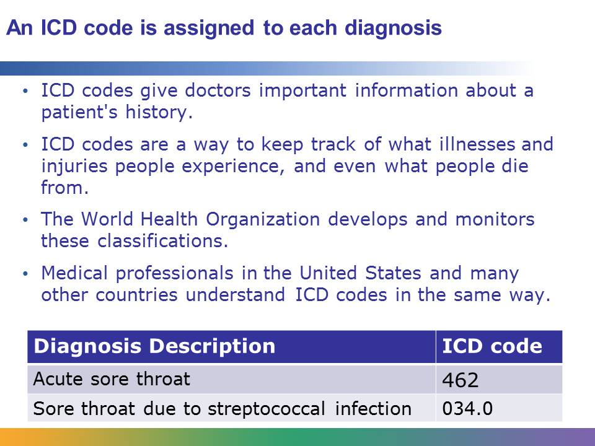
When Guillermo goes to the doctor for a sore throat, the first ICD-9 code would be 462 (Acute Sore Throat.) When the test results come back, the doctor knows Guillermo has strep throat. Now a new ICD-9 code is entered: 034.0 (Sore Throat due to Streptococcal Infection.)
Hundreds of years ago, doctors began trying to keep track of what killed people: diseases, accidents, childbirth, etc. That evolved into an international system of classification of causes of death. By the early 20th century, doctors felt that it was important to keep track of what illnesses and injuries people experienced while they were alive as well as what killed them. That eventually led to the creation of the ICD (International Classification of Disease), which is used by the World Health Organization and health organizations across the globe. In the United States, the ICD codes are administered by the Department of Health and Human Services and the CDC. ICD codes are also used to identify a cause of death, which helps researchers track things like how many people are dying of cardiovascular disease or whether a contagious disease is becoming an epidemic.
ICD codes are important because they tell us diagnostic information: why did the doctor do what he did? Sometimes ICD codes are added to a file after the patient’s visit is over. In Guillermo’s case, a new ICD code would be added after the test results came back. But those codes are still important because they tell anyone reading Guillermo’s medical record why the doctor ordered those lab tests. After finding out Guillermo has strep, the doctor might prescribe medication for him. Having the ICD code for strep throat in the file explains why the doctor ordered that medication.
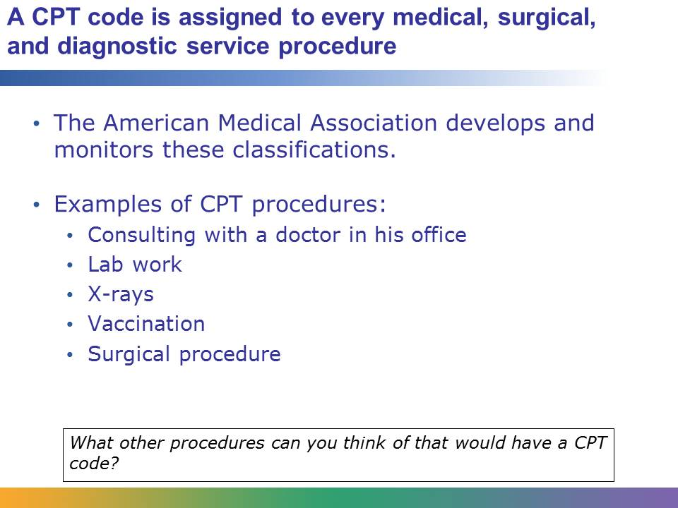
In many cases, a patient visit might include several procedural or CPT codes for only one or two diagnostic (ICD-9) codes. If a patient has lab work done, gets an X-ray, receives a vaccination, or has a minor surgical procedure, each of these things has its own CPT code. Just talking with the doctor in his office gets a CPT code (for a consultation).
Some CPT codes are grouped by the type of service, such as anesthesia, laboratory, or radiology services. Other CPT codes, such as surgical codes, are grouped by bodily system: muscular, respiratory, cardiovascular, and so on.
Nowadays, most medical practices and hospitals enter CPT codes on a computer during the patient’s visit.
CPT codes are then used for billing purposes. A hospital or physician’s billing office creates a bill based on what services were provided to the patient. The biller uses the CPT codes in the patient’s file to create the bill. The patient’s insurance company also uses CPT codes to determine how much they will reimburse the practitioner for each service. Since everyone uses the same codes to mean the same thing, they ensure uniformity.
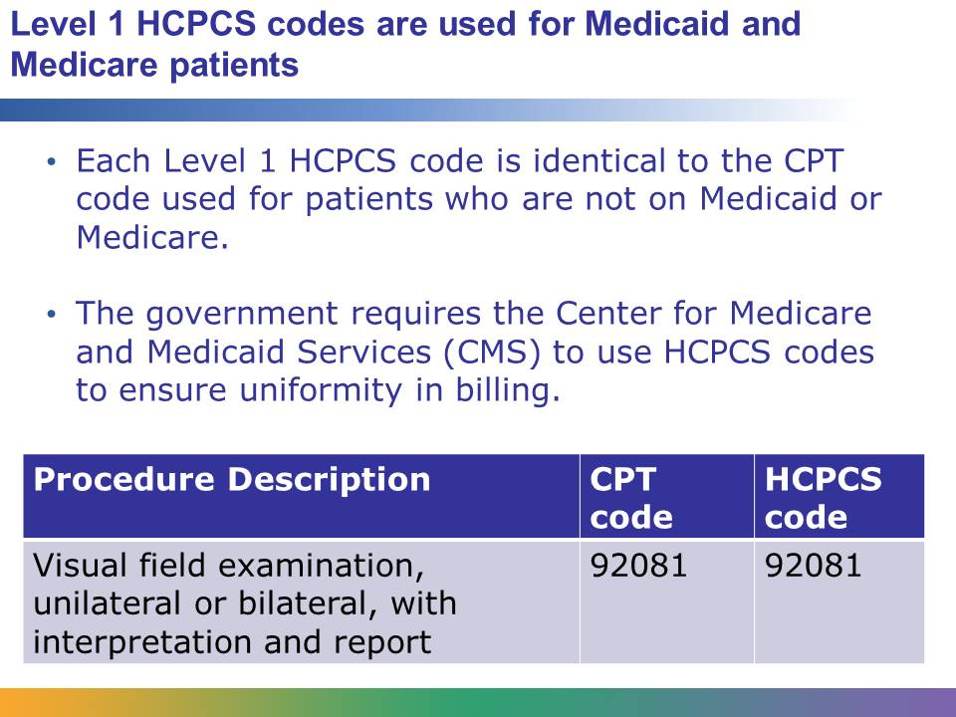
Medicare is the US government’s health insurance program for people over 65. Medicaid is the US government’s health insurance program for people who fall below a certain income level. These programs are administered by the Center for Medicare and Medicaid Services (CMS), which also supervises the HCPCS codes.
Remember that Level 1 HCPCS and CPT codes are identical procedural codes. They answer the question “What was done to/for the patient?”
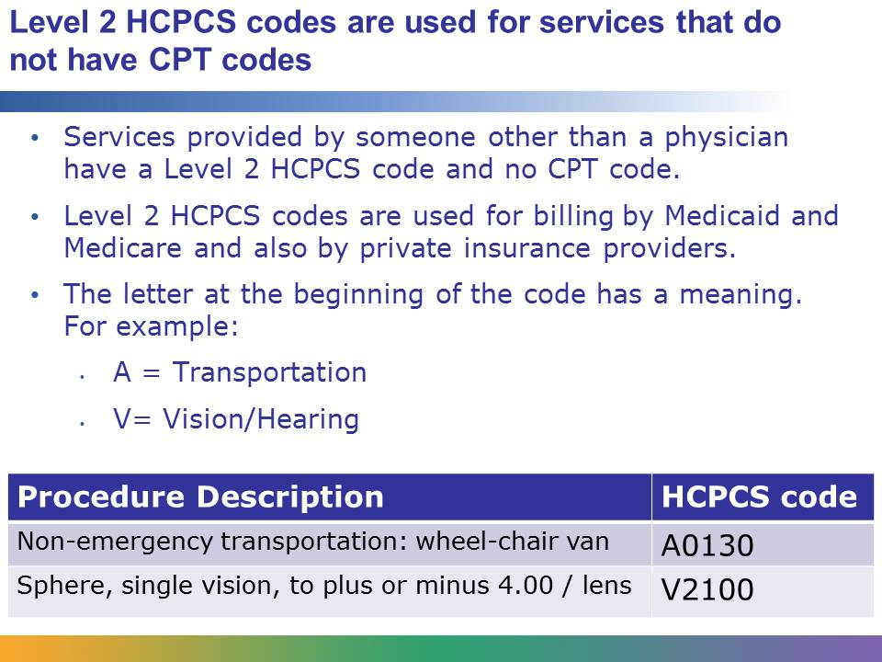
Most services and procedures are covered by CPT codes. However, CPT codes do not cover most services that are not provided by a doctor. Ambulance services are a good example of that. Durable medical equipment, the medical equipment that a patient might use at home, is another example. Durable medical equipment includes things like an oxygen machine or a wheelchair.
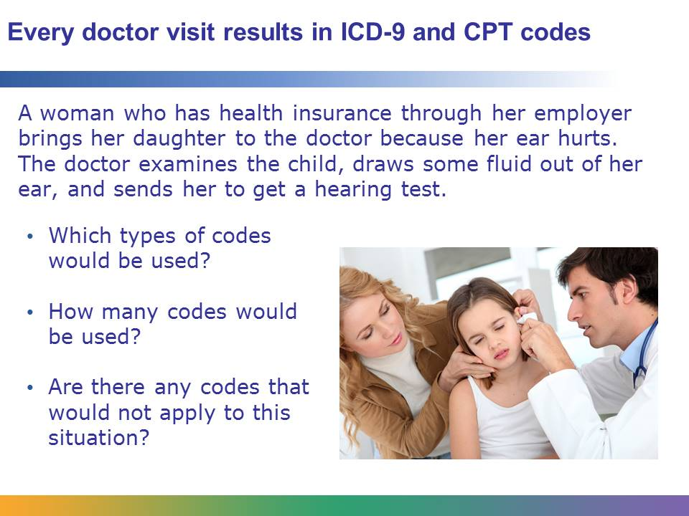
ICD-9 and CPT codes would be used in this situation. An initial ICD-9 code would be used for the child’s ear pain; once the test results came back, an additional ICD-9 code might be used, depending on test results.
At least three CPT codes would be used: one for the doctor’s examination, one for the tympanocentesis (drawing fluid from the ear), and one for the hearing test.
HCPCS codes would not apply in this situation. The child is not a Medicare patient (she’s too young) and she is not a Medicaid patient (her family has insurance). She has not used ambulance or durable medical equipment services. Therefore no HCPCS codes would be used.
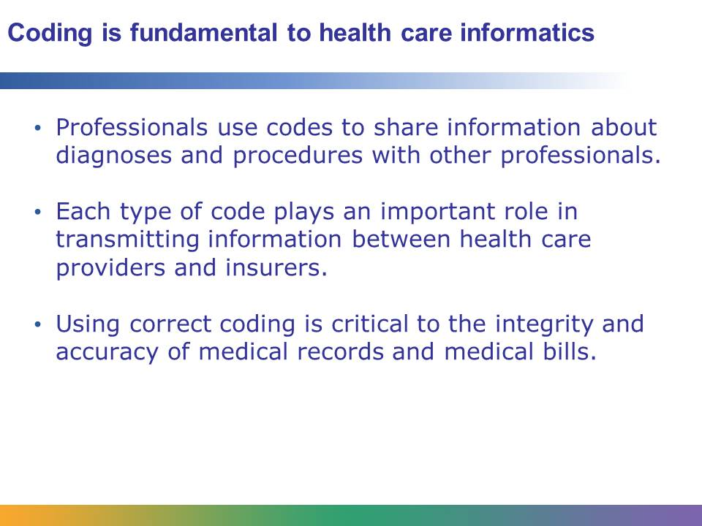
No matter what health care career you pursue, your training is likely to include memorizing at least some of the most frequently used medical codes. Understanding the basics of medical coding can help you when interviewing for an internship or applying for a job.
Student Resource 14.5
Note Taking: Patient Medical Records
Student Name: Date:
Directions: Complete this resource as you read Student Resource 14.6, Reading: Patient Medical Records.
- What is a medical record? What information is in a patient’s medical record?

- What is an electronic medical record (EMR)? What are the advantages of an EMR?

- Who can access a patient’s medical record?

- How do insurance companies use medical records?

- What happens to old medical records?

- What jobs involve working with medical records? What training do you need for these jobs? How much money do these jobs pay?

Student Resource 14.6
Reading: Patient Medical Records
Dr. Alice Wozniak was about to see her first patient of the day. She refreshed her memory about the patient’s situation. James was a 91-year-old man who had a stroke about two months earlier. Now he was on blood-thinning medication, but some of the medication’s side effects were causing him problems.
Dr. Wozniak knocked on the door of the exam room and greeted James and his granddaughter, who had brought him to the appointment. The doctor looked over James’s weight and blood pressure, which the medical assistant had noted, and then began asking James questions about his medication: when did he take it? Did he take it with food? What other medications was he taking? Dr. Wozniak recorded his answers, and then suggested that James should change the time of day at which he took his medication. If that didn’t work, they could adjust the dose, but Dr. Wozniak thought he should stay on the same dosage for at least another month or two. James and his granddaughter thanked the doctor. Dr. Wozniak said goodbye and headed off to see her next patient.
A lot of medical information was needed for such a simple appointment. Dr. Wozniak had to review the patient’s medical history. The medical assistant needed to record the patient’s weight and blood pressure. Dr. Wozniak needed to keep track of the patient’s answers to her questions, and Dr. Wozniak needed to make note of what she recommended to the patient. All of this information goes in the patient’s medical record. A medical record is a file that records all of a patient’s health information: tests and procedures that are performed, diseases/medical problems the patient has, and doctor’s recommendations and diagnoses.
The Changing Face of Medical Records
A medical record used to be a paper file that was stored in your doctor’s office. If you went to the hospital, the hospital kept a paper file on you, too. Can you imagine how inconvenient that was? It took up a lot of space to store all those paper records, and it was hard to find information. Plus, if you had to go to the emergency room, you’d have a file at the hospital, but your doctor wouldn’t know that file was there or what the hospital did for you unless you notified him. Plus, paper charts were costly; they had to be stored somewhere.
Today, most medical practices and health systems are moving to electronic records. An electronic medical record (EMR) is maintained in a secure computer system and it can be accessed by many different people. Take James, for example. When he sees Dr. Wozniak, his regular doctor, she records all his information in his EMR. When James went to the emergency room because he was having a stroke, the doctors and nurses at the hospital could access his EMR, so they could see his entire medical history. The hospital staff also recorded information in his EMR, so the next time he saw Dr. Wozniak, the information from the hospital was already available to her. With an EMR it is also easier to find specific information. James would have a pretty thick medical record, since he’s 91. It might take some time for the doctor to determine what medications he was taking five years ago. With an EMR, searching for that information is much simpler.
The term electronic health record (EHR) is also used for records that include a patient's long-term and cumulative health information generated by encounters with multiple physicians and other caregivers.
Some EMR programs enable the provider to print out a visit summary that the patient can take home. This summary may include specific instructions for further care as well as details about what was done during the appointment. Some EMR systems also allow patients to access their information remotely and email their doctors directly. Imagine that James has a blood test. When the test results are ready, they are posted to James’s EMR. James can log in to the EMR system using a password he got from his doctor. He can read his blood test results and even compare them to the last blood test he took. If he has a question, he can email his doctor about it. EMRs make it easier for people to access the information in a patient’s medical record. While EMRs clearly reduce paperwork, it is also important to note that electronic records increase the potential for privacy errors. You will learn more about the importance of protecting the privacy of data stored in EMRs later in this lesson.
As you can see in this screen shot, an EMR stores all kinds of information. This window shows the patient’s vital signs, but there are also tables to show things like a problem list, a patient history, demographics, and allergies. When health professionals have more information, they are better equipped to provide the correct treatment.
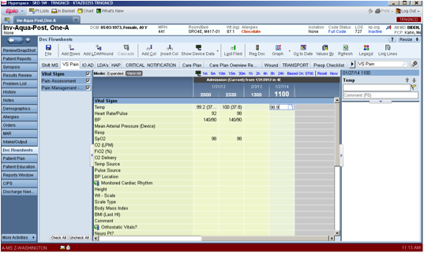
Accessing Medical Records
One of the benefits of EMRs is that it is easier for multiple people to access it. But a patient’s medical record is confidential. Who is entitled to access a patient’s medical record?
- The patient or patient’s representative
- Medical providers
- The patient’s insurance company
- The government
A patient can request access to his medical record. In addition to remote EMR access, patients sometimes need their entire record, such as when they are moving to a new provider. A patient can request a copy of his medical record from his doctor’s office. The copy can be sent directly to the patient or the patient can request that it be sent to another doctor or hospital. If the patient cannot act for himself (for example, an underage patient or a patient who is not competent to manage his own medical care), a family member or caregiver may be able to access the record. Insurance companies access EMRs to determine what they owe the provider and to make sure the provider is caring for the patient well. The government is entitled to access a patient’s medical record for a variety of reasons, including for legal actions and checking on potential public health issues.
Health care providers are required to keep records on all of their patients for a set number of years, which varies depending on the setting. Frequently, a provider maintains records on former patients for up to 10 years. After that time period, the provider may dispose of old medical records in a safe and secure manner.
Health Information Management as a Career
Hospitals used to have a medical records department, where paper files on all the hospital’s patients were maintained. Today, that department is called Health Information Management, and the paper files have been replaced by computers.
A Registered Health Information Technician (RHIT) makes sure that medical records are complete and accurate. The RHIT enters data into the patient’s record, makes correction, and uses computers to search the data to find information for researchers and health care administrators. An RHIT needs an associate degree and makes an average salary of $52,771.
A Registered Health Information Administrator (RHIA) is in charge of the Health Information Management department. The RHIA supervises the RHITs and advises health care administrators and health care professionals on issues related to health information management. An RHIA needs a bachelor’s degree plus an additional certificate and makes an average salary of $68,213.
Student Resource 14.7
Reference: Health Informatics Careers
Admitting Clerk
Responsible for processing information for patients who are admitted to or discharged from the hospital. Enters data into the patient’s EMR (electronic medical record) and may also take payments from the patient. Requires a high school diploma. Average yearly salary: $28,661.

Health Educator
Teaches people about health topics, including nutrition, exercise, disease and injury prevention, and so on. May work for a health system or insurance company or for the government. Health Educators must be up to date on latest health research on their topic and must know how to present this information effectively to diverse target audiences. Requires a bachelor’s degree; many health educators pursue a master’s degree as well. Average yearly salary: $44,340.

Health Care Administrator
Responsible for overseeing the functioning of a medical practice, hospital, or health system. Job titles can include director, vice-president, CFO (chief financial officer), COO (chief operating officer), or CEO (chief executive officer). Requires a bachelor’s degree and a master’s degree (typically a master of business administration), as well as years of experience. Salaries vary greatly depending on the level of administration but frequently exceed $100,000 per year.

Privacy Officer or Compliance Officer
Responsible for making sure the organization meets HIPAA standards for EMR privacy. Informs patients of their rights regarding access to their EMR. Tracks any privacy breaches and informs patients who may be affected by the breach. Requires a bachelor’s degree as well as years of experience and specialized training. Average salary: $74,781.

Medical Coder
Responsible for adding ICD, CPT, or HCPCS codes to the patient’s EMR and for making sure all codes are accurate. Requires an associate degree and specialized training. Average salary: $43,359.

Registered Health Information Technician
Makes sure that medical records are complete and accurate; enters data into the patient’s record, makes corrections, and uses computers to search the data to find information for researchers and health care administrators. Requires an associate degree. Average salary: $52,771.

Registered Health Information Administrator
In charge of the health information management department. Supervises technicians and advises health care administrators and health care professionals on issues related to health information management. Requires a bachelor’s degree plus an additional certificate. Average salary: $68,213.

Medical Illustrator
Uses drawing skills to convey scientific information through pictures and graphics. May illustrate medical procedures, anatomical structures, or other scientific information. Usually illustrations are used for textbooks, magazines, or websites about medical/scientific subjects. Some illustrators also provide images for lawyers to use in court cases. Requires a bachelor’s degree. Average salary: $42,700.

Patient Accounts Director
Supervises patient accounts office, which may include charity, credit, billing, insurance, and collection. Oversees a staff of people. Ensures that patients pay their bills and tracks hospital or medical practice revenue. Requires a bachelor’s degree and several years of experience; many directors have master’s degrees. Average salary: $114,474.

Patient Account Representative
Tracks outstanding accounts. Bills insurance companies and patients, follows up on unpaid bills, answers billing inquiries, adjusts bills/account records as necessary. Requires a high school diploma and two to four years of related experience. Average salary: $33,105.

Patient Advocate
Works on behalf of a patient. May be employed by a hospital or health system, or may be independently hired by the patient/patient’s family. Responsible for getting answers to patient questions, coordinating care between multiple health care providers, educating family members/caregivers about the patient’s condition, and managing insurance/billing issues. Requires a bachelor’s degree; some advocates have a master’s degree. Average salary: $51,895.
Student Resource 14.8
K-W-L Chart: Protecting Patient Privacy
Student Name:_______________________________________________________ Date:___________
Directions: Write down anything you already know about the laws and methods for protecting patient privacy in the What I Know column. Then write down anything you would like to learn about this topic in the What I Want to Know column. Finally, as you view the presentation on HIPAA, add to this chart in the What I Learned column.
What I Know | What I Want to Know | What I Learned
Student Resource 14.9
Reading: HIPAA Privacy and Security Compliance
In this presentation, you will learn about patient privacy and why it is important. You will also learn about the law called HIPAA, which provides legal guidelines for health care workers about how to handle patient information.
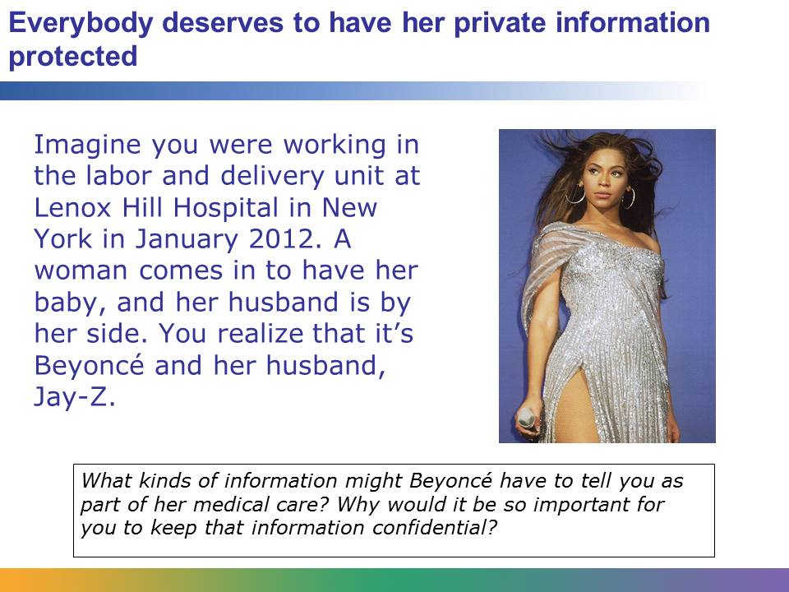
Upon being admitted to the hospital, Beyoncé would need to give hospital staff information including her address and contact information, her insurance coverage, and her medical history. Can you imagine how much money TMZ or a tabloid newspaper would pay for that kind of information? And once the baby was born, can you imagine how much they would pay for photos of the baby? But Beyoncé and Jay-Z deserve privacy, just like everybody else. They have a right to share information about their baby when and how they want to. If word got out that she was having her baby at your hospital, you might have crowds of fans showing up, which would be a nuisance. You might even have people who tried to kidnap the baby, since both parents are very famous and very rich. All of these are good reasons to keep patient information confidential, but there is one more good reason: it’s against the law to share patient information except in very specific circumstances.
A real-life example is the psychiatric hospitalization of Britney Spears that was leaked. The information was actually sold by someone in the medical records department who is doing jail time for making the disclosure. Also there were over 100 people including nurses and doctors who accessed her EMR and were either fired, fined, or reported on just for accessing a medical record they had no business being in. Those in the medical field take HIPAA very seriously.
Image retrieved from http://commons.wikimedia.org/wiki/File:Beyonce.jpg on May 2, 2012. Image courtesy of Jen Keys.
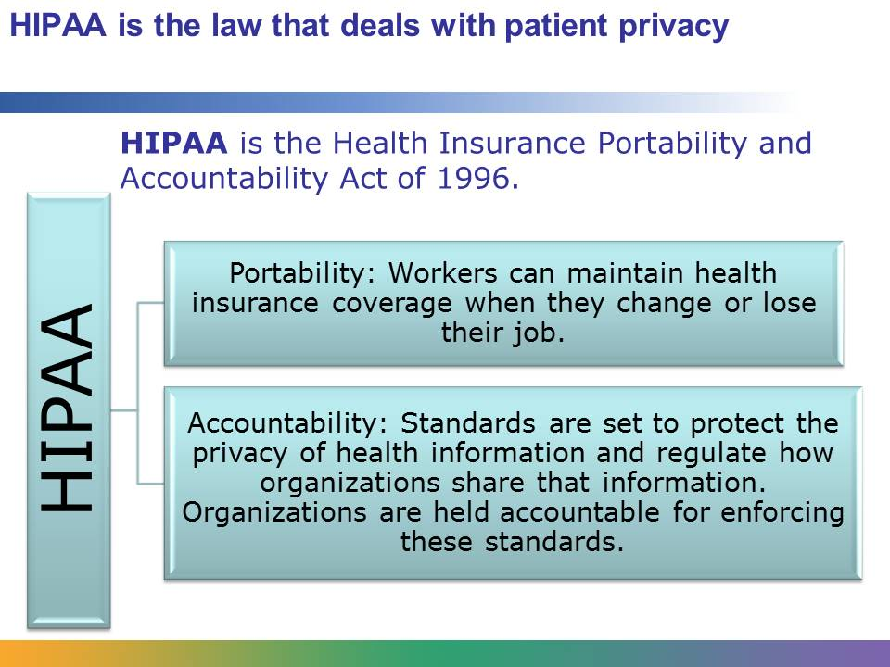
HIPAA is an extremely important act to understand if you work in the health care industry. All employees need to know about HIPAA because each professional who has access to a patient’s health information is responsible for abiding by HIPPA standards and regulations. Doctors, nurses, technicians, and other care providers might access a patient’s electronic medical record (EMR) to input data or to evaluate the patient’s progress. An admitting clerk might access the patient’s EMR when the patient enters the hospital; a patient account representative might access the EMR to bill the patient or the patient’s insurance company. Even support staff, such as custodians, need to know about HIPAA. If a janitor finds a printout of patient information on the floor, he needs to know how to dispose of that information correctly. You will have to abide by HIPAA any time that you observe or work in a medical setting. If you don’t, the health care organization where you are serving could get in a lot of trouble.
There are two parts to HIPAA: portability and accountability. We will look at each piece in more detail.
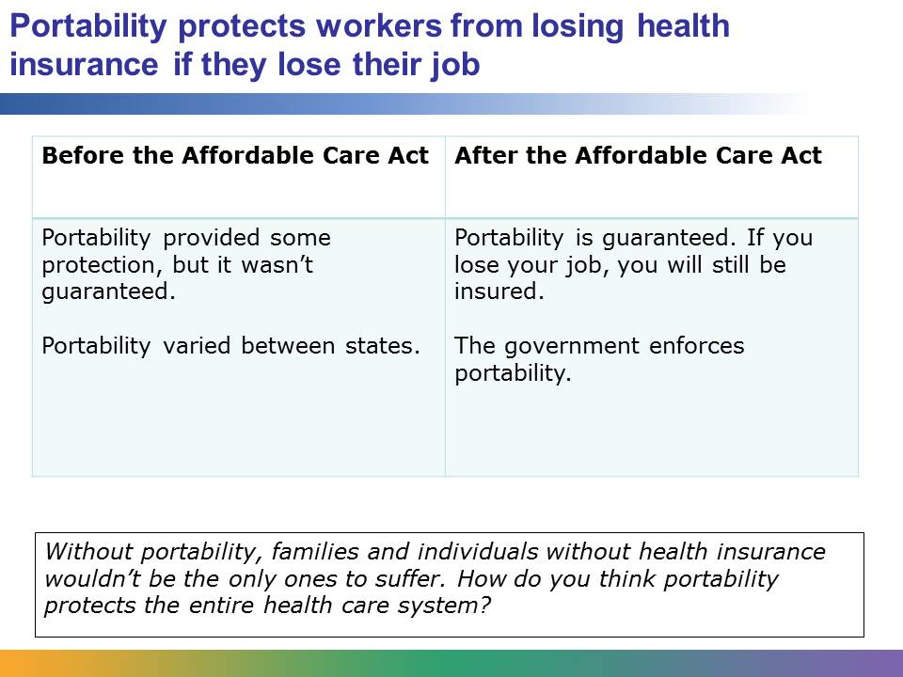
Imagine this scenario: Julia’s company lays off half of the staff, and unfortunately Julia is one of the employees to lose her job. Not only did she receive health insurance through her company, but her entire family did. Her husband has a chronic heart condition and her daughter has autism; both conditions require frequent medical attention.
What if when Julia lost her job, she lost her health insurance too? Julia’s family would experience a very serious hardship. HIPAA addressed this problem. HIPPAA created a safety net for people to maintain health insurance when they change jobs or lost their job. However, the Affordable Care Act (ACA) made that safety net even safer. Now portability, which protects workers from losing health insurance if they lose their job, is guaranteed and enforced by the government.
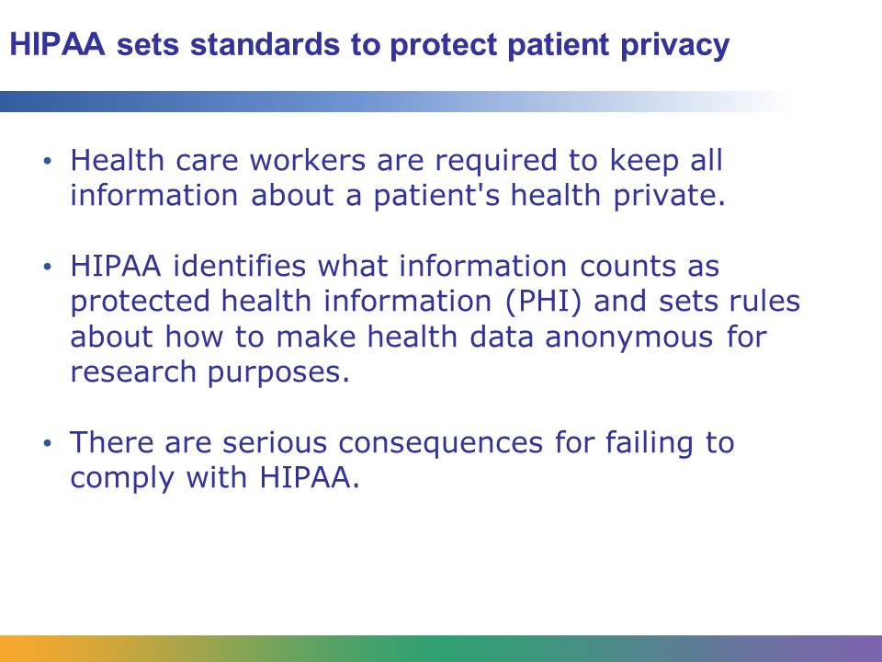
With more and more organizations using electronic transactions and electronic medical records (EMRs), HIPAA set the standard for how an organization should protect its patient information.
HIPAA regulates:
- What information is classified as private
- When it’s okay to share a patient’s information
- How to make data anonymous by removing all information that could be used to identify a person
HIPAA also established substantial penalties for people and organizations that don’t protect patient privacy. This law obliges organizations and their employees to respect the privacy of all patients, not just famous ones like Beyoncé.
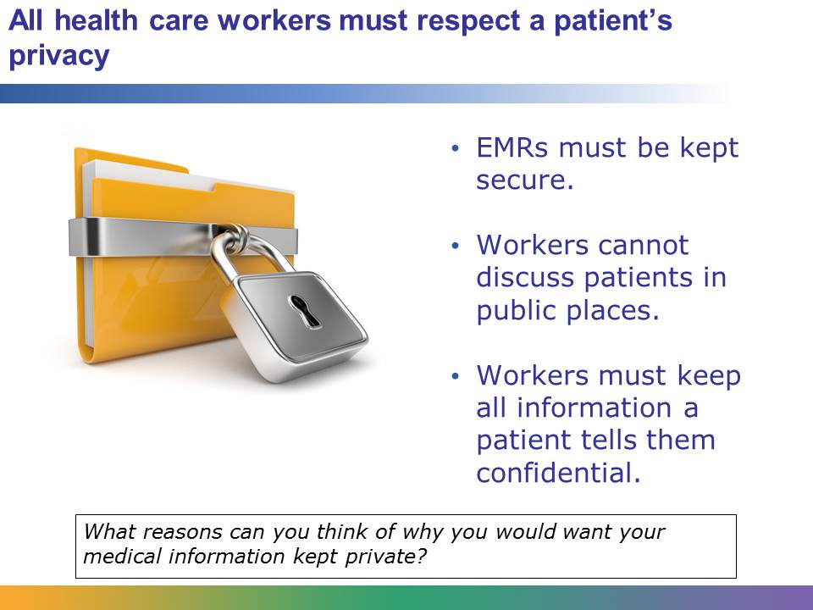
A patient’s EMR has a lot of important information in it. It includes the patient’s name, address, social security number, and birthdate, among other things. This information could be used by criminals for identity theft, which is one reason a medical organization needs to keep the EMR secure.
Beyond that, the EMR has the person’s medical history: what diseases the person had, what tests or procedures have been done, and so on. That information also needs to be kept private. The information might be embarrassing; for example, a patient might not want people to know he had an STD. On the other hand, a patient might worry that he will lose his job if his employer finds out he has HIV, a woman might want to wait before telling her boss that she is pregnant, or a dying father might want to choose his own time to tell his children about his prognosis. It is unfair and inappropriate for these patients’ medical information to become public knowledge without their consent.
Health care workers must be careful about discussing patients. They might need to talk about a patient’s care: for example, a doctor giving a nurse instructions about how to care for a patient after surgery. But if they have that discussion in the hallway, other people might hear details about that patient that should have remained private.
In the same way, if a patient confides in a doctor or another medical professional, that information must remain private.

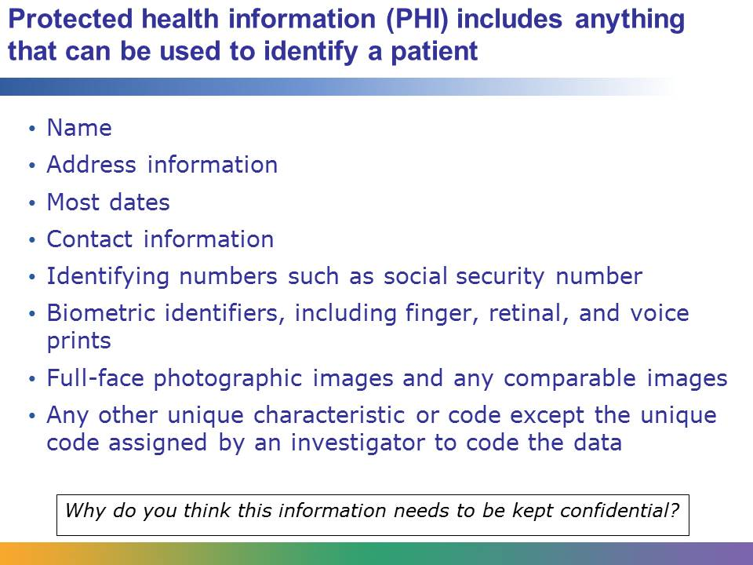
PHI includes anything that would help people identify a specific patient. Names, biometric identifiers (fingerprints, retinal scans, or voice prints) and full-face photos are obviously PHI. In terms of a patient’s location, anything more specific than the US state is considered PHI. For dates, the year can be used, but more specific dates are considered PHI. A patient’s contact information―phone numbers, fax numbers, email addresses―is PHI.
Identifying numbers are a major part of PHI. These include social security numbers, medical record numbers, account numbers, health insurance numbers, certificate/license numbers, vehicle identification numbers or license plate numbers, and device identifiers and serial numbers.
In some cases, data can by made anonymous by removing PHI. For example, imagine a hospital wants to evaluate how quickly their emergency department responds to a patient having a heart attack. They would look at the record of what was done to each patient. What time did the patient enter the emergency room? How fast was the patient seen by a doctor? How quickly did the patient get the necessary treatment? What was the outcome: was the patient admitted to the hospital? To answer these questions, they don’t need to know a patient’s name, their date of birth, or where they live. The data might include the patient’s year of birth and their gender, so if there were three heart attack patients in one night, the researcher could use that information to tell them apart. But PHI cannot be included in research data.
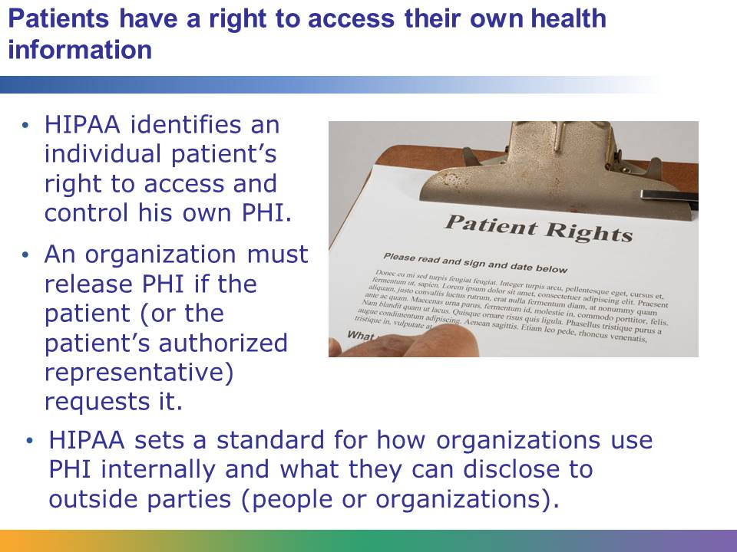
HIPAA states that an organization is required to disclose PHI in two situations:
- If the patient (or the patient’s authorized representative) requests it
- If the US Department of Health and Human Services requests it
A patient request is the most common reason to disclose PHI. For example, a man gets a biopsy done of a mole on his face to find out if he has skin cancer. He calls the doctor’s office to find out the results of the biopsy. The office releases the biopsy results to him.
A “patient’s authorized representative” generally means a family member who is acting for a patient. For example, a mom might call the doctor’s office to find out test results on her 8-year-old son. Her son is under age, which makes her an authorized representative for him. A son might talk with the doctor about his elderly mother who is suffering from Alzheimer’s. Since she is not competent to make medical decisions, her son would have legal paperwork identifying himself as an authorized representative.
HIPAA sets requirements about what information can be released to people. If someone is hospitalized, the hospital cannot tell people anything about that patient’s condition unless the patient gives permission.
Where this gets very sticky is when a young woman who is a minor becomes pregnant. Once she is pregnant, she is considered an emancipated minor, and neither her parents nor anyone else is authorized to have information released to them.
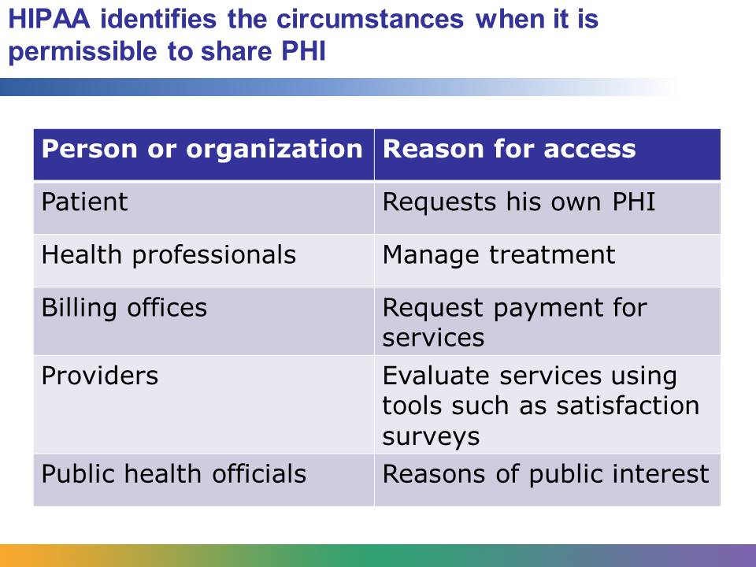
You’ve already considered how PHI might be released to the patient or patient’s representative. HIPAA identifies other situations in which PHI can be accessed.
A medical practice uses PHI to determine the course of treatment. For example, if a doctor requests an X-ray on a patient, the radiologist and technicians can access the patient’s EHR in order to perform the X-ray effectively.
A medical practice’s billing office needs to access the EHR in order to know what services to bill for.
Providers also use PHI to evaluate how effective their care is. In some cases, they can use anonymous data, but often providers do patient satisfaction surveys. In order to contact patients, they need to access PHI.
Public interest is a broad category. Public health issues may require the release of PHI because a patient infected with a highly contagious disease may have spread the disease to others. Public interest also covers a health care provider’s responsibility to report child abuse or neglect. PHI may also be released in cases that involve legal proceedings, such as patients who suffered as result of a crime.
Finally, PHI can be used in less serious circumstances if patients are offered the opportunity to opt out. For example, many hospitals maintain a directory of patients. People calling the hospital can request this information. However, a patient must be allowed to opt out of this directory if he or she prefers.
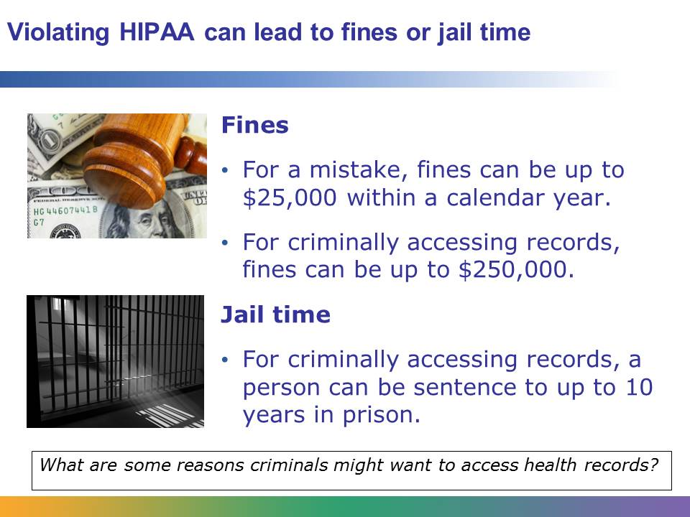
When workers are careless and HIPPA violations occur by mistake, a single instance may lead to a fine of $100. Fines for carelessness can total up to $25,000 in a year.
Sometimes people access PHI for unethical and illegal reasons. HIPAA defines this based on intent: “a person who knowingly obtains or discloses individually identifiable health information in violation of HIPAA.” Criminally accessing records can lead to significant fines and jail time. The amount of the fine and the length of imprisonment depend on how the information is used. If a person accessed PHI with an intent to make money off of it, that person faces fines of $250,000 and imprisonment of 10 years. How would a person make money off PHI? Think about Beyoncé. There are websites, newspapers, magazines, and TV shows that would pay a lot of money for inside information about her health. If a health care employee accesses a celebrity’s medical record, that is a HIPAA violation. If the employee then sells that information to TMZ or a tabloid, that is a criminal violation, and the employee is in serious trouble. In addition to fines and jail time, employees are likely to lose their jobs for violating HIPAA.
Beyond the fines and potential imprisonment, HIPAA violations reflect badly on an organization. If a privacy breach happens, the organization has to notify all the patients who are potentially involved. Do you think those patients will want to return to that organization for care in the future? HIPAA violations are a serious problem.

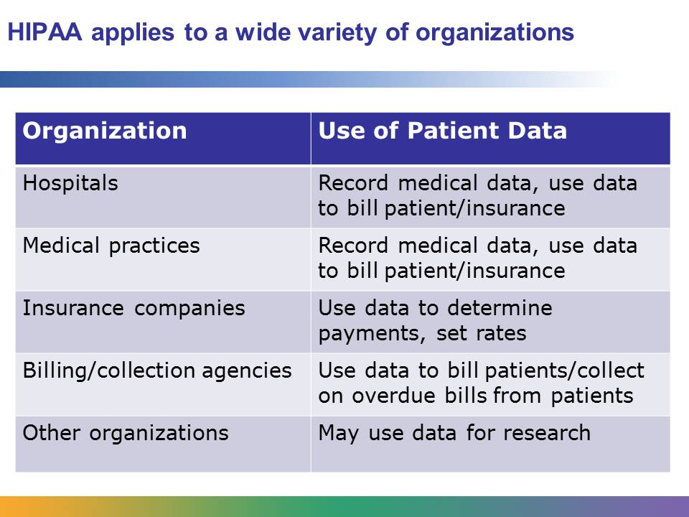
It seems obvious that doctors and medical professionals shouldn’t share confidential information. But any organization that deals with health information has to follow HIPAA guidelines. That includes insurance companies, billing or collection agencies, or any organization that uses medical data for research. You may never meet the patient whose EHR you are working on, but you are still bound by HIPAA to protect that patient’s privacy.

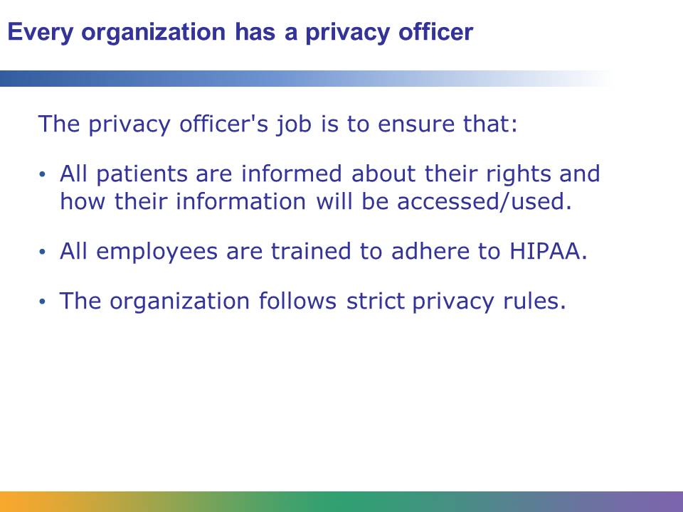
Every health care organization, such as a hospital, is required to have a privacy officer (also called a compliance officer) whose job is to make sure that the organization is compliant with HIPAA. The privacy officer works with hospital administrators to make sure that all patients are informed about their rights regarding their medical information. This information may be posted on the walls of the hospital where patients can read it, or it may be included in the paperwork a patient signs when being admitted to the hospital.
The privacy officer makes sure that all employees are trained to comply with HIPAA.
If a privacy breach occurs, the privacy officer is the main contact person. The privacy officer notifies patients that may have been affected by the breach. He works with government officials and hospital administrators to determine how the breach happened and fix any holes in the system. This may include making changes to computer security or even firing or disciplining employees. An employee who is involved in a breach must be retrained on HIPAA. The privacy officer oversees these retrainings as well.
Sometimes breaches are minor: an employee looks at a friend’s medical record to see how a friend is doing, or two employees gossip about a patient. Sometimes breaches are significant, and hundreds of thousands of patient records are at risk. The privacy officer has to follow up on every breach, no matter the size, and treat each breach seriously.
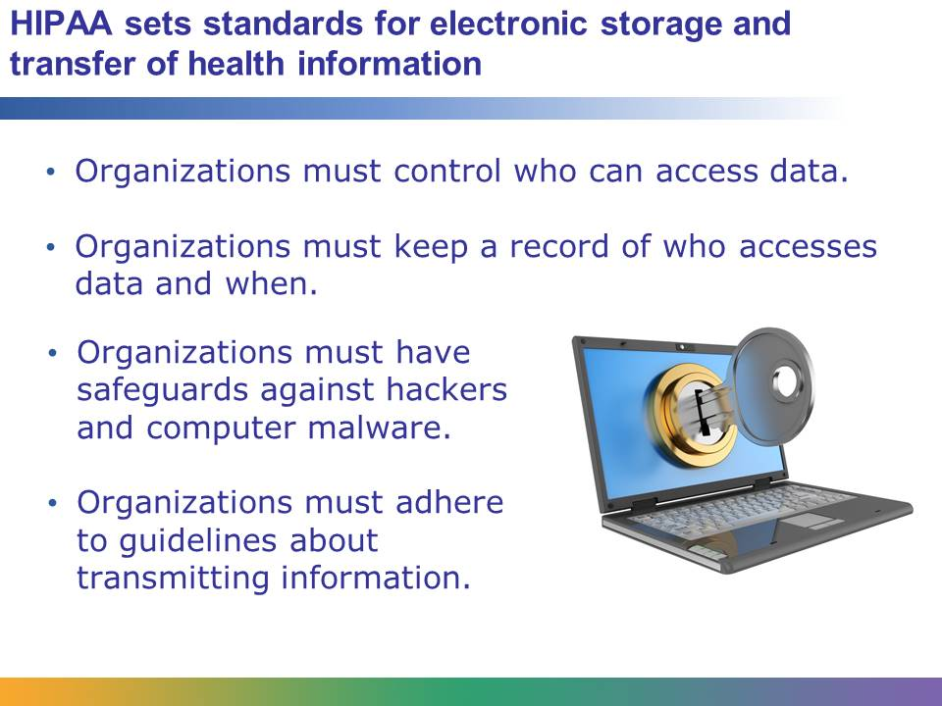
EMRs are stored in a secure system that is designed to protect the information from hackers and any other types of malicious computer attacks. To access an EMR system, an employee needs a user name and password. Most EMR systems keep an access log that records each time a person logs in and it also records what EMRs that person views.
Why is that important? Because if a nurse looks up information on a patient that she is not responsible for, that is a HIPAA violation. Believe it or not, a nurse cannot look up her own EMR. She cannot look at a friend’s EMR, or her son’s, or her husband’s. Any time she looks at an EMR for a patient that she is not caring for, that is a HIPAA violation. If the nurse wants to check out her own test results, she needs to talk to her doctor’s office, just like any other patient.
In addition, all organizations must follow careful procedures about transmitting information. Some EMR systems allow patients to log in remotely to view their test results. In that case, the organization must be very careful to make sure it is giving access to the right patient. If the organization transmits information to an insurance company, they need to take precautions to make sure they are sending information on the right patient to the right person at the right insurance company. A simple mistake, like sending the records for John B. Smith when the patient was John A. Smith, is also a HIPAA violation.
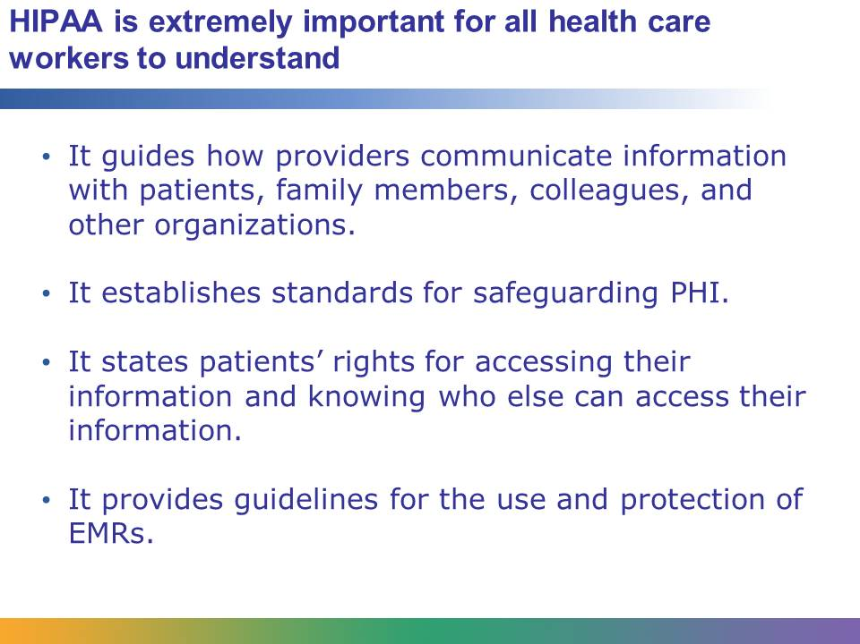
Whatever career you pursue in the health care industry, you need to understand HIPAA. If you are a doctor, nurse, or care provider, HIPAA regulates what information you can share and under what circumstances. If you work in health informatics, do health research, or work for an insurance company, you must follow HIPAA standards when accessing PHI. You might even consider a career as a privacy officer or working for a company that designs and maintains EMR systems. HIPAA influences every aspect of the health care industry today.

