Student Resource 13.2
Reading: How Is a Dental Office Organized?
Most dentists are general practitioners. That means they do regular preventive care and treatment of oral health problems like cavities or mild gum disease. A general practitioner usually has three people working in the office with her: a dental assistant, a dental hygienist, and a receptionist.
Preparing a Dental Tray
Consuelo is a dental assistant. One of her responsibilities is to prepare the trays of instruments.
First, Consuelo checks the appointment log to see what patients are coming in that morning. Different procedures require different instruments. This morning, she is preparing for a routine teeth cleaning.
Consuelo makes sure she has a mask and a pair of gloves already out. She lays out a bib and the short chain called the bib connector, which keeps the bib on the patient.
She puts her gloves and mask on and then grabs a sterilized pack of instruments and opens it up. Consuelo lays the instruments on the tray in the order they will be used, starting with a mirror to look inside the mouth and an “explorer” tool which can be used to check for cavities.
She also puts a small square of gauze on the tray so she can wipe the mirror clean, and a suction tool, which she can use to draw excess saliva out of the patient’s mouth.
Now the tray is all set and Consuelo can bring in the first patient.
When the day begins, the dental assistant prepares the room or rooms where the dentist will work. This room is called the operatory. The dental assistant cleans and disinfects the room and sets up the equipment based on what appointments are scheduled for that day. The tools the dentist uses have to be sterilized to control the risk of infection.
The receptionist handles duties such as answering phones and greeting patients. When a patient arrives, the assistant brings the patient into the operatory. Since many patients are nervous about dental care, the assistant needs to be reassuring and friendly. The assistant gets the patient seated in the dental chair and puts a bib on the patient to keep the patient’s clothes clean. The assistant usually wears medical scrubs, and when working on a patient, the assistant might wear gloves, eye protection, and a mask for sanitary reasons. The dental hygienist and dentist will also wear protective gear when working with the patient.
If the patient is getting a checkup and cleaning, the dental hygienist usually begins to work with the patient next. Before seeing the patient, the hygienist reviews the patient’s chart to become familiar with the patient’s oral health history. If the patient is new to the dental practice, the hygienist will begin by charting the patient’s oral health history and asking questions about previous dental problems, mouth pain, oral care habits, and so on. With an established patient, the hygienist might just ask a few questions about whether anything has changed since the patient’s last visit. Then the hygienist will do a visual examination of the patient’s mouth, teeth, and gums.
If the patient needs to have X-rays taken, the hygienist does that, sometimes with help from the dental assistant. There are several different types of X-rays that show different parts of the mouth. Once the X-rays have been taken, the hygienist uses several different tools to clean the teeth and gums.
After the cleaning, the dentist sees the patient. The dentist does an examination of the patient’s mouth and recommends specific treatment, like filling a cavity, extracting a tooth, or repairing a damaged tooth. After the examination, the hygienist meets with the patient again and gives the patient specific advice about oral health care. In addition to general tips like brushing twice a day, the hygienist might show the patient a better technique for how to floss or how to use a toothbrush to take care of the gums as well as the teeth.
Every dental office needs someone to keep the office running smoothly. In some smaller offices the dental assistant does this work, but most offices have a dental receptionist. The receptionist’s duties include greeting patients who enter the office, making appointments, and billing patients or insurance companies. Some dentists have a large office with several operatories. In that case, the receptionist is the one responsible for keeping the dentist on schedule, reminding the dentist which patient needs to be seen next, and making sure the dentist has the right charts available for each patient.
After each patient, the dental assistant cleans the operatory, takes the instruments away to be sterilized, and sets up a new instrument tray for the dentist and hygienist to use.
Most dental offices open early in the morning so people can have appointments before work, and most cleaning appointments take an hour to an hour and a half of the hygienist’s time. Some dental offices are open on evenings or weekends to accommodate patients with busy schedules.
Many dentists are in private practice, which means they are their own boss. In addition to taking care of their patients, dentists in private practice are running their own business, so they have some of the same responsibilities as a business owner, like buying equipment or hiring new staff.
At the end of each day, there are a few tasks that still need to be handled. Dental models might need to be shipped to a lab, or dentist might need to consult with a specialist about how to care for a particular patient. The assistant is responsible for making sure all the instruments have been sterilized and all the equipment is being maintained properly. The hygienist and the dentist share responsibility for making sure the patient charts are up to date before the receptionist files them away.
A dental office has a small team of people who work together closely. Each person plays an important role in making sure their patients enjoy good oral health.
Student Resource 13.3
Venn Diagram: Doctors’ and Dentists’ Offices
Student Names:_______________________________________________________ Date:___________
Directions: Using Student Resource 13.2 for information about a dental office, and referring back to Student Resource 7.3, Reading: Health Care Professionals’ Roles in a Doctor’s Office, compare and contrast characteristics of a doctor’s office and a dentist’s office in this Venn diagram.
Student Resource 13.4
Note Taking: Dental Health Procedures
Student Name:_______________________________________________________ Date:___________
Directions: Take notes using 13.5. Write down each procedure in the left column. Then write down a brief explanation of the purpose of the procedure in the middle column. In the right column, write down the job title of the professional who does the procedure.
Procedure | Its Purpose | Who Does It?
Student Resource 13.5
Reading: Dental Health Procedures

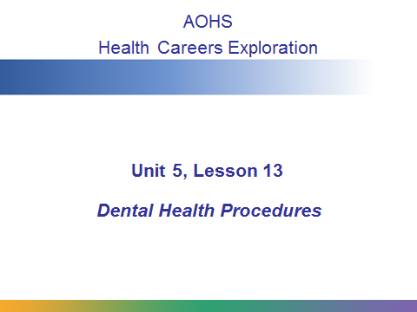
In this lesson you are going to learn about common dental health procedures and the dental health professionals who are responsible for them.

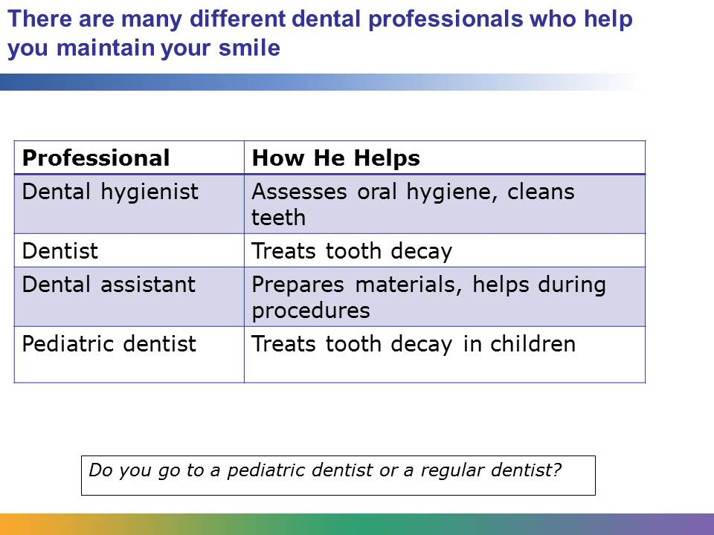
All of us encounter dentists, dental hygienists, and dental assistants on an ordinary visit to the dental office. The dental assistant answers the phone, makes appointments, and prepares the equipment for each patient. It takes one year of training and classes to become a dental assistant.
The dental hygienist evaluates a patient’s oral hygiene, takes her oral health history, and does general teeth cleaning. It takes two to four years of schooling to become a dental hygienist.
A dentist treats tooth decay, fills cavities, extracts teeth, and may do other dental procedures that you will learn about in this presentation. To become a dentist, a person must graduate from college and complete four years of dental school.
A pediatric dentist specializes in treating children. A pediatric dentist does many of the same procedures as a regular dentist. You may have a pediatric dentist now, or you might have gone to one in the past. A pediatric dentist must complete college, dental school, and two years of post-dental-school training in working with children and children’s teeth.
All dental professionals must pass national certification exams and/or state certification exams after they finish their schooling.
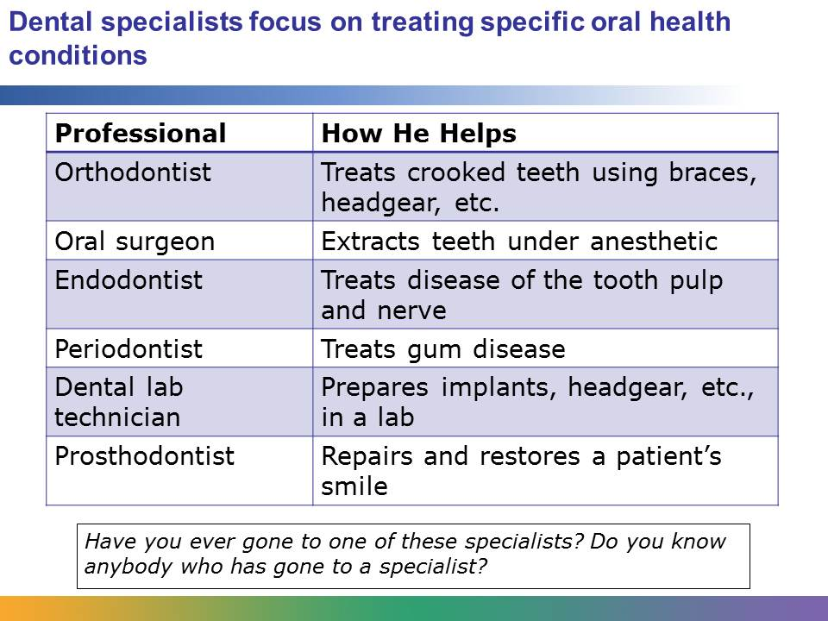
Many people visit an orthodontist to get crooked teeth corrected, and many people need an oral surgeon to remove their wisdom teeth.
Visiting an endodontist or periodontist is less common, but it might be necessary if you have certain oral health conditions. Prosthodontists work to repair damage to a patient’s smile. This can include replacing missing teeth or doing cosmetic dentistry to make the teeth look better.
All of these specialists must complete college, dental school, and two to three years of post-dental-school training in their specialty, plus the appropriate licensing exams.
Specialists may have their own dental offices or they might share a dental office with other dentists. Some oral surgeons work at a hospital to repair jaw and mouth deformities or damage caused by car accidents.
Dental lab technicians do not visit with patients, but they work together with prosthodonists and orthodontists to create the dental implants and orthodontic devices that some people need as part of their oral health care. A dental lab technician needs two years of training and classes, plus a certification exam.
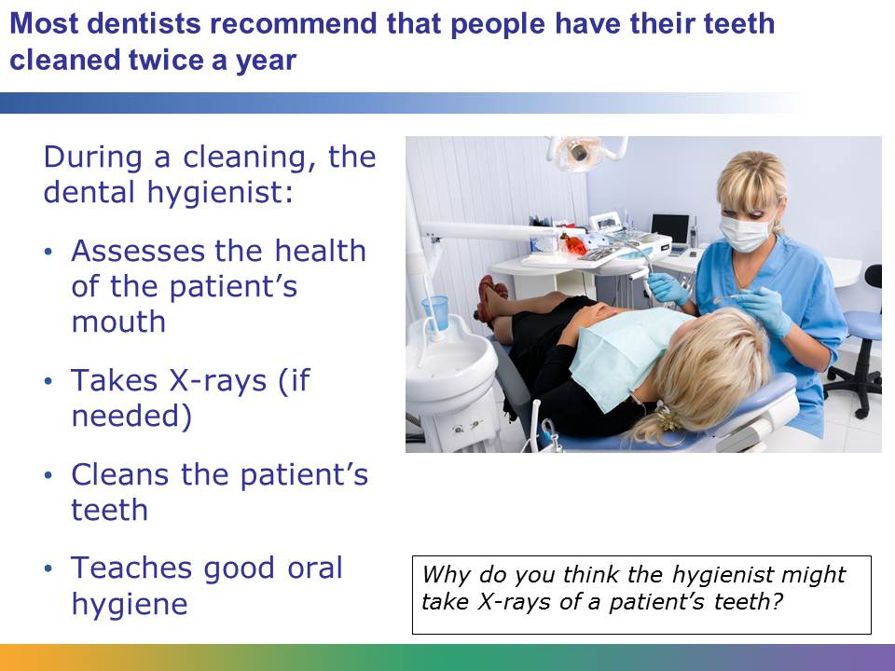
A dental cleaning is like a checkup for your teeth. When a patient has a cleaning, he interacts primarily with the dental hygienist. The hygienist begins by asking about the patient’s dental history and any dental problems he might have. The hygienist might take X-rays of the patient’s teeth as well. X-rays can be used to identify some problems, like tooth decay or gum loss. X-rays can also identify teeth that are still coming in, which can be very important when treating children or teenagers.
Then the hygienist examines the patient’s mouth, looking for gum disease, cavities, cracked or loose teeth, or any problems with previous dental work, like a loose filling. Next, the hygienist cleans the patient’s teeth, using dental tools to remove plaque deposits from above and below the gum line.
Once the cleaning is done, the dentist comes in to check on any problems. The dentist uses the X-rays and dental history, plus a visual examination, to determine if the patient has cavities that need filling or if the patient needs to be referred to a specialist for anything.
After the dentist examines the patient, the hygienist might come back to give advice about brushing and flossing techniques or other things the patient can do to improve his oral health.
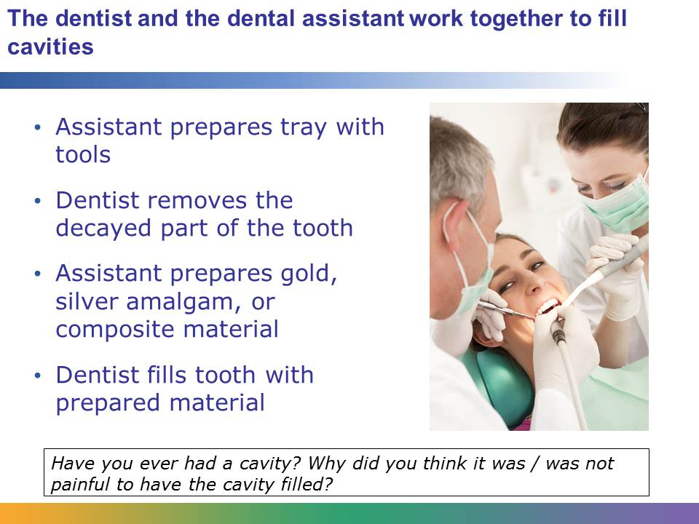
Cavities, or dental caries, are holes in the teeth caused by tooth decay. Some cavities hurt, but sometimes a patient can have a cavity with little or no pain. Even if it doesn’t hurt, a cavity needs to be filled. Cavities that aren’t treated can become bigger problems.
A cavity can be filled with many different substances, including gold, silver amalgam, or composite. Gold fillings last a long time, but they are expensive. Silver amalgam fillings are less expensive, but they are very noticeable in someone’s mouth. Composite fillings can be colored to match the patient’s teeth, but they do not last as long as gold or silver fillings do. Dentists often use composite fillings on noticeable teeth, like those right in front.
When it’s time to fill a cavity, the dentist tells the assistant which material to use. The assistant prepares the filling material and sets up a tray with all the equipment the dentist needs. During the procedure, the assistant hands the dentist tools and suctions excess saliva out of the patient’s mouth.
The dentist may give the patient a local anesthetic to numb the tooth. Then the dentist uses a drill to remove the decayed part of the tooth. The dentist will clean the parts of the tooth that are left and fill in the tooth with the filling material. After the procedure, the assistant cleans up and sterilizes the instruments.
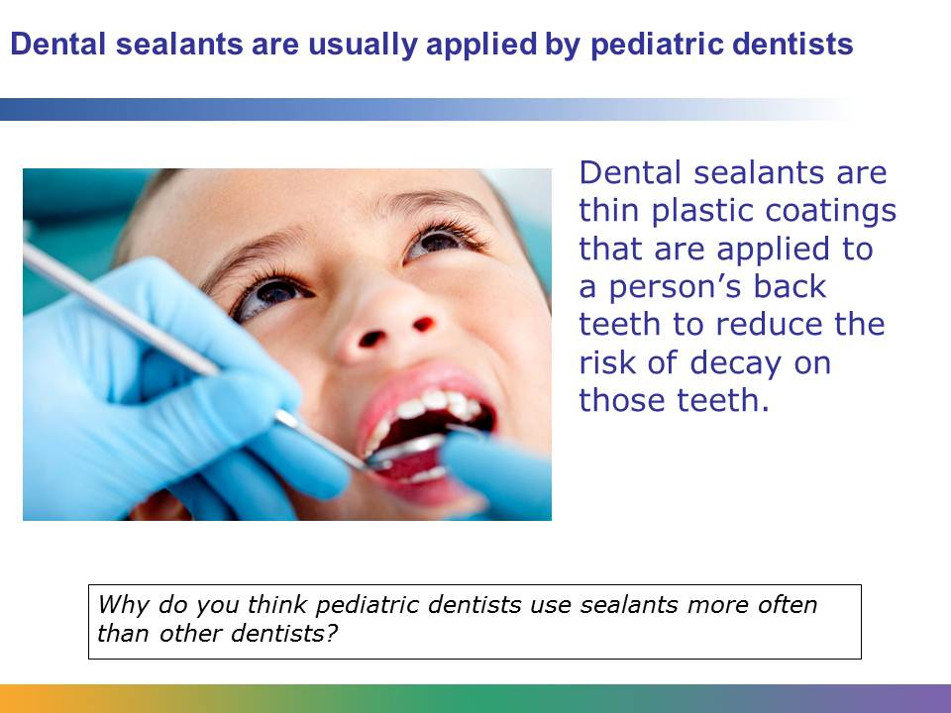
Dental sealants are a preventive measure designed to reduce the risk of tooth decay. After the teeth are thoroughly cleaned, a special gel is placed on the surface. The tooth is washed and dried, and then the sealant is placed on the chewing surface of the tooth. It takes about a minute for the sealant to form a protective barrier over the tooth. Sealants are usually invisible in a patient’s mouth. They can last 5-10 years and can be reapplied.
Pediatric dentists, also called pedodontists, are frequently called upon to apply dental sealants. Since the sealant is a preventive measure, it is most appropriate to apply it to brand new teeth. Permanent molar teeth usually come in between the ages of 6 and 12, so a pediatric dentist is often the likely person to apply the sealant.
In addition to applying sealants, pediatric dentists might fill cavities or extract teeth. A pediatric dentist is trained to do all the things a general dentist can do, but the pediatric dentist has more training in working with kids and more knowledge about how to handle problems that might happen with baby teeth.
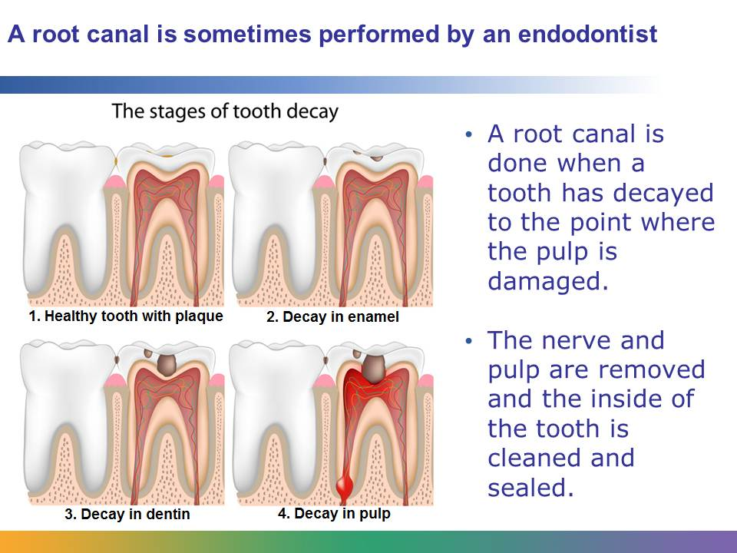
When a cavity goes a long time without being treated, it can break through the tooth enamel and the dentin until it reaches the pulp of the tooth. When bacteria gets into the tooth pulp, it can spread quickly and the tooth can become abscessed. An abscessed tooth can make someone very sick.
Sometimes a general practitioner dentist will perform the root canal, but an endodontist specializes in diagnosis and treatment of problems with the dental pulp and dental nerves. If a root canal looks like it will be complicated, the general dentist will refer the patient to an endodontist.
The endodontist uses X-rays to determine the extent of the damage in the patient’s mouth. Then, working under local anesthesia, the endodontist drills into the tooth and removes all the bacteria and decayed nerve tissue. The endodontist rinses out the tooth to make sure it is totally clean, then seals it back up with a sealer paste and a rubber compound. Then the endodontist fills in the hole that was drilled in the tooth. Because the hole is large, some people need a crown or other restorative dental work after a root canal.
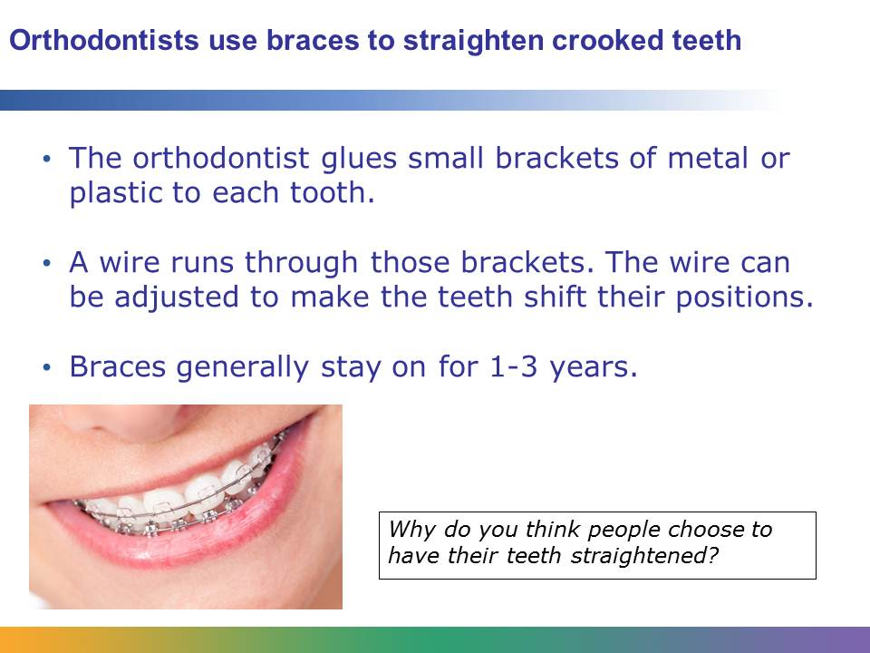
Many things happen before someone gets braces. An orthodontist begins by evaluating how crooked the patient’s teeth are. If the patient doesn’t have all her permanent teeth in yet, the orthodontist may use X-rays to predict how the teeth will grow in. Then the orthodontist creates a plan for how to address problems including crooked teeth, an irregular bite pattern, or gaps between teeth. In addition to braces, the orthodontist may use tools like headgear or rubber bands to help the teeth move.
Most people get braces during their preteen or teen years. The brackets can be metal or plastic. Plastic brackets are less noticeable, but they can get stained by food and they aren’t as durable as metal brackets. Braces work by slowly putting pressure on the teeth to force them to move. Once the braces are removed, most patients receive a retainer that is designed to help the teeth “remember” where they should be.
Invisalign is an alternative approach that orthodontists sometimes use to straighten teeth. Invisalign uses a series of clear plastic trays rather than metal wires to achieve movement.
Many people get orthodontic treatment for cosmetic reasons – they think they look better with straight teeth. But orthodontic care can also correct speech impediments, and it can fix bite problems that interfere with a person’s ability to chew food properly. Plus, it is easier to maintain good oral health if your teeth are spaced properly and not crowded together at strange angles.
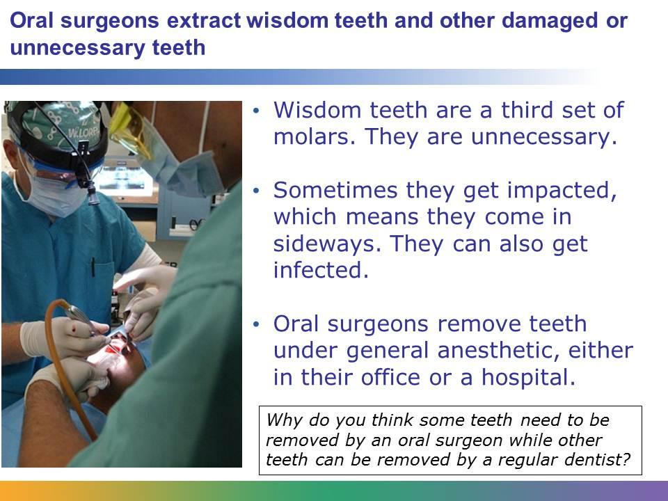
Wisdom teeth usually grow in between the ages of 17 and 25. No one is totally sure why they are called wisdom teeth, but most people think it’s because these teeth come in when you are older and presumably wiser than you were as a child.
Scientists think that ancient humans had larger jaws, so these teeth fit in their mouths. But over time, the human mouth has shrunk, so even though these teeth still come in, there isn’t really much room for them.
Some people have their wisdom teeth removed as a preventive measure. Other people wait until the teeth become impacted or infected. Wisdom teeth removal is a type of surgery and is done under general anesthetic. Some organizations recommend against removing the teeth as a preventive measure, because it could be an unnecessary surgery.
Any dentist can extract a tooth. They might pull out a baby tooth so that the adult tooth can grow in more easily, or they might pull out an adult tooth if it is damaged beyond repair. Oral surgeons typically remove teeth that have not fully come in yet, such as wisdom teeth. Because this involves cutting into the gums and removing teeth close to the jaw bone, it requires a surgeon.
Image retrieved from http://commons.wikimedia.org/wiki/File:US_Navy_030728-N-0023O-078_Lt._Cmdr._Al_Parulis_(left),_the_ship%27s_oral_surgeon,_aided_by_Dental_Technician_2nd_Class_C.J._Garrison,_applies_gauze_to_a_patient%5Ersquo,s_wisdom_tooth_during_oral_surgery_in_dental_spaces_aboard_US.jpg. Image courtesy of Photographer’s Mate Airman Kyle L. O’Neill.
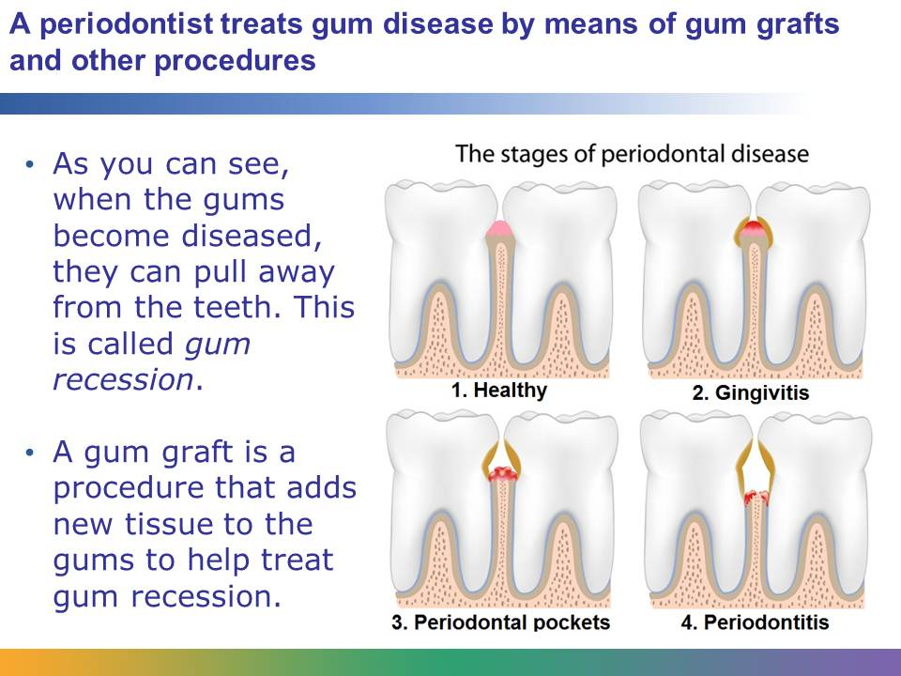
A general dentist can treat mild forms of gum disease, but for something more serious the patient will need to see a periodontist. Periodontists treat all forms of gum disease, from mild inflammation (gingivitis) to advanced gum disease, called periodontitis. Advanced gum disease affects 4%-12% of the adult population. As the gums become more severely inflamed, they begin to pull away, or recede, from the teeth. This can require the patient to get a gum graft.
During the gum graft procedure, a periodontist takes tissue from another part of the patient’s mouth and grafts it, or attaches it, to the place where the gums have receded. This procedure is done under local anesthetic.
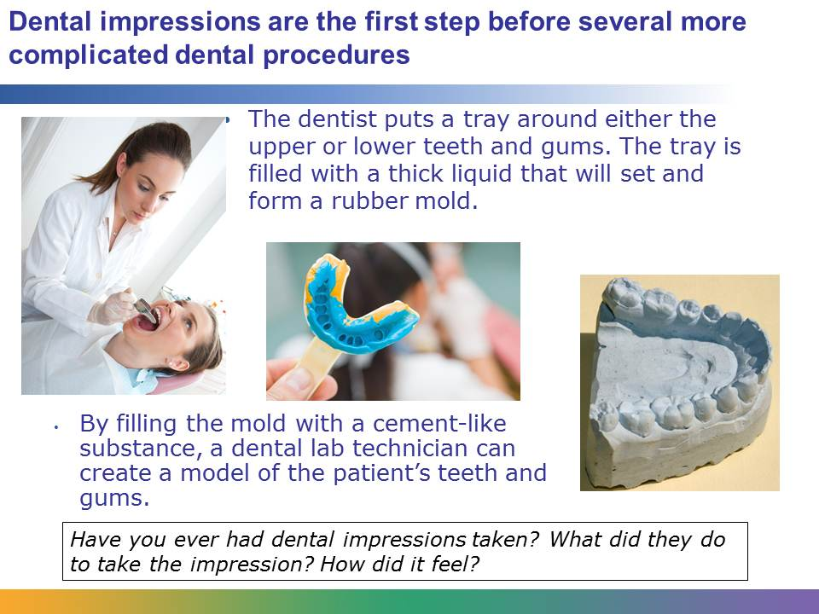
Dental impressions are a way for dental professionals to get an exact model of a patient’s teeth and gums. The liquid in the tray, sometimes called dental alginate, solidifies and forms a negative mold. In other words, there are dents in the mold where each tooth is, as you can see in one of the photos above. The blue stuff is dental alginate. By filling up that mold with a cement-like substance, a dental lab technician can make a dental model, which you can see in the far-right photo.
Impressions, and the models created by impressions, can be used to design many different oral appliances that must be custom fit to each patient’s mouth. This work is done by a dental lab technician.
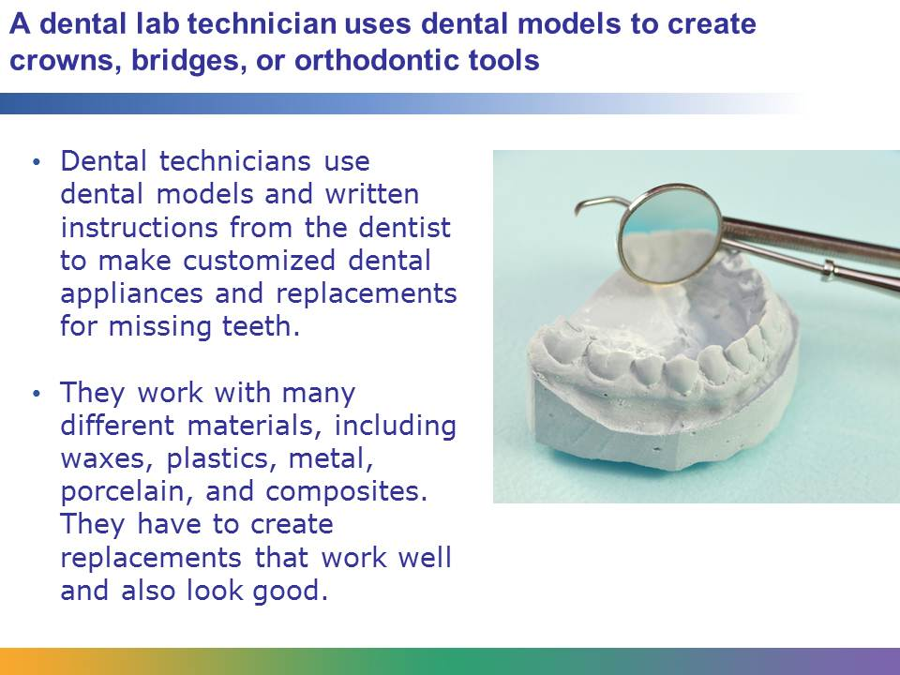
Dental lab technicians are the only dental professionals we’ve learned about who do not interact with patients directly, but their work is very important to maintaining a patient’s dental health. They might make the following:
- Full dentures for people who don’t have any teeth
- Partial dentures or bridges for people who are missing one or a few teeth
- Crowns (caps for teeth that restore their original size and shape)
- Veneers (to make teeth look better)
- Implant crowns (the tooth-shaped part on the top of a dental implant)
- Orthodontic appliances (headgear, etc.) to help teeth move
- Custom mouth guards to reduce damage from teeth grinding
Many dental lab technicians are very good at handling delicate and complicated instruments and equipment. They have to be very precise and careful about their work.
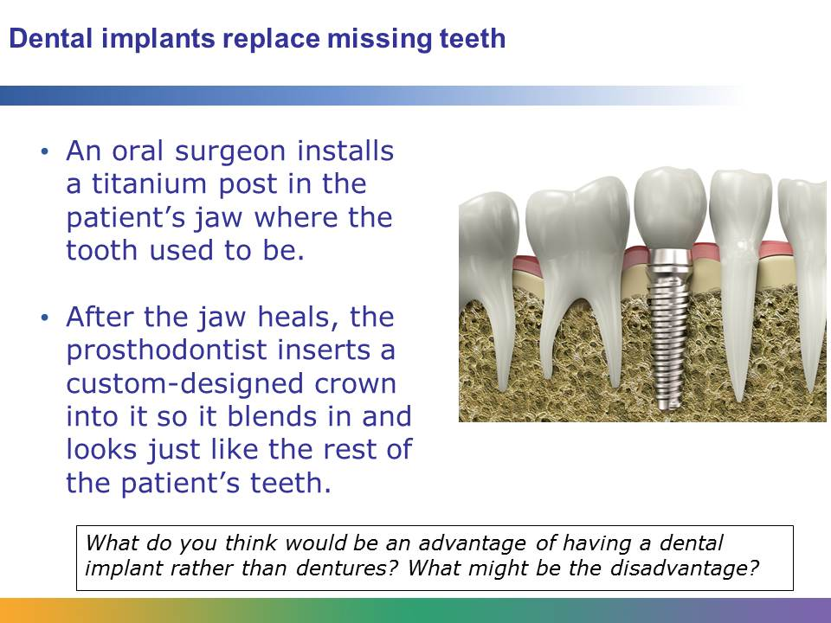
While bridges and dentures can be used to replace missing teeth, dental implants are the closest thing to getting a real tooth back. The implants are much stronger than dentures or bridges. A bridge is cemented onto the teeth, but an implant is attached to the jaw with a metal post.
Dental implants are much stronger and can look more like real teeth than bridges or dentures. It can be easier to chew food, and if the patient takes good care of the implants, they can last a lifetime.
However, dental implant surgery is time consuming. After getting the post installed, the patient must wait 6-12 weeks for the gum to heal before the crown can be installed. Also, because implantation is a type of oral surgery, people with heart conditions or other medical problems can’t get implants. Implants can also be very expensive, and insurance typically does not pay for the procedure.
In addition to working on dental implants, prosthodontists do other cosmetic dentistry procedures. They specialize in making a patient’s smile look better. But their work can be just as complicated as other dental specialties, especially if they are helping someone who had major facial or jaw trauma.
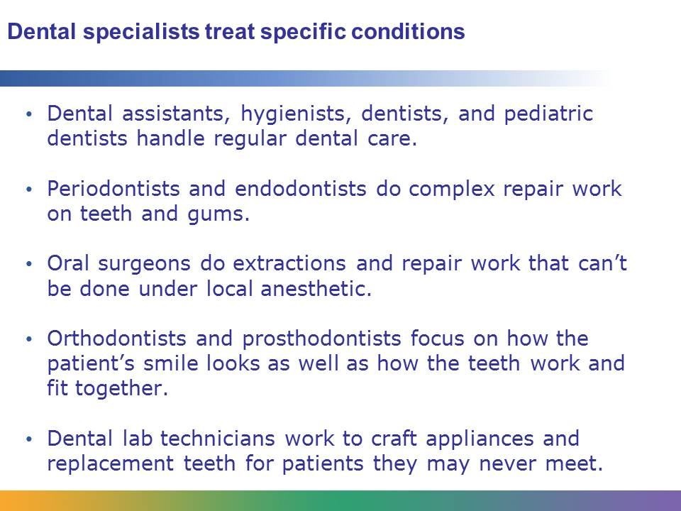
General dentists can do some of the specialized procedures, like root canals, if they get additional training. However, most specialists do not do regular dental care, like cleanings.
With the exception of dental lab technicians, all of these jobs involve working with people. Since some people are nervous about going to the dentist, having a good bedside manner is very important. In addition to that, people working in dentistry need to be detail oriented and good at working in small spaces. All dental workers have the opportunity to help people, and specialists may be able to solve serious oral health problems, which is even more rewarding.

