Student Resource 12.8
Anticipation Guide: Substance Abuse
Student Name:_______________________________________________________ Date:___________
Directions: For each of the statements below use what you know and underline “I agree” if you think the statement is accurate or “I disagree” if you disagree with it. Write one reason to explain your guess.
Over time, drugs can permanently change the way that the brain functions.
My guess: | I agree I disagree
My reason:
I learned:
You can become addicted to a drug the first time you try it.
My guess: | I agree I disagree
My reason:
I learned:
Some people with strong character traits, like resilience or stubbornness, can control becoming addicted to a drug.
My guess: | I agree I disagree
My reason:
I learned:

Although there is no cure for addiction, it is a treatable disease.
My guess: | I agree I disagree
My reason:
I learned:
People who have an addiction don't typically suffer from other mental health disorders.
My guess: | I agree I disagree
My reason:
I learned:
There are only a few truly addictive drugs, which include methamphetamines, heroin, and crack.
My guess: | I agree I disagree
My reason:
I learned:
Repeated use of marijuana can lead to an addiction.
My guess: | I agree I disagree
My reason:
I learned:

Researchers are looking for the genes that put people at risk for alcoholism.
My guess: | I agree I disagree
My reason:
I learned:
Prescription drugs, like Vicodin, are less addictive than illegal drugs, like cocaine.
My guess: | I agree I disagree
My reason:
I learned:

Student Resource 12.9
Reading: Myths and Truths about Substance Abuse and Addiction
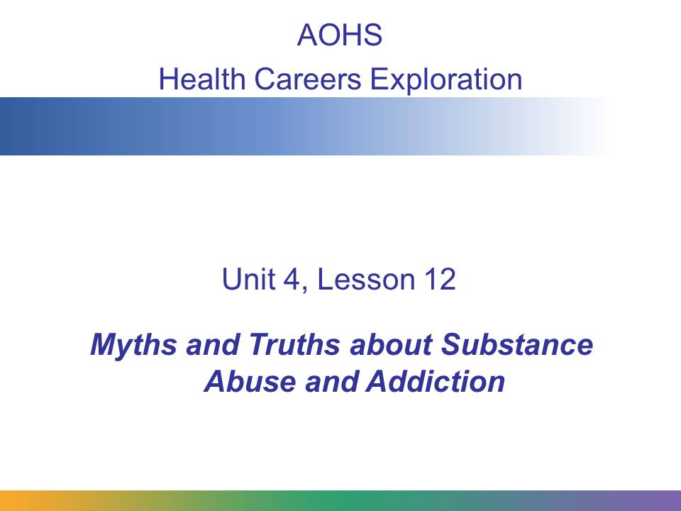
Substance addiction is a serious disease that can have devastating consequences. In this presentation, we’ll look at some of the common myths and truths about substance abuse and addiction.
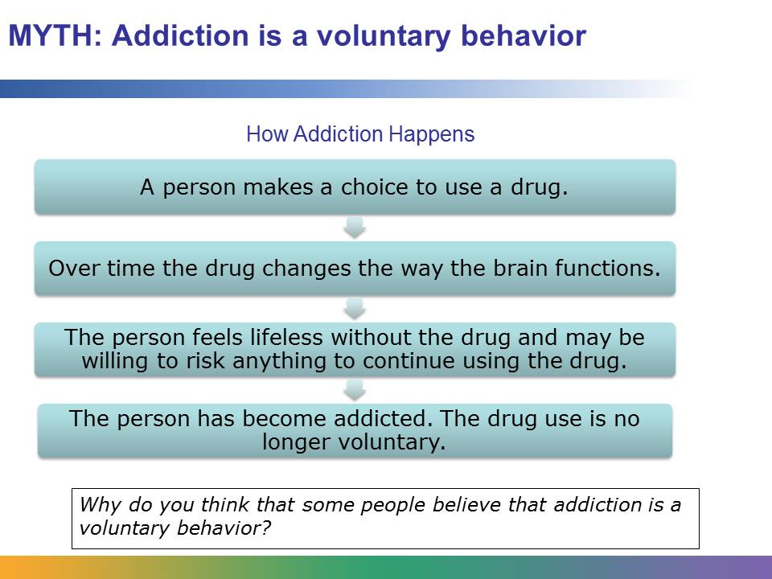
When a person first begins using alcohol or drugs, he or she is making a choice. It is a voluntary behavior. But if the drug use continues, something may happen to the person’s brain. The continued use of the drugs actually changes how his or her brain functions. The person no longer can think clearly and can’t feel right without the drug.
Imagine how you feel when something good happens to you, like scoring the winning basket in a basketball game. Your brain responds to this pleasurable experience by releasing dopamine. It creates the high you feel. It tells the brain that something important has happened and to remember the experience and the feeling. You do remember it. In fact, in the next game, you’re driven to play harder and win again.
Drugs are chemicals that tap into this communication system of the brain. They interfere with the way that we send, receive, and process information. They release too much dopamine. In fact, they flood the brain with it. Over time, the drug use changes the brain. Without the drugs, a person feels lifeless. He doesn’t feel pleasure in the things he used to. He may be willing to risk everything that once mattered to him. He may be willing to risk ruining his marriage, hurting his children, losing his job, or going to jail to continue using the drug. His brain has changed.
For many people, they begin by abusing a substance, and this behavior leads to addiction. Abusing a substance means a person continues to use the substance even though it creates strain in his relationships, or his performance at work or school begins to suffer. When the person becomes addicted, he likely experiences strong, unpleasant physical and mental symptoms when he tries to stop using the substance, and he may be unable to stop using it, even after several attempts to do so.

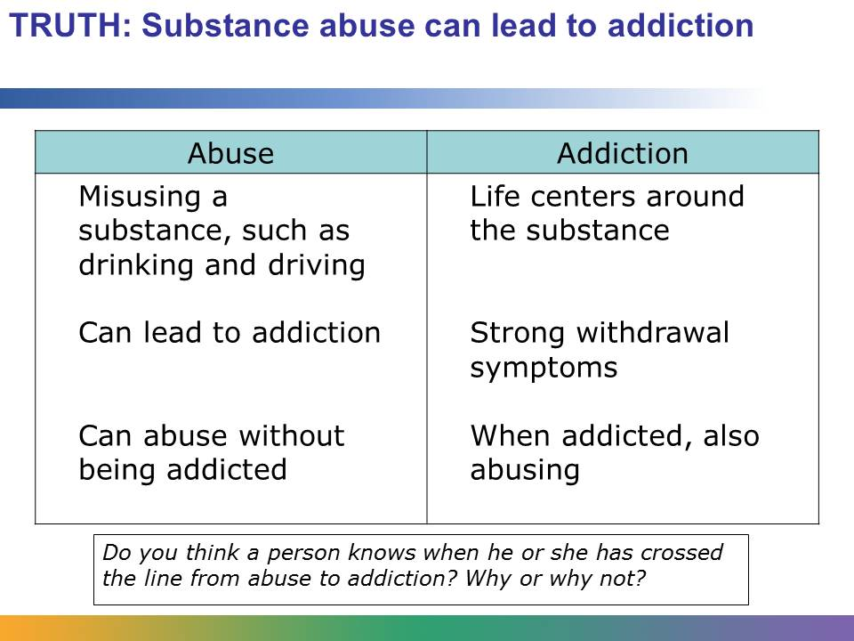
Substance abuse and addiction are two separate things, but the difference is slight. When someone abuses a substance, he or she is misusing it. For example, a person abusing alcohol might drink and drive. Or abuse of drugs or alcohol might lead to deteriorating performance at work or school. Abuse sometime results in financial instability. Abuse can lead to addiction.
When someone is addicted to a substance, he lacks the control about whether or not he is going to use it. Addiction can be physical, psychological, or both. When someone is physically addicted to a substance, his body is dependent on it; he will experience strong withdrawal symptoms if he tries to stop using it. When someone is psychologically addicted to a substance, he has a powerful desire, both mentally and emotionally, to use the substance. The line between abuse and addiction is not always clear. In general, a person has crossed the line from abuse to addiction when his life centers around the substance and he feels like he has no choice but to use it. A person can abuse a drug without being addicted. However, someone who is addicted to a substance is always abusing it.
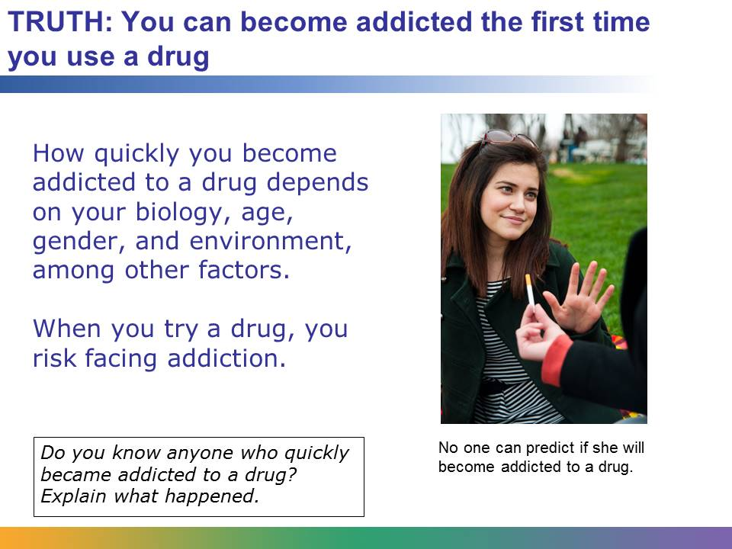
There are many factors that play into how quickly a person becomes addicted to a substance. They include your biology, age, gender, and the environment you live in.
Every person responds differently to different drugs. One person may use cocaine once, never use it again, and not suffer any long-term effects. Another person may use cocaine once, quickly use it again, and then become addicted. A third person may use cocaine once, overdose, and die.
There is no way knowing in advance how your body will react to using different drugs. The only thing researchers know for certain is that when you try a drug, you risk facing addiction.

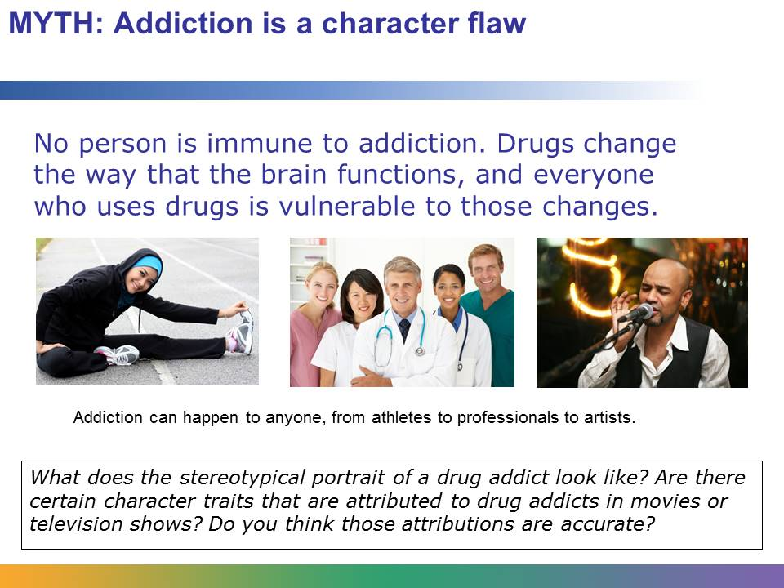
No one sets out to become a drug addict. No one begins using drugs with the intention of developing an addiction that could eventually cost his or her life.
Most people think that drug addiction could not happen to them. Many people think that it couldn’t happen to them because of who they are. Maybe they think that because they have a college degree, come from a supportive family, or have a thriving professional career that they are immune to addiction. Perhaps they think that because the have a strong, resilient, or outgoing personality that they could fight addiction. Like all mental health issues, substance abuse affects all communities and all types of people. As you learned, drugs change the way that the brain functions, and everyone who uses drugs is vulnerable to those changes.

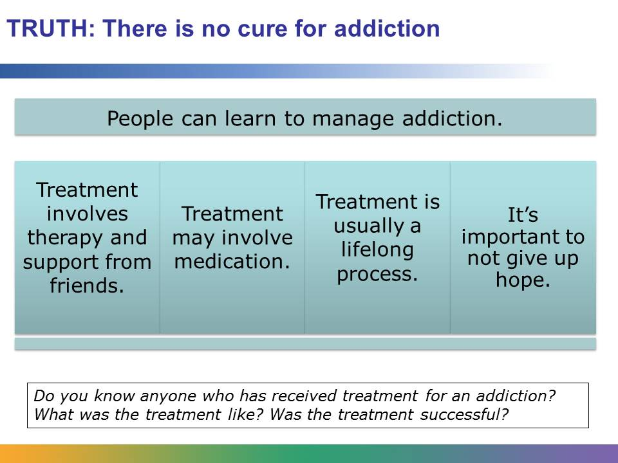
Although there is no cure, addiction is a treatable disease. As they do for other chronic diseases, like diabetes, people learn to manage their condition, and they continue to manage it over the course of their lives.
Treatment often involves therapy that is aimed at helping people learn to change their behavior. For addictions to some drugs, like heroin, medications can help some people. Some people can quit a drug cold turkey or manage their addiction after just one time at a rehabilitation facility. But for most addicts, treatment is a lifelong process, and multiple courses of treatment are often needed. Setbacks are typical, and one of the most challenging parts of treatment is not giving up hope.
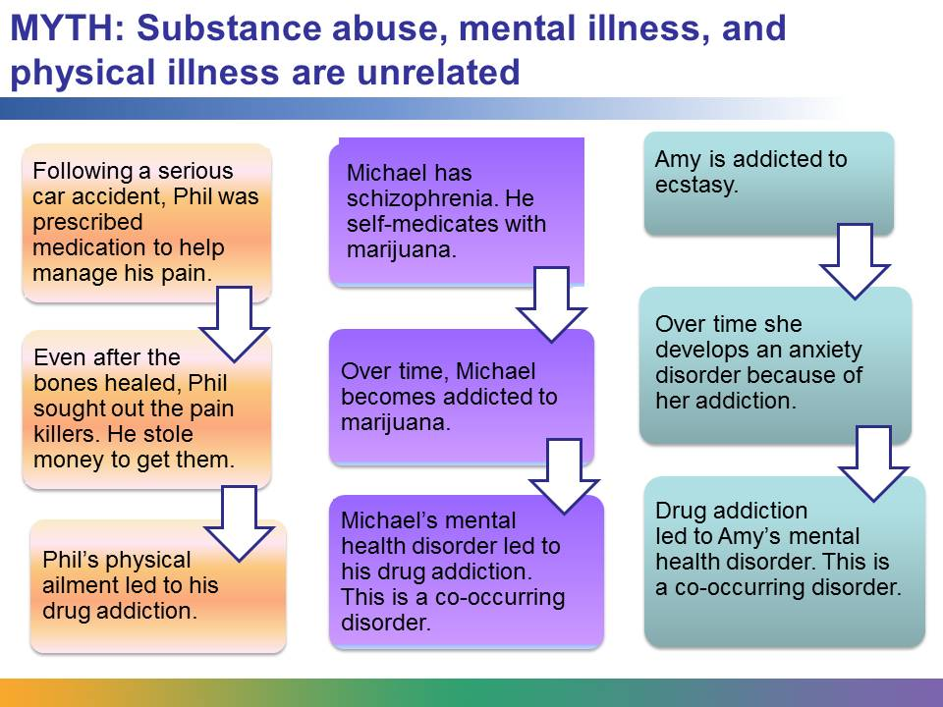
Many people who are addicted to drugs also suffer from a mental disorder, such as schizophrenia, depression, or bipolar disorder, or have a physical illness. Mental health professionals call this condition a co-occurring disorder. Co-occurring disorders are common.
Whether the mental disorder or drug abuse occurs first varies from person to person. Some people with mental disorders or physical illness or injury use drugs to help alleviate their symptoms. Professionals call this self-medicating. For example, imagine a person who was in a serious car accident. He broke several bones and needed months of rehabilitation. He was also prescribed different medications to help manage the pain. The injury changed his life, and it was difficult to deal with the new reality. Even after his bones were healed, he sought out the pain killers. He went to great lengths to get them, including stealing money from his wife. His physical injury led to a drug addiction.
For other people, the mental disorder is caused by the drug use. For example, long-term use of ecstasy can lead to depression and anxiety.
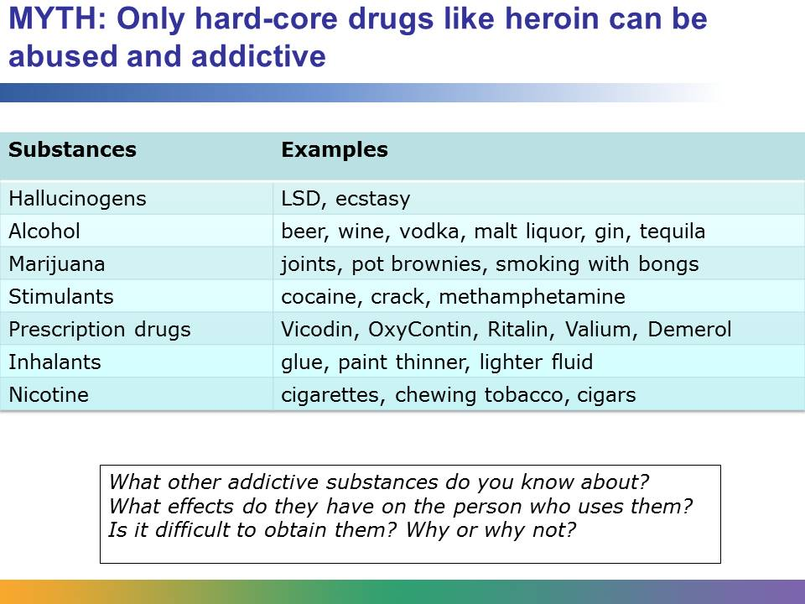
There are many substances that are abused. Some are illegal, like LSD or cocaine, and some can be obtained legally, like paint thinner and Ritalin.
Most adults are familiar with alcohol, which is legal to buy and consume if you are over the age of 21. People often drink during social situations, but unfortunately the irresponsible behavior that can result from drinking is a leading cause of accidental death in the United States. Like all addictions, alcoholism can tear people’s lives apart and can contribute to life-threatening physical health problems, including liver damage and heart disease.
The severity of the addictive properties of nicotine in cigarettes is similar to heroin. Continued smoking can lead to lung cancer, ulcers, and high blood pressure.
Marijuana is the most frequently used drug that is illegal by federal law. It’s associated with increased blood pressure, problems with motor skills, and difficulty processing information. Stimulants, like cocaine, give users an illusion of enhanced power and energy and contribute to serious medical problems, including seizures, strokes, and heart attacks. Used correctly, prescription drugs are not harmful, but used inappropriately, prescription drugs can cause devastating effects. For example, a person who is addicted to Demerol, a painkiller, can suffer from depression, fever, anxiety, and even suicidal thoughts.
Hallucinogens, like ecstasy and LSD, can cause hallucinations and feelings of euphoria, but both can have serious long-term effects, including experiencing hallucinations years after taking the drug. Inhalants, like glue and lighter fluid, are easy to obtain and cheap, but they can be deadly. High concentration of inhalant fumes can cause suffocation and heart failure.

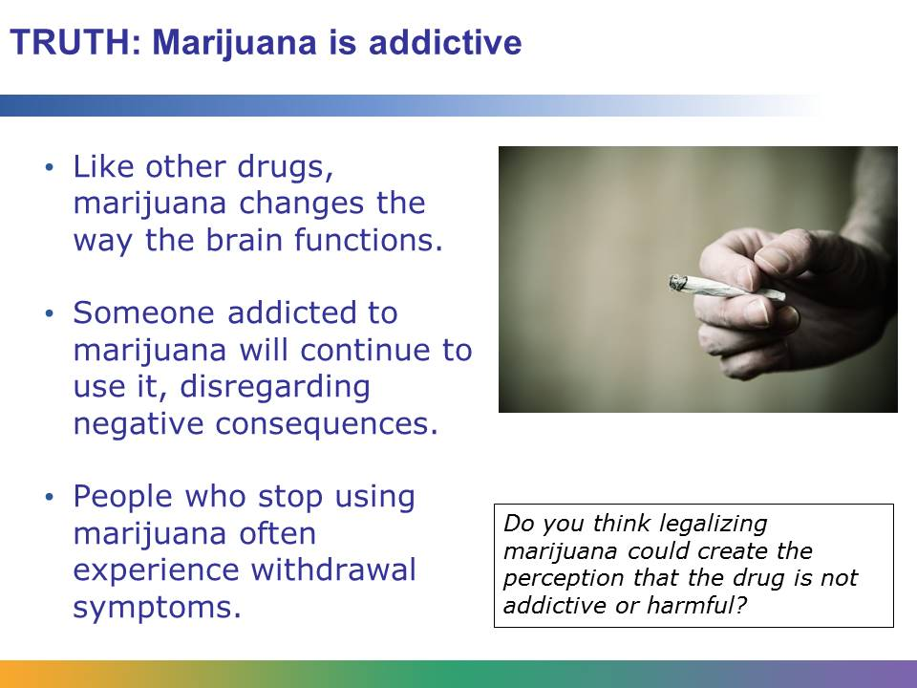
Many people don’t think of marijuana as addictive, but, in fact, it is. Like other drugs, it changes the way the brain functions. It increases dopamine, and a user may experience the urge to smoke again and again to recreate the pleasurable feeling produced by the dopamine. Repeated use of marijuana can lead to an addiction. Someone addicted to marijuana will continue to use it in spite of potentially negative consequences, such as financial irresponsibility or poor performance at work or school. When people stop using marijuana, they often report uncomfortable withdrawal symptoms, such as sleep problems and weight loss.
Marijuana is now legal in some states for medicinal purposes and in a few states for recreational use. For example, adults over the age of 21 can purchase the drug for recreational use in Colorado. However, even though the drug is legal, it is still addictive.

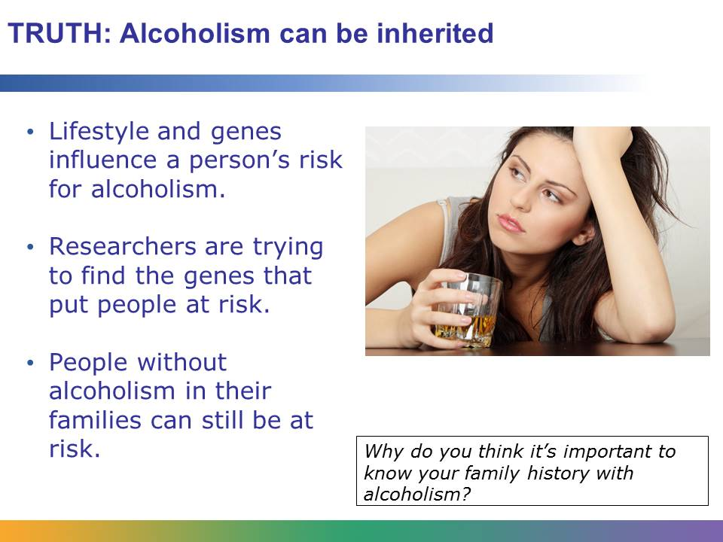
The risk for developing alcoholism is influenced by a person’s lifestyle, such as the drinking habits of close friends and the amount of stress a person deals with. But genes also play a big part. This means that if a person’s parents, or other family members, have struggled with alcoholism, that person’s chances for developing an addiction are increased. Researchers are currently trying to discover the genes that put people at risk for alcoholism.
Just because alcoholism runs in families doesn’t mean that the child of an alcoholic is destined to develop the disease. People who have no family history of alcoholism can develop a problem, and people who come from alcoholic families may not experience any trouble with the substance.

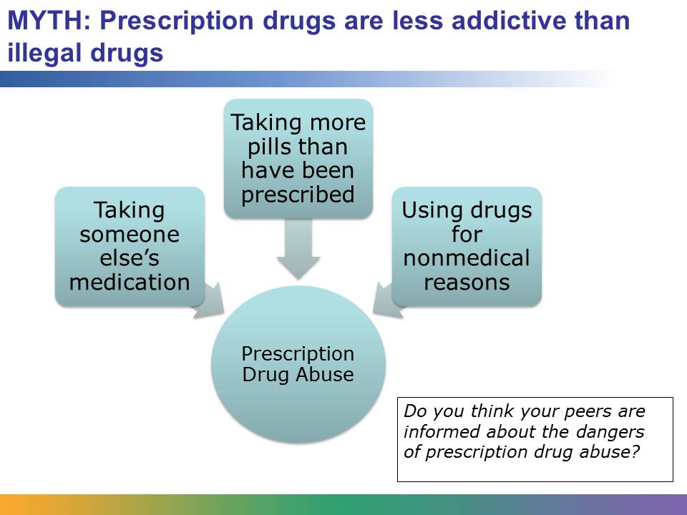
Some people think that abusing prescription drugs, like painkillers, is safer than using drugs that are illegal, like methamphetamine. But they can be just as dangerous if you take more pills than you’ve been prescribed, use another person’s medication, or use the drugs for a reason other than the one prescribed, such as to stay up studying for a test. Stimulant abuse can cause dangerously high body temperature and irregular heartbeat. Abusing depressants can cause seizures, shallow breathing, and disorientation. Prescription and over-the-counter drugs are the fourth most commonly abused drugs by twelfth graders, according to a 2010 survey.
Even though prescription drugs are legal when used with a prescription, abusing them is illegal.

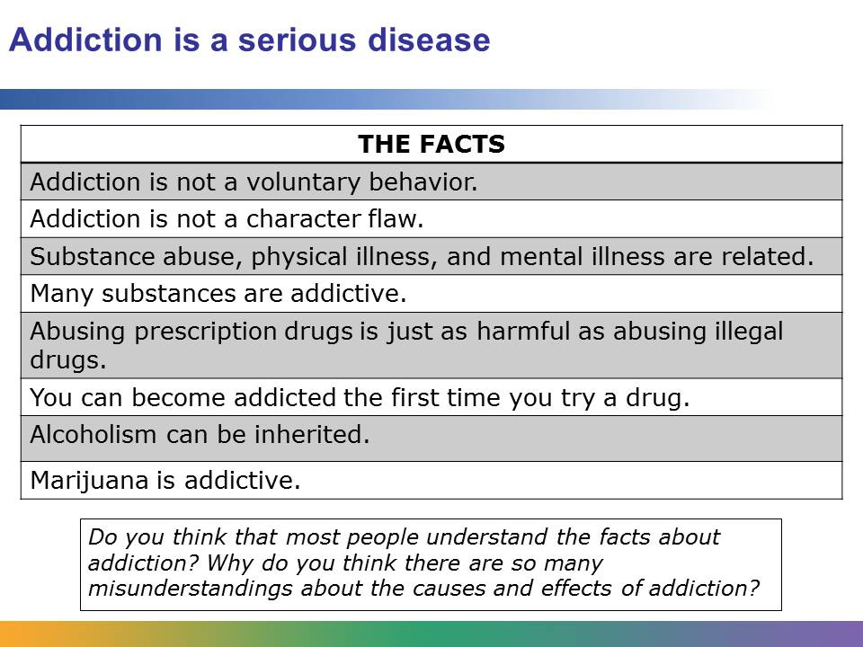
Addiction is a serious disease that impacts millions of Americans each year. Addiction can cause long-term physical and mental health problems. It can tear families and communities apart, and it can even result in premature death. Knowing the facts is the first step to helping yourself or someone you know find the professional help to fight addiction.

