Student Resource 12.1
Analysis: History of Mental Health Care
Student Name:_______________________________________________________ Date:___________
Directions: Visit each information station and collect answers the questions in Part 1 below. After you have visited all of the stations, answer the questions in Part 2.
Part 1: Information Collection
Ancient Greeks
How did Hippocrates perceive mental illness?

Middle Ages through the 1700s
What major change happened during this period that affected the way people with mental illnesses were perceived?

1800s
What major event happened during this period that changed the way people with mental illnesses were treated?

1900 to 1950
What happened during this period that is still relevant to the care and treatment people with mental illnesses receive today?

1950s
What major breakthrough in the treatment of mental illness happened during this period?

1960s
What was one perception of mental illness that developed during this period?

1970 to 2000
How do you think more people with mental illnesses in jail and living on the streets affected the general perception of mental illness?

21st century
Based on what you know, why do you think mental disorders in the elderly is an important mental health topic in the 21st century?

Part 2: Your Analysis
- Some people in the 1960s believed that mental illness did not exist. They thought that people who were perceived to be mentally ill simply didn’t behave according to society’s rules. Do you agree or disagree? Explain your response.

- In general, how do you think medication has changed the way that people with mental illnesses are perceived?

- Why do you think people with mental illnesses were treated so inhumanely throughout history?

- What stigmas do you think are still attached to mental illness today?
Student Resource 12.2
Reading: What Is Symptomatic Behavior?
Three weeks ago, Amanda’s parents announced that they are getting a divorce. Since then, Amanda has missed two days of school. She doesn’t want to hang out with her friends. Is her behavior a normal reaction to the situation? Or is her behavior symptomatic? Symptomatic behavior refers to symptoms or behaviors that could function as a signal to indicate that a person might be in need of attention and health care. What’s the difference between normal and symptomatic behavior?
These questions are not easy to answer. Life has its ups and downs. Reactions of fear, sadness, and anger to trying times are normal. In hard times, it’s normal for people to behave differently than they usually do. It’s normal for them to feel like they need help figuring out their emotions and thoughts. The distinction between normal and symptomatic behavior isn’t always obvious.
Maintaining Mental Health and Wellness
We know that it’s important for everyone—sick or healthy—to take care of their physical health by doing things like making smart food choices and exercising. It’s also important to take care of your mental health.
Good habits like getting plenty of rest, being physically active, and eating a healthy diet can help you to maintain your emotional well-being. You can also work on building strong relationships with friends, family members, and people in your community. When you need help sorting through thoughts or emotions, reach out to someone you trust or to a professional. Take time to do things you enjoy, like journaling, listening to music, using your artistic abilities, or playing sports. These types of activities can help you make sense of your feelings and release stress.
The DSM  To diagnose osteoporosis, a physician will order a bone density test. But there is no test that professionals use to diagnose a mental disorder. However, professionals do use the Diagnostic and Statistical Manual of Mental Disorders, or the DSM, to help them make diagnosis. This guide published by the American Psychiatric Association explains the signs and symptoms of mental health conditions. | 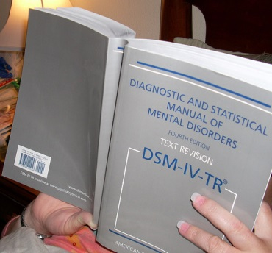
 | Image courtesy of Wikimedia Commons.
Differentiating between Normal and Symptomatic Behavior
When a client is showing signs of symptomatic behavior, a mental health professional conducts a diagnostic evaluation, looking for signs and symptoms of a problem. The professional looks at how daily life has been affected by the client’s behavior, including the client’s ability to function normally at work or school and maintain healthy relationships. The mental health professional inquires about when the symptoms started and how long they’ve been going on, and may also request that the client see a physician to rule out physical illnesses.
The professional also considers whether the client perceives his or her feelings and behaviors as normal, and may also inquire about the perceptions of others. Do the people close to client think that he or she is acting normally?
For example, if Jared has undiagnosed bipolar disorder, he might think mood swings are just part of the normal highs and lows of life. However, people close to him may see him going through intense highs when he stays up all night, followed by severe lows when he can’t get off the couch. They may see the effect this has on his performance at school and express concern. They may think he isn’t behaving normally.
Mental Health Disorders Develop Over Time
A mental health disorder doesn’t usually appear out of the blue. Usually, a mental health disorder develops gradually. Over time, a person will exhibit symptoms that may indicate a problem is developing. If a person has a mental health disorder, symptomatic behaviors are usually not temporary; they are prolonged. The earlier a person with a developing mental health condition gets treatment, the more likely that the treatment will be effective.
Each mental health condition has its own set of signs and symptoms, and a person with a mental health condition usually doesn’t just have one symptom. The person usually shows several symptoms.
Here some of the signs and symptoms that mental health professionals look for. Remember the symptoms vary among individuals. Also, having just one symptom doesn’t necessarily indicate a serious problem. Professionals look for more than one symptom that develops over time.
- Deep and ongoing sadness, anger, or euphoria (extreme excitement)
- Delusions, such as thinking that the radio is controlling your mind
- Obsessive behavior, like constant hand washing
- Loss of interest in spending time with friends and family
- An unusual drop in functioning, such as quitting a sports team or failing at a subject in school that you have typically done well in
- Problems with memory or concentration you can’t explain
- Feeling disconnected from yourself and your environment
- Loss of desire to participate in any activity
- Strong nervous feelings, anxiety, and suspiciousness of others
- Uncharacteristic behavior, such as going on a shopping spree if you usually are conservative with money
- Deterioration in personal hygiene, such as not bathing or wearing the same clothes
- Strong mood swings
- Dramatic changes in eating or sleeping patterns
- Strange and grandiose ideas
- Unusual beliefs about your personal powers to influence events
- Abuse of alcohol or drugs
- Excessive hostility

Student Resource 12.3
Note Taking: What Is Symptomatic Behavior?
Student Name:_______________________________________________________ Date:___________
Directions: As you read Student Resource 12.2, Reading: What Is Symptomatic Behavior? respond to the questions below.
- Describe some of the characteristics of good mental health.

- What are some of the things that professionals ask a patient about when they are doing a diagnostic evaluation?

- What do professionals use the DSM for?

- When doing a diagnostic evaluation, why are professionals concerned with the way that other people perceive the patient’s behavior?

- Does a person with a mental health disorder usually exhibit more than one symptom? Explain your response.

- Do mental disorders usually appear with no warning? Explain your response.

Student Resource 12.4
Scenarios: Normal and Symptomatic Behavior
Student Name:_______________________________________________________ Date:___________
Directions: The scenarios below describe how teens responded to a difficult time. Use what you know about symptomatic behavior to decide whether the behavior exhibited by the characters in each of the scenarios below is normal or symptomatic. Then explain your answer.
Scenario One
In January, Abel’s closest friend moved away. He felt really alone. He started sleeping more than usual. He was often late to school. Occasionally, he’d skip school and sleep for most of the day. By March, Abel had quit the debate team, which he had worked hard to join. He was also in danger of getting a D in Spanish, a subject he had always aced. Abel’s father said that he was concerned that Abel wasn’t acting like himself, but Abel said that everything was fine.
Do you think Abel’s behavior is normal or symptomatic? Explain your answer.

Scenario Two
On the bike path by Ellie’s house, a man was mugged. The next week, a kid from her school was beaten up on the path. The events really spooked Ellie. She avoided the bike path, even though it added an extra five minutes to her trip to school. She also had a long conversation with her mom about not feeling safe in her neighborhood anymore.
Do you think Ellie’s behavior is normal or symptomatic? Explain your answer.

Scenario Three
Cara’s mom lost her job. Her mom was very stressed about how she was going to support the family, and sometimes she’d lose her temper at Cara for no reason. On two occasions, she slapped Cara. Cara began spending more and more time away from her house. She began drinking daily in a park with some older kids she knew. A teacher asked Cara if anything was going on that she wanted to talk about, and Cara said no.
Do you think Cara’s behavior is normal or symptomatic? Explain your answer.

Scenario Four
Brandon had always been a private person, but at the beginning of the summer he started acting extremely secretive. He didn’t want anyone to come into his room. He asked his mom if she really trusted Mona, who had been a family friend for 10 years, to watch the dog when they were out of town. In August Brandon told his mom that he believed that they needed a house alarm. He said that he didn’t feel that they were safe. When his mom asked him what he was nervous about, Brandon told her that he had information he couldn’t share with her. By the end of the summer Brandon had lost interest in visiting with his friends or going to the movies.
Do you think Brandon’s behavior is normal or symptomatic? Explain your answer.

Scenario Five
After three months of going out, Zak broke up with Karen. Then he posted on Facebook secrets that Karen had told Zak in private. Karen was humiliated and furious. She didn’t want to go to school and risk running into Zak or being laughed at by his friends. In tears, she told her grandmother what happened, and her grandmother said she could take a day off of school. Karen cried. She stayed in bed and wrote in her journal about the experience. She went to school the next day, but she avoided seeing friends of Zak’s.
Do you think Karen’s behavior is normal or symptomatic? Explain your answer.

Scenario Six
Kendra’s parents had always fought, but then one weekend in April her dad left. Weeks went by and no one heard from him. Kendra missed her dad and checked her email at least once an hour to see if he’d contacted her. She felt sad and confused, so she made an appointment to speak with the school counselor. She also found herself playing basketball more, something she did when she felt a lot of stress.
Do you think Kendra’s behavior is normal or symptomatic? Explain your answer.

Student Resource 12.5
Fact Sheet and Personal Analysis: Teen Stress
Student Name:_______________________________________________________ Date:___________
Directions: Read the following fact sheet on stress. Then answer the questions below about managing stress in your life. You will not be asked to share your responses with anyone.
It seems like when people talk about stress they are talking about something that is harmful to our mental health. Is all stress bad?
No. Everyone has stress. If we cope with it properly, stress doesn’t have to cause negative effects to our physical or mental health. And some stress can even be a positive motivator.
All animals, humans included, have a stress response. During the stress response, the brain releases chemicals and hormones. Our pulse quickens, we breathe faster, our muscles get tense, and our brain uses more energy. Animals use their stress response to get out of life-threatening situations. Athletes can use their stress response to perform at a high level, and business people can use their stress to deliver captivating presentations. Musicians can use their stress to give emotional, exciting performances.
What causes stress?
Different people experience stress for different reasons. These are some of the typical things that can cause stress in teens:
- Family issues, such as divorce, separation, or death of a family member
- School issues, such as struggling with a learning disability, responding to pressure to excel, or completing college applications
- Social issues, such as the loss of a friendship, breaking up with a girlfriend or boyfriend, or bullying
- Transitions, such as learning to drive, getting your first job, or changing schools
- Fear, such as living in a violent neighborhood, being in an abusive relationship, or feeling pressure to join a gang
- Responsibilities, such as caring for an elderly family member or younger siblings
- Traumatic events, such as a car accident or a natural disaster
So, what makes stress bad?
Stress becomes unhealthy when a person continues to experience it over a long period of time; this is called chronic stress. Chronic stress occurs when our stress response goes on too long. The chemicals that are released when we have a stress response can have negative long-term consequences on our physical and mental health. Feeling stress is not necessarily abnormal. But if the stress goes on for too long or if we don’t know how to cope with the stress, physical and mental health problems like these can develop:
- Lowered immunity, making us more susceptible to flus, colds, and other sickness
- Headaches and sleeplessness
- Prolonged feelings of anger, irritation, or sadness
- Problems with our digestive, excretory, and reproductive systems
- Risk for heart disease, high blood pressure, diabetes, depression, and anxiety disorders

What are the best ways to cope with stress?
The ways that people cope with stress depend on the individual and the situation. In general, healthy techniques for managing stress include:
- Asking for help. For example, if you’re feeling stress because you are struggling in chemistry, ask for help from the teacher or a tutor.
- Recognizing how your body responds to stress. Does your mood change? Do you sleep more? Do you eat less? Do you get headaches or stomach aches?
- Learning to say no. If you feel overwhelmed with things you need to do, prioritize, and don’t take on more than you think you can accomplish. At the end of the day, praise yourself for what you have done instead of beating yourself up about what you haven’t done.
- Exercising daily. Researchers have found that daily exercise greatly reduces stress.
- Finding time for healthy, relaxing activities. Do things each day that put you at ease, like listening to music, journaling, or talking with friends.
- Avoiding taking on other people’s stress. For example, if your best friend is feeling stress about her relationship with her parents, you can support her by listening to her, but you don’t need to take on her stress, too. Practice distinguishing between other people’s problems and your own problems.
- Seeking help from a mental health professional. If you are feeling overwhelmed by stress and don’t know how to cope, seek help from a mental health professional.
Managing Stress in Your Life
What are three things that cause stress in your life?
1.

2.

3.

How does your body respond to stress? How do you feel? How do you act?

What techniques do you use for managing stress now?

What are two things you could do to improve the ways you manage stress?
1.

2.

Student Resource 12.6
Reading: Suicide Prevention

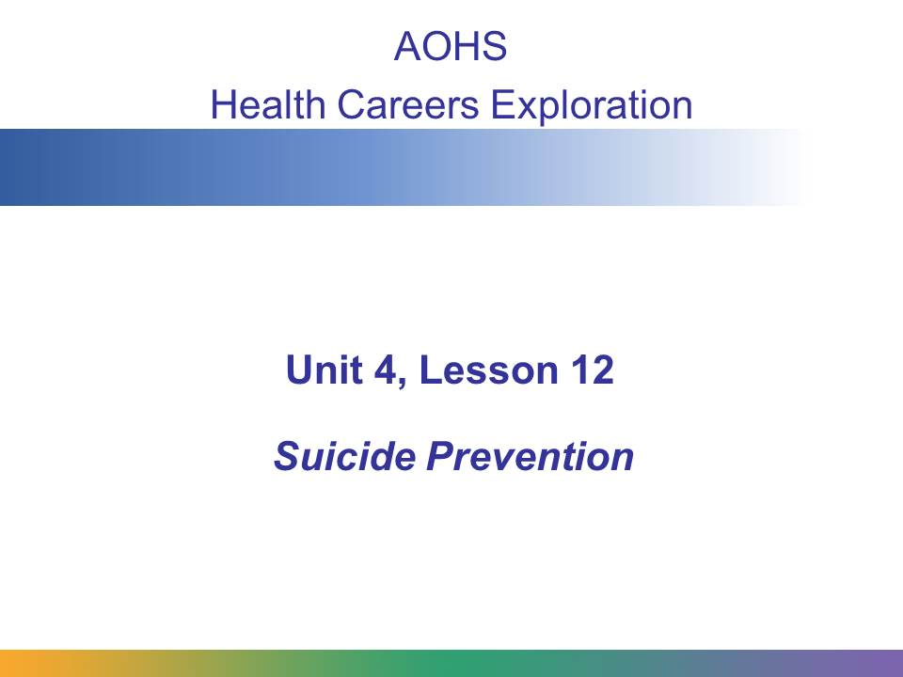
In this presentation we are going to look at the reasons why teens consider suicide, signs of suicidal behavior, and what steps you can take if you think someone you know is in trouble.
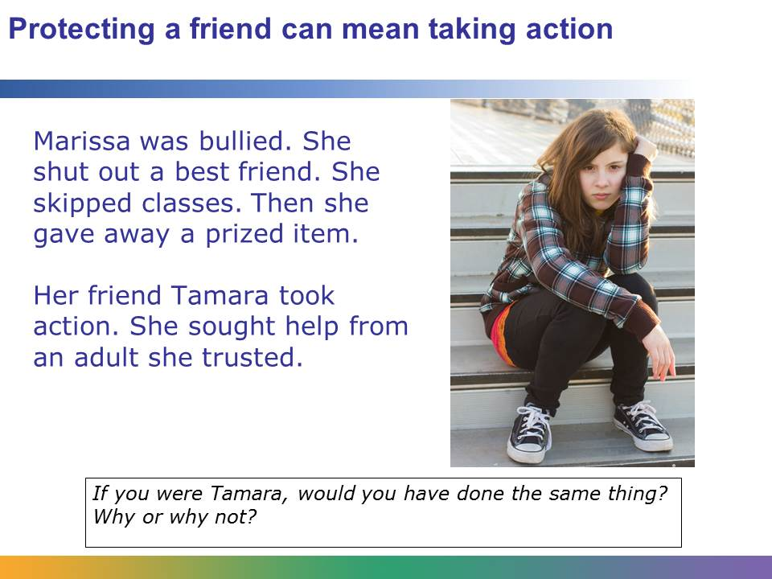
Marissa and Tamara used to be friends. But Marissa stopped talking to Tamara for no reason. She said that Tamara didn’t get her and that no one understood what she was going through. Tamara knew that Marissa had been harassed by an ex-boyfriend. He sent her angry texts and insulted her on Facebook, but Tamara thought that the bullying had stopped.
Soon after, Marissa stopped talking to her, Tamara noticed that Marissa started skipping classes. She had always been an A student. Then one morning, Tamara opened her locker and found Marissa’s favorite necklace in an envelope. On the outside, Marissa had written a note: I don’t need this anymore. It’s yours.
Tamara was scared that Marissa was going to hurt herself. She thought about what to do. Tamara decided to confide in Mr. Martinez, her algebra teacher. Mr. Martinez was a gentle listener, and he knew Marissa, too. Tamara took the envelope and headed right over to his classroom.
Tamara did the right thing. It is hard to predict if someone is considering suicide, but if you suspect someone is in trouble, seeking help and support is always the right thing to do. Marissa showed several troubling signs―being bullied, breaking off friendships, ditching class, and giving away special items ―and Tamara took action. She sought out the help of a trusted adult.

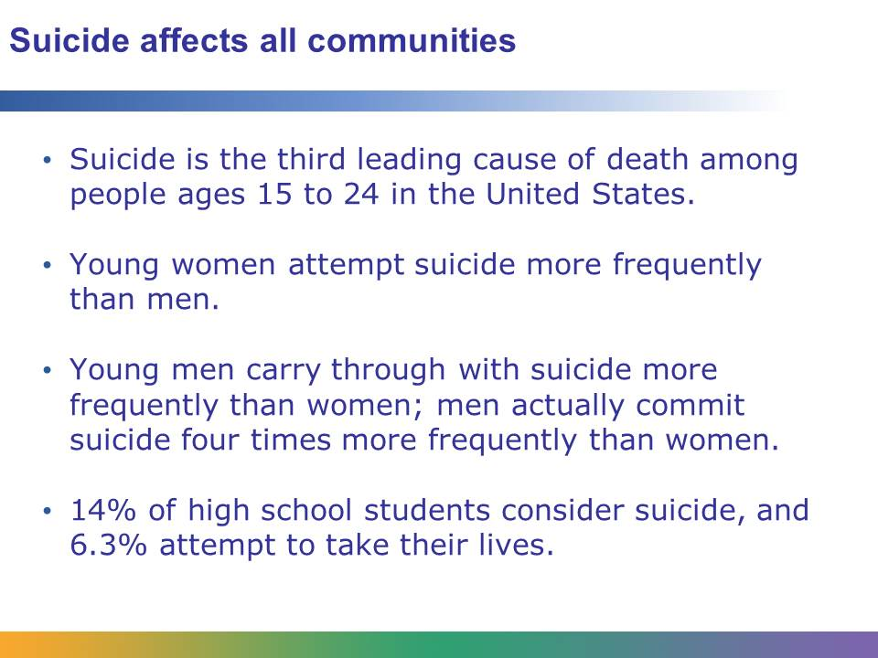
Suicide is one of the leading causes of death among teens in the United States. Even though the teen suicide rate has declined over 25% since the early 1990s, it is the third leading cause of death among people ages 15 to 24. Women attempt suicide more frequently than men, but men actually carry through much more often. Four times as many young men commit suicide as women.
In a typical year, nearly 14% of high school students seriously consider suicide. Nearly 11% make plans about how they would kill themselves and 6.3% attempt to do so.
Suicide affects all people in all communities, from wealthy and impoverished classes, suburban and rural, Muslim and Christian, Latino and Native American. No community is immune to suicide.
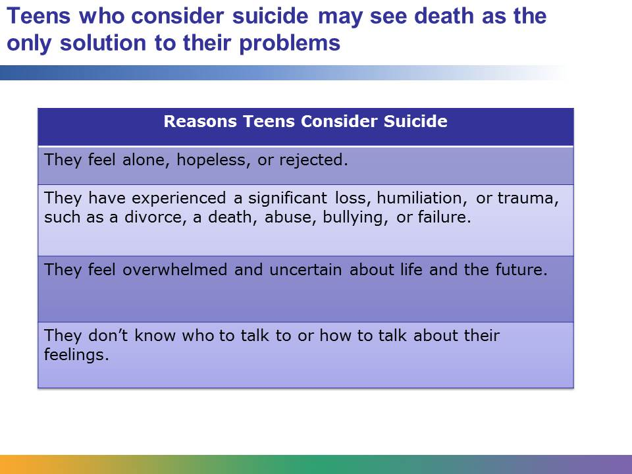
Teens who consider suicide are experiencing intense emotional pain. They may feel alone or hopeless. They may feel rejected by their friends, family, or community.
Some teens who consider suicide have experienced a significant loss, humiliation, or trauma. Their parents may be divorcing, or a good friend may have died unexpectedly. They may have been abused or molested by a family member, or a sibling may have a problem with drugs or alcohol. They may feel that they have failed at something important, such as a championship game or acceptance into college. A friend may have cut off ties or a romantic relationship may have ended.
However, teens don’t have to go through a major upsetting event to become suicidal. Some teens who consider suicide feel overwhelmed by life and uncertain about the future. They may feel scared, frustrated, or angry.
They may not want to talk about their problems and how they are feeling because they don’t know whom to trust or they don’t have the words to express their feelings. They may not want to burden someone else with their problems, or they fear that they won’t be taken seriously or that they will be made fun of.
Some of these teens are in so much emotional pain that they think that death is the only solution to their problems.
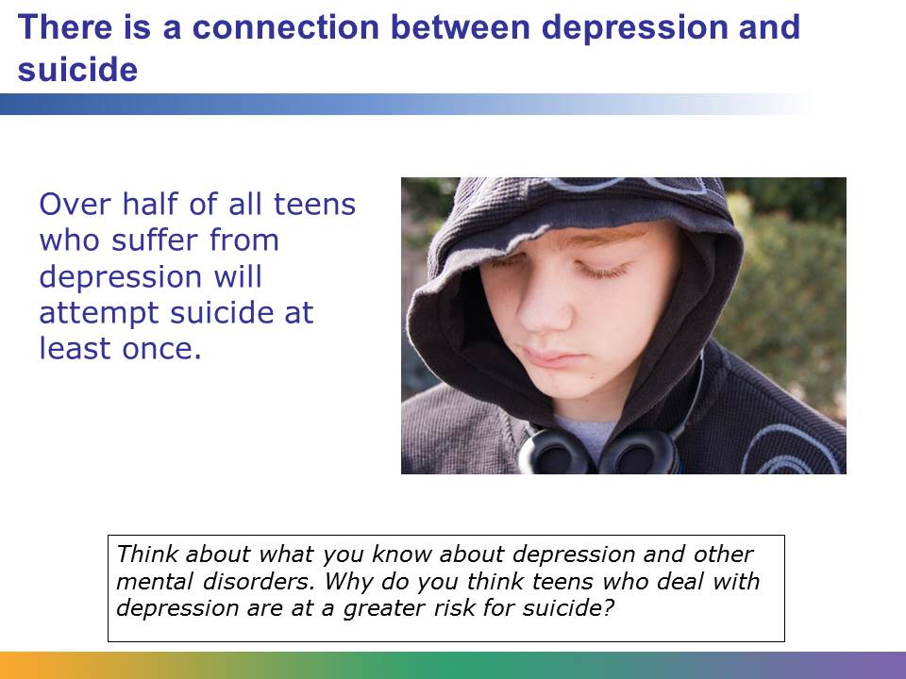
Teens who are dealing with depression or another mental disorder are at an increased risk for suicide. The CDC estimates that over half of all teens who suffer from depression will attempt suicide at least once and more than 7% will die as a result.
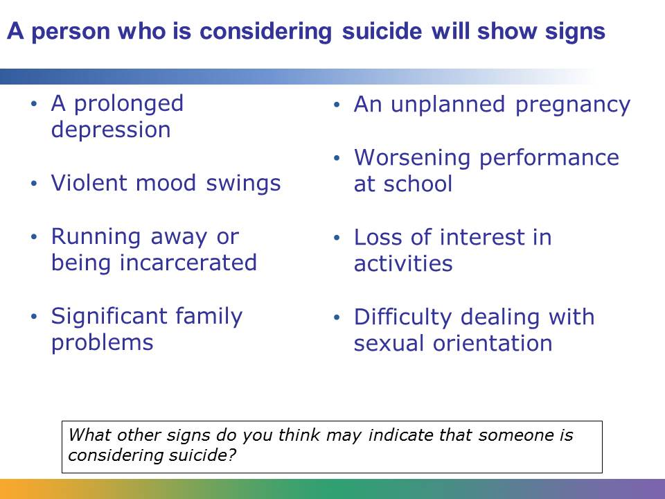
Usually, a person who attempts suicide will exhibit more than one sign. These signs are usually a change in behavior. Often peers can see changes in a teen’s behavior and attitude that parents, teachers, and other adults can not. You can use your observations to help people you know find the help they need.
There is no guaranteed way to identify someone who is seriously considering suicide, but people who behave in certain ways or experience certain events may be at a greater risk. These signs include:
- A prolonged depression. This may be indicated by unprovoked episodes of crying, neglect in personal appearance, or a change in sleep or eating habits.
- Violent mood swings. A person may seem calm one moment and then fly into a fit of rage.
- Running away or being incarcerated. A person may be frequently running away from home or getting in trouble with the law.
- Loss of a family member or significant problems with parents. A death of a parent, divorce or separation, or financial problems in a family can result in teens feeling isolated and helpless.
- Difficulties in dealing with sexual orientation. Gay, lesbian, bisexual, and transgender teens have higher suicide rates. They face societal pressures that may seem too difficult to handle.
- Unplanned pregnancy. An unplanned pregnancy can result in a teen feeling overwhelmed and alone.
- Loss of interest in activities that were once enjoyable. A teen who has always loved playing in a band drops out for no apparent reason.
- A worsening performance at school. A student who has always received good grades suddenly starts getting poor marks, cutting classes, or neglecting to do homework.

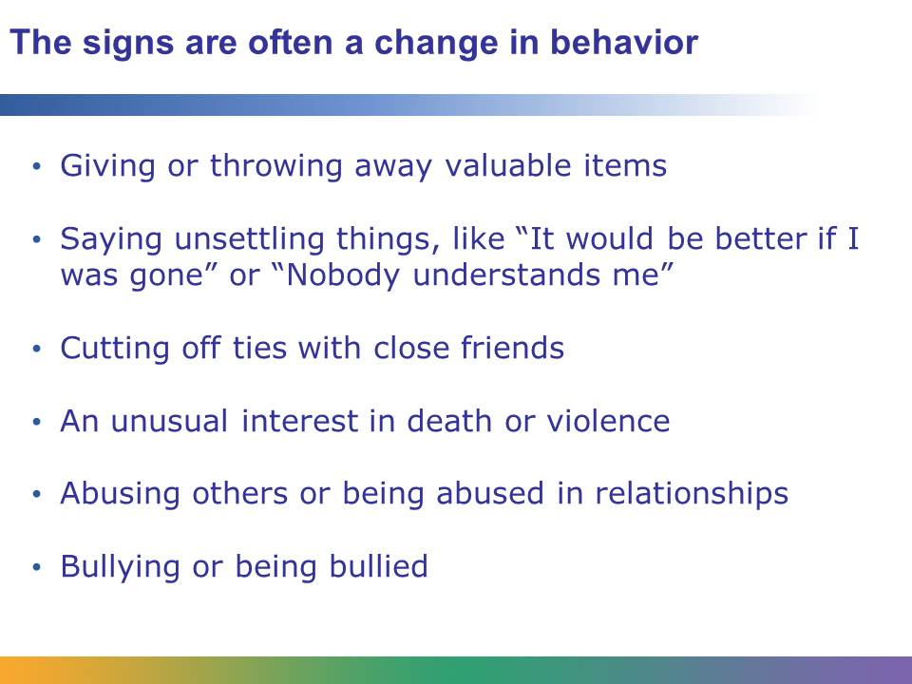
Here are more signs to look for:
- “Cleaning house.” A teen who is considering suicide may begin throwing or giving away favorite or valuable items.
- Saying unsettling things. Listen for clues like “It would be better if I was gone” or “Nobody understands me”
- Cutting off ties. A friend who ends a relationship for no reason may be in trouble.
- An unusual interest with death or violence, such as someone who has a strong interest in weapons, sketches violent scenes, or listens to music with violent lyrics.
- Abusive relationship with a family member or girlfriend or boyfriend. Unexplained injuries, like bruises that a person doesn’t want to discuss, may indicate a problem.
- Bullying. Studies have shown that both teens who are bullied and teens who bully are at higher risk for suicide.
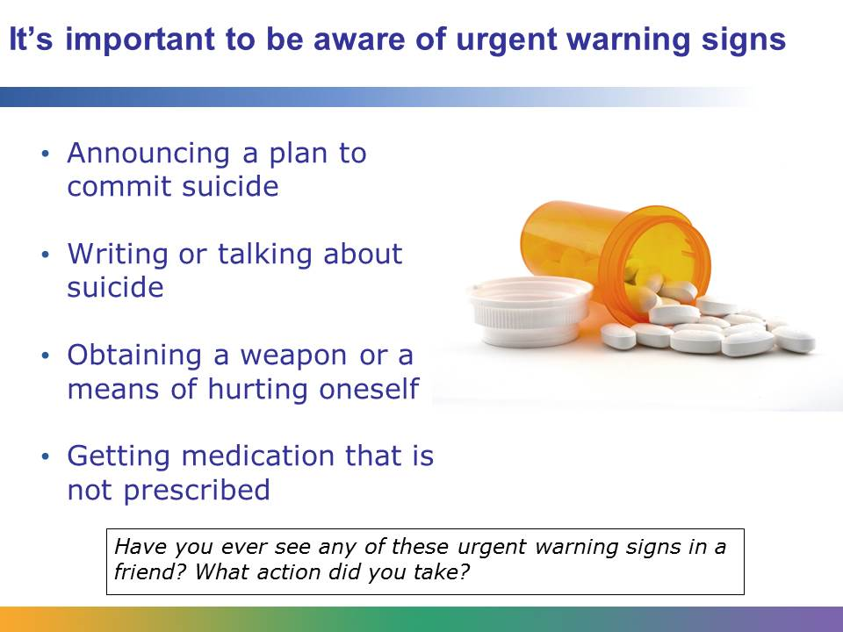
There are some urgent warning signs. If someone shows these signs, immediate action should be taken. They include:
- A person announcing that he has a plan to kill himself. If a person declares how and when he intends to commit suicide, he should receive immediate help.
- A person talking or writing about suicide. This may involve a person saying things things like “I wish I were dead” or “I’m going to end it all.”
- Obtaining a weapon. If a person gets a weapon, such as a gun, or another means of suicide, like prescription medication, immediate action should be taken.
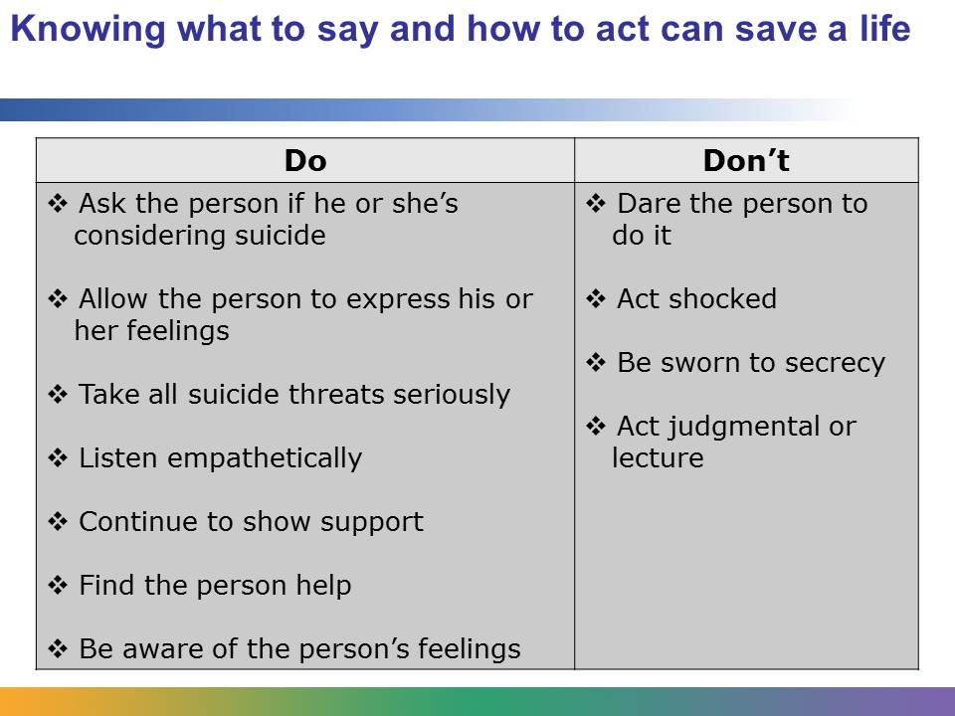
Imagine that a friend reaches out to you. She confides in you that she was diagnosed with depression. She says that she’s in a lot of pain and that she doesn’t want to live with it anymore. How do you respond? What do you do and say?
For someone who is feeling alone, hopeless, rejected, or overwhelmed, simply opening up to someone she trust can make a big difference. If you know someone who you think may be considering suicide, talk to her. Remember, talking about suicide with someone will not encourage her to do it. Be honest, direct, and open with the person. Ask the person if she is considering suicide, but never promise that you will keep someone’s suicidal thoughts a secret. The most important thing that you will do for the person is help her find help.
When the person is talking to you, allow her to express her feelings, even if you don’t agree with her. Try to be nonjudgmental and don’t act shocked. This isn’t an appropriate time to get into a debate about if suicide is right or wrong. What your friend needs is someone to listen empathetically, not lecture. After you talk, continue to support your friend. Show interest in her life and her problems. Never dare someone who is considered suicide to do it.
A person who is considering suicide may feel like there is no escape from the pain. When you talk to her, it’s important to be aware of some of the feelings that she may be having. She may not be able to think clearly or see any way out of her problems. She may feel like she can’t sleep, eat, go to school, or do any activities. She also may feel like she isn’t worthwhile and has no control of her life.
After you talk to your friend, the next step will be helping your friend find the help that she needs.
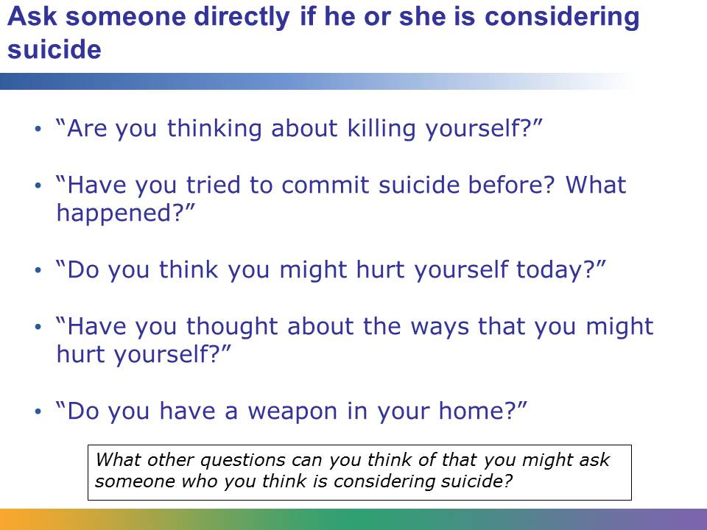
Remember, asking a person if she’s considering suicide will not increase her suicidal thoughts. However, it will give her the opportunity to open up and give you information that you need to help her find help. There are different types of questions that you can ask. You can ask if she’s having suicidal thoughts or ideas. If she says yes, you can ask if she has a plan and if she has access to lethal means. If she says yes to these questions, seek immediate help.
It can be very effective if the person will give you a pact that she will not hurt herself before a specific time limit (like the next 24 hours, until her appointment tomorrow, or until you see the school counselor with her).
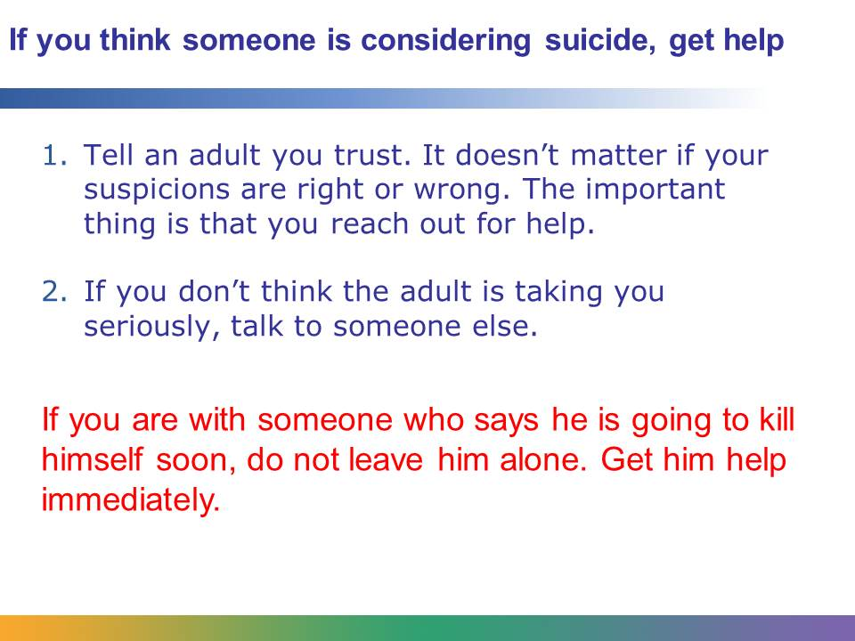
If someone has told you that he is considering suicide, you should tell an adult you trust. If you suspect that anyone you know may be considering suicide, you should also tell an adult. Choose an adult who is responsible and understands young people. This person may be a teacher, guidance counselor, or coach. It may be one of your parents, an older sibling, a leader at your church, temple, or mosque, or someone who works at a youth or community center. If you don’t think that the adult is taking you seriously or responding in an appropriate way, talk to someone else.
Your suspicions may be right or wrong. That doesn’t matter. It can be extremely difficult to tell if someone is considering suicide. If you know someone who says he is considering suicide, take him seriously. You don’t have to feel absolutely certain before talking to an adult. Even if the person is not considering suicide, the signs that you picked up on may indicate another serious problem, like depression or drug abuse. The important thing is that you reach out for help.
If you are with someone who says that he intends to kill himself soon, such as by jumping off a bridge or taking an overdose of medication, do not leave him alone. Encourage him to come with you to talk to a responsible adult or contact an adult to come to you.
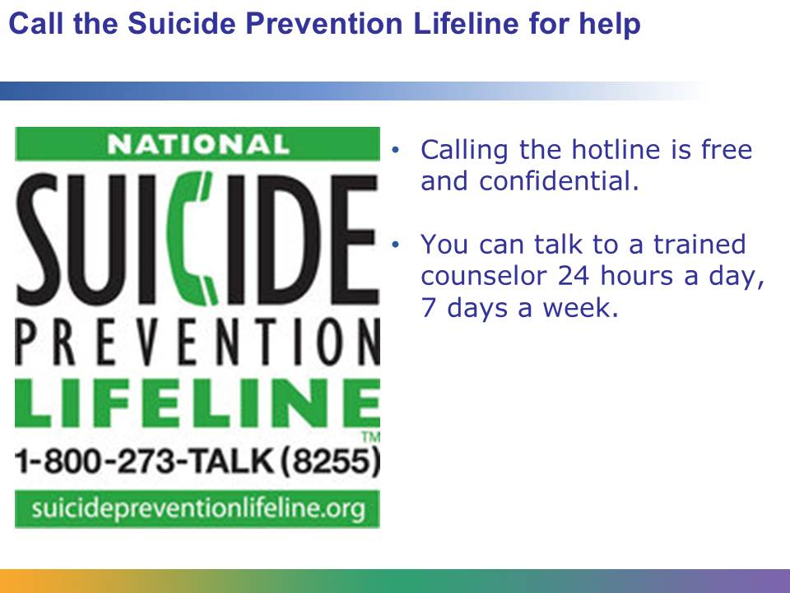
If you don’t know who to talk to or you feel disappointed with the interactions you’ve had with adults, call the National Suicide Prevention Lifeline at (800) 273-TALK (8255).
When you call the number, you will be put through to a crisis center near your location. The call is free and confidential. The person you talk to is a trained counselor. You can call 24 hours a day, 7 days a week.
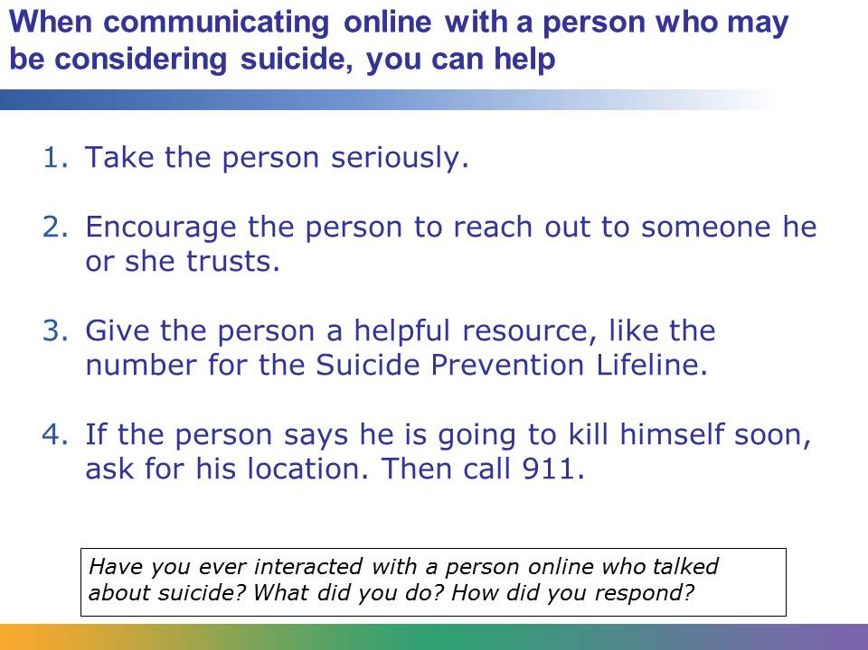
If you interact with someone online who is considering suicide, there are steps you can take to help this person, even if you don’t know them. As you would with a friend in person, take the person’s words seriously. Encourage the person to reach out to someone he trusts or give the person a helpful resource, like the Suicide Prevention Lifeline phone number or website. Make sure the person knows that the counselors at the organization are available 24/7 and that the call is free.
If the person online says that he is going to kill himself soon or is in the process of killing himself, ask for his location and immediately call 911.
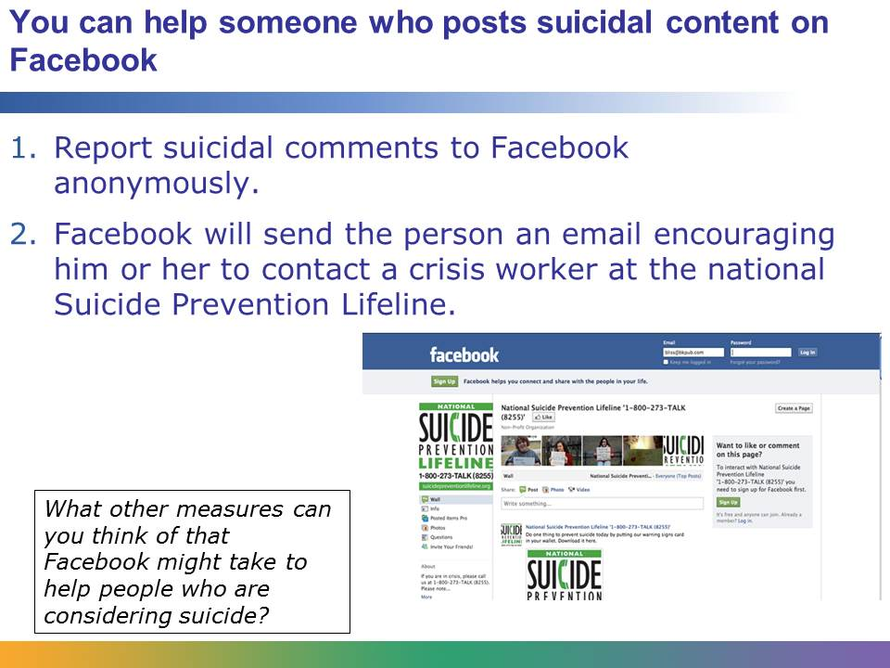
If you are on Facebook and you see a suicidal comment, you can anonymously report it using the Report Suicidal Content link. After you make the report, the person who posted the comment will then immediately receive an email from Facebook encouraging him or her to call the National Suicide Prevention Lifeline. The person will also be given a link to click on to begin a confidential chat session with a crisis worker.
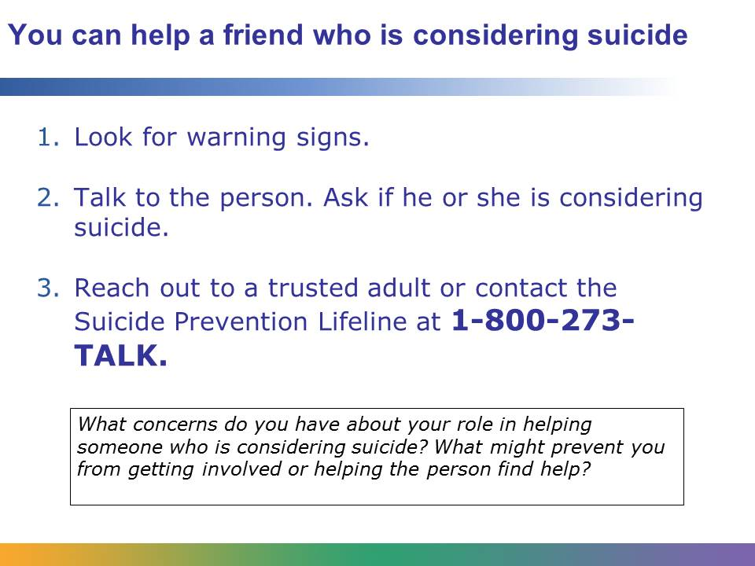
Suicide is a serious problem and a preventable cause of death. Remember, if you know someone who is considering suicide, you can help. Look for warning signs, like giving away special objects. Talk to the person openly and honestly. Ask if the person is considering suicide. Talking about suicide will not increase the person’s risk. Then get help. Reach out to a trusted adult, like a parent or coach, or contact the Suicide Prevention Lifeline.

