Sample Analytical Report: Rwanda
Rwanda is a country in Africa with a population of more than 11 million people. In the 1990s it experienced civil war and genocide, and an estimated 800,000 people were killed. Since then the country has made many changes, including revising its constitution and establishing a court system to prosecute people who committed genocide. In the 2000s Rwanda’s economy grew rapidly, and more tourists began to visit as well.
Rwanda’s life expectancy numbers are not very good. The life expectancy at birth is 58.85. This means that people do not live very long. The country’s infant mortality rate is 61 deaths per 1,000 live births. That is very high.
Rwanda is in the earliest stages of demographic transition. The country has very high birth rates and high mortality rates. There are nearly 1 million children born each year of each gender, but there are fewer than 200,000 people of each gender who are age 50 or above.
Most deaths in Rwanda are from communicable diseases, especially HIV/AIDS, which is the leading cause of death. In fact, 6 of the top 10 causes of death are communicable diseases like tuberculosis, malaria, and even measles. This means that Rwanda is probably in the first stage of epidemiological transition, the Age of Pestilence and Famine, because there are so many deaths due to infectious disease.
Poor people in Rwanda are a vulnerable population. A UN report showed that 60% of the adult population lives below the poverty line, with 42% in extreme poverty. Many households are headed by widows because men were killed during the genocide in the 1990s. Other vulnerable groups include uneducated young people and the elderly. The government has set up a fund to help victims of the genocide. It has also formed specific policies to care for the elderly, in addition to creating laws to protect the elderly and programs to help them get food and medical care.
Rwanda suffered tremendous losses during its civil war and genocide. Since then it has been fighting to remake itself as a country. It has made progress, but it still has a long way to go. Rwanda remains in the earliest stages of demographic and epidemiological transition, with high infant mortality rates and deaths due to communicable diseases. Also, as a result of the civil war and genocide, it has a lot of vulnerable populations, particularly people living in poverty, and the elderly, who need special care and attention.
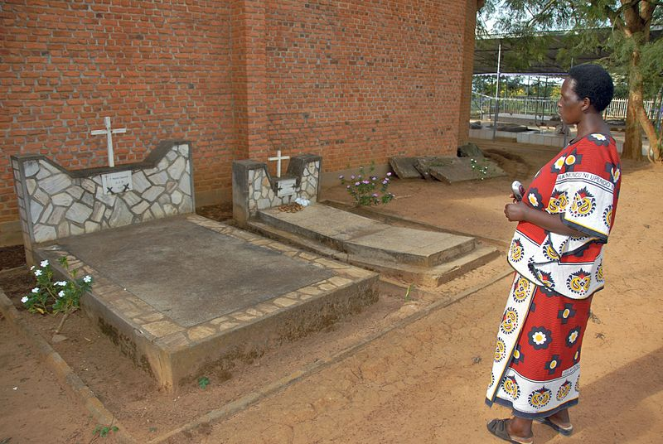
A woman visits the Nyamata Genocide Memorial Church in Rwanda where tens of thousands of people were killed and buried. The country is still struggling to recover from the economic, social, and health costs of the genocide.

Sources
- “International Programs: International Data Base.” United States Census Bureau, http://www.census.gov/population/international/data/idb/region.php?N=%20Results%20&T=13&A=separate&RT=0&Y=2013&R=-1&C=RW (accessed June 26, 2014).
- “Rwanda.” Wikipedia, http://en.wikipedia.org/wiki/Rwanda (accessed June 27, 2014).
- “Rwanda WHO Country Office.” World Health Organization, http://www.afro.who.int/en/rwanda/who-country-office-rwanda.html (accessed June 26, 2014).
- “The World Factbook.” Central Intelligence Agency, https://www.cia.gov/library/publications/the-world-factbook/ (accessed June 26, 2014).

