Rejection of Versailles

President Woodrow Wilson, a Democrat and idealist, and Senator Henry Cabot Lodge, a Republican and realist, remained bitter enemies throughout their prestigious political careers. After the President's party lost Congress in the 1918 elections, Lodge became both Senate Majority Leader and chairman of the Senate Foreign Relations Committee, thus his support of the Treaty of Versailles and its provision for a League of Nations was crucial for it to pass.
However, rather than cooperate with Lodge and the Republican Senate, Wilson bypassed them during negotiations at the Paris Peace Conference and sometimes publicly insulted them. Lodge and his political allies advocated a more punitive settlement against Germany, rather than Wilson's conception of a "peace without victory," and added a number of amendments and "reservations" to the treaty. Wilson was unwilling to compromise and commenced a tour of the country to promote the Treaty directly to the American people. In October 1919, the President suffered a debilitating stroke while on the road. Wilson remained unwilling to negotiate with the Senate, and on November 19, 1919, it rejected a peace treaty for the first time. Congress later passed a joint resolution ending the war with Germany.

Question to consider:
The political cartoons below can be interpreted in various ways, though they are all related to the Treaty of Versailles. How do you interpret them and what story do they tell? What are some alternative interpretations? Please label any symbols you see in each picture in addition to explaining the cartoon’s overall meaning.

This cartoon entitled "Touch Not a Single Bough" depicts President Wilson attempting to defend the treaty from a menacing-looking Senate.

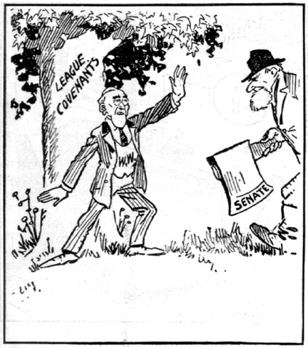

In this political cartoon, the ill-fated treaty of Versailles emerges in tatters from the Senate Foreign Relations Committee escorted by Lodge.

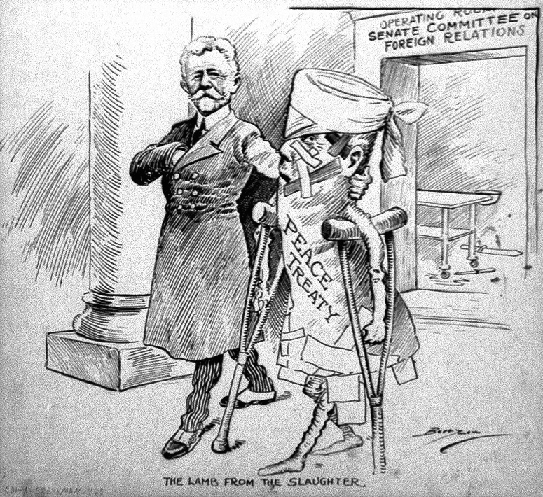

The third cartoon, "Blowing Bubbles," shows the idealistic Wilson.

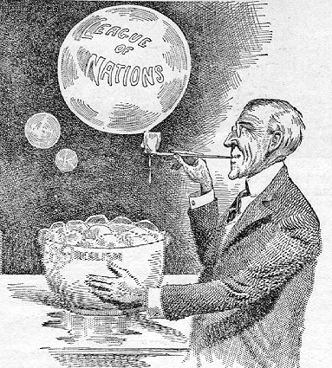

This last cartoon depicts why the League of Nations failed.

