Reading: Distribution of Scarce Resources
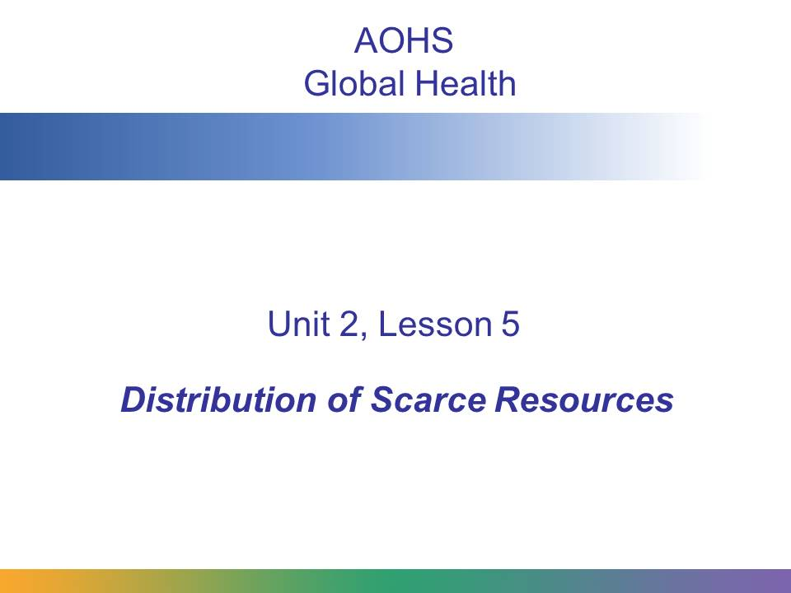
Global health professionals often have to make decisions about how to distribute health resources, because there are not enough resources to go around. In this presentation, you will learn about the guiding principles that health professionals use to make these difficult choices.
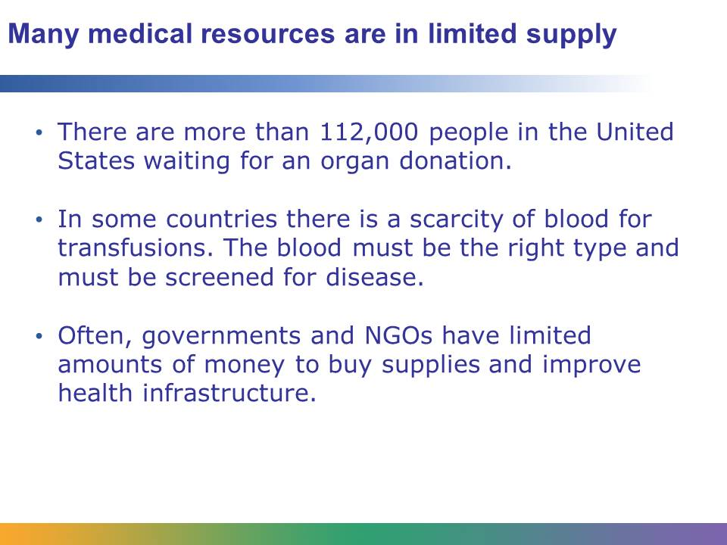
A limited supply of medical resources is a challenge for all countries, developing and developed. Often there isn’t enough to meet the need.
In the United States, there were more than 28,000 organ transplants performed in 2010. Yet organ donation groups estimate that there are more than 112,000 people in the United States alone currently waiting for an organ donation. Imagine you are in charge of an organ donation program. Someone dies and donates his organs: how do you decide which person gets his heart? His liver? His eyes?
Some decisions involve the distribution of financial resources or material. What if you are a government official who is in charge of building a new hospital? How do you decide where to build it? Do you build in the country, where you have more space? Or in the city, where there is a higher population density and therefore more people who need help?
Or maybe you’re a doctor or nurse working with HIV patients in South Africa, where 2009 estimates suggest that 5.6 million people are suffering from HIV and AIDS. The antiretroviral drugs they need are very expensive, and you can only get a limited supply. How do you decide who gets treated?
In the spring of 2011, Colombia was devastated by floods. Almost 7,500 homes were destroyed and more than 225 health institutions were damaged. If you were part of a disaster relief group sent into Colombia to help, what would you do? Where would you start?
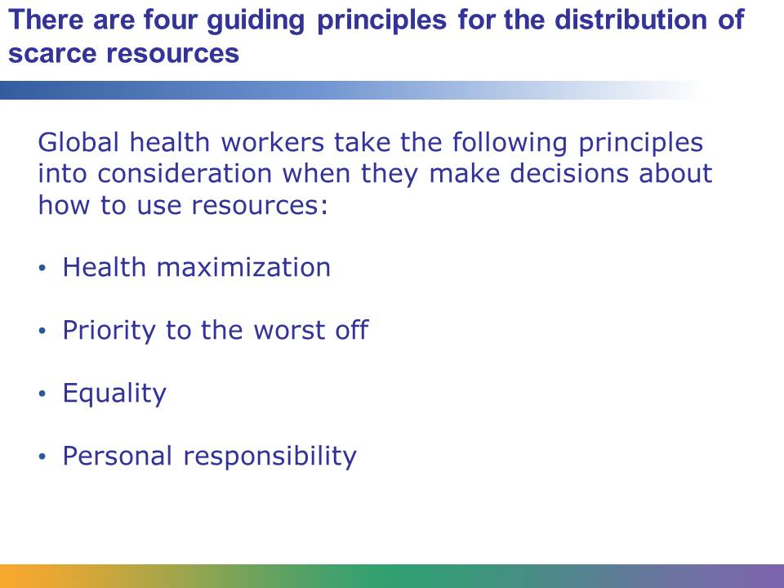
Sometimes health resources are distributed by unfair methods. Some countries have used a first come, first served approach, meaning that the first people to ask for help received what they needed.
This can sound fair, but in practice it can favor those people with political connections. In low-income countries that may already have very corrupt governments, this can lead to government officials and their families being well cared for, while less well-connected people who are truly suffering get no help at all. In other cases, groups of people are prevented from getting the care they need because of poverty or discrimination.
To prevent this, global health professionals use these four guiding principles to help them make good decisions when distributing medical resources. On the following slides, we will consider each of these principles in more depth.
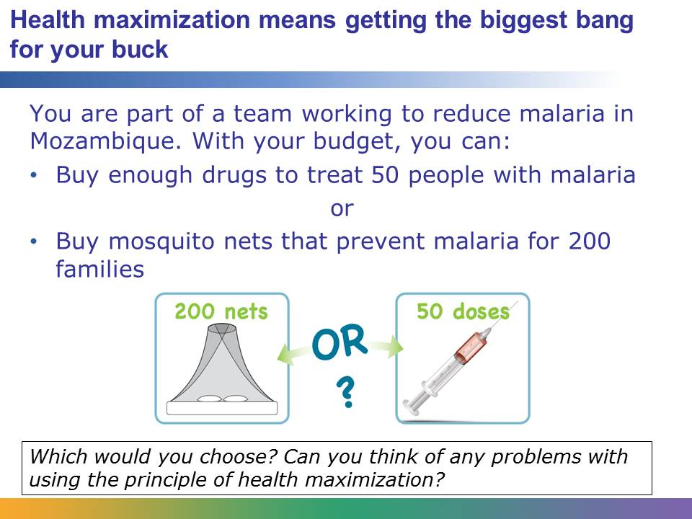
The principle of health maximization states that a health professional should use resources in the way that will have the greatest overall impact on health. In this example, the principle would lead you to buy the mosquito nets because you could have a greater overall impact by providing a preventive tool to 200 families rather than drugs to 50 people. You also have to consider whether the people who need the most help are the people who you are best able to help.
In 2010 a serious earthquake struck Haiti. Large portions of the capital city, Port Au Prince, were destroyed. Because a lot of people live in the capital city, the principle of health maximization would dictate that relief groups focus on helping the people there.
But there were people who lived out in the country, and before the earthquake they had been even poorer than those living in the city. When the earthquake happened, the people in the countryside were suffering, and they had fewer resources to help them. So, in this case, health maximization might actually lead to more people dying in the country. The people health professionals were best able to help (the city dwellers) were not necessarily the people who needed the most help (the country people).
That is why health professionals consider more than one principle when determining how to distribute scarce resources. In this situation, another principle might override the principle of health maximization.
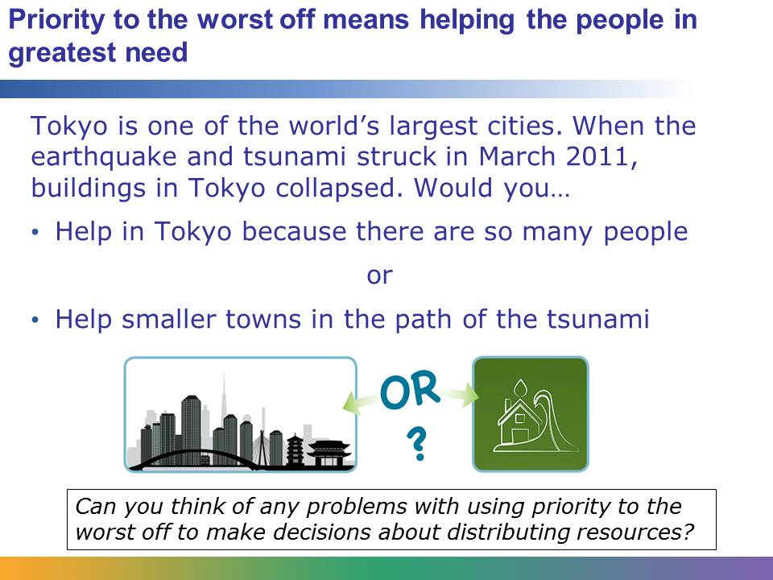
This principle recognizes that some people need more help because they were disadvantaged to begin with. In other cases, people need more help because they are more directly impacted by the disease, violence, or natural disaster. In the case of the Japanese earthquake and tsunami, the principle of priority to the worst off meant that people in smaller towns got more aid than people in Tokyo because they were more directly affected.
That sounds fair. However, this principle has its difficulties, too. First of all, how do you determine who is the “worst off”? Imagine there is a pandemic flu outbreak and you have to decide who will get drugs that can treat the disease. Do you give the drugs to the people who are sickest right now? Or do you give the drugs to people who just got sick but who have pre-existing conditions that make them more likely to die from the flu, like pregnant women or the elderly? Which group is the worst off?
What if the worst-off group is already terminally ill? If you are working with HIV patients in South Africa, do you spend your money on antiretroviral drugs for people with HIV or on preventive measures to stop more people from getting HIV in the first place? The principle of priority to the worst off doesn’t always solve the problem, either.
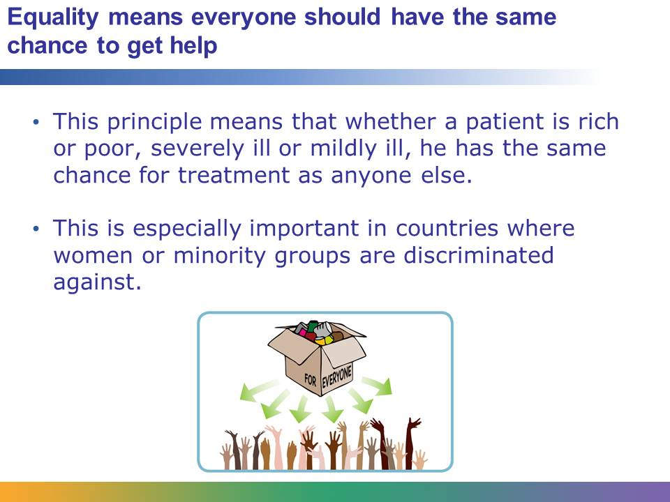
Equality is an important principle in the distribution of resources. In some countries, international supervision is needed to make sure resources are distributed equally. For example, Rwanda experienced a civil war and genocide during the 1990s. At one time, the people responsible for the genocide were in control of parts of the country. If you were running an NGO that wanted to donate food or medical supplies, you wouldn’t want to rely on those people to distribute your supplies, because they would likely not hand out the supplies equally.
Like the other principles, equality doesn’t address every problem. Imagine you are in charge of distributing donated organs. If you wanted to follow the principle of equality, you might hold a lottery. That way, everyone who needed a kidney had the same chance of getting one. You would just draw a name at random and that person would get a transplant. It sounds fair, but is it the best use of resources? What if the person who wins the lottery is very ill and likely to die soon? Does it still make sense for that person to get a transplant? What if someone who had been on the list to get a kidney for only a month won out over someone who had been on the list for six months? Distributing organs is a complicated process that involves several of these principles of distribution of scarce resources, not just one.
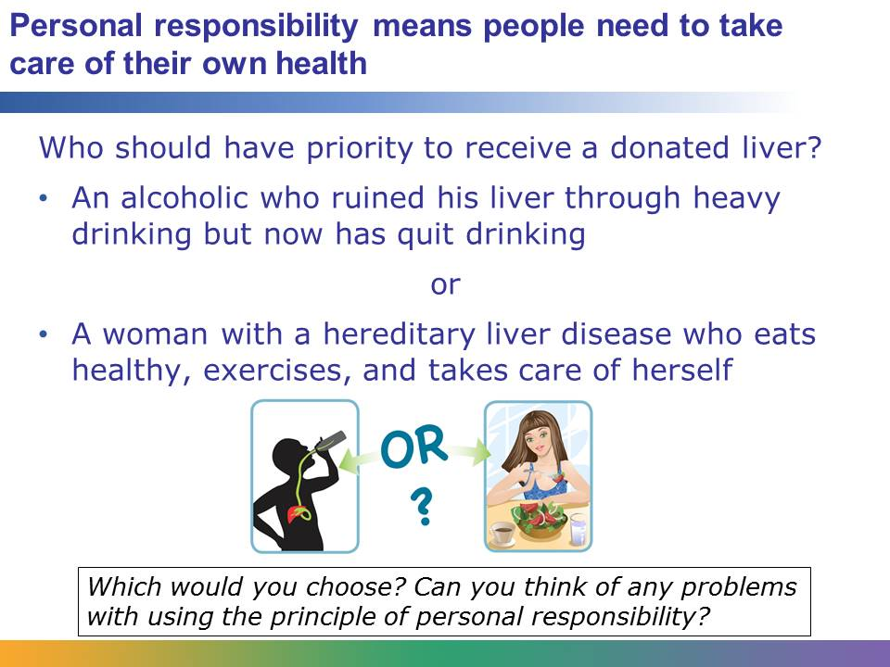
The principle of personal responsibility states that people need to make an effort to take care of their own health. In the case of the donated liver, the liver would go to the woman with hereditary liver disease, because she did not cause her illness and she tries to take care of her health.
This principle sounds logical: if resources are limited, you should give the resources to people who will use them properly, not waste them on people who don’t take responsibility for their own health. However, in real life it isn’t always so easy to determine who is being responsible and who isn’t.
HIV/AIDS is one of the diseases where this principle is frequently cited. Many people acquire HIV because of lifestyle choices; for example, using drugs or having unprotected sex with multiple partners. But sometimes people acquire HIV through no fault of their own. What if a woman’s husband contracts HIV because he cheats on her and she gets the disease from sleeping with him? She did not do anything irresponsible, but she now has the disease.
When applying the principle of personal responsibility, it is important to consider whether the person knew that what he or she was doing was a health risk. People who are illiterate or poorly educated may not understand the risks they are taking. In other cases, they may not have had much choice. Children living on the streets will eat and drink whatever they can get her hands on. If they get sick from eating bad food or drinking dirty water, that isn’t really their fault.
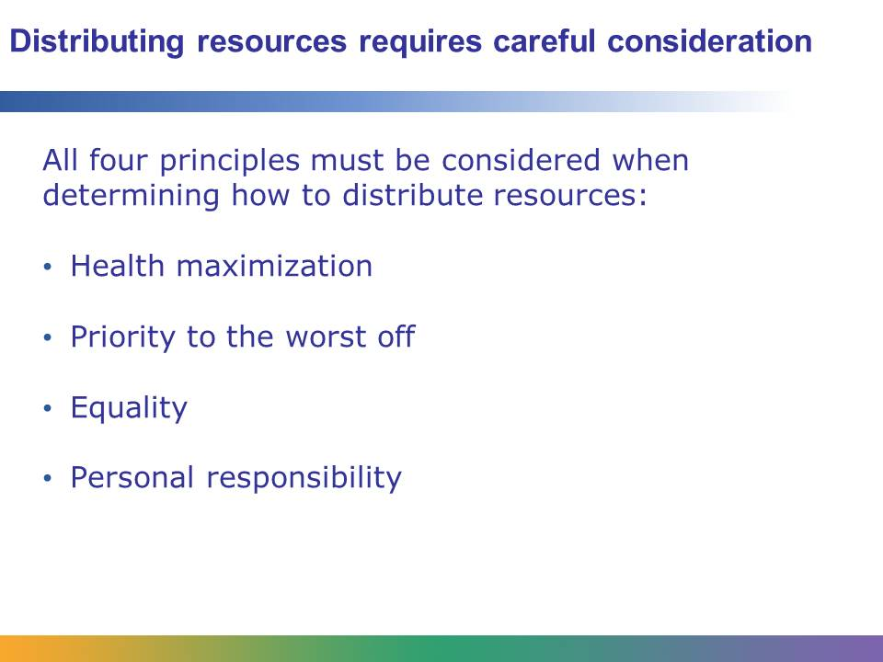
As you have seen, each of these principles can be used to make a good argument for how to distribute scarce resources, but each of them has its own weaknesses as well. When trying to determine how to distribute resources, health professionals use a combination of all of these principles to guide them.
For example, imagine that a major earthquake has struck Los Angeles. The first aid that arrives would probably go to the people who lived closest to the epicenter, where the shaking was the worst (priority to the worst off). Aid might be distributed through local hospitals or at relief shelters where the greatest number of people could get assistance (health maximization). Hospitals and Red Cross clinics would care for anyone who was injured, whether it was a street person who was cut by broken glass or a millionaire whose expensive house collapsed in the quake (equality). And the first people cared for would be the ones injured by the quake, not looters or people who took foolish chances after the quake hit (personal responsibility). By using all four principles, resources would be distributed fairly, even under difficult circumstances.

