Student Resource 6.3
Reading: Health and Socioeconomic Development
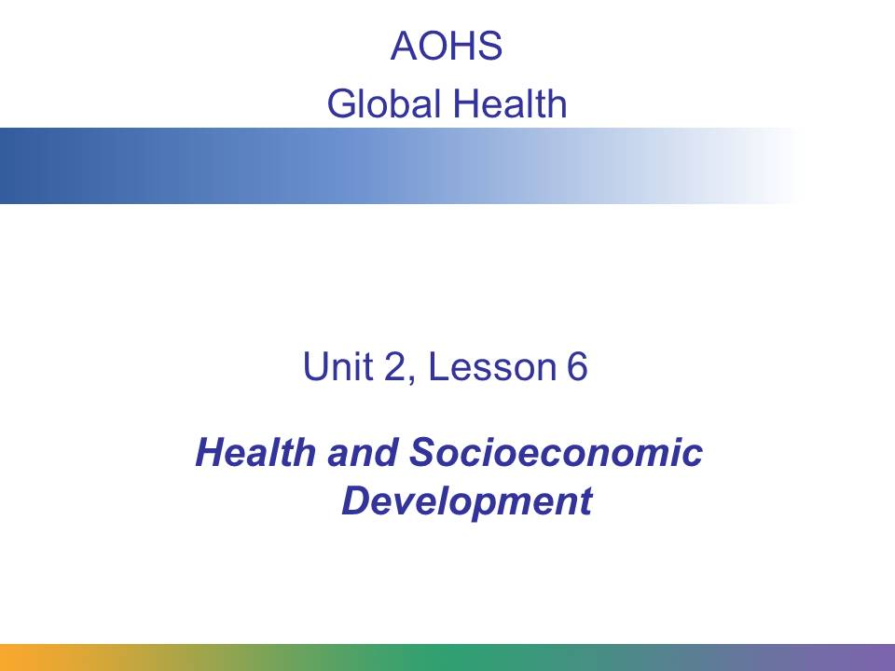
In this presentation, you will learn about the relationship between health and economic development, and how that affects global health.
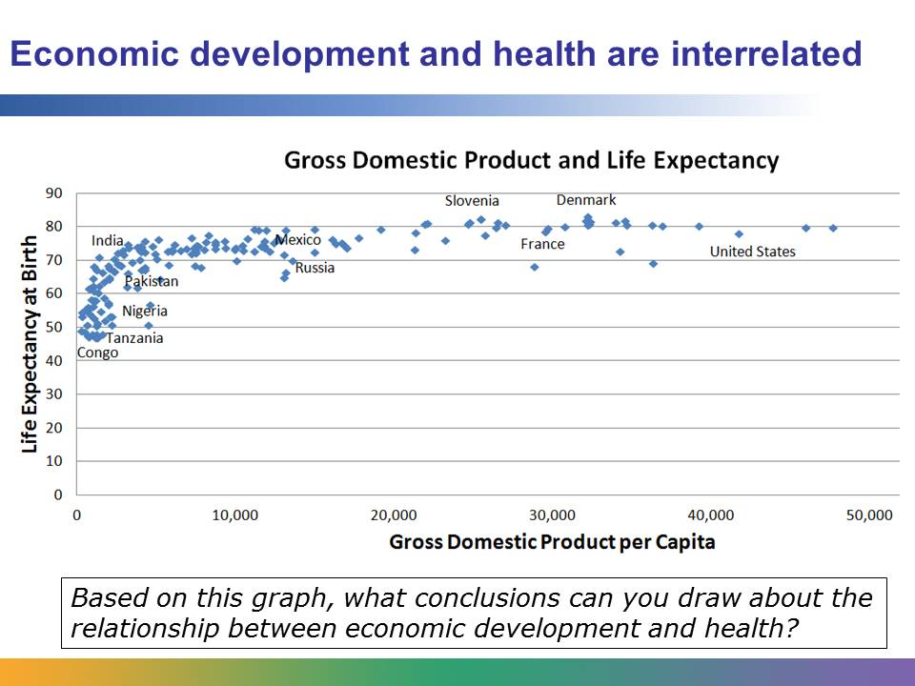
This graph shows the relationship between a country’s gross domestic product (GDP) and the life expectancy in that country. The data is from 2010.
GDP per capita is the average total value of goods produced and services provided by each person within a country in one year. So, for example, in the US in 2010, every person produced, on average, goods and services valued at $47,184. It’s one way to measure a country’s level of economic development.
Each dot on the graph represents a country. As you can see in the graph, if the GDP is low, the life expectancy is also likely to be low. The countries represented by dots on the left side, such as Congo, start with life expectancy below 50 and a GDP that is less than $1,000 per year. The graph curves upward, because as the GDP rises, so does the life expectancy. But economic development is only one factor in determining life expectancy. As you can see, some of the wealthiest countries are not necessarily highest in life expectancy.
The general trend corresponds with what you have already learned: that developed countries tend to have healthier populations. Developed countries are usually farther along in demographic and epidemiological transition. Their people have longer life expectancies and lower birth rates. They generally die from noncommunicable diseases rather than from infectious diseases.
The data used to compile this graph is available from the United Nations Development Program (UNDP) site at http://hdr.undp.org/en/data.
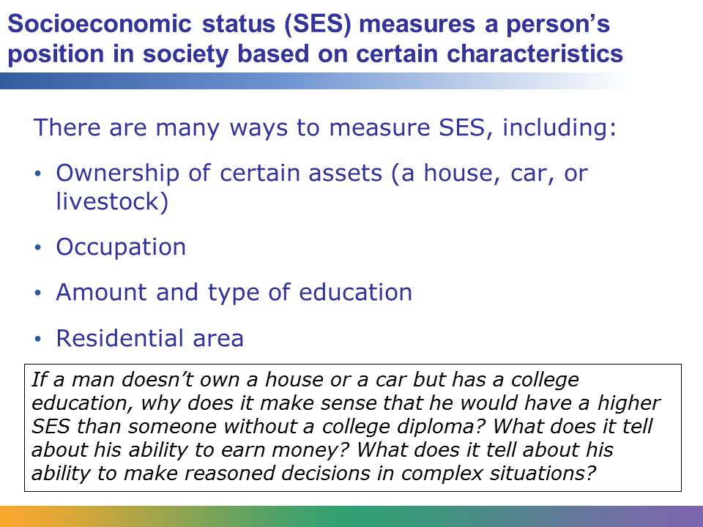
A person’s or a family’s socioeconomic status can have a significant impact on their health. There is no single way to determine someone’s SES; instead a range of different factors can be considered:
Ownership – What a person owns can tell us a lot about how much money that person has and how he or she chooses to spend it. SES can be evaluated based on whether someone owns a home, a car, a bicycle, a television, a radio, or livestock (cows, pigs, sheep, other farm animals).
Occupation – Different jobs require different levels of training, earn different salaries, and command different levels of respect. Occupation is often closely tied to education.
Education – If a person is literate, that person is much better equipped to make good health decisions than someone who cannot read and write. Typically, the more education someone has, the more likely he or she is to be able to access goods and services (such as health care).
Residential area – Where does someone live? In a rural environment? An urban environment? Is it a safe area? How much access does the person have to clean drinking water or healthy foods?
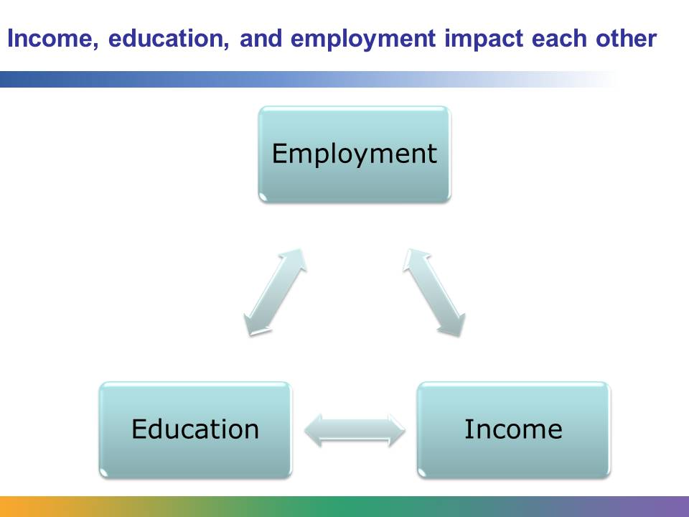
Income, education, and employment are all interconnected. If you have a good job, you will make a good income. If you have a good income, you can afford to educate your children. If your children are well educated, they have a better chance to get a good job for themselves.
All of these things together affect your health. On the next few slides, we will look at each of these factors more closely.
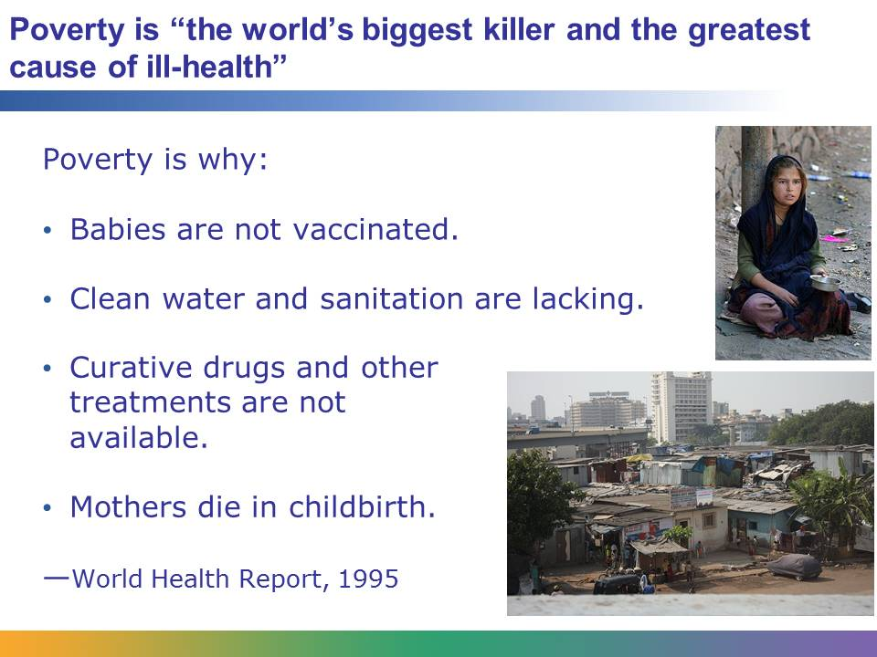
People who lack income live in poverty. More than 1 billion people, approximately 1 out of every 6 people in the world, try to survive on less than $1 per person per day. The 1995 World Health Report named extreme poverty “the world’s biggest killer and the greatest cause of ill-health and suffering across the globe.”
Poverty can have a major impact on health. It affects:
- The type of dwelling someone lives in (which might be unstable, made with dangerous materials, or unventilated—all health risks)
- How crowded a home is (which can cause the spread of infectious disease)
- Where a home is located (does it have access to clean drinking water, good sanitation, schools, or public transportation?)
Poor communities frequently suffer from unsafe drinking water, poor sanitation, or a lack of water for personal hygiene. Some communities may lack enough wood to boil water or cook food. Many poor people live without electricity, which means there is no way to safely store food or medicines. Plus, many poor people lack the money to buy medicine or pay for a doctor’s visit, or to pay for an education or the supplies needed to educate their children.
Images retrieved from http://commons.wikimedia.org/wiki/File:India_poverty.jpg and http://commons.wikimedia.org/wiki/File:Urban_Poverty.jpg, and reproduced here under the terms of the Creative Commons Attribution 2.0 Generic license (http://creativecommons.org/licenses/by/2.0/deed.en). Images courtesy of Steve Evans and Nikkul, respectively.
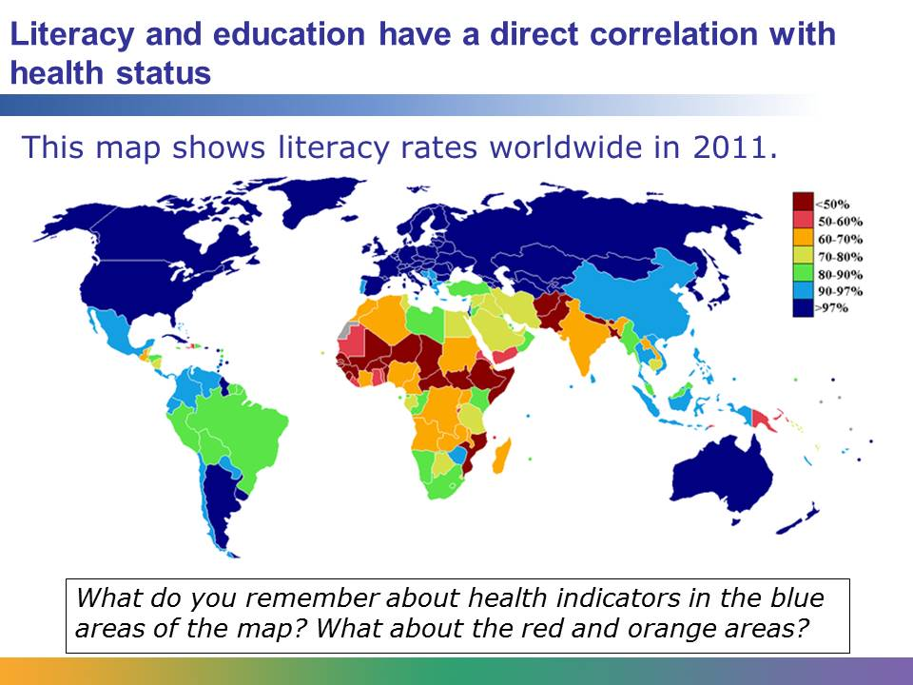
Literacy means functional literacy; that is, a person can read and write well enough to handle everyday tasks. The map above shows literacy rates worldwide. If you think about other maps you have seen in the course—maps that show levels of infection for illnesses like HIV, for example, or maps showing infant mortality rates—you may notice that the dark blue areas (the areas with the highest literacy rates) generally have better health indicators.
Education level refers to the amount of education a person has completed and the type of education the person received. Education level and literacy both have a significant impact on health. For one thing, people with a better education tend to have a higher income. This means they are less likely to experience the problems of poverty that you just learned about. They are also likely to work in less dangerous jobs, eat better-quality food, and be able to access medical care when they need it.
Literacy plays an important role in health care because literate people are better able to read and understand information about medical issues. They have an easier time understanding instructions from the doctor and are better equipped to learn about preventive measures they can take. Illiterate people not only struggle to understand medical information but also may be reluctant to seek medical care, not wanting to admit that they cannot read or write.
Map retrieved from http://commons.wikimedia.org/wiki/File:Literacy_rate_world.PNG and reproduced here under the terms of the GNU Free Documentation License (http://en.wikipedia.org/wiki/GNU_Free_Documentation_License).
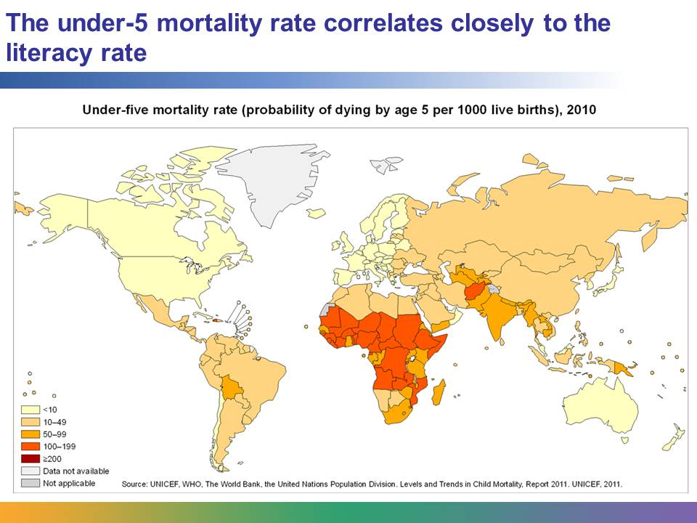
You can probably recognize that the areas with the highest literacy rates generally have lower rates of under-5 mortality. Literacy rates, particularly for women, affect infant and under-5 mortality rates.
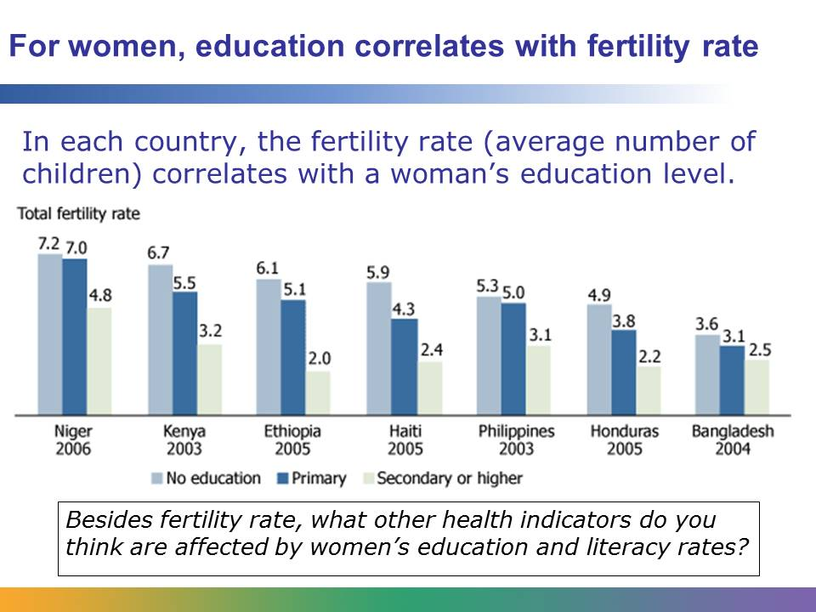
Educated and literate women improve the health of a country in many ways. As you can see in the graph above, more-educated women tend to have fewer children. Maternal education levels are also connected to decreased levels of under-5 child mortality, as you just saw, and to improved levels of childhood growth and nutrition. Educated women also tend to have an easier time obtaining help for their own health care needs.
Graph retrieved from the Population Reference Bureau at http://www.prb.org/Educators/TeachersGuides/HumanPopulation/Women.aspx on August 14, 2012, and reproduced here under fair-use guidelines of Title 17, US Code. Copyrights belong to respective owners.
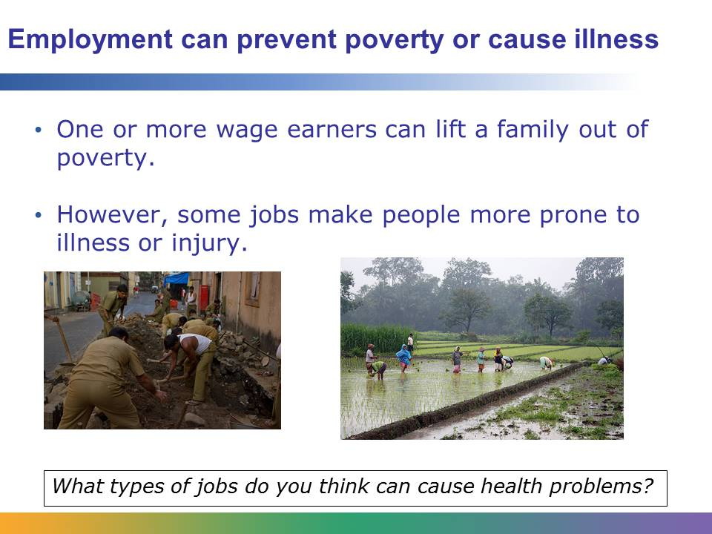
Jobs are rated based on skill and education level. Low-skill jobs, such as manual labor, may be the only work available for people with limited education or people who are illiterate.
These photos show some types of manual labor jobs, including building a road and farming. Unfortunately, these jobs are often dangerous. They may involve working in dangerous conditions or being exposed to chemicals or bacteria that can cause illnesses. In Europe, for example, professional workers (like teachers or engineers) have significantly lower risks than unskilled workers (such as janitors or security guards) for a range of health conditions, including noncommunicable diseases such as heart disease, lung cancer, and stroke. Unskilled workers also have high rates of suicide.
Images retrieved from http://commons.wikimedia.org/wiki/File:Mumbai_Workers_Victor_Grigas_Random_Shots-4.jpg and http://commons.wikimedia.org/wiki/File:Rice_plantation_in_Java.jpg and reproduced here under the terms of the Creative Commons Attribution-Share Alike 3.0 Unported license (http://creativecommons.org/licenses/by-sa/3.0/deed.en). Images courtesy of Victor Grigas and Gunkarta Gunawan Kartapranata, respectively.
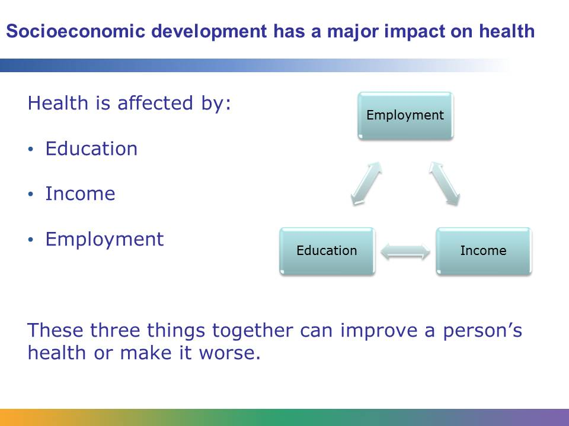
Education, employment, and income are all interconnected. A person with a good education has an easier time finding good employment and earning a good income. That person has an easier time accessing health services and can afford to provide a good education for his or her children. However, a person with limited education may not find a good job, may not earn much money, and may struggle to access health services. This person’s children may not get a good education, and their lives may suffer as a result, just like their parent’s.
Many NGOs that work on global health issues have broadened their outlook to include working on poverty, education, and employment issues because they have realized that if this cycle is not broken, people will continue to suffer and die from easily curable and/or preventable diseases.

