- We hold these truths to be self-evident, that all men are created equal, that they are endowed by their Creator with certain unalienable Rights.

- 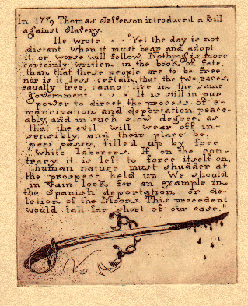

- Jefferson's Runaway Slave Notice
- 