Student Resource 8.3
Reading: Air Pollution
As Shreya weaves her way home through a dense maze of rickshaws, taxis, buses, and cars on the streets of Mumbai, India, she pulls fabric over her mouth. The air is thick with heat, dust, and smog. Her eyes and lungs burn as she walks. Once home, she begins to prepare dinner. She burns wood inside of her one-room home located in a slum that is larger than many cities in the world. The inside of her home fills with smoke. She stifles a violent cough and continues to cook.
Like many of the poor people in the world, Shreya is exposed to many types of air pollution, a major environmental health risk. Outdoor air pollution in the city where she lives is unavoidable. At home she’s exposed to indoor air pollution produced by burning biomass in an unventilated space.
Indoor Air Pollution
In the United States, most families cook with modern stoves using gas, electricity, or kerosene. In 2011, Shreya was just one of around 3 billion people in the world who cooked and heated their homes using solid fuels in open fires. This is the main source of indoor air pollution around the world. Solid fuels include coal and biomass, like wood, animal dung, logging wastes, and crop waste. A biomass is an energy source. People use the energy from burning biomass to cook and heat their homes. Most of the people who cook with solid fuels are poor and live in developing countries.
Cooking and heating with these materials inside a home produces high levels of indoor air pollution. Many of these homes are not vented to the outside, so the pollutants stay inside the homes and penetrate deep into the inhabitants’ lungs.
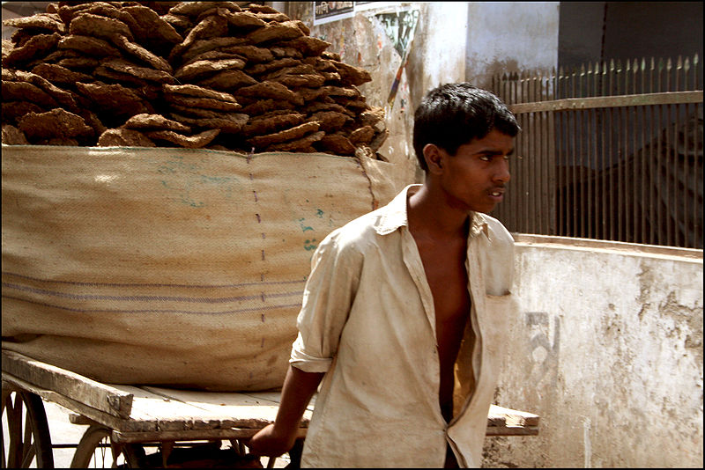 | At left, a boy in India wheels a supply of cow dung patties. The patties are a common source of energy for cooking in many poor communities around the world.  Image retrieved from http://commons.wikimedia.org/wiki/File:Cow_dung_transport_in_India.jpg and reproduced here under the terms of the Creative Commons Attribution 2.0 license (http://creativecommons.org/licenses/by/2.0/deed.en). Image courtesy of Flickr user lazyoldsun.
Women and children are especially vulnerable. In poor societies, women are often responsible for cooking food for the family, and young children spend most of their time in the home. Consequently, women and children are more exposed to the effects of indoor cooking with biomass than men.
According to the World Health Organization (WHO) in 2011, indoor air pollution was estimated to cause approximately 2 million premature deaths per year. Almost half of the deaths were due to pneumonia in children under 5. Indoor air pollution is associated with serious diseases that include respiratory infections, chronic obstructive pulmonary disease (COPD), and lung cancer. There are also new reports indicating that indoor air pollution increases the risk asthma, low birth weight, tuberculosis, cardiovascular disease, and blindness.

Other Sources of Indoor Air Pollution
Pollutant | Indoor Sources | Potential Effect
Tobacco smoke | Cigarettes, cigars, pipes | Bronchitis and pneumonia, emphysema, lung cancer, heart disease
Radon | Soil under buildings, ground water | Lung cancer
Asbestos | Damaged or deteriorating insulation | Lung cancer; asbestosis
Bacteria, viruses, animal dander, mites, fungi | House dust, pets, poorly maintained air conditioners, wet or moist structures | Asthma; allergic reactions; eye, nose, and throat irritation; influenza
Organic chemicals | Aerosol sprays, glues, cleaning agents, pesticides, paints | Headaches; damage to liver, kidneys, and brain; eye, nose, and throat irritation
Nitrogen oxides | Unvented or malfunctioning gas appliances | Eye, nose, and throat irritation; respiratory infections in children
Outdoor Air Pollution
There are many sources of outdoor air pollution. Power plants, industries, households, and vehicles, like cars, trucks, and buses, emit mixtures of air pollutants. Many of these pollutants are harmful to our health. According to the WHO in 2011, urban outdoor air pollution was estimated to cause 1.3 million deaths worldwide per year.
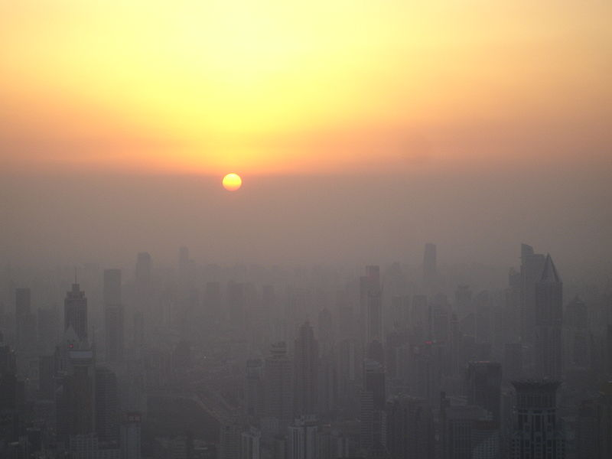 | Smog dominates the skyline at sunset in Shanghai. Smog is a mixture of pollutants.  Image retrieved from http://commons.wikimedia.org/wiki/File:Shanghaiairpollutionsunset.jpg and reproduced here under the terms of the Creative Commons Attribution-Share Alike 3.0 Unported license (http://creativecommons.org/licenses/by-sa/3.0/deed.en). Image courtesy of Suicup.
The most dangerous pollutant to human health produced by these sources is fine particulate matter, or PM, which comes from burning fuel for energy. PM is estimated to cause about 9% of lung cancer cases in the world. Diesel smoke from trucks, cars, and buses is an example of particulate matter. The major components of PM are sulfate, nitrates, ammonia, sodium chloride, carbon, mineral dust, and water.
There are many common air pollutants in an urban environment. Carbon monoxide and lead are two examples. The combustion of gasoline and fossil fuels in cars is a source of carbon monoxide. The health effects include a reduction in the capacity the blood has to carry oxygen. Lead is found in paint and batteries, and it is also found in leaded gasoline. Leaded gasoline is no longer commonly used in the United States, but it is used in other countries. Health effects of exposure to lead over time can include brain damage and digestive problems.
Older and younger people are susceptible to illnesses related to outdoor air pollution. People with preexisting conditions, such as lung or heart disease, are also at a greater risk. Outdoor air pollution affects people worldwide, but some of the areas most greatly affected are urban areas in China, India, and Eastern Europe.

Short-Term Effects of Outdoor Air Pollution | Long-Term Effects of Outdoor Air Pollution
Irritation to eyes, nose, and throat | Chronic respiratory disease
Upper respiratory infections, like bronchitis and pneumonia | Lung cancer
Headaches and nausea | Heart disease
Aggravation of conditions like asthma and emphysema | Damage to brain, nerves, liver, or kidneys

Most people around the world are exposed to some type of air pollution. The type of air pollution depends on where they live. Some people, like Shreya in Mumbai, are exposed to both indoor and outdoor air pollution. However, all air pollution, both indoor and outdoor, can pose serious health risks.
Student Resource 8.4
Note Taking: Air Pollution
Student Name:_______________________________________________________ Date:___________
Directions: Complete this chart with information you learn while reading Student Resource 8.3, Reading: Air Pollution.
 | Indoor Air Pollution | Outdoor Air Pollution
What are the sources of it?
Who is affected by it?
What effect does it have on health?

