Student Resource 8.1
Note Taking: Environmental Risk Factors Related to Sanitation, Water, and Hygiene
Student Name:_______________________________________________________ Date:___________
Directions: As you watch the presentation, take notes using the chart below.
Topic | Important Points
Causes of global health issues related to water
Reasons inadequate sanitation is a health concern
Reasons hand washing is important
Causes and effects of diarrhea
Repercussions of poor sanitation, water, and hygiene
Solutions to the problems of poor sanitation, water, and hygiene
Student Resource 8.2
Reading: Environmental Risk Factors Related to Sanitation, Water, and Hygiene
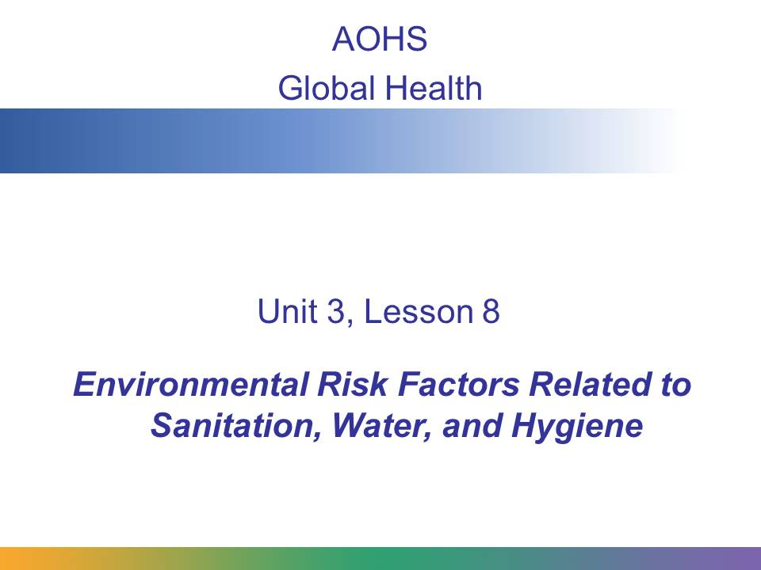
Urban air pollution, indoor air pollution from burning solid fuels, unsafe water, hygiene, and sanitation are the most important environmental issues affecting health. You will learn about outdoor and indoor air pollution later in this lesson. In this presentation, we focus on sanitation, water, and hygiene.
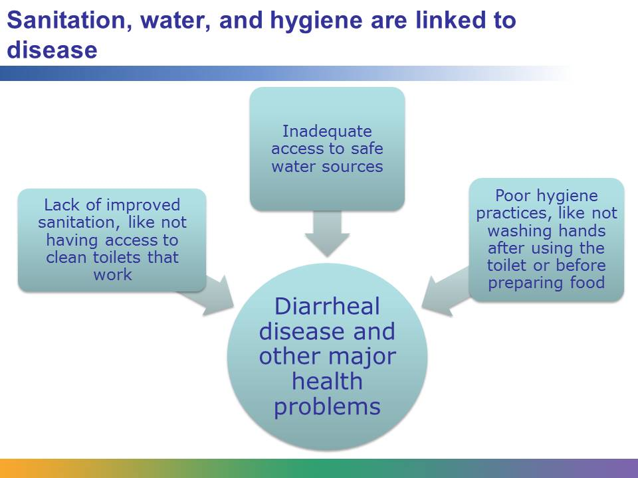
According to data from 2011, 2.4 billion people lack improved sanitation facilities, and over 768 million people use unsafe drinking water sources. Many of these people also lack knowledge about effective hygiene practices. All three of these issues—lack of improved sanitation, inadequate access to safe water, and poor hygiene practices—are linked. They are issues that mostly affect the poorer people of the world. They are responsible for diarrheal disease, the seventh leading cause of death in low- and middle-income countries.
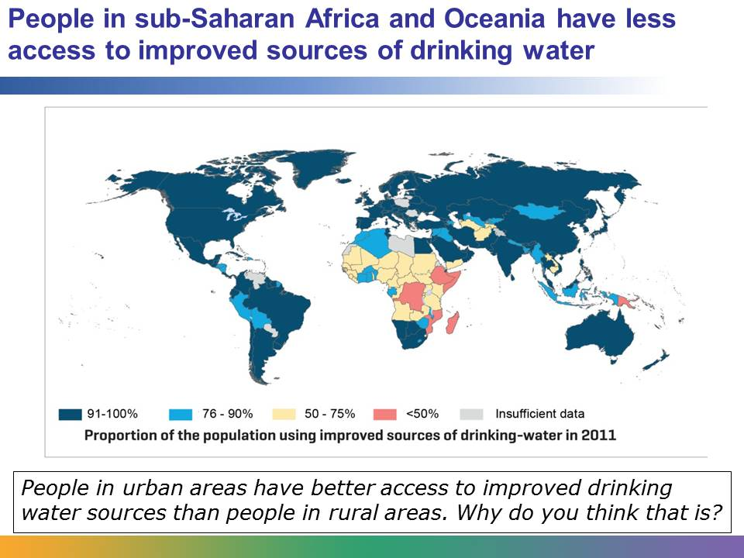
This map of sub-Saharan Africa and Oceania shows various areas with poor access to drinking water. Oceania is the regional name for the islands scattered throughout most of the Pacific Ocean.
As of 2011, much of the world’s population has access to improved drinking water sources. But still it was estimated in 2011 that 768 million people were without improved drinking water sources, and many of them were children. The majority of the deaths due to diarrheal disease, which is related to water, sanitation, and hygiene, are among children. Children are particularly vulnerable because their bodies are still developing; they may not have the immunity necessary to fight off diseases related to water, sanitation, and hygiene.

Image retrieved from WHO/UNICEF report “Progress on Sanitation and Drinking-Water, 2013 Update” at http://apps.who.int/iris/bitstream/10665/81245/1/9789241505390_eng.pdf and included here under fair-use guidelines of Title 17, US Code. Copyrights belong to respective owners. Data from http://www.who.int/mediacentre/news/notes/2013/sanitation_mdg_20130513/en/index.html.

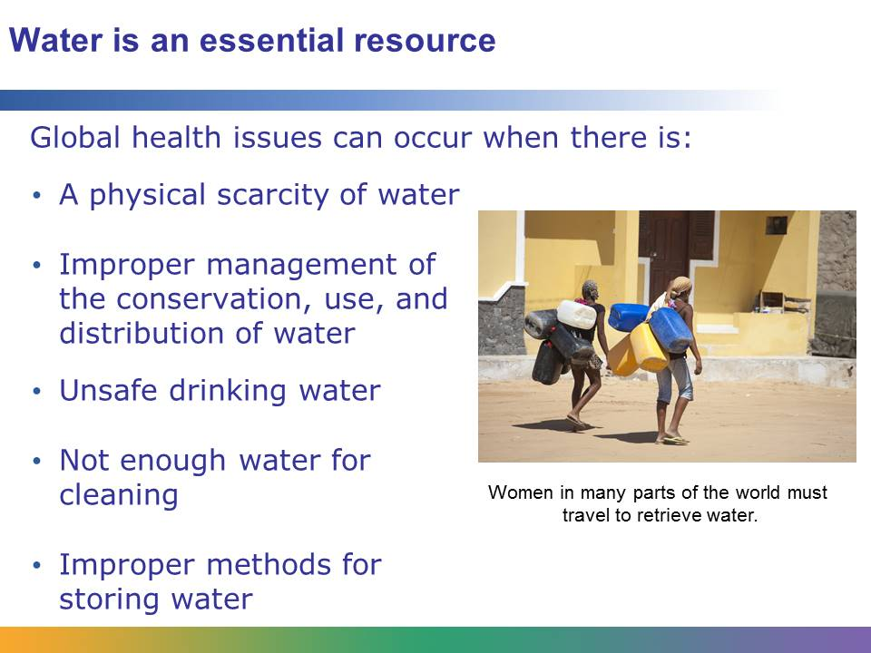
Without water, there is no life. Water is an essential resource, but more than 1 billion people lack access to water from sources that are within a reasonable distance from their homes. They live in areas where water is physically scarce. Most of these people live in low- and middle-income countries. A 2004 study found that access to water ranged from 56% of people in sub-Saharan Africa to universal access, or access for everyone, in high-income countries like the United States, Japan, and Germany.
Water scarcity doesn’t just occur in areas where there is no water. In areas where there is plenty of rainfall or freshwater, water scarcity can still be a problem. It may not be distributed to everyone or stored properly, for example. To meet the demands of households, farms, and industry, water needs to be conserved and used and distributed properly in communities. The water scarcity situation on the planet is worsening. As the global population grows and the world becomes more urbanized—meaning that more and more people live in cities—there is an increased need for water.
In addition to access, safety is another concern. When water is scarce, people are forced to rely on unsafe drinking water. The water may contain pathogens (remember that these are bacteria, microorganisms, or viruses) that can cause numerous waterborne diseases. Water scarcity also creates situations where people cannot bathe or keep their clothes and homes clean. When water is scarce, people might be forced to store water in dangerous ways. They may store water in their homes, which increases the risk for contamination. It also provides a breeding ground for mosquitoes that carry diseases like malaria.
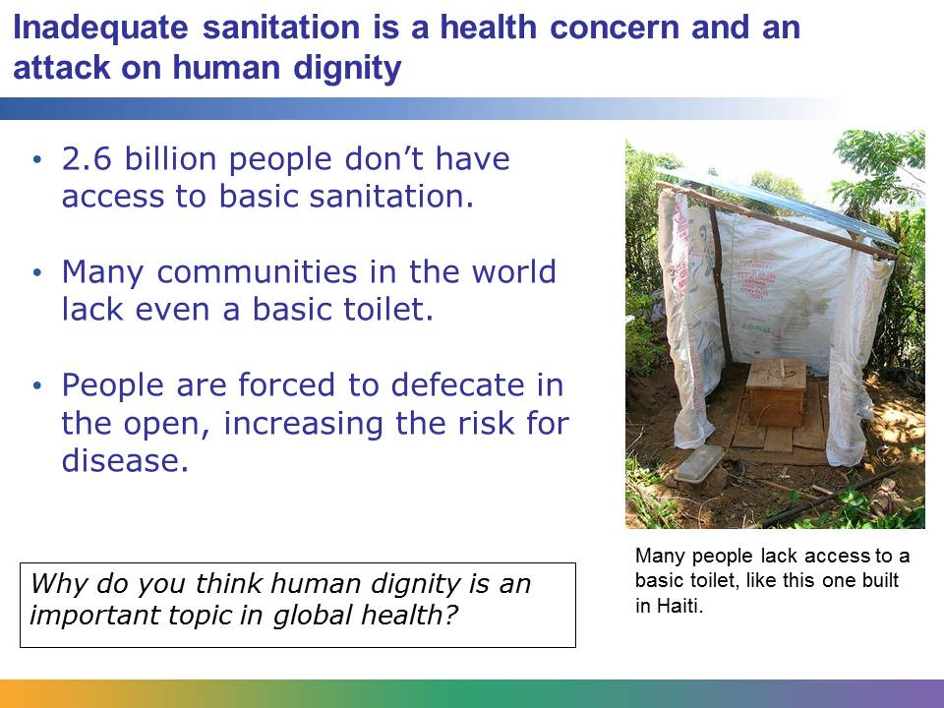
Currently, 2.6 billion people don’t have access to basic sanitation, and the number is growing. This means that they have no toilets—not even basic outdoor latrines. There are large cities in Africa that have no modern sanitation system. In some areas of Asia, women wait until nightfall and then defecate in groups on the side of the road or in open fields because they have no access to sanitary disposal of human waste, not even a simple pit latrine. Sanitation is a serious health concern. Lack of sanitation is also an issue that affects basic human dignity. The regions that are most affected are sub-Saharan Africa, southern Asia, and Oceania. Countries that have weak infrastructures, like poor sewage systems, and scarce resources, like water, are at a greater disadvantage to offer adequate sanitation facilities.
Without adequate sanitation facilities, people are forced to defecate in the open. This may mean that they do so in rivers that are used as a water source, in fields where food is grown, or even near areas where children play and food is prepared. This greatly increases the risk of diseases.

Image retrieved from http://commons.wikimedia.org/wiki/File:Arborloo_in_Haiti.jpg on April 23, 2012, and reproduced here under the terms of the Creative Commons Attribution-Share Alike 3.0 Unported license (http://creativecommons.org/licenses/by-sa/3.0/deed.en). Image courtesy of Rémi Kaupp.

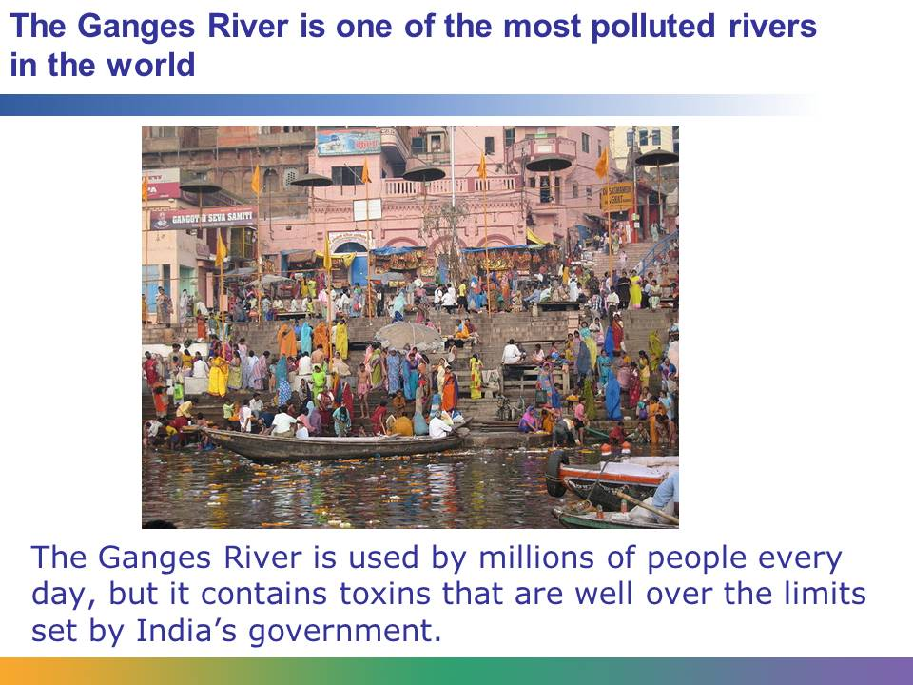
Without proper sanitation, people are forced to defecate and get rid of their waste in areas that have a direct effect on their health. For example, the Ganges River in India is used to collect drinking water, bathe, and wash clothes and dishes. It’s used by millions of people every day, but over a million liters of raw sewage are dumped into it every minute. People defecate near the river; the remains of cremated bodies are also put into the river. The result is that it is one of the most polluted rivers in the world, and the toxic levels near the ancient city of Varanasi are more than one hundred times the level that the Indian government says is safe. The state of the river is a major health threat to the people who use it, along with the animal and fish species that live in the river or depend on it.
Image retrieved from http://commons.wikimedia.org/wiki/File:Ganges_river_at_Varanasi_2008.jpeg on April 23, 2012, and reproduced here under the terms of the Creative Commons Attribution 2.0 Generic license (http://creativecommons.org/licenses/by/2.0/deed.en). Image courtesy of JM Suarez.
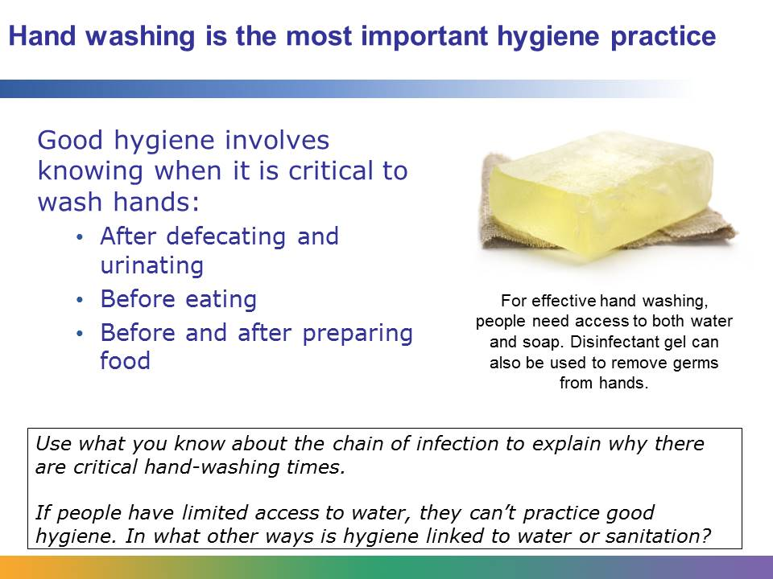
Improved sanitation facilities and improved water access and safety do not necessarily lead to improved health. Understanding and using hygienic practices, hand washing in particular, is critical to improving health outcomes.
For effective hand washing, people need access to both soap and water. They also need knowledge about the most important times to wash their hands: after defecating or urinating, before eating, and before and after preparing food. Studies have shown that hand washing with soap at these times can reduce the number of diarrheal bouts by almost half. Hand washing can also lower people’s risk for other diseases, including skin and eye infections and Avian influenza, or bird flu. In fact, the risk for most bacterial or viral infections can be reduced by hand washing.
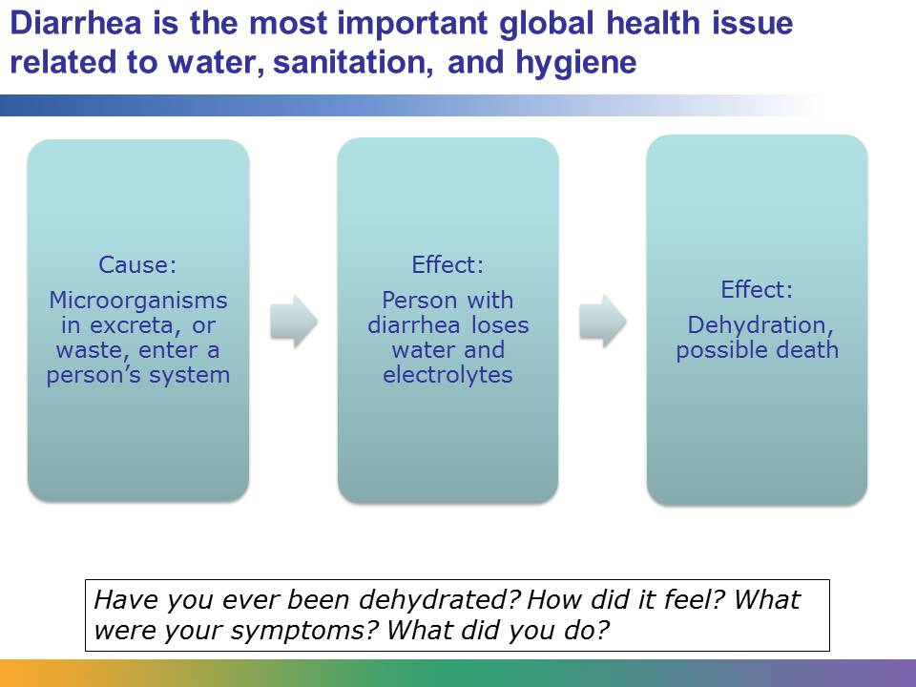
Diarrhea is the most important global health issue related to water, sanitation, and hygiene. It is caused by a variety of microorganisms, including viruses, bacteria, and protozoans. When these microorganisms enter a person’s system through food, water, or bodily contact, they can make a person very sick. When a person has diarrhea, that person loses both water and electrolytes, which include sodium, chloride, potassium, and bicarbonate. The balance of electrolytes in the body is necessary for the cells and organs to function properly. Diarrhea can lead to dehydration. In severe cases, it can lead to death.
Dehydration occurs when a person loses more fluids than he or she consumes. These fluids must be replaced. A person who is mildly dehydrated can often replace the fluids by drinking water, but with severe dehydration, medical attention is often required. When people are severely dehydrated, they may have a difficult time keeping fluids down. They may need to receive fluids intravenously. They may also need rehydration salts mixed into clean water. The rehydration salts will help them replace the electrolytes that they lost. Dehydration can become a serious issue for people who live in areas where there is limited clean water and limited access to medical clinics and rehydration salts.
Globally, there are about 4 billion cases of diarrhea each year that cause 1.8 million deaths. Over 90% of the deaths are among children under 5 years old. Children who have repeated episodes of diarrheal disease become more vulnerable to other diseases and malnutrition.
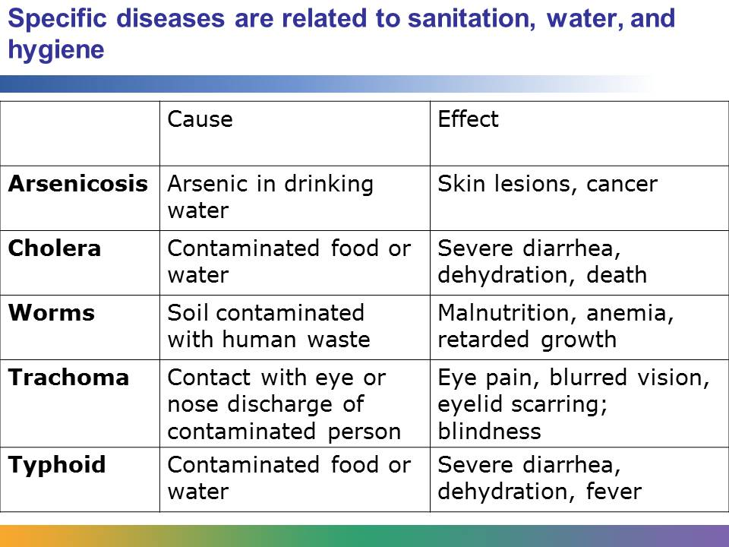
Whereas diarrheal disease is the most important health problem related to water, sanitation, and hygiene, there are many other serious related health diseases and conditions. Let’s look at five of them.
Arsenicosis is caused by long-term exposure to low concentrations of arsenic from natural sources in drinking water. It causes painful skin lesions and can result in cancers of the skin, lungs, bladder, and kidney.
Cholera is a bacterial infection in the intestinal tract. It causes severe attacks of diarrhea. Without treatment, it quickly can lead to dehydration and death.
Intestinal parasitic worms are caused by contact with soil that has been contaminated with human waste from an infected person or by eating contaminated food. The severity of the infection can vary, but it can lead to malnutrition when the body doesn’t have enough healthy red blood cells (anemia), or to retarded growth. Children are particularly vulnerable to worms. There are different kinds of worms. A quarter of the world’s population is believed to be infected with roundworm and whipworm.
Areas of inadequate water supply and unsafe sanitation are breeding grounds for trachoma, an eye infection spread by poor hygiene.
Typhoid fever is a bacterial infection caused by contaminated food or water. About 12 million people are affected by it each year. Symptoms include headaches, nausea, severe diarrhea, dehydration, and fever.
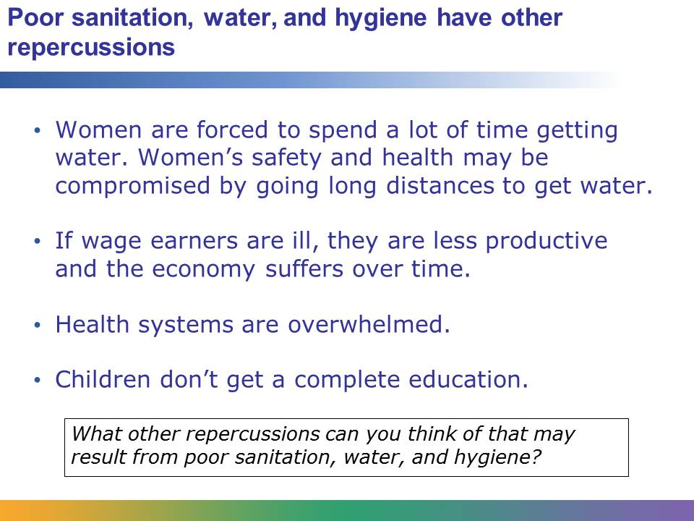
Poor sanitation, water, and hygiene have many other serious repercussions in addition to disease. In areas where water is scarce, women are often forced to spend large parts of their day retrieving water. Not only does this activity take up a lot of time, but the physical work can cause damage to their back and neck. They are also at risk for assault when they retrieve water from areas that are unsafe.
When wage earners are less productive due to illness caused by poor sanitation, water, and hygiene, the economy of a community, or even a nation, can suffer. In addition, health systems are overwhelmed diagnosing and treating people.
The education of children may also suffer because of poor sanitation, water, and hygiene. Children, girls especially, may drop out of school early because their schools lack decent sanitation facilities. Their schools may not have toilets. If they do, the conditions may be extremely unsanitary, or the facilities may not offer any privacy. The schools may lack a clean source of drinking water and facilities for hand washing. If hygiene practices at the school are poor, children who attend the school may be at risk of contracting serious illness. Once girls begin menstruating, they may be less likely to attend a school that doesn’t have private, adequate toilets. These girls may drop out of school instead.
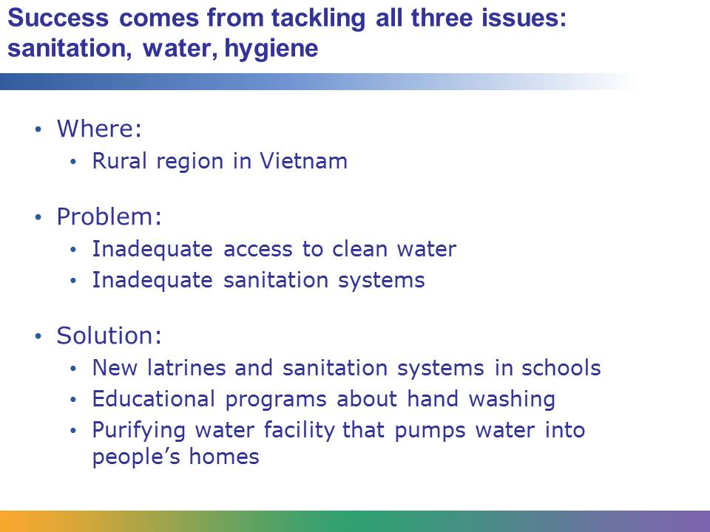
The most successful attempts to eliminate the risks caused by poor sanitation, water, and hygiene address the link between all three issues. The attempts to improve access to a safe water supply include the increase of basic sanitation information about hygienic practices in order to decrease the risk for diarrheal disease and other dangerous conditions that affect much of the world’s population.
For example, in the mountainous northern region of Vietnam, safe water and proper sanitation can be difficult to find. Basic knowledge about hand washing in rural areas is poor. One study found that fewer than 10% of existing latrines meet national hygienic standards.
One NGO teamed up with the Vietnamese government to address the needs of these remote communities on multiple levels. They educated the community, changed the environment, and worked with families. They built white concrete latrines and sanitation systems in schools. They worked with local teachers to develop a regular, ongoing program to teach children about hand washing. They organized parents to pitch in to cover the costs of soap.
In the community, women often had to retrieve water from wells down the road three or four times a day. The organization constructed a facility that takes water from a natural spring, purifies it, and then pumps it directly into the homes of people in the village. Now women have more time to spend with their children and devote to other responsibilities.

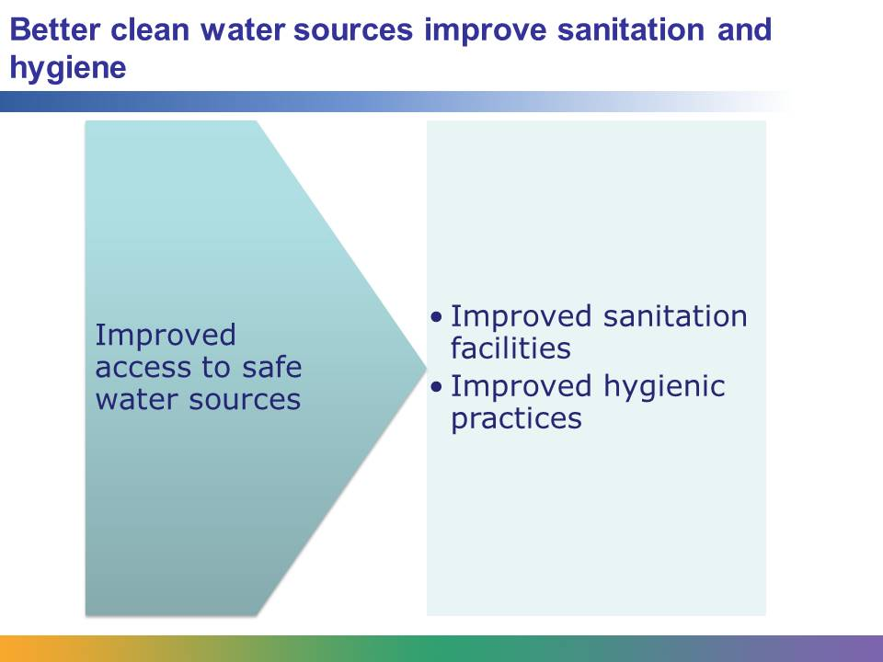
As the world population expands, issues related to sanitation, water, and hygiene will likely become more and more serious. Global health workers who focus on these issues understand that they are linked. People need improved access to safe water sources in order to establish improved sanitation facilities and hygienic practices. Tackling all three issues can reduce the number of children who die as a result of diarrheal diseases and other preventable conditions.

